my.uscis.gov Navigation Test

Welcome Screen
This contains the OMB number, privacy statement, and description of test
**PAPERWORK REDUCTION ACT STATEMENT**
An agency may not conduct or sponsor an information collection and a person is not required to respond to a collection of information unless it displays a currently valid OMB control number. The public reporting burden for this collection of information is estimated at 7 minutes per response, including the time for reviewing instructions, completing and submitting the responses. Send comments regarding this burden estimate or any other aspect of this collection of information, including suggestions for reducing this burden, to: U.S. Citizenship and Immigration Services, Customer Service & Public Engagement Directorate, Public Engagement Division, 20 Massachusetts Ave, Washington, DC 20529. OMB No. 1615-0121. Do not return the completed form to this address.
**PARTICIPANT CONSENT**
This consent information relates to usability testing conducted by U.S. Citizenship and Immigration Services and its affiliates as part of a project aiming to understand the customer’s experience of filling out an online immigration form and using related online services.
*Taking Part Is Voluntary*
Participation in this project is completely voluntary. You might be uncomfortable with some of the tasks and questions we will ask about. If you are uncomfortable at any point about anything we ask you, you may end your survey session at any time. If you elect not to participate in this project, or terminate your participation early, it will in no way affect the adjudication of the requested benefit.
*Confidentiality*
We will take necessary and appropriate precautions to protect your confidentiality. You will not be asked to disclose any personal details beyond age, gender, ethnicity, and language preference. Research records will be kept in a secure location, and raw notes will not be shared outside of our project team.
*Impact*
The information we gather and our findings during our research may be used in reports, shared online, and used in presentations. Taking part in this survey will not benefit you personally, but we may learn new information that will help others. If you have an ongoing application, petition, or request with the United States government, participating in this survey in no way guarantees special consideration and will have no bearing at all on the outcome of your case.
*Statement of Consent*
I have read the above information. I consent to take part in this survey and to have any information I provide be used in the manner described above. I understand that my name will not be used in connection with this test. I expressly release the U.S. Citizenship and Immigration Services from and against any and all claims which I have or may have for invasion of privacy, defamation, or any other cause of action arising out of the production, distribution, display, or publication of the results of the project, so long as the conditions of use described above are met.
------------------------------------------------------------
HELLO! WE WANT YOUR FEEDBACK!
Thank you for visiting myUSCIS. You have been selected to participate in a brief (about 7 minutes) customer survey to let us know how we can improve your experience. The survey includes 5 tasks and 2 questions.
The feedback you provide will help USCIS enhance this site and serve you better in the future. All results are strictly confidential.
If you would like to participate in this survey, please scroll to the top of this box and read through the Participant Consent information and then select the Begin Evaluation button to begin the survey.
OMB Control Number: 1615-0121
Expiration Date: 3/31/2018
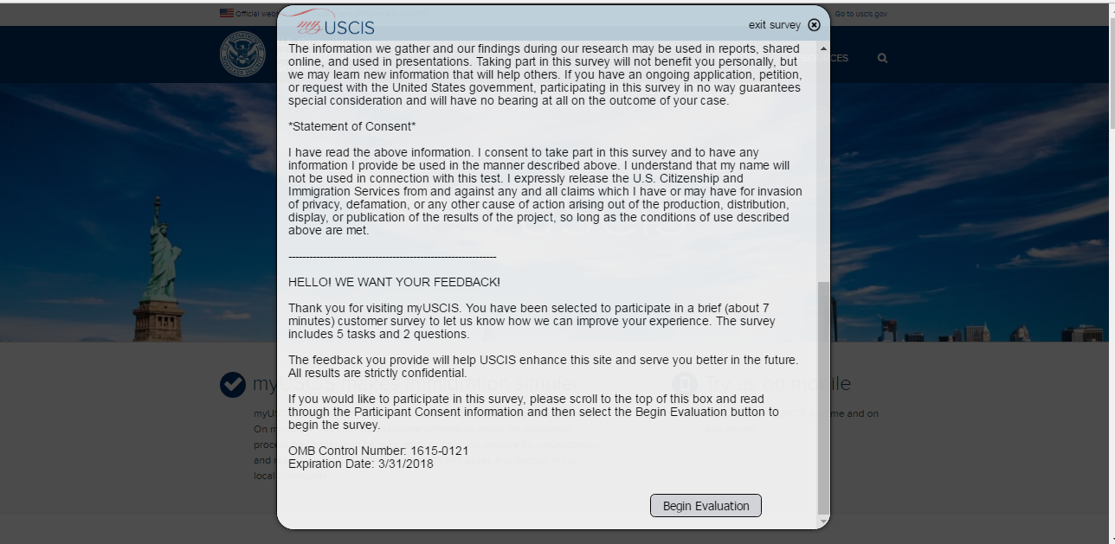

Loop11 Tool Description
This describes the tool functionality
In this exercise, you will be asked to carry out a number of tasks on a website.
• On the side of the page, you will see the current task you are to complete.
• To complete each task, you will need to navigate through the website to the page that contains the information for the task or the page that you think best answers or complete the task.
• When you have navigated to the page that contains the information for the task, select 'Task Complete'.
• If you can't find the page or are having difficulty you can select 'Abandon Task'.
Please remember -- we are not evaluating you, we are evaluating the website.
When you have read these instructions click NEXT TASK to begin the first task.
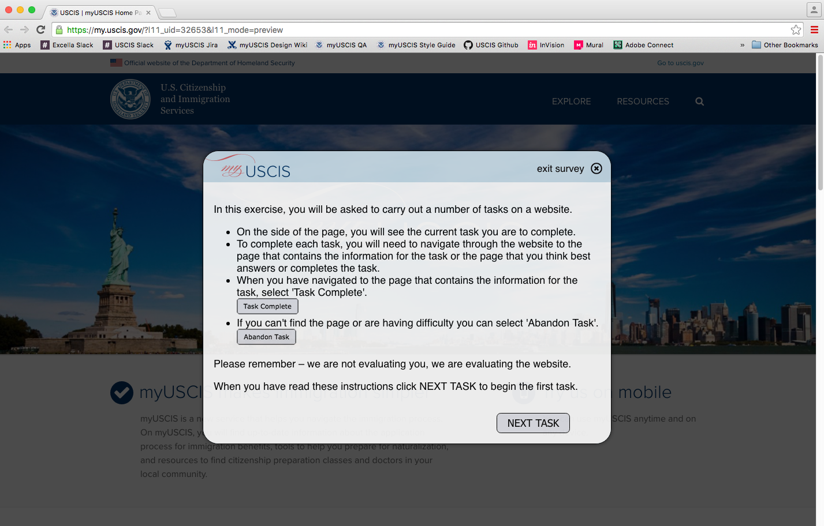

Start Task 0
This is a task that helps volunteer understand test controls
Before we get started, let's practice how to complete a task.
As your first task, navigate to the bottom left corner of this box and select the "Move" button. Move this box down to the bottom of the page so you can better navigate around the site.
After you move this box, select the "Task Complete" button.
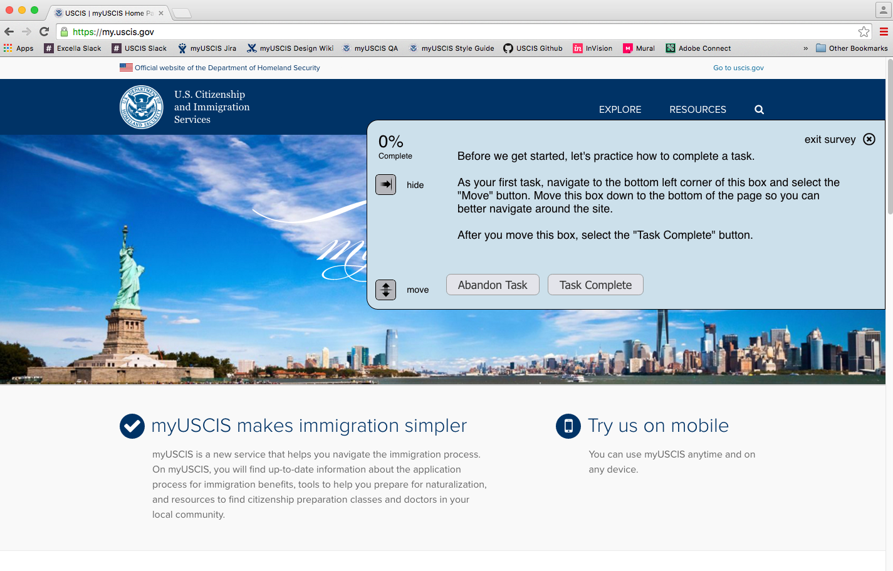

Navigation Task 1
Task on user ability to find citizenship information
Pretend you are interested in becoming a U.S. citizen. Where would you go to learn more about the citizenship process?
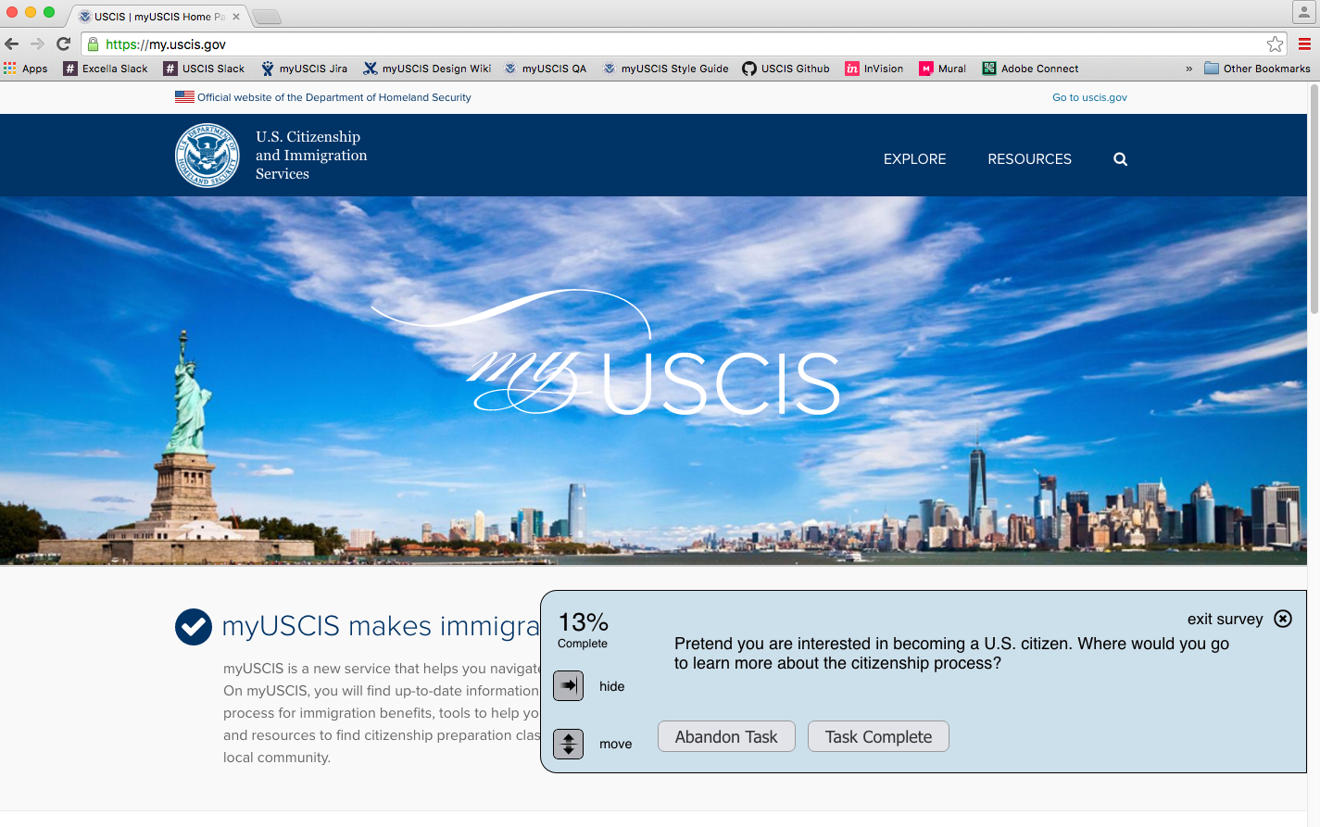

Navigation Task 2
Task on user ability to find citizenship application information
Pretend you are a current permanent resident of the United States (a Green Card holder). Where would you go to find out how to apply to become a U.S. citizen?
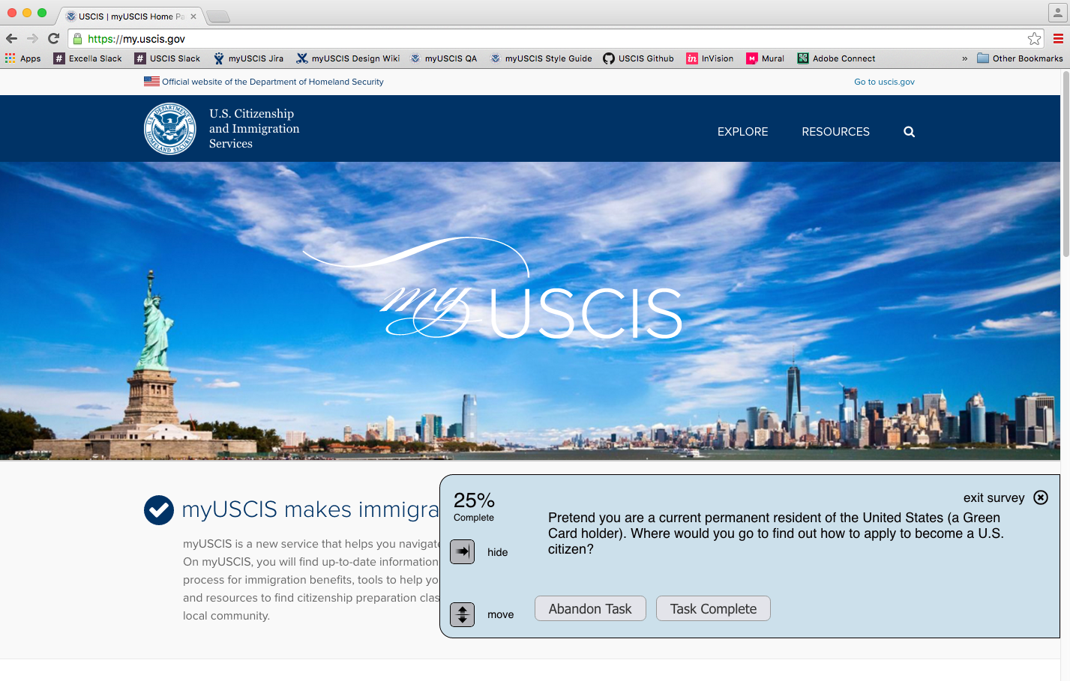

Navigation Task 3
Task on user ability to find the practice test
Pretend you are preparing for your naturalization interview as part of the process to become a U.S. citizen. Where would you go to take the practice civics test?
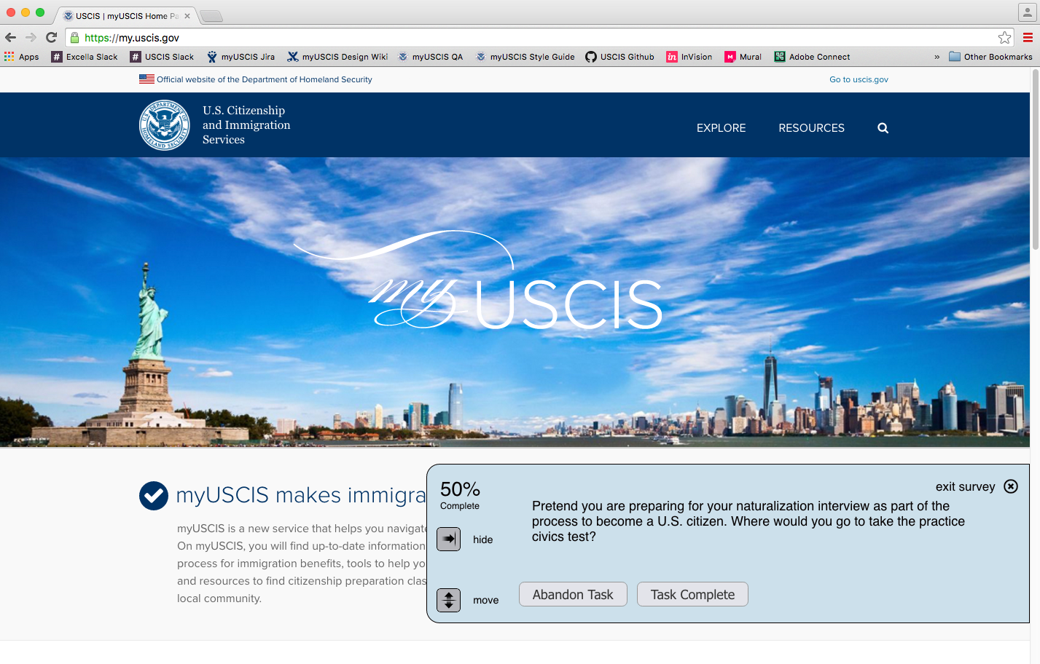

User Task 4
Task on user ability to find where to ask a question
Pretend you need to find an answer to a question. Where would you go for help?
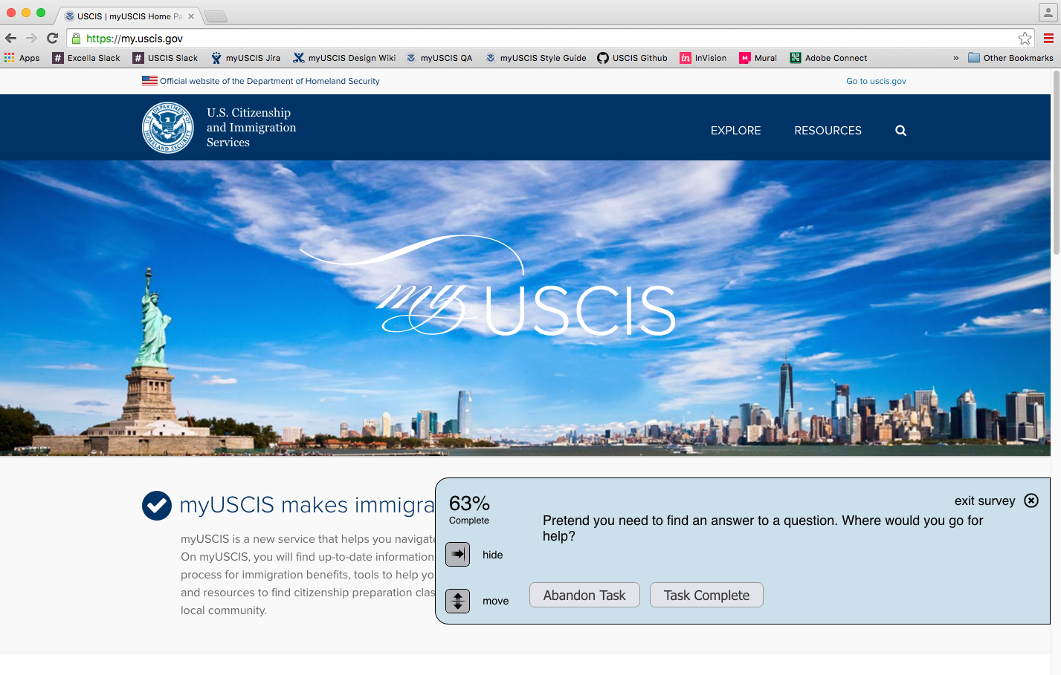

User Task 5
Task on user ability to find where to make an appointment
Pretend you want to go to a USCIS field office in person. Where would you go to schedule a visit?
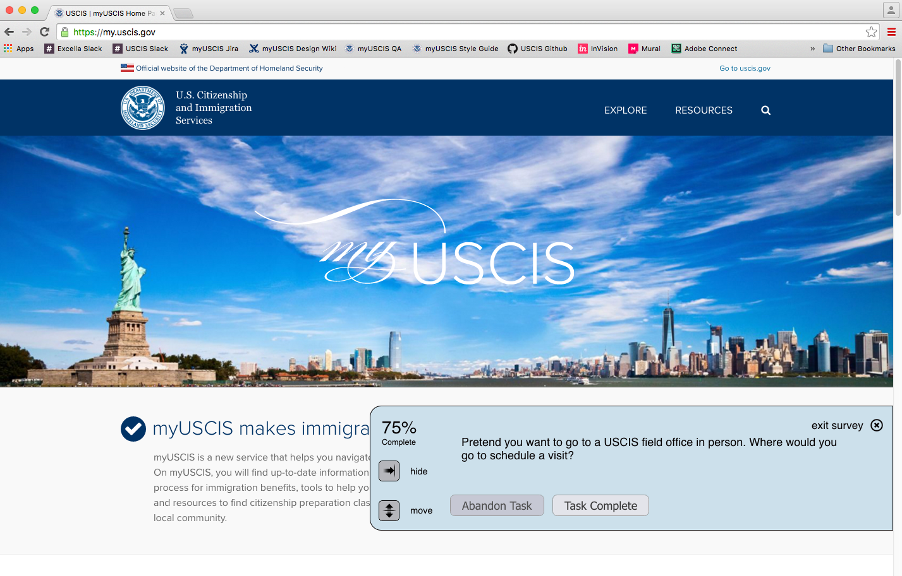

Finish Screen
Screen to complete evaluation
Evaluation complete
