SUPPORTING STATEMENT
First Responder Communities of Practice
(OMB No. 1640-0016)

A. Justification

- The Department of Homeland Security Science and Technology (S&T) Directorate First Responder Communities of Practice (FRCoP) program is responsible for providing a collaborative environment for the first responder community to share information, best practices, and lessons learned. Section 313 of the Homeland Security Act of 2002 (PL 107-296) established this requirement.
- First Responder Communities of Practice is a network of vetted, active and retired first responders, emergency response professionals and Federal, State, local, or Tribal Homeland Security officials sponsored by the U. S. Department of Homeland Security (DHS) Science & Technology (S&T) Directorate's First Responders Group. Registered members of this professional network share information, ideas, lessons learned and best practices, enabling them to more efficiently and effectively prepare for all hazards. Members use tools such as wikis, blogs and RSS feeds to collaborate online on the creation and management of critical planning, training, and other initiatives. Through information sharing and active participation in community workspaces, members are able to leverage each other's experiences to meet mission objectives. First Responder Communities of Practice not only offers information repositories and content creation tools, but also provides networking capabilities for practitioners across the country to connect with one another in a trusted, online environment.
- FRCoP is solely a web-based tool and thus only employs web-based technology to collect information from users to both reduce the burden and increase the efficiency of connecting an otherwise widespread and disparate group. FRCoP can be accessed at https://communities.firstresponder.gov

- Currently, there is no other entity identified which serves the same level of professional networking and collaboration among First Responders providing a similar function or that stores similar data. If an entity is identified in the future, FRCoP will work with the identified collection agent to leverage a cooperative partnership.

- It has not been determined that the collection of this data impacts small business or any small entities. The FRCoP web-based tool is a voluntary program and thus does not impose any mandatory burden on any entity.

- No consequences have been identified. The collection of information from first responders is voluntary. There is no established increment or frequency for collecting information.

- No special circumstances have been identified. The collection of information from first responders is voluntary. Data shared via the tool is simply for networking and collaboration.

- By notice in the Federal Register on August 29, 2013 (78 FR 53464), DHS S&T notified the public that it was requesting comments on this information collection for a 60-day period. DHS S&T then by notice in the Federal Register on November 4, 2013 (78 FR 66036), notified the public during a 30-day public comment period. DHS S&T did not receive any comments on the information collection.

DHS S&T consulted with First Responders regarding requiring participants to register at the site and the related collection of registration information. The FRs are very much in favor of requiring users to register so that everyone knows who they are talking to.
The Communities of Practice system is unique and while there may be other similar systems, there are none focused on connecting First Responders using a professional Web 2.0 social networking platform and providing them the collaboration tools in a secure environment.

9. DHS S&T does not provide payments or gifts to respondents in exchange for a benefit sought.

10. A Privacy Threshold Analysis and a Privacy Impact Assessment have been conducted for this collection. DHS may release this information of an individual on a case-by-case basis as described in the DHS/ALL-002 and DHS/ALL-004 System of Records Notice (SORN). There is no assurance of confidentiality provided to the respondent.

11. There are no questions of a sensitive nature in this information collection.

12. Estimated Annualized Burden Hours and Costs

Form Name | User Registration Form
No. of Respondents | 2000
No. of Responses per Respondent | 1
Avg. Burden per Response (in hours) | .50 (30 minutes)
Total Annual Burden (in hours) | 1000
Average Hourly Wage Rate | $50
Total Annual Respondent Cost | $50,000

Annual Reporting Burden and Respondent Cost: The total estimated ICR Public Burden in hours is 1000. This figure was derived by summing the total annual burden hours from all forms. The total annual number of respondents is 2000. This figure was derived by summing the number of respondents to each form.

Public Cost

The estimated annual public cost is $50,000. This figure was derived by summing the estimated annual respondent costs for all forms.

13. There are no capital or start-up costs associated with this information collection.
14. Government Cost
Estimate annual cost to the federal government in relation to this information collection is $110,000. This cost includes staffing costs for senior level directors, computer programmers, system administrators and mid level technical/engineers. Costs also include the data center hosting charges for servers and software to support collecting, retaining, and storing the collected information. A breakdown of annual costs is presented below:

Category | Total Cost
Labor | $40,000
Data Center Hosting | $70,000
Total: | $110,000

15. This is a renewal and revision of an information collection. The program would like to add one more field to the registration. The new field will be titled: Country of First Responder Affiliation. There is no change in the estimated burden associated with this collection.

16. DHS S&T does not intend to employ the use of statistics or the publication thereof for this information collection.

17. DHS S&T displays the expiration date of OMB approval for this information collection.
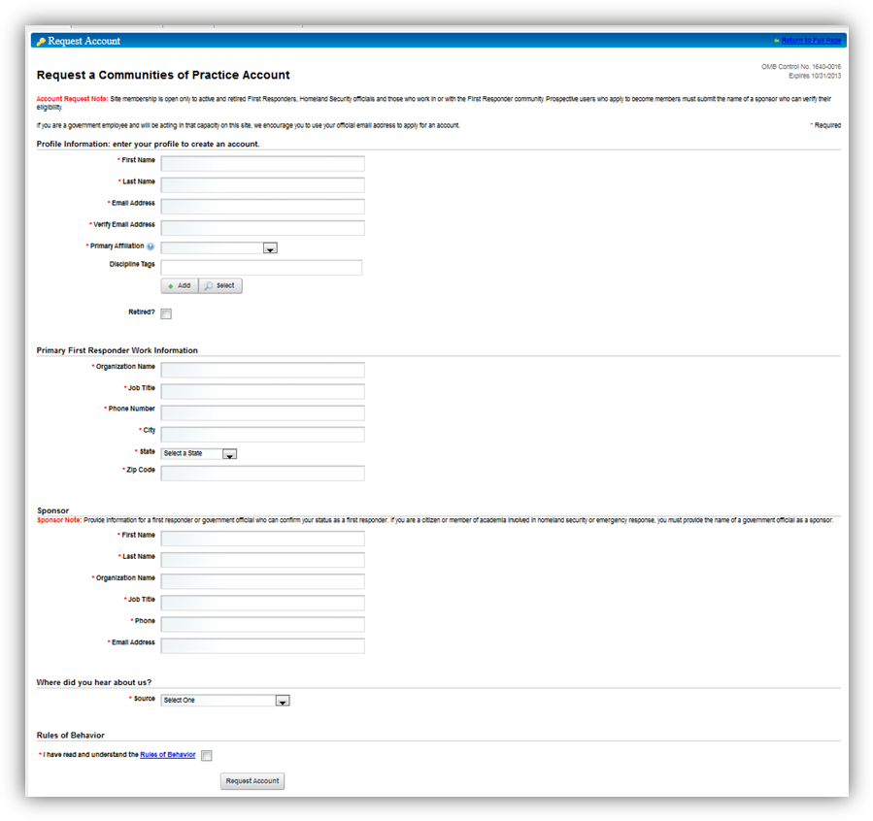
Form can also be viewed at: https://communities.firstresponder.gov/web/guest/home?p_p_id=58&p_p_lifecycle=1&p_p_state=maximized&p_p_mode=view&p_p_col_id=column-2&p_p_col_count=4&saveLastPath=0&_58_struts_action=%2Flogin%2Fcreate_account

18. DHS S&T does not request an exception to the certification of this information collection.

