|  |  |
| --- | --- |
| **R10 VR&E Forms**  **Content Specifications** | Version: 9.0 |
| Date: July 7, 2015 |
| **User Experience Content Specifications** | |
| Prepared by: **EVSS** | |

Revision History

| **Revision** | **Description of Change** | **Author** | **Date** |
| --- | --- | --- | --- |
| Rev: 1.0 | Providing content that corresponds to each page and section of wireframes | Michael Betsch | 05/20/2015 |
| Rev: 2.0 | Updated Privacy Act instructions/link | Michael Betsch | 06/01/2015 |
| Rev: 3.0 | Wholesale changes made to match wireframes | Michael Betsch | 06/10/2015 |
| Rev: 4.0 | Approved comments from VR&E approvers; minor edits to correct typos, misspellings, etc. | Michael Betsch | 06/17/2015 |
| Rev: 5.0 | Updated content per 06/18 meeting with VR&E. See green highlighted text for content updates. See pink highlights for questions from Mike Betsch. | Michael Betsch | 06/18/2015 |
| Rev: 6.0 | Incorporating updates from VR&E | Michael Betsch | 06/25/2015 |
| Rev: 7.0 | Received and incorporated latest edits from VR&E to include missing hyperlinks and minor text edits for clarification. | Michael Betsch | 06/26/2015 |
| Rev: 8.0 | Updates made to multiple sections per Corey Williams and feedback from John Watson | Michael Betsch | 06/30/2015 |
| Rev: 9.0 | Included edits from Mike Carr (BAS) to swap VR&E for formal program name and or formal program name w/ acronym. SEE: Item #s 20 and 25 to finalize button language. |  |  |

Table of Contents

1.0 VR&E Forms Feature Content 4

1.0 VR&E Forms Feature Content

This document provides detailed screenshots and proposed content for VR&E Forms.

Content provided in screenshots and wireframes should be considered as sample content for visualization purposes only. Wireframes can be found here: <http://7xsaxh.axshare.com/#p=starting_page__learn_vre_>

**NOTE:** The wireframes are for visualization purposes only and will not be updated to reflect proposed or final content. All stages of content development, from proposal to final approval, will be made in this document.

1. **VR&E Page 1, eBenefits VR&E Landing page** – This is the starting page in the wireframes for VR&E. The proposed content below the screenshot will appear on the current [eBenefits VR&E production page](https://www.ebenefits.va.gov/ebenefits/learn/employment). You can find this wireframe here: <http://7xsaxh.axshare.com/#p=starting_page__learn_vre_>

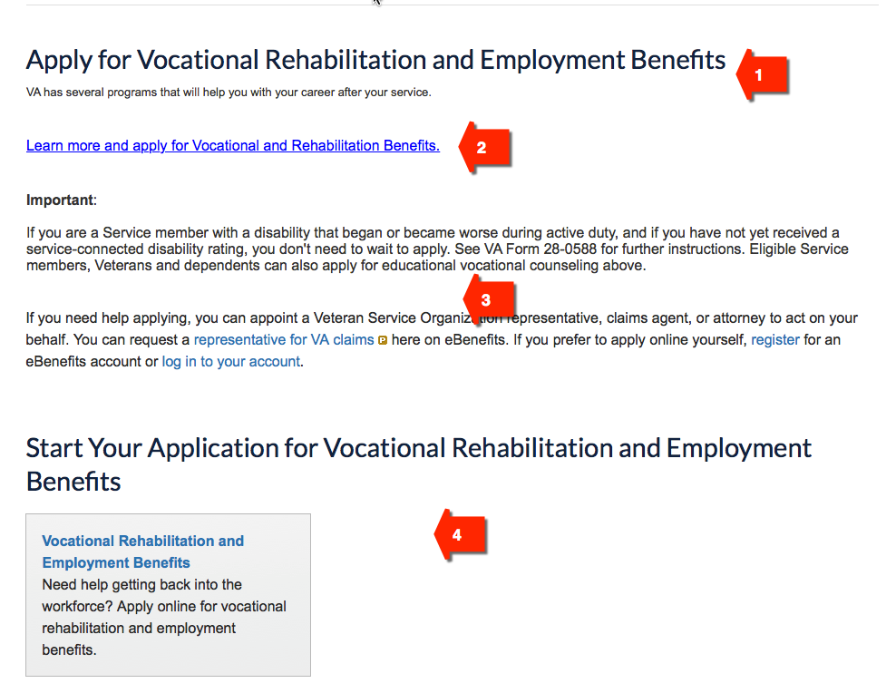

**#1 – Section Title and Short Description**  
**Title:** Apply for Vocational Rehabilitation and Employment Benefits  
**Description:** VA may assist you in receiving vocational rehabilitation and employment services to help with job training, employment accommodations, resume development, and job seeking skills coaching. Other services may be provided to assist Veterans in starting their own businesses or with independent living services.

**#2 – Action Prompt**

**Link Title:** Learn about Vocational and Rehabilitation benefits and apply online.

**Link URL:** <http://www.benefits.va.gov/vocrehab/>.  
 **#3 – Informational Content**

**Instructions 1:**

Important  
  
If you are a Service member who is currently enrolled in the Integrated Disability Evaluation System and have not yet received a service-connected disability rating, you may still apply. Entitlement is based on the receipt of:

* VA Form 28-1900
* Documentation of referral to a military Physical Evaluation Board, and
* Attendance at the initial evaluation appointment

Please contact your local Physical Evaluation Board Liaison Officer for additional information. Eligible Service members and Veterans can also apply for educational vocational counseling using the link above.

**Instructions 2:** If you need help applying, you can appoint a Veteran Service Organization representative, claims agent, or attorney to act on your behalf. You can request a [representative for VA claims ](https://www.ebenefits.va.gov/ebenefits/about/feature?feature=request-vso-representative) here on eBenefits. If you prefer to apply online yourself, [register](https://myaccess.dmdc.osd.mil/identitymanagement/registration.do) for an eBenefits account or [log in to your account](https://www.ebenefits.va.gov/ebenefits-portal/dsLogon.htm).

**#4 – Section Title and Menu Box Information**

**Title:** Start Your Application for Vocational Rehabilitation and Employment Benefits  
**Menu Box Title/Information:** Use existing menu as currently found on eBenefits

1. **VR&E Page 2, 28-8832 Log-in** – This is the second page in the wireframes for VR&E. It displays the DS Logon page. No developer changes required to wireframe found here: <http://7xsaxh.axshare.com/#p=28-8832_log-in>
2. **VR&E Page 3, VR&E Forms Never Applied** – This is the third page in the wireframes for VR&E. It displays two menu options available to users for requesting counseling or applying for Vocational Rehabilitation. training. You can find this wireframe here: <http://7xsaxh.axshare.com/#p=vre_forms_never_applied>

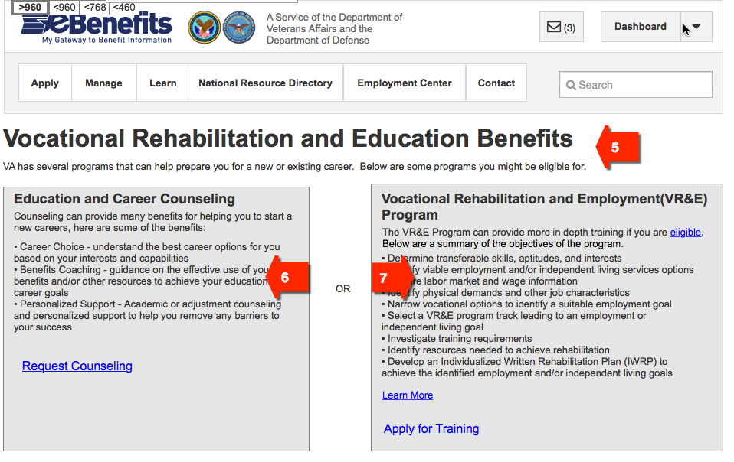

**#5 – Page Title**

**Title:** Vocational Rehabilitation and Employment Benefits

**Description:** VA may assist you in receiving vocational rehabilitation, employment services, and education and career counseling to help with job training, employment accommodations, resume development, and job seeking skills coaching.

**#6 – Left Menu Box**

**Title:** Education and Career Counseling  
**Description:** VA’s Education and Career Counseling program is a great opportunity for Service members and Veterans to get personalized counseling and support to help guide your career paths. Service members are eligible to enroll in Education and Career Counseling if you are a Service member within 180 days of anticipated discharge from active duty or if eligible for Chapter 33 benefits while on active duty. Veterans are eligible to enroll within one year from the date of discharge or release from active duty, if you are participating in an education benefit.

Services include:

• Career Choice - evaluation to understand the best career options for you based on your interests and capabilities.

• Benefits Coaching - guidance on the effective use of your VA benefits and/or other resources to achieve your education and career goals.

• Personalized Support - Academic or adjustment counseling and personalized support to help you remove any barriers to your success.

**Link Title:** Request Counseling

**#7 – Right Menu Box**

**Title:** Vocational Rehabilitation and Employment Program

**Description:** If eligible and entitled, the Vocational Rehabilitation and Employment (VR&E) Program can help Veterans with service-connected disabilities find meaningful, sustainable careers and connect you with training or other opportunities to help you reach your employment goals. Here are some ways VR&E can help you succeed in your career:

• Determine your transferable skills, aptitudes, and interests.

• Identify your viable employment and/or independent living services options.

• Explore labor market and wage information in your area.

• Identify physical demands and other characteristics of jobs you’re seeking.

• Narrow vocational options to identify your suitable employment goals.

• Select a VR&E program track leading to your employment or independent living goal.

• Investigate your training requirements.

• Identify resources needed to achieve your rehabilitation.

• Develop an Individualized Written Rehabilitation Plan to achieve your identified employment and/or independent living goals.

**Link Title 1:** Learn More

**Link Title 2:** Apply for Chapter 31

1. **VR&E Page 4, VR&E Forms Start – Dependent –** This is the fourth page in the wireframes for VR&E. It displays one menu option available to a Veteran’s dependent for requesting Education and Career Counseling. You can find this wireframe here: <http://7xsaxh.axshare.com/#p=vre_forms_start_-_dependent>

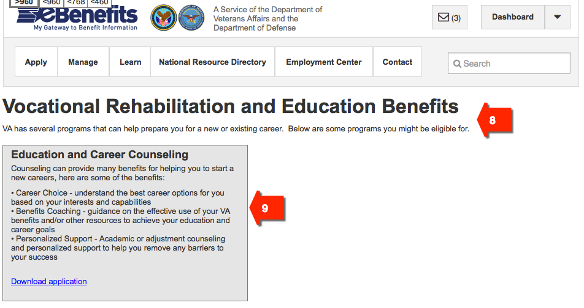

**#8 – Page Title**

**Title: Vocational Rehabilitation and Employment Benefits**

**Description:** VA may provide vocational counseling services to Service members still on active duty, as well as Service members within the Selected Reserve, and Veterans and dependents who are eligible for one of VA’s educational benefit programs. These services are designed to provide counseling and support services, help the individual choose a career goal, and/or determine the course needed to achieve the chosen goal. Education and Career counseling

Dependents may apply by printing and completing VA Form 28-0588 and submitting to your area Regional Benefit Office. [Find locations and contact information](http://www.va.gov/directory/guide/division.asp?dnum=3&isFlash=0).

**#9 – Menu Box**

**Title:** Education and Career Counseling  
**Description:** VA’s Education and Career Counseling program is a great opportunity for Service members, Veterans, and Dependents to get personalized counseling and support to help guide your career paths. Services include:

• Career Choice - evaluation to understand the best career options for you based on your interests and capabilities.

• Benefits Coaching - guidance on the effective use of your VA benefits and/or other resources to achieve your education and career goals.

• Personalized Support - Academic or adjustment counseling and personalized support to help you remove any barriers to your success.

**Link Title:** Download Application

1. **VR&E Page 5, Already Enrolled –** This is the fifth page in the wireframes for VR&E. It displays a message that the user is already enrolled in a VR&E program and not allowed to request admittance into another program. You can find this wireframe here: <http://7xsaxh.axshare.com/#p=already_enrolled>

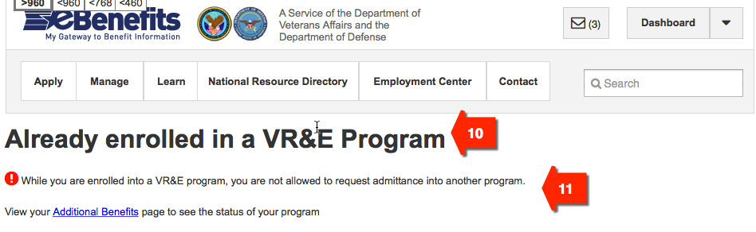

**#10 – Page Title**

**Title:** Already Enrolled in a Vocational Rehabilitation and Employment Program

**#11 – Informational Content**

**Instruction 1:** You are already enrolled in a Vocational Rehabilitation and Employment (VR&E) program and cannot request to be admitted into another VR&E program. Please contact your Regional Benefit Office to continue services. [Find locations and contact information](http://www.va.gov/directory/guide/division.asp?dnum=3&isFlash=0).

**Instruction 2:** Go to your additional benefits page to check your VR&E program enrollment status. [Find out about VR&E enrollment calculations](http://www.benefits.va.gov/vocrehab/program_definitions.asp).

1. **VR&E Page 6, VR&E Forms Applied at Least Once --** This is the sixth page in the wireframes for VR&E. It displays a message that the user is already enrolled in a VR&E program and not allowed to request admittance into another program. You can find this wireframe here: <http://7xsaxh.axshare.com/#p=vre_forms_applied_at_least_once>

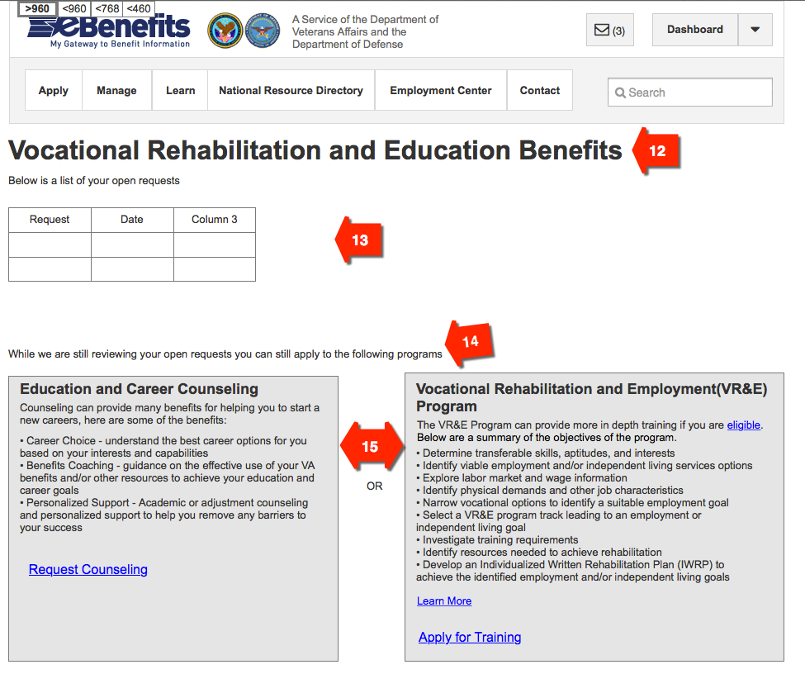

**#12 – Page Title**

**Title:** Vocational Rehabilitation and Employment Benefits

**#13 – Informational Content**

**Description:** A history of your Vocational Rehabilitation and Employment benefits requests is below.  
**Requests Table Column 1 Title:** Request Submitted  
**Request Table Column 2 Title:** Date

**#14 – Informational Content**

**Instructions:** You only need to apply once for either one of the VR&E programs below. You will be contacted directly by VR&E soon after we receive your request.

**#15 – Menu Boxes**

**Developer Instructions:** Use the same menu boxes provided above in VR&E Page 3, item #s 6 and 7, or see wireframes here: <http://7xsaxh.axshare.com/#p=vre_forms_never_applied>

1. **VR&E Page 7, Verify Information 1900 --** This is the seventh page in the wireframes for VR&E. It displays the 1900 applicant’s personal and contact information. You can find this wireframe here: <http://7xsaxh.axshare.com/#p=verify_information_1900>

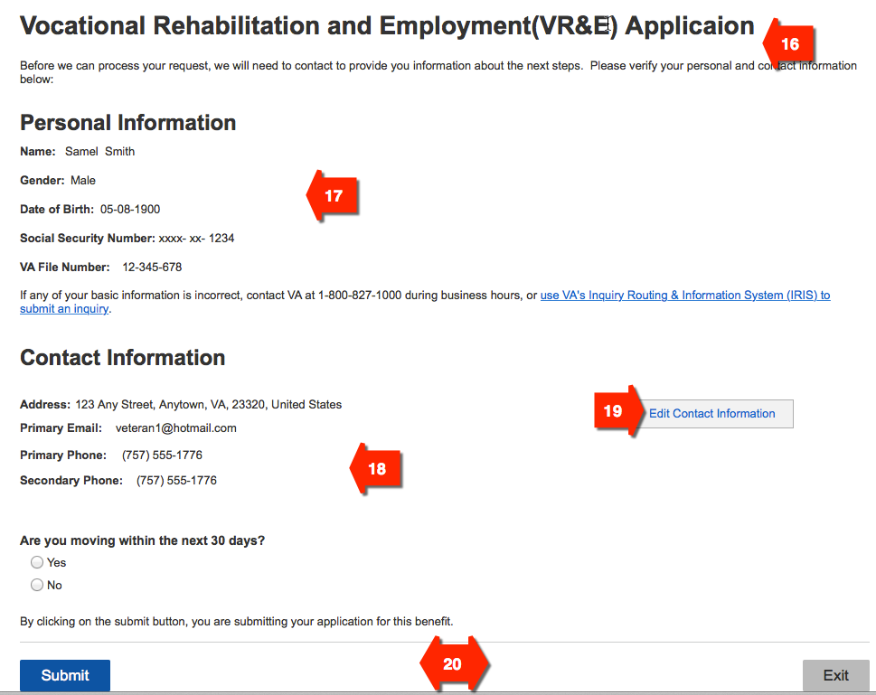

**#16 – Page Title  
Title:** Vocational Rehabilitation and Employment Application

**Description:** We may need to contact you to discuss next steps before we can process your application for Vocational Rehabilitation and Employment benefits. Please verify your personal and contact information below. Follow the instructions if you need to make updates.

**#17 – Personal Information Details**

**Section Title:** Personal Information

**Detail 1:** Name

**Detail 2:** Gender

**Detail 3:** Date of Birth

**Detail 4:** Social Security Number  
**Detail 5:** VA File Number  
**Instructions:** If any of your personal information is incorrect, contact VA at 1-800-827-1000 (711 if you use TDD), Monday - Friday, 8:00 am - 9:00 pm ET. You can also submit a question to VA's Inquiry Routing & Information System (IRIS) and receive a response within five business days.

**#18 – Contact Information Details**

**Section Title:** Contact Information

**Detail 1:** Address

**Detail 2:** Primary Email

**Detail 3:** Primary Phone

**Detail 4:** Secondary Phone

**Question:** Are you moving within the next 30 days?

**Answer Option 1:** Yes

**Answer Option 2:** No

**Instructions:** By clicking the Submit button, you are submitting your application for this benefit.

**#19 – Action Prompt**

**Link Title:** Edit Contact Information

**#20 – Button Text**

**Left Button:** Apply for Ch. 31   
**Right Button:** Exit Ch. 31 Application

1. **VR&E Page 8, Verify Information 8832** -- This is the eighth page in the wireframes for VR&E. It displays the 8832 applicant’s personal and contact information. You can find this wireframe here: <http://7xsaxh.axshare.com/#p=verify_information_8832>

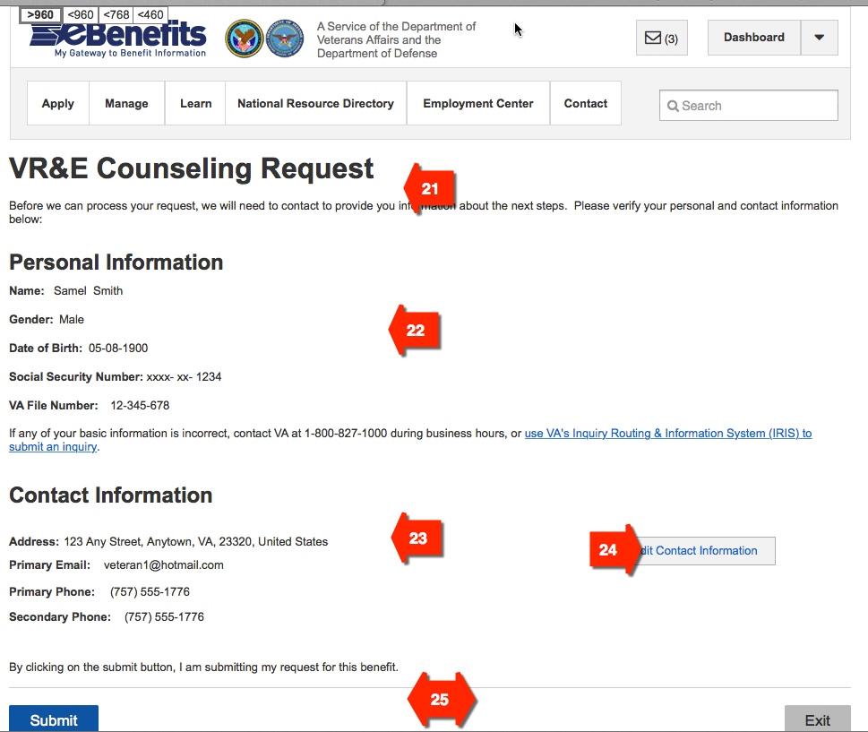

**#21 – Page Title  
Title:** Education/Career Counseling Request

**Description:** We will need to contact you to discuss next steps before we can process your request for Education/Career counseling. Please verify your personal and contact information below. Follow the instructions if you need to make updates.

**#22 – Personal Information Details**

**Section Title:** Personal Information

**Detail 1:** Name

**Detail 2:** Gender

**Detail 3:** Date of Birth

**Detail 4:** Social Security Number  
**Detail 5:** VA File Number  
**Instructions:** If any of your personal information is incorrect, contact VA at 1-800-827-1000 (711 if you use TDD), Monday - Friday, 8:00 am - 9:00 pm ET. You can also submit a question to VA's Inquiry Routing & Information System (IRIS) and receive a response within five business days.

**#23 – Contact Information Details**

**Section Title:** Contact Information

**Detail 1:** Address

**Detail 2:** Primary Email

**Detail 3:** Primary Phone

**Detail 4:** Secondary Phone

**Instructions:** By clicking the Submit button, you are submitting your application for this benefit.

**#24 – Action Prompt**

**Link Title:** Edit Contact Information

**#25 – Button Text**

**Left Button:** Submit Ch. 36 Application

**Right Button:** Exit Ch. 36 Application

1. **VR&E Page 9, Exit Verify Information** -- This is the ninth page in the wireframes for VR&E. It displays an exit warning message and requests confirmation form the user before terminating the online application request. You can find this wireframe here: <http://7xsaxh.axshare.com/#p=exit_verify_information>

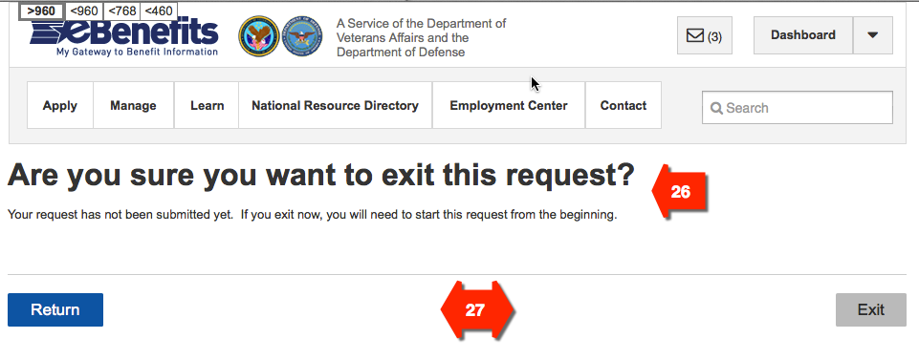

**#26 -- Page Title**

**Title:** Are you sure you want to exit this request?

**Description/Instructions:** Your Vocational Rehabilitation and Employment request has not been submitted. Click the Return button below to complete and submit your request. If you exit now, you will need to start a new request.

**#27 – Button Text**

**Left Button:** Return

**Right Button:** Exit

1. **VR&E Page 10, Verify Information 8832 – Error** -- This is the tenth page in the wireframes for VR&E. **Developers Note:** The content for this page is identical to **VR&E Page 8, Verify Information 8832** above, but displays an error message in the Contact Information section. You can find this wireframe here: <http://7xsaxh.axshare.com/#p=verify_information_8832_-_error>

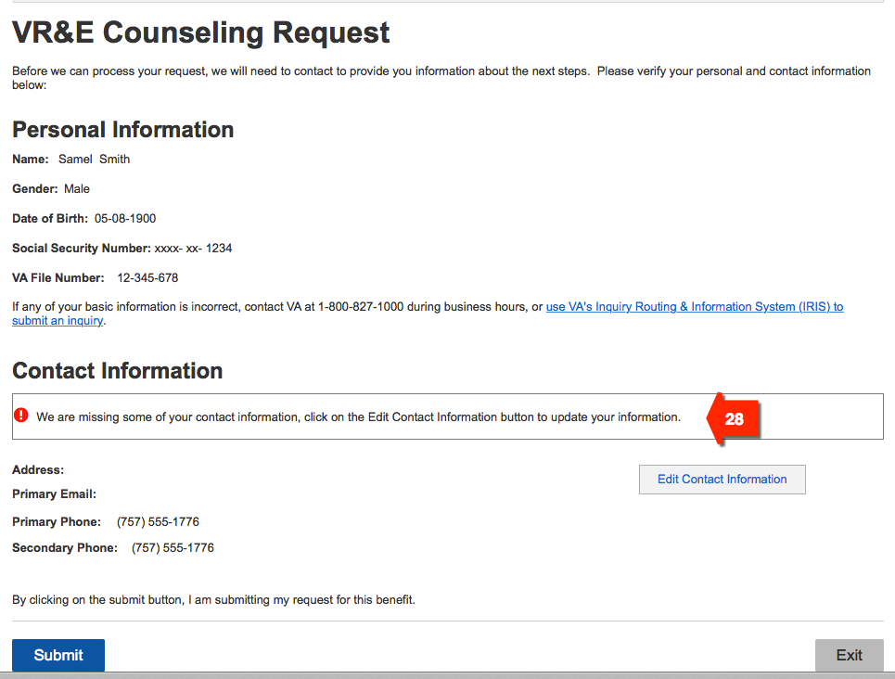

**#28 – Contact Information Missing Error Message  
Error Message:** Some of your contact information is missing. Please click the Edit Contact Information button to make updates.

1. **VR&E Page 11, 8832 Confirmation** – This is the eleventh page in the wireframes for VR&E that confirms user submitted 8832 and provides information about next steps. The proposed content below the screenshot corresponds with the wireframe found here: <http://7xsaxh.axshare.com/#p=confirmation_8832>

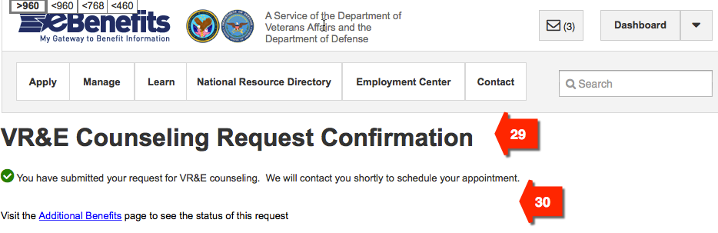

**#29 – Page Title**

**Title:** Education/Vocational Counseling Request Confirmation

**#30 – Informational Content**

**Instructions:** You have successfully submitted your request for Education/Vocational counseling. We will contact you soon to schedule your appointment.

1. **VR&E Page 12, 1900 Confirmation** – This is the twelfth page in the wireframes for VR&E that confirms user submitted 1900 and provides information about next steps. The proposed content below the screenshot corresponds with the wireframe found here: <http://7xsaxh.axshare.com/#p=confirmation_1900>

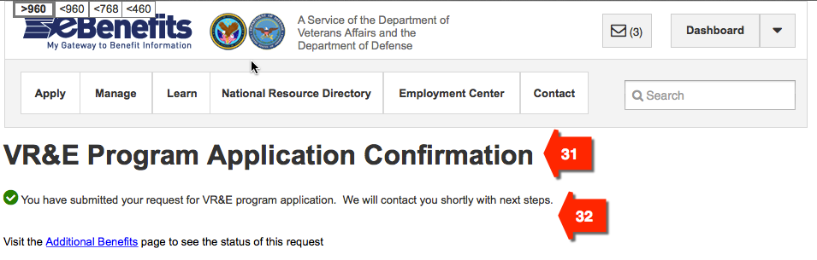

**#31 – Page Title**

**Title:** Vocational Rehabilitation and Employment Program Request Confirmation

**#32 – Informational Content**

**Instructions:** You have successfully submitted your request to participate in the Vocational Rehabilitation and Employment program. We will contact you soon to discuss next steps.

1. **VR&E Page 13, Error Submitting 8832 –** This is the thirteenth page in the wireframes for VR&E. It displays an error message to the user if request for counseling cannot be processed. The proposed content below the screenshot corresponds with the wireframe found here: <http://7xsaxh.axshare.com/#p=error_submitting_8832>

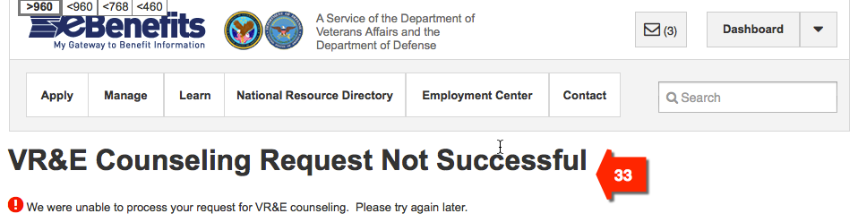

**#33 – Page Title and Error Message**

**Title:** We’re Having Problems with Your Vocational Rehabilitation and Employment Counseling Request   
**Description/Instructions:** We are unable to process your request for VR&E counseling right now. We apologize for the inconvenience. Please try again in an hour. If you are still having trouble, contact VA at 1-800-827-1000 (711 if you use TDD), Monday - Friday, 8:00 am - 9:00 pm ET.

1. **VR&E Page 15, Message Notification –** This is the fifteenth page in the wireframes for VR&E. It displays the eBenefits Message Center notification sent to the user confirming receipt of user’s VR&E request. The proposed content below the screenshot corresponds with the wireframe found here: <http://7xsaxh.axshare.com/#p=message_notification>

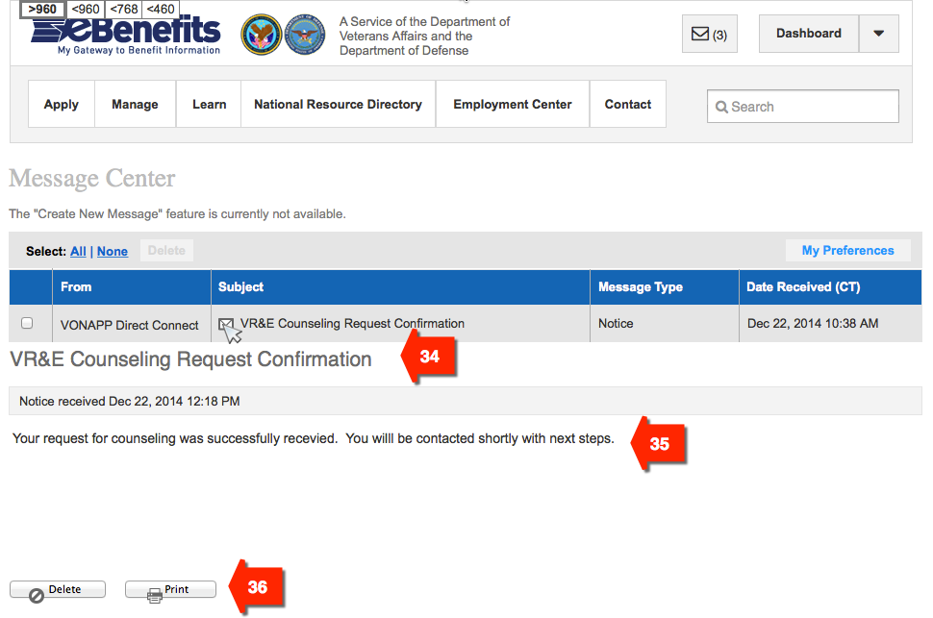

**#34 – Message Title**

**Message 1 Title:** Education/Career Counseling Request Confirmation

**Message 2 Title:** Education/Career Counseling Request Confirmation

**#35 – Message Content**

**Message 1 Instructions:** You have successfully submitted your request for Education/Career counseling. We will contact you soon to schedule your appointment.  
**Message 2 Instructions:** You have successfully submitted your request to participate in the Vocational Rehabilitation and Employment program. We will contact you soon to discuss next steps.

**#36 – Button Text**

**Left Button:** Delete

**Right Button:** Print

1. **VR&E Page 16, Additional Benefits** – This is the sixteenth page in the wireframes for VR&E. It provides summary information about VR&E benefits and contact information. The proposed content below the screenshot corresponds with the wireframe found here: <http://7xsaxh.axshare.com/#p=additional_benefits>

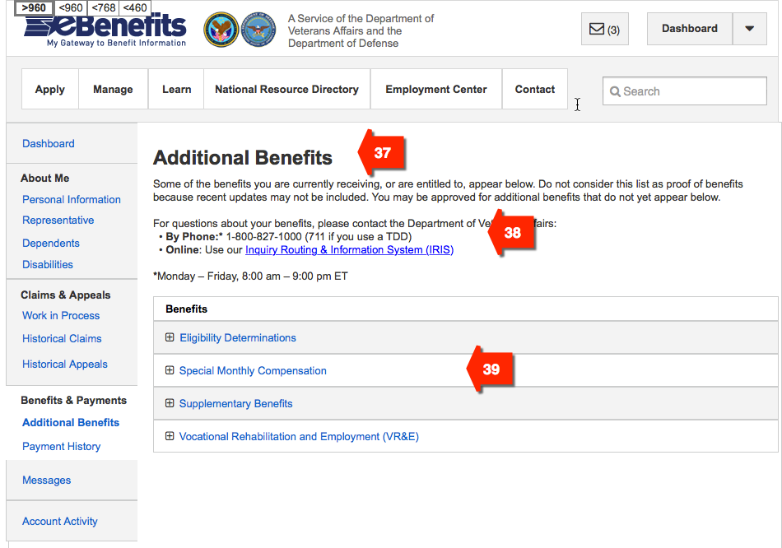

**#37 – Page Title**

**Title:** Additional Benefits

**#38 – Informational Content**

**Instructions:**

Some of the benefits you are currently receiving, or are entitled to, appear below. Do not consider this list as proof of benefits because recent updates may not be included. You may be approved for additional benefits that do not yet appear below.

For questions about your benefits, please contact VA:

• **By Phone:**\* 1-800-827-1000 (711 if you use a TDD)

• **Online**: Submit a question to our Inquiry Routing & Information System (IRIS)

*Monday – Friday, 8:00 am – 9:00 pm ET

**#39 – Informational Content   
Menu/Header Title:** Benefits **Sub-menu Item 1:** Eligibility Determinations

**Sub-menu Item 2:** Special Monthly Compensation

**Sub-menu Item 3:** Supplementary Benefits

**Sub-menu Item 4:** Vocational Rehabilitation and Employment

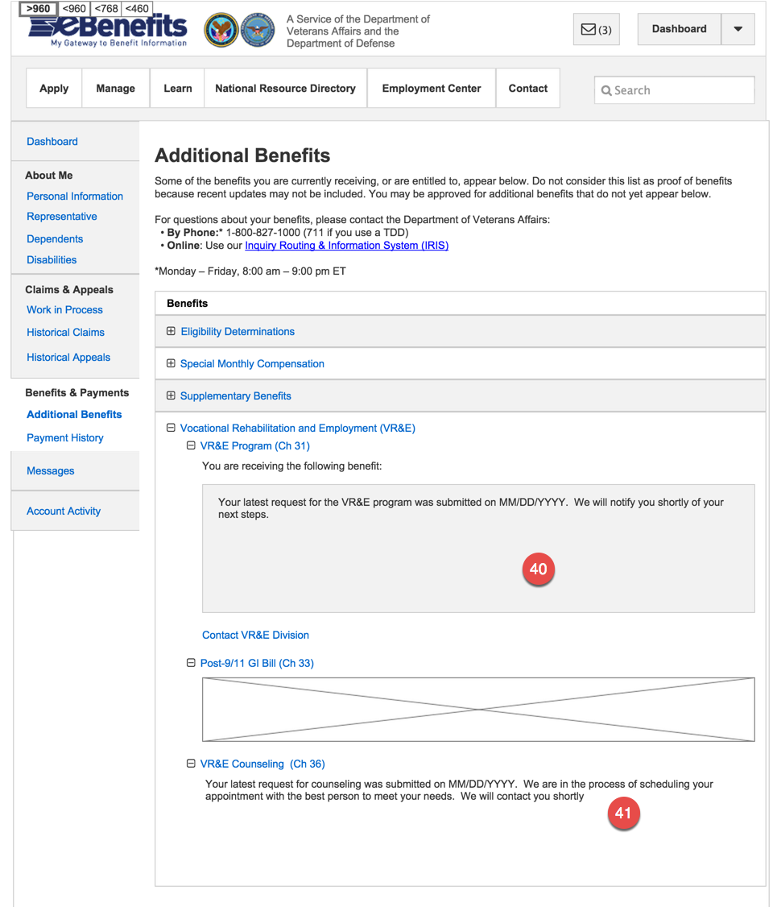

**#40 – VR&E Ch31 Status**

**Header Title:** Vocational Rehabilitation and Employment Program

**Introduction:** Below is the status of your benefit

**Scenario 1 - If applied, but not yet accepted:**

**Instructions:** Your latest request for the Vocational Rehabilitation and Employment program was submitted on [MM/DD/YYYY]. We will notify you soon about next steps.

**Scenario 2 - If accepted and still has benefit remaining:**

**Field 1:** Eligible starting [MM/DD/YYYY] until [MM/DD/YYYY]

**Field 2:** Benefits Used: [Amount (days, months, years)]

**Field 3:** Benefits Remaining: [Amount (days, months, years)]

**Link:** Find out how these dates are calculated.

**[URL:** http://www.benefits.va.gov/vocrehab/program_definitions.asp]

**Field 4:** Case Status: [Open/Closed]

**Field 5:** Jurisdiction: [City, State, Zip Code]

**Scenario 3 - If accepted and but has used up benefit:**

**Field 1:** Your eligibility ended [MM/DD/YYYY]. You can reapply by clicking the Reapply button.

**Link:** Find out how these dates are calculated.

[**URL:** http://www.benefits.va.gov/vocrehab/program_definitions.asp]

**Field 2:** Case Status: [Open/Closed]

**Field 3:** Jurisdiction: [City, State, Zip Code]

**Scenario 4 - If accepted, has used up benefit, and applied again:**

**Field 1:** Your eligibility ended [MM/DD/YYYY]. Your latest request was submitted on [MM/DD/YYYY]. We will notify you soon about next steps.

**Link:** Find out how these dates are calculated.

[**URL:** http://www.benefits.va.gov/vocrehab/program_definitions.asp]

**Field 2:** Case Status: [Open/Closed]

**Field 3:** Jurisdiction: [City, State, Zip Code

**#41 – VR&E Ch36 Status**

**Header Title:** Education/Career Counseling

**Introduction:** The status of your benefit is below.

**Scenario 1 - If applied, but not yet accepted:**

**Instructions:** Your latest request for counseling was submitted on [MM/DD/YYYY]. We are in the process of scheduling your appointment with the best person to meet your needs. We will contact you soon.

**Scenario 2 - If accepted and an appointment is scheduled:**

**Instructions:** Your appointment is scheduled on [MM/DD/YYYY]. If you are unable to make it, please contact your Regional Office to reschedule. [Find ocations and contact information](http://www.va.gov/directory/guide/division.asp?dnum=3&isFlash=0).

**If accepted and but has used up benefit:**

**Instructions:** You completed your last counseling session on [MM/DD/YYYY].

**Button:** Apply Now

1. **VR&E Page 14, Error Submitting 1900 –** This is the fourteenth page in the wireframes for VR&E. It displays an error message to the user if application for VR&E program cannot be processed. The proposed content below the screenshot corresponds with the wireframe found here: <http://7xsaxh.axshare.com/#p=error_submitting_1900>

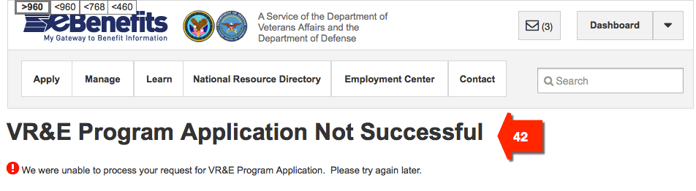

**#42 – Page Title and Error Message**

**Title:** We’re Having Problems with Your Application for the VR&E Program  
**Description/Instructions:** We are unable to process your application for the VR&E program right now. We apologize for the inconvenience. Please try again in an hour. If you are still having trouble, contact VA at 1-800-827-1000 (711 if you use TDD), Monday - Friday, 8:00 am - 9:00 pm ET.