TITLE PAGE
Title of Competition
Deadline
OMB Control Number 3045-0129 Expiration Date: TBD

IMPORTANT NOTICES
These application instructions conform to the Corporation for National and Community Service (CNCS) online grant application system, eGrants. All CNCS funding announcements are posted on www.nationalservice.gov and www.grants.gov.

Public Burden Statement: Public reporting burden for this collection of information is estimated to average 8 hours per submission, including reviewing instructions, gathering and maintaining the data needed, and completing the application and reporting forms. Comments on the burden or content of this instrument may be sent to the Corporation for National and Community Service, Attn: Amy Borgstrom, 1201 New York Avenue, NW, Washington, D.C. 20525. CNCS informs people who may respond to this collection of information that they are not required to respond to the collection of information unless the OMB control number and expiration date displayed on page 1 are current and valid. (See 5 C.F.R. 1320.5(b)(2)(i).)

Privacy Act Notice: The Privacy Act of 1974 (5 U.S.C § 552a) requires that the following notice be provided to you: The information requested on the these Application Instructions is collected pursuant to 42 U.S.C. 12592 and 12615 of the National and Community Service Act of 1990 as amended, and 42 U.S.C. 4953 of the Domestic Volunteer Service Act of 1973 as amended. Purposes and Uses - The information requested is collected for the purposes of reviewing grant applications and granting funding requests. Routine Uses - Routine uses may include disclosure of the information to federal, state, or local agencies pursuant to lawfully authorized requests. In some programs, the information may also be provided to federal, state, and local law enforcement agencies to determine the existence of any prior criminal convictions. The information may also be provided to appropriate federal agencies and contractors that have a need to know the information for the purpose of assisting the to respond to a suspected or confirmed breach of the security or confidentiality or information maintained in this system of records, and the information disclosed is relevant and unnecessary for the assistance. Effects of Nondisclosure - The information requested is mandatory in order to receive benefits.
Federal Funding Accountability and Transparency Act: Award recipients will be required to report at www.FSRS.gov on all subawards over $25,000 and may be required to report on executive compensation for recipients and subrecipients. Recipients must have the necessary systems in place to collect and report this information. See 2 C.F.R. Part 170 for more information and to determine how these requirements apply.

Universal Identifier: Applications must include a Dun and Bradstreet Data Universal Numbering System (DUNS) number and an Employer Identification Number. All award recipients are required to maintain a valid registration with the System for Award Management (SAM), which must be renewed annually.

TABLE OF CONTENTS

I. Application Resources 2
II. Submitting your Application in eGrants 2
III. Application Components 3
IV. Reporting Requirements 6
Certifications and Assurances 12
Budget Worksheet 20

Application Instructions

I. Application Resources

Use these instructions in conjunction with the Notice of Federal Funding Availability or Notice of Federal Funding Opportunity (Notice). The Notice includes deadlines, eligibility requirements, submission requirements, and other information that changes year-to-year for CNCS grant programs.

Please use the following application instructions if you are a new applicant. If you are submitting a request for continuation funding (typically in years two or three of a three year grant period) you will open your existing application in eGrants, and enter new information in the Continuation Changes field, or as directed by your Program Officer.

If there is any inconsistency between the Notice and the Application Instructions, the Notice takes precedence over the Application Instructions.

II. Submitting your Application in eGrants

Applicants need to establish an eGrants account by accessing this link: https://egrants.cns.gov/espan/main/login.jsp and selecting “Don’t have an eGrants account? Create an account.” If you need help establishing a new organization account in eGrants, or a new user account for an existing organization account, contact the National Service Hotline at 800-942-2677.

After you create your eGrants account, begin by selecting “New” under the Creating an Application heading on your Home Page. Select “Other” as the Program Area and click “Go.” You will then be asked to select the appropriate competition. Choose: [Competition Name] [YYYY]. Once you create an application, you will be allowed to edit as needed until you are ready to submit.

Do not use the New button again as this will start a brand new application. Once you have initiated an application, it will be listed in the View My Grants/Applications section of the homepage under the status: Grantee Edit of Application or Report. If you exit and then return to eGrants and wish to continue entering or editing your application, please open your saved version by selecting View My Grants/Applications in the status Grantee Edit of Application or Report.

III. Application Components

The completed application will consist of the following components, described in more detail below:
- Standard Form 424
- Executive Summary
- Narratives:
  - Program Design
  - Organizational Capability
  - Cost-Effectiveness and Budget Adequacy
- Performance Measures, if applicable
- Budget
- Authorization, Assurances, and Certifications

A. Standard Form 424
You can find the Standard Form (SF) 424 and instructions here: http://www.grants.gov/agencies/forms_instruction_information.jsp.

Applications must include a Dun and Bradstreet Data Universal Numbering System (DUNS) number on the Standard Form 424.

Please note that the SF-424 is automatically generated by completing the data elements in the eGrants system. When completing the application in eGrants, many of the fields will be populated with information entered during the organization’s registration process.

1. Applicant Info
Please note that the Authorized Representative name is blank. You cannot select a name for this field. Instead, the Authorized Representative must establish his/her own account to click on the Assurances and Certifications at the end of the application, as well as sign the documents electronically. The Authorized Representative is the person within your organization authorized to accept and commit funds on behalf of the organization.

Under Project Information select, “Enter New” and choose a title for the proposed project. It is possible to enter another address for the project, which may or not be the same as that of the Legal Applicant.

Select a Project Initiative: Choose the model which best describes your [Competition Name] application from the options provided.

To select an individual as the Project Director, choose a name from the pull-down menu or add a new contact.

2. Application Info
Areas affected by the project: List only the largest political or municipal entities affected (e.g., counties and cities).

Enter the dates for the proposed project start and end dates. Your project period is up to [X] years and must begin no later than [Month, DD, YYYY].

Delinquent on any federal debt: Check the appropriate box. This question applies to the applicant organization, not the person who signs as the Authorized Representative. Categories of debt include delinquent audit allowances, loans, and taxes. If 'Yes', type your explanation in the text box provided.

State Application Identifier: Enter N/A.

B. Executive Summary
Summarize your proposed project in 2,000 characters or less. Executive summaries for all applications will be made public and posted to the CNCS website.

C. Narratives
The page count for the application will be specified in the Notice. CNCS strongly encourages applicants to print out the application from the “Review and Submit” page before submitting it, in order to make sure it is within the page limit.

Please include the following elements in your narrative:

1. Program Design
Describe your approach to addressing the need or problem described in the Notice.

2. Organizational Capability

Describe your organization’s capability to initiate and manage the proposed program in response to criteria described in the Notice.

3. Cost-Effectiveness and Budget Adequacy

Budget and Program Design: Explain how the proposed program budget reflects the program’s goals and design.

Matching Funds: The Notice will include specific information about match requirements. If match is required, list your planned sources of match.

D. Performance Measures
Please enter Focus Areas, Service Categories, and Performance Measures following the prompts on the screens in eGrants.

E. Budget
Please see Budget Instructions in Attachment C.

F. Authorization, Assurances, and Certifications.
Authorize and certify your application in eGrants. eGrants requires that you review and verify your entire application before submitting, by completing the following sections in eGrants:

- Review
- Authorize
- Assurances
- Certifications
- Verify
- Submit

Read the Authorization, Assurances, and Certifications carefully (Attachment A). The person who authorizes the application must be the applicant’s Authorized Representative or his/her designee and must have an active eGrants account to sign these documents electronically. An Authorized Representative is the person in your organization authorized to accept and commit funds on behalf of the organization. A copy of the governing body’s authorization for this official representative to sign must be on file in the applicant’s office.

Be sure to check your entire application to make sure that there are no errors before submitting it. eGrants will also generate a list of errors if there are sections that need to be corrected prior to submission when you verify the application. If someone else is acting in the role of the applicant’s Authorized Representative, that person must log into his/her eGrants account to proceed with Authorize and Submit. After signing off on the Authorization, Assurances, and Certifications, his/her name will override any previous signatory that may appear and show on the application as the Authorized Representative.

Note: Anyone within your organization who will be entering information in the application at any point during application preparation and submission in the eGrants system must have their own eGrants account. Individuals may establish an eGrants account by accessing this link: https://egrants.cns.gov/espan/main/login.jsp and selecting “Don’t have an eGrants account? Create an account.”

IV. Reporting Requirements

How will CNCS use the information reported?
The Grantee Progress Report (GPR) provides information for CNCS staff to monitor grantee progress, and to respond to requests from Congress and other stakeholders. Some information provided in the GPR may be used by CNCS’s Office of Public Affairs to promote service. Program staff will use the information provided to identify trends and issues that may lead to changes in policies and procedures, allocation of training and technical assistance, or opportunities for peer learning.

When is the GPR due?
The deadline for the GPR can be found in the Notice. If you cannot meet the submission deadline for the progress report, you must request an extension from your Program Officer. Requests for extensions may be granted when:
- The report cannot be finished in a timely manner for reasons legitimately beyond the control of the grantee.
- CNCS receives a request explaining the need for an extension before the due date of the report.

Selecting the Right GPR
After logging into eGrants, click the “Progress Report” link in the lower right corner of the screen.

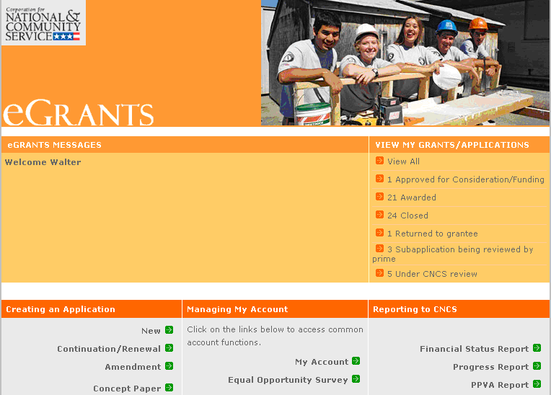

You will see a list of possible progress reports for each of your existing grants. Find the grant number which includes the appropriate grant year, and expand the list by clicking on the orange arrow key to the right of the grant number.

Find the progress report with that applies to your competition and due date, and click on the “edit” link. You will be taken to the main progress report screen.

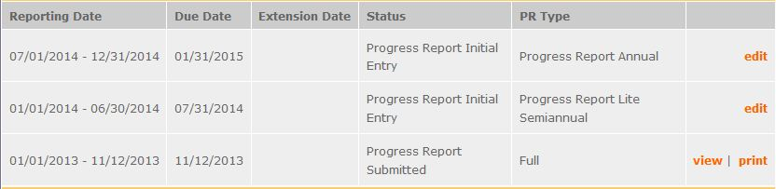

Demographics Tab

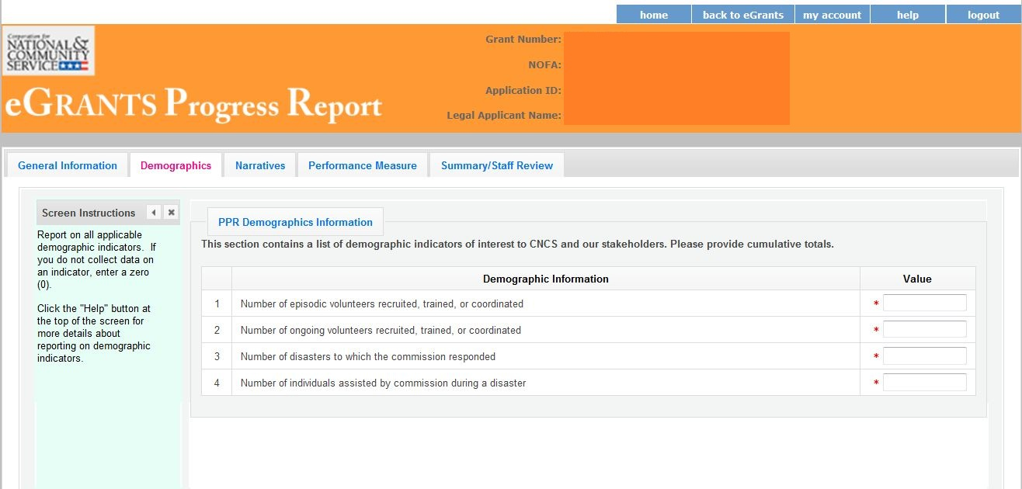

This tab contains a list of indicators of interest to CNCS. You are required to report:
- number of episodic volunteers recruited, trained, or coordinated
- number of ongoing volunteers recruited, trained, or coordinated
- number of disasters to which the project responded
- number of individuals receiving assistance from during a disaster.

Enter a numerical value in each field; do not enter decimals or punctuation. Ensure that counts are not duplicated and only represent the direct efforts of the grantee (not the work of subgrantees). If you do not collect data on an indicator, enter a zero (0) in that field. The progress report cannot be submitted unless there is a numerical value, including zero, entered in every field on this tab.

Click “Next” to proceed to the next tab.
Performance Measures Tab

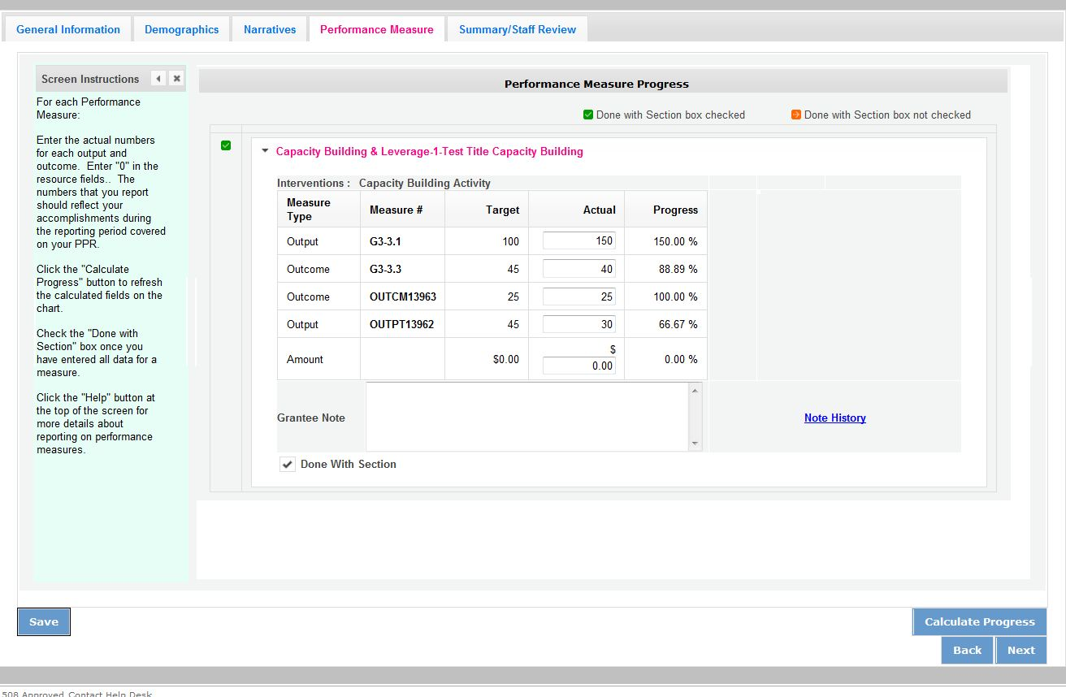

Each performance measure panel contains a chart showing each output and outcome for the performance measure.

For each output and outcome, enter a numerical value documenting progress toward the target. Round any decimals to the nearest whole number. Enter “0” in the amount field. When you have entered all data for one performance measure, check the “Done with Section” box. This will cause a green checkmark to appear on the accordion panel when it is collapsed signaling that you are done entering data in this panel.

Once data has been entered for each performance measure, click the “Calculate” button at the bottom of the page. This will enable eGrants to calculate the percent of target in the “Progress” column.

An explanation is required for any output or outcome target that was not met. Enter an explanation in the “Grantee Note” text field.

The progress report cannot be submitted unless all required data has been entered.

Click “Next” to go to the next tab.

Narratives Tab

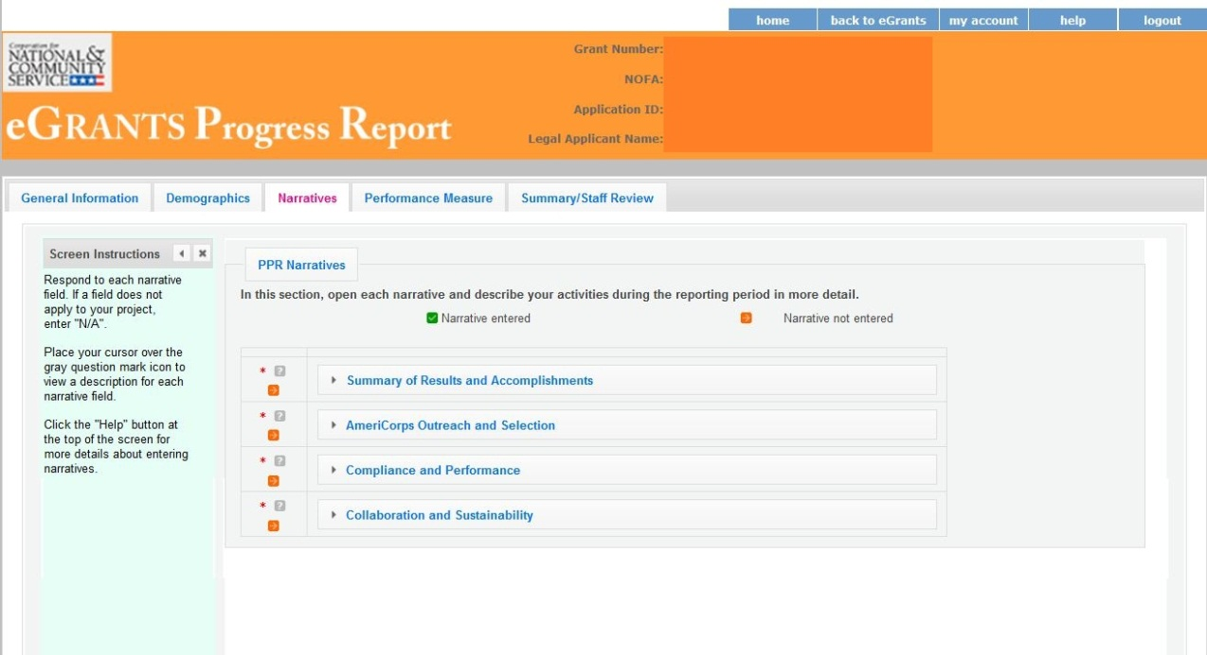

Click on the accordion panels to enter narratives. When accordion panels are closed, green check marks indicate that text has been entered in the text box. Text must be entered in every narrative field before submitting the GPR. For fields that are not required, if not providing narrative, enter “NA” in the text box.

Provide the narratives which will be provided via guidance from your program officer.

Click “Next” to go to the next tab.

Summary Tab

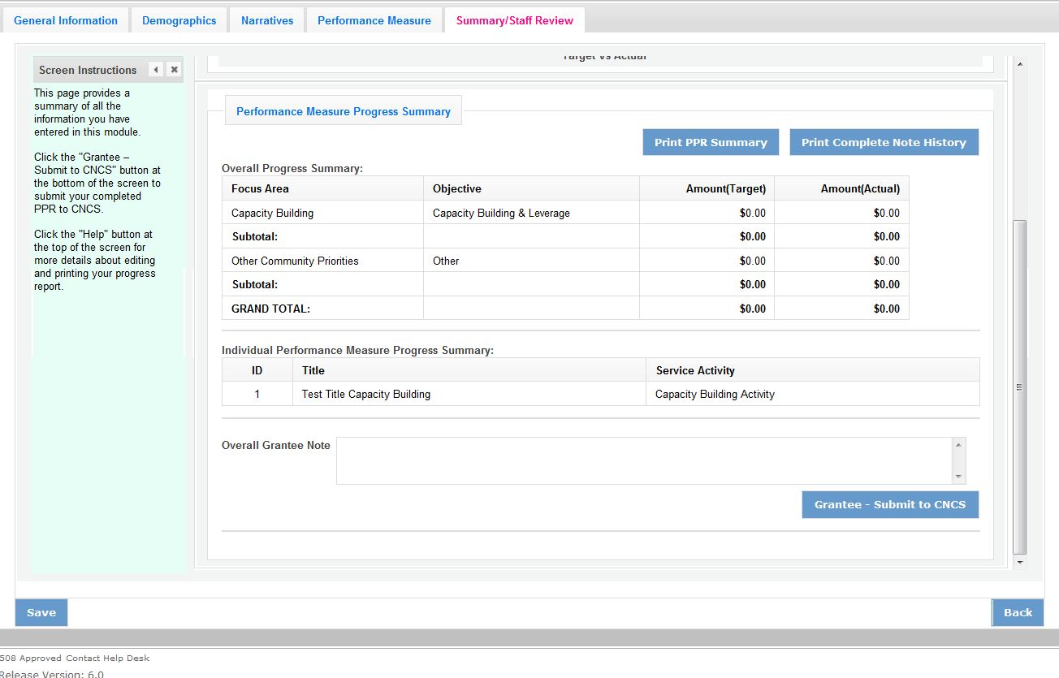

This tab provides a summary of the data entered in previous tabs.

From this tab, you can view or print all text and data entered into the GPR by clicking “Print PPR Summary.” To print all notes entered in the GPR, click “Print Complete Note History.”

To comment on this summary, enter text in the “Overall Grantee Note” text box.

Submitting the GPR

When all data has been entered into the progress report, go to the Summary Tab and click the “Grantee – Submit to CNCS” button.
ATTACHMENTS

Attachment A. Certifications and Assurances

Instructions

By signing and submitting this application, as the duly authorized representative of the applicant, you certify that the applicant will comply with the Assurances and Certifications described below.

a) Inability to certify
Your inability to provide the assurances and certifications listed below will not necessarily result in denial of a grant. You must submit an explanation of why you cannot do so. We will consider your explanation in determining whether to enter into this transaction. However, your failure to furnish an explanation will disqualify your application.

b) Erroneous certification or assurance
The assurances and certifications are material representations of fact upon which we rely in determining whether to enter into this transaction. If we later determine that you knowingly submitted an erroneous certification or assurance, in addition to other remedies available to the federal government, we may terminate this transaction for cause or default.

c) Notice of error in certification or assurance
You must provide immediate written notice to us if at any time you learn that a certification or assurance was erroneous when submitted or has become erroneous because of changed circumstances.

d) Definitions
The terms “covered transaction”, “debarred”, “suspended”, “ineligible”, “lower tier covered transaction”, “participant”, “person”, “primary covered transaction”, “principal”, “proposal”, and “voluntarily excluded” as used in this clause, have the meanings set out in the Definitions and Coverage sections of the rules implementing Executive Order 12549. An applicant shall be considered a “prospective primary participant in a covered transaction” as defined in the rules implementing Executive Order 12549. You may contact us for assistance in obtaining a copy of those regulations.

e) Assurance requirement for subgrant agreements
You agree by submitting this proposal that if we approve your application you shall not knowingly enter into any lower tier covered transaction with a person who is debarred, suspended, declared ineligible, or voluntarily excluded from participation in this covered transaction, unless authorized by us.

f) Assurance inclusion in subgrant agreements
You agree by submitting this proposal that you will obtain an assurance from prospective participants in all lower tier covered transactions and in all solicitations for lower tier covered transactions that the participants are not debarred, suspended, ineligible, or voluntarily excluded from the covered transaction.

g) Assurance of subgrant principals
You may rely upon an assurance of a prospective participant in a lower-tier covered transaction that is not debarred, suspended, ineligible, or voluntarily excluded from the covered transaction, unless you know that the assurance is erroneous. You may decide the method and frequency by which you determine the eligibility of your principals. You may, but are not required to, check the List of Parties Excluded from Federal Procurement and Nonprocurement Programs.

h) Non-assurance in subgrant agreements
If you knowingly enter into a lower tier covered transaction with a person who is suspended, debarred, ineligible, or voluntarily excluded from participation in this transaction, in addition to other remedies available to the federal government, we may terminate this transaction for cause or default.

i) Prudent person standard
Nothing contained in the aforementioned may be construed to require establishment of a system of records in order to render in good faith the assurances and certifications required. Your knowledge and information is not required to exceed that which is normally possessed by a prudent person in the ordinary course of business dealings.

ASSURANCES

As the duly authorized representative of the applicant, I certify, to the best of my knowledge and belief, that the applicant:

- Has the legal authority to apply for federal assistance, and the institutional, managerial, and financial capability (including funds sufficient to pay the non-federal share of project costs) to ensure proper planning, management, and completion of the project described in this application.
- Will give the awarding agency, the Comptroller General of the United States, and if appropriate, the state, through any authorized representative, access to and the right to examine all records, books, papers, or documents related to the award; and will establish a proper accounting system in accordance with generally accepted accounting standards or agency directives.
- Will establish safeguards to prohibit employees from using their position for a purpose that constitutes or presents the appearance of personal or organizational conflict of interest, or personal gain.
- Will initiate and complete the work within the applicable time frame after receipt of approval of the awarding agency.
- Will comply with the Intergovernmental Personnel Act of 1970 (42 U.S.C. 4728-4763) relating to prescribed standards for merit systems for programs funded under one of the nineteen statutes or regulations specified in Appendix A of OPM’s Standards for a Merit System of Personnel Administration (5 CFR 900, Subpart F).
- Will comply with all federal statutes relating to nondiscrimination. These include but are not limited to: Title VI of the Civil Rights Act of 1964 (P.L. 88-352) which prohibits discrimination on the basis of race, color, or national origin; (b) Title IX of the Education Amendments of 1972, as amended (20 U.S.C. 1681-1683, and 1685-1686). which prohibits discrimination on the basis of sex; (c) Section 504 of the Rehabilitation Act of 1973, as amended (29 U.S.C. 794), which prohibits discrimination on the basis of disability (d) The Age Discrimination Act of 1975, as amended (42 U.S.C. 6101-6107), which prohibits discrimination on the basis of age; (e) The Drug Abuse Office and Treatment Act of 1972 (P.L. 92-255), as amended, relating to nondiscrimination on the basis of drug abuse; (f) The Comprehensive Alcohol Abuse and Alcoholism Prevention, Treatment and Rehabilitation Act of 1970 (P.L. 91-616), as amended, relating to nondiscrimination on the basis of alcohol abuse or alcoholism; (g) sections 523 and 527 of the Public Health Service Act of 1912 (42 U.S.C. 290dd-3 and 290ee-3), as amended, relating to confidentiality of alcohol and drug abuse patient records; (h) Title VIII of the Civil Rights Act of 1968 (42 U.S.C. 3601 et seq.), as amended, relating to nondiscrimination in the sale, rental or financing of housing; (i) any other nondiscrimination provisions in the National and Community Service Act of 1990, as amended; and (j) the requirements of any other nondiscrimination statute(s) which may apply to the application.
- Will comply, or has already complied, with the requirements of Titles II and III of the Uniform Relocation Assistance and Real Property Acquisition Policies Act of 1970 (P.L. 91-646) which provide for fair and equitable treatment of persons displaced or whose property is acquired as a result of federal or federally assisted programs. These requirements apply to all interests in real property acquired for project purposes regardless of federal participation in purchases.
- Will comply with the provisions of the Hatch Act (5 U.S.C. 1501-1508 and 7324-7328) which limit the political activities of employees whose principal employment activities are funded in whole or in part with Federal funds.
- Will comply, as applicable, with the provisions of the Davis-Bacon Act (40 U.S.C 276a and 276a-77), the Copeland Act (40 U.S.C 276c and 18 U.S.C. 874), and the Contract Work Hours and Safety Standards Act (40 U.S.C. 327-333), regarding labor standards for Federally assisted construction sub-agreements.
- Will comply, if applicable, with flood insurance purchase requirements of Section 102(a) of the Flood Disaster Protection Act of 1973 (P.L. 93-234) which requires the recipients in a special flood hazard area to participate in the program and to purchase flood insurance if the total cost of insurable construction and acquisition is $10,000 or more.
- Will comply with environmental standards which may be prescribed pursuant to the following: (a) institution of environmental quality control measures under the National Environmental Policy Act of 1969 (P.L. 91-190) and Executive Order (EO) 11514; (b) notification of violating facilities pursuant to EO 11738; (c) protection of wetlands pursuant to EO 11990; (d) evaluation of flood hazards in floodplains in accordance with EO 11988; (e) assurance of project consistency with the approved state management program developed under the Coastal Zone Management Act of 1972 (16 U.S.C 1451 et seq.); (f) conformity of federal actions to State (Clean Air) Implementation Plans under Section 176(c) of the Clean Air Act of 1955, as amended (42 U.S.C. 7401 et seq.); (g) protection of underground sources of drinking water under the Safe Drinking Water Act of 1974, as amended (P.L. 93-523); and (h) protection of endangered species under the Endangered Species Act of 1973, as amended (P.L. 93-205).
- Will comply with the Wild and Scenic Rivers Act of 1968 (16 U.S.C 1271 et seq.) related to protecting components or potential components of the national wild and scenic rivers system.
- Will assist the awarding agency in assuring compliance with Section 106 of the National Historic Preservation Act of 1966, as amended (16 U.S.C. 470), EO 11593 (identification and protection of historic properties), and the Archaeological and Historic Preservation Act of 1974 (16U.S.C. 469a-l et seq.).
- Will comply with P.L. 93-348 regarding the protection of human subjects involved in research, development, and related activities supported by this award of assistance.
- Will comply with the Laboratory Animal Welfare Act of 1966 (P.L. 89-544, as amended, 7 U.S.C. 2131 et seq.) pertaining to the care, handling, and treatment of warm blooded animals held for research, teaching, or other activities supported by this award of assistance.
- Will comply with the Lead-Based Paint Poisoning Prevention Act (42 U.S.C. §§ 4801 et seq.) which prohibits the use of lead based paint in construction or rehabilitation of residence structures.
- Will cause to be performed the required financial and compliance audits in accordance with the Single Audit Act of 1984, as amended, and OMB Uniform guidance at 2 CFR 200 and CNCS’s implementing regulations.
- Will comply with all applicable requirements of all other Federal laws, executive orders, regulations, application guidelines, and policies governing this program.

CERTIFICATIONS

Certification – Debarment, Suspension, and Other Responsibility Matters
This certification is required by the government-wide regulations implementing Executive Order 12549, Debarment and Suspension, 2 CFR Part 180, Section 180.335, What information must I provide before entering into a covered transaction with a Federal agency?
As the duly authorized representative of the applicant, I certify, to the best of my knowledge and belief, that neither the applicant nor its principals:
- Is presently excluded or disqualified;
- Has been convicted within the preceding three years of any of the offenses listed in § 180.800(a) or had a civil judgment rendered against it for one of those offenses within that time period;
- Is presently indicted for or otherwise criminally or civilly charged by a governmental entity (Federal, State, or local) with commission or any of the offenses listed in § 180.800(a); or
- Has had one or more public transactions (Federal, State, or local) terminated within the preceding three years for cause or default.
Certification – Drug Free Workplace

This certification is required by the Corporation’s regulations implementing sections 5150-5160 of the Drug-Free Workplace Act of 1988 (P.L. 100-690), 45 CFR Part 2545, Subpart B. The regulations require certification by grantees, prior to award, that they will make a good faith effort, on a continuing basis, to maintain a drug-free workplace. The certification set out below is a material representation of fact upon which reliance will be placed when the agency determines to award the grant. False certification or violation of the certification may be grounds for suspension of payments, suspension or termination of grants, or government-wide suspension or debarment (see 2 CFR Part 180, Subparts G and H).

As the duly authorized representative of the grantee, I certify, to the best of my knowledge and belief, that the grantee will provide a drug-free workplace by:

- Publishing a drug-free workplace statement that:
  - Notifies employees that the unlawful manufacture, distribution, dispensing, possession, or use of a controlled substance is prohibited in the grantee’s workplace;
  - Specifies the actions that the grantee will take against employees for violating that prohibition; and
  - Informs employees that, as a condition of employment under any award, each employee will abide by the terms of the statement and notify the grantee in writing if the employee is convicted for a violation of a criminal drug statute occurring in the workplace within five days of the conviction;

- Requiring that a copy of the statement described in paragraph (A) be given to each employee who will be engaged in the performance of any Federal award;

- Establishing a drug-free awareness program to inform employees about:
  - The dangers of drug abuse in the workplace;
  - The grantee’s policy of maintaining a drug-free workplace;
  - Any available drug counseling, rehabilitation, and employee assistance programs; and
  - The penalties that the grantee may impose upon them for drug abuse violations occurring in the workplace;

- Providing us, as well as any other Federal agency on whose award the convicted employee was working, with written notification within 10 calendar days of learning that an employee has been convicted of a drug violation in the workplace;

- Taking one of the following actions within 30 calendar days of learning that an employee has been convicted of a drug violation in the workplace:
  - Taking appropriate personnel action against the employee, up to and including termination; or
  - Requiring that the employee participate satisfactorily in a drug abuse assistance or rehabilitation program approved for these purposes by a Federal, State, or local health, law enforcement, or other appropriate agency;

- Making a good faith effort to continue to maintain a drug-free workplace through implementation of paragraphs (A) through (E).

Certification - Lobbying Activities
As required by Section 1352, Title 31 of the U.S. Code, as the duly authorized representative of the applicant, I certify, to the best of my knowledge and belief, that:
- No federal appropriated funds have been paid or will be paid, by or on behalf of the applicant, to any person for influencing or attempting to influence an officer or employee of any agency, a member of Congress, an officer of Congress in connection with the awarding of any federal contract, the making of any federal loan, the entering into of any cooperative agreement, or modification of any federal contract, grant, loan, or cooperative agreement;
- If any funds other than federal appropriated funds have been paid or will be paid to any person for influencing or attempting to influence an officer or employee of any agency, a member of Congress, an officer or employee of Congress, or an employee of a member of Congress in connection with this federal contract, grant, loan, or cooperative agreement, the applicant will submit Standard Form-LLL, "Disclosure Form to Report Lobbying," in accordance with its instructions;
- The applicant will require that the language of this certification be included in the award documents for all subcontracts at all tiers (including subcontracts, subgrants, and contracts under grants, loans and cooperative agreements) and that all subrecipients will certify and disclose accordingly.

Certification - Grant Review Process (State Commissions Only)
I certify that in conducting our review process, we have ensured compliance with the National and Community Service Act of 1990, the Corporation's peer review requirements, and all state laws and conflict of interest rules.

Assurances and Certifications

NOTE: Sign this form and include in the application.
ASSURANCE SIGNATURE
By signing this assurances page, you certify that you agree to perform all actions and support all intentions in the Assurances section.

Organization Name:
Program Name:
Name and Title of Authorized Representative:
Signature:
Date:

NOTE: Sign this form and include in the application.
CERTIFICATION SIGNATURE
By signing this certification page, you certify that you agree to perform all actions and support all intentions in the Certification sections of this application. The three Certifications are:
- Certification: Debarment, Suspension and Other Responsibility Matters
- Certification: Drug-Free Workplace
- Certification: Lobbying Activities

Organization Name:
Program Name:
Name and Title of Authorized Representative:
Signature:
Date:

Attachment B: Budget Instructions

Before You Begin: In eGrants, the preparation of a detailed budget provides the data that creates the summary budget and the budget narrative. Your detailed budget should provide a full explanation of associated costs including their purpose, justification, and the basis of your calculations. Where appropriate, your calculations should be presented in an equation format, identifying the number of persons involved with the event, the per person/unit cost, and/or the annual salary cost.

Use the Budget Worksheet as a guide as you prepare your budgets.

SECTION I

- Personnel Expenses – Include the portion of principal staff time attributed directly to the operation of the project. List each staff position and a brief statement of responsibilities for each in the ‘Position/Title’ field. For each position, also include the annual salary, and the percentage of staff time that will apply to the grant.

- Personnel Fringe Benefits – Include costs of benefit(s) for your project staff. You can identify and calculate each benefit or show cost as a percentage of all salaries.

- Project Staff Travel - Describe the purposes for staff travel. Costs allowable are transportation, lodging, subsistence, and other related expenses for local and outside the project area travel.

- Equipment – Equipment is defined as tangible, non-expendable personal property having a useful life of more than one year AND an acquisition cost of $5,000 (five thousand) or more per unit (including accessories, attachments, and modifications). Include items that do not meet this definition in E. Supplies below. Purchases of equipment are limited to 10% of the total grant amount, i.e., the federal share of all budget line items. If applicable, show the unit cost and number of units you are requesting.

- Supplies – Include the funds for the purchase of consumable supplies and materials that does not fit the definition above. You must individually list any single item costing $1,000 (one thousand) or more.

- Contractual and Consultant Services - You may include costs for consultants related to the project’s operations. Consultants used for evaluation should be included in H. Evaluation below. Where applicable, indicate the daily rate for consultants.

- Training – You may include the costs associated with training of staff working directly on the project, especially training that specifically enhances staff project implementation and professional skills.

- Evaluation - Include costs for project evaluation activities, such as use of evaluation consultants, purchase of instrumentation and other costs specifically for this activity. Indicate daily rates of consultants, where applicable.

- Other – These costs may include office space rental, utilities, and telephone and Internet expenses that are specifically used for participants, directly involve project staff, and are not part of the organization’s indirect cost/admin cost. If shared with other projects or activities, you must prorate the costs equitably. List each item and provide a justification in the budget.

- Indirect Costs

1. Definitions
Administrative costs are general or centralized expenses of overall administration of an organization that receives Corporation funds and does not include particular project costs. For organizations that have an established indirect cost rate for federal awards, administrative costs mean those costs that are included in the organization’s indirect cost rate. Such costs are generally identified with the organization’s overall operation and are further described in Office of Management and Budget Uniform Guidance at 2 CFR Parts 200. For organizations that do not have an established indirect cost rate for federal awards, administrative costs include:
- costs are financial, accounting, auditing, contracting or general legal services, except in unusual cases whether they are specifically approved in writing by the Corporation as project costs;
- costs for internal evaluation, including overall organization’s management improvement costs (except for independent and internal evaluations of the project evaluations that are specifically related to creative methods of quality improvement); and
- costs for general liability insurance that protects the organization(s) responsible for operating a project, other than insurance costs solely attributable to the project.
Administrative costs may also include that portion of salaries and benefits of the project’s director and other administrative staff not attributable to the time spent in support of a specific project. The principles that pertain to the allocation and documentation of personnel costs are set out in the OMB cost circulars and regulations referenced above, which are incorporated in the Corporation’s regulations at 45 CFR 2541.220(b) and 2543.27.
Administrative costs do not include the following allowable expenses directly related to a project (including their operations and objectives), such as:
- allowable direct charges for AmeriCorps members (if applicable), including living allowances, insurance payments made on behalf of members training and travel;
- costs for staff (including salary, benefits, training and travel) who recruit, train, place or supervise AmeriCorps members (if applicable) or who develop materials used in such activities, if the purpose is for a specific project objective;
- costs for independent evaluations and any internal evaluations of the project that are related specifically to creative methods of quality improvement;
- costs, excluding those already covered in an organization’s indirect cost rate, attributable to staff that work in a direct project support, operational, or oversight capacity, including, but not limited to: support staff whose functions directly support project activities; staff who coordinate and facilitate single or multi-site project activities; and staff who review, disseminate and implement Corporation guidance and policies directly relating to a project;
- space, facility and communications costs that primarily support project operations, excluding those costs that are already covered by an organization’s indirect costs rate; and
- other allowable costs, excluding those costs that are already covered by an organization’s indirect cost rate, specifically approved by the Corporation as directly attributable to a project.

2. Calculating Administrative/Indirect Costs

Federally Approved Indirect Cost Rate Method
If you have a federally approved indirect cost (IDC) rate you must use it unless authorized by the Corporation to use another method. Specify the Cost Type for which your organization has current documentation on file, i.e., Provisional, Predetermined, Fixed, or Final indirect cost rate. Supply your approved IDC rate (percentage). It is at your discretion whether or not to use your entire IDC rate to calculate administrative costs. If you choose to claim a lower rate, please include this rate under the Rate Claimed field.

Determine the amount of direct costs to which you will apply the IDC rate, including both the Corporation and Grantee’s shares, as proscribed by your organization (i.e., based on salaries and benefits, total direct costs, or other).

- Source of Funds. If applicable, describe the grantee match contribution for Section II by clearly indicating the source(s), the type of contribution (cash/in-kind), the amount (or estimate), and the intended purpose of the match. You may enter this information in any category in the Purpose-Calculation field.

Budget Worksheet

A. Personnel Expenses
Position/Title/Description | Qty | Annual Salary | % Time | Total Amount | CNCS Share | Grantee Share
Totals

B. Personnel Fringe Benefits
Purpose/Description | Calculation | Total Amount | CNCS Share | Grantee Share
Totals

C. Travel
Purpose | Calculation | Total Amount | CNCS Share | Grantee Share
Totals

D. Equipment
Item/ Purpose/Justification | Qty | Unit Cost | Total Amount | CNCS Share | Grantee Share
Totals

E. Supplies
Purpose | Calculation | Total Amount | CNCS Share | Grantee Share
Totals

F. Contractual and Consultant Services
Purpose | Calculation | Daily Rate | Total Amount | CNCS Share | Grantee Share
Totals

G. Training
Purpose | Calculation | Daily Rate | Total Amount | CNCS Share | Grantee Share
Totals

H. Evaluation
Purpose | Calculation | Daily Rate | Total Amount | CNCS Share | Grantee Share
Totals

I. Other Costs
Purpose | Calculation | Daily Rate | Total Amount | CNCS Share | Grantee Share
Totals

J. Administrative Costs
Purpose | Calculation | Daily Rate | Total Amount | CNCS Share | Grantee Share
Totals

Budget Total: Validate this budget  Required Match Percentages: | Total Amount | CNCS Share | Grantee Share

- Source of Match
Source(s), Type, Amount, Intended Purpose
 | Private | State and/or Local | Federal | Sources
In-kind | $ | $ | $ | .
Cash | $ | $ | $
Total | $ | $ | $

