National Oceanographic Data Center Send2NODC (S2N) web application images.

Figure 1. Login. | 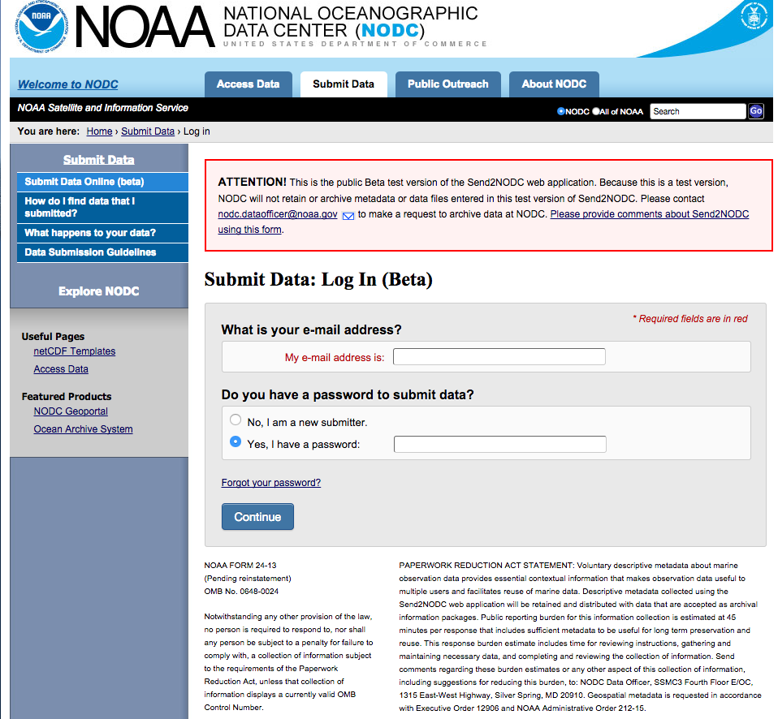
Figure 2. User agreement. | 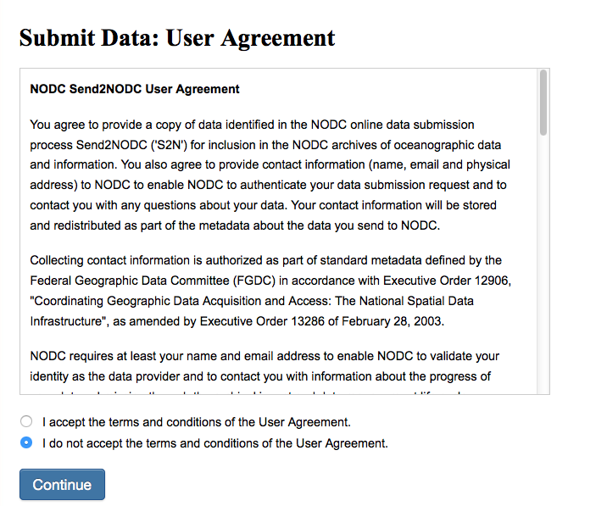
Figure 3. Create account step one. | 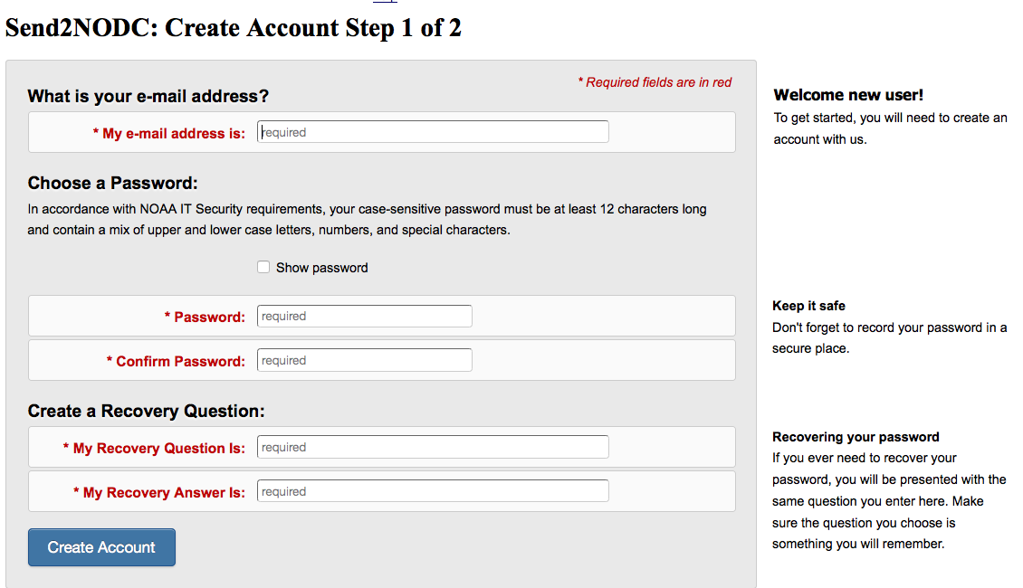
Figure 4. Create account step two. | 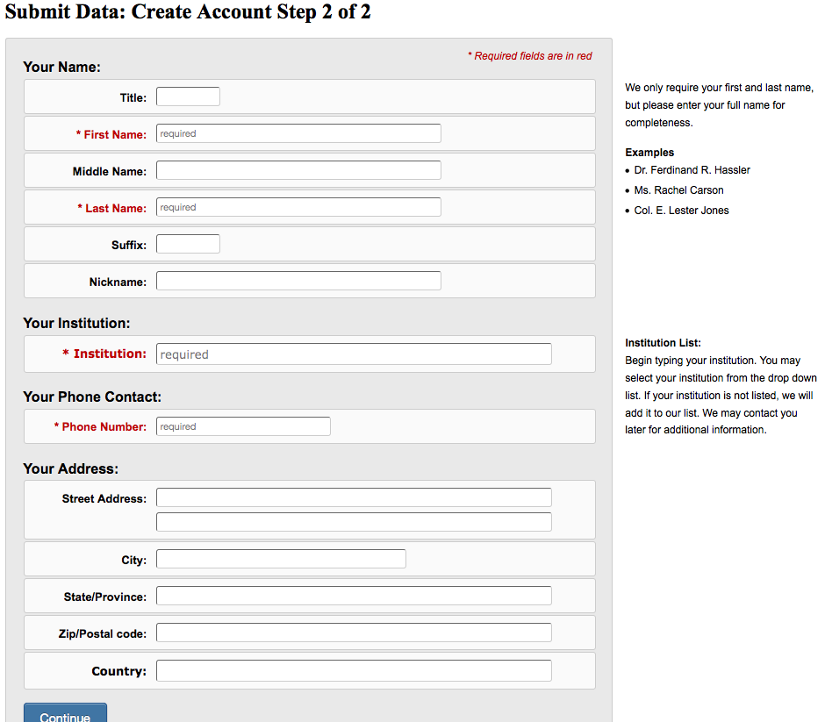
Figure 5. Create first submission package. | 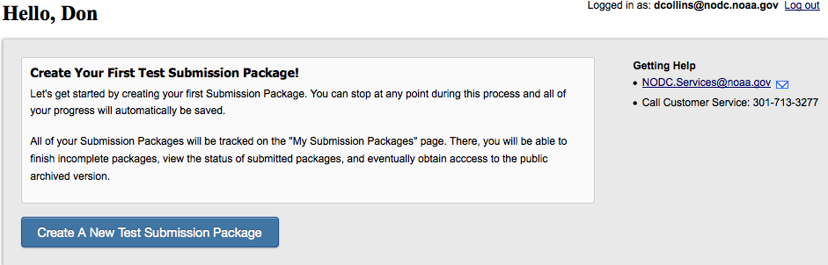
Figure 6. Summary of submission packages. | 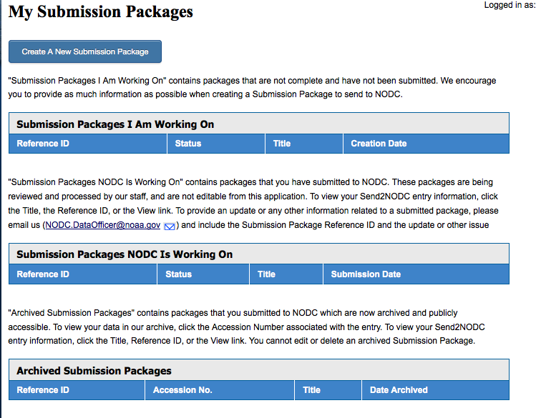
Figure 7. People and projects information entry. | 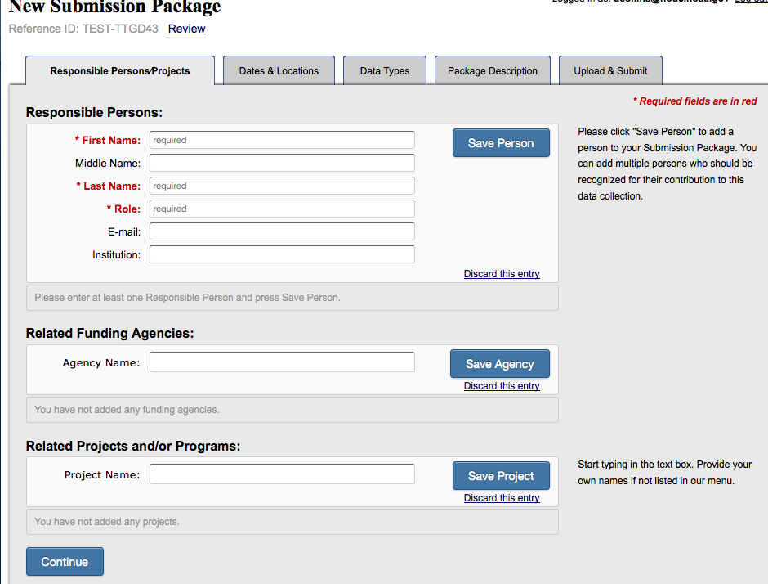
Figure 8. Dates and locations information entry | 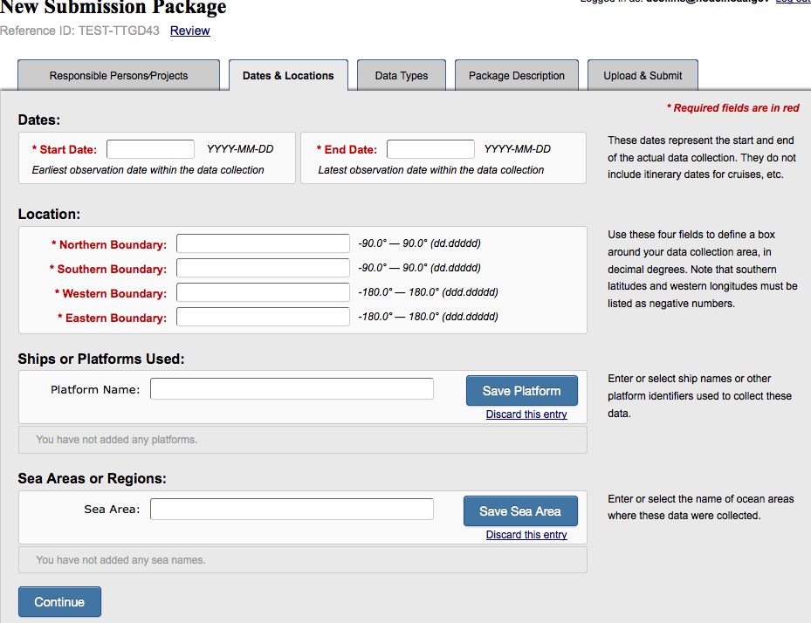
Figure 9. Data types description information entry. | 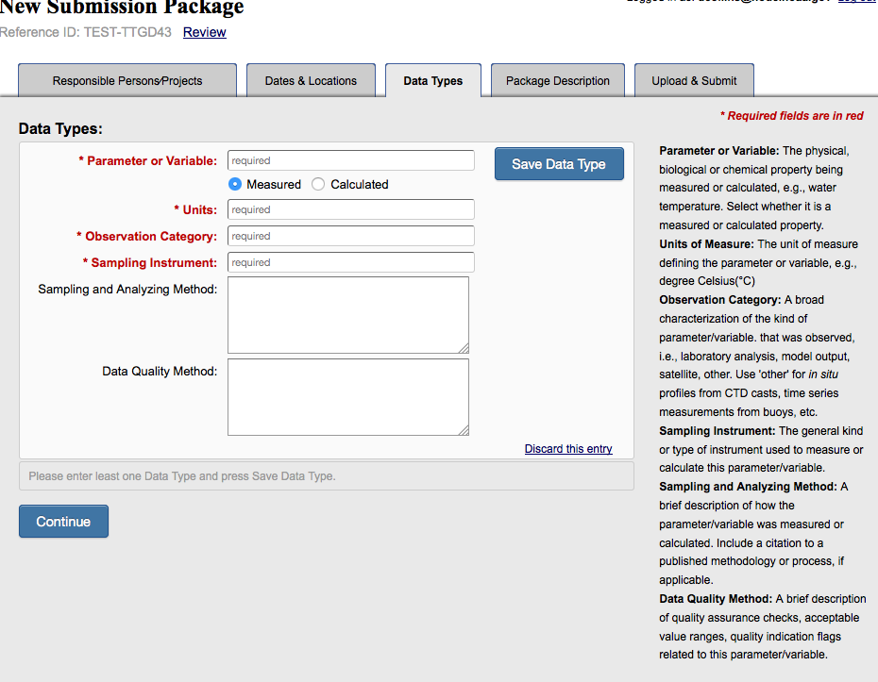
Figure 10. General package description information entry. | 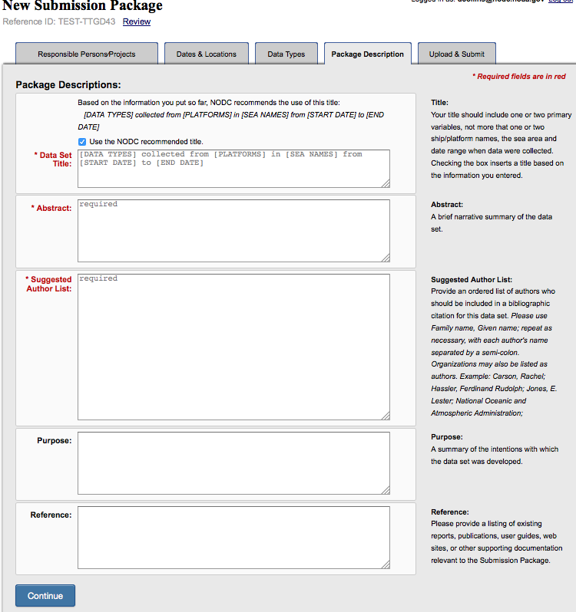
Figure 11. Incomplete package summary. | 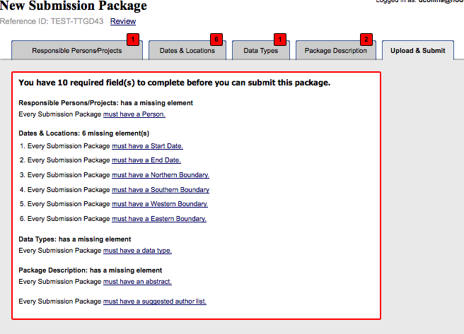
Figure 12. Upload and submit a completed package summary. | 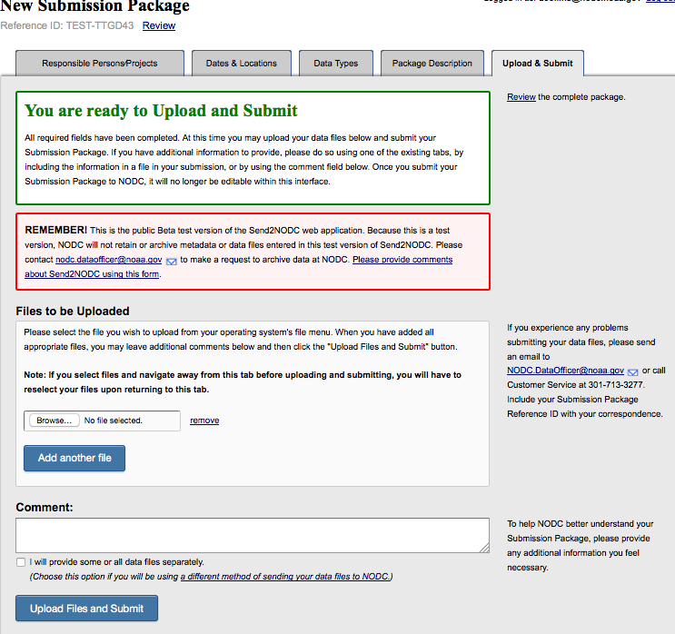
Figure 13. Metadata review. | 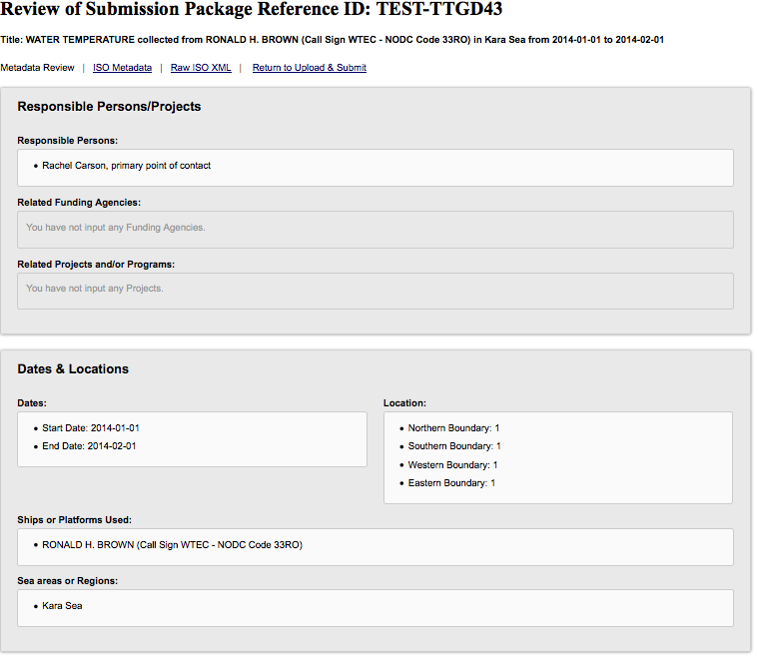
Figure 14. Metadata review. | 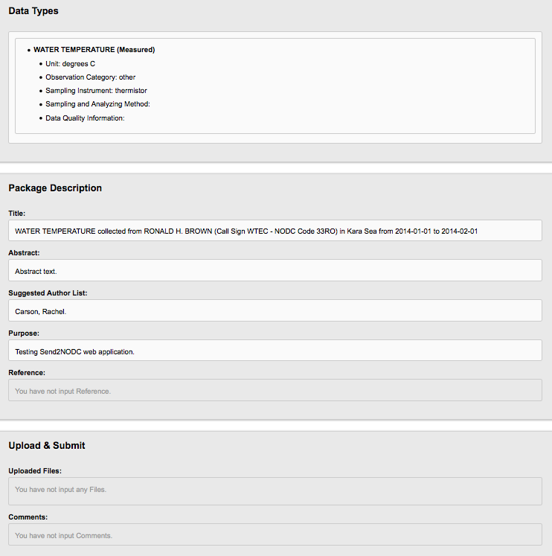
Figure 15. Metadata review in styled XML. | 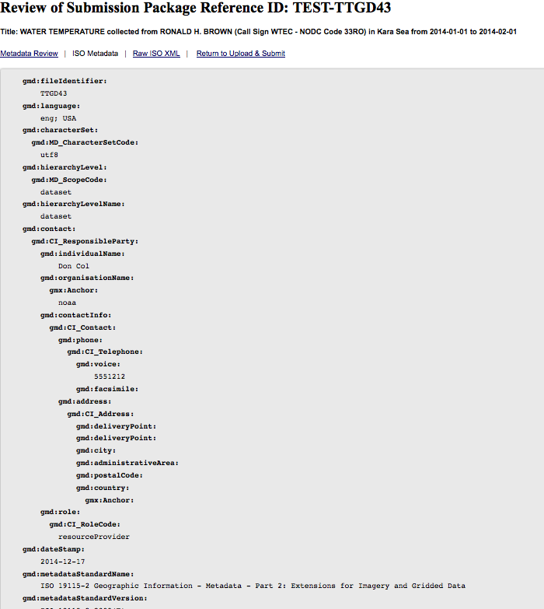
Figure 16. Metadata review in styled XML view. | 