FMS Directory Data Elements Document | 2011
Example: EIS Directory information / data collection
NOTE: Appendix B in this document includes the data elements collected from alumni of the other CDC fellowship programs.

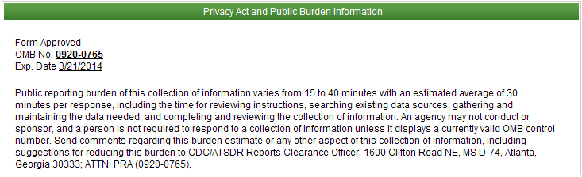

Table of Contents
1 Introduction 4
1.1 Document Structure 4
2 Login and Registration Pages 5
2.1 Login Page 5
2.2 Registration Page 6
2.3 Forgot Your E-mail? 7
2.4 Forgot Your Password? 9
2.5 Reset Password 11
3 Electronic Consent 12
4 Contact Information 13
5 Education/Training/Skills 16
5.1 Education 16
5.2 Clinical Training 17
5.3 Board Certification 18
5.4 Fellowship 20
5.5 EIS Assignment 21
5.6 Language 22
6 Professional Experience 23
7 Directory 25
7.1 Current EIS Officers 25
7.2 EIS Classes by Year 26
7.3 Officers / Alumni by Geographic Locations 26
7.4 One – Year International EIS Fellows 27
8 Appendix A - E-mails 28
8.1 Initial launch announcement and password reset 28
8.2 Alumni Registration Confirmation 29
9 Appendix B - Changes In Other Programs 30
9.1 Hubert differences 30
9.1.1 Assignment 30
9.2 PHPS differences 30
9.2.1 Certifications 30
10 Appendix C – List Of Values 31
10.1 Countries 31
10.2 States 33
10.3 Secret Questions 34
10.4 Visa Types 34
10.5 College Education Statuses 34
10.6 Degrees 34
10.7 Major Classifications 36
10.8 License Statuses 36
10.9 Languages 36
10.10 Proficiencies 37
10.11 Clinical Titles 37
10.12 Specialties 38
10.13 Board Statuses 39
10.14 Program Names 39
10.15 Work Settings 40
10.16 Organizations 40
10.17 Research Roles 41
10.18 Research Grant Amounts 41
10.19 Job Functions 41
10.20 Job Roles 41
10.21 Honor Types 42
10.22 Hear About Us Options 42
10.23 Areas Of Interests 42
10.24 CIO 43

Introduction
The purpose of this document is to list all the data elements collected online from the Epidemic Intelligence Service (EIS) program alumni. The data element differences between EIS and other CDC fellowship programs are documented in Appendix B. The data elements are grouped by the high level entities in the system.
The Fellowship Management System (FMS) alumni directory system is a self-service connection to allow alumni to update their personal information including current address, contact information and education. FMS is a robust flexible framework and has been successfully tailored for the various CDC fellowships including EIS.

Document Structure
This document is broken down by the major sections/screens of the alumni directory system. The alumni login & registration pages are documented as the separate section. A section has its own chapter that is further divided by subsections where applicable. Each section/subsection contains:
- Table that lists the data elements (columns name), columns label, high level entity, list of values, and the figure numbers.
- Screen-shots to illustrate the instructions and label of the data elements.
The consolidated lists of values are documented in Appendix C.
The emails generated by system are documented in Appendix A, and the data element differences between the EIS and other programs are documented in Appendix B.

Login and Registration Pages

Login Page

Column Name | Column Label | Entity | Figure | List of Values
E-Mail | E-mail | Person | Figure 2—A | N/A
Password | Password | Person | Figure 2—A | N/A
Table 2.1
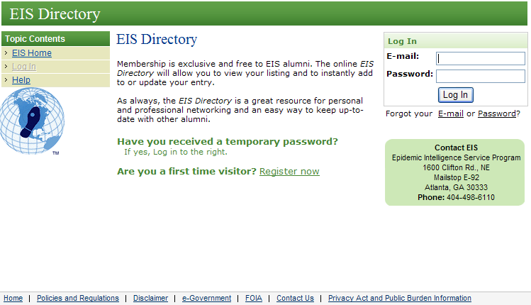
Figure 2—A
Figure 2—B

Registration Page

Column Name | Column Label | Entity | Figure | List of Values
First Name | First Name | Person | Figure 2—C | N/A
Middle Name | Middle Name | Person | Figure 2—C | N/A
Last Name | Last Name | Person | Figure 2—C | N/A
Program Year | EIS Entry Year | Alumni | Figure 2—C | N/A
E-Mail | E-mail Address | Person | Figure 2—C | N/A
Phone Number | Primary Phone | Person | Figure 2—C | N/A
Program Assignment | Program Assignment | Assignment | Figure 2—C | N/A
Table 2.2

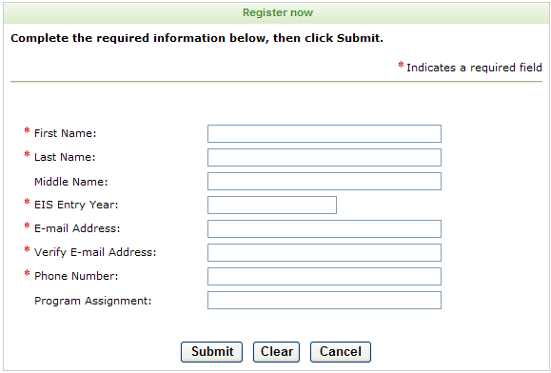
Figure 2—C

Forgot Your E-mail?

Column Name | Column Label | Entity | Figure | List of Values
First Name | First Name | Person | Figure 2—C | N/A
Last Name | Last Name | Person | Figure 2—C | N/A
E-Mail | New E-mail | Person | Figure 2—E | N/A
Program Year | Program Year | Alumni | Figure 2—C | N/A
Secret Question | Secret Question | Person | Figure 2—D | Secret questions
Secret Answer | Secret Answer | Person | Figure 2—D | N/A
Table 2.3

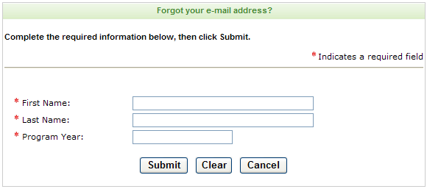
Figure 2—D

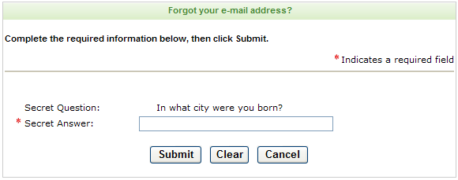
Figure 2—E

Figure 2—F

Forgot Your Password?

Column Name | Column Label | Entity | Figure | List of Values
E-Mail | Login E-mail | Person | Figure 2—G | N/A
Password | Password | Person | Figure 2—I | N/A
Secret Question | Secret Question | Person | Figure 2—H | Secret questions
Secret Answer | Secret Answer | Person | Figure 2—H | N/A
Table 2.4

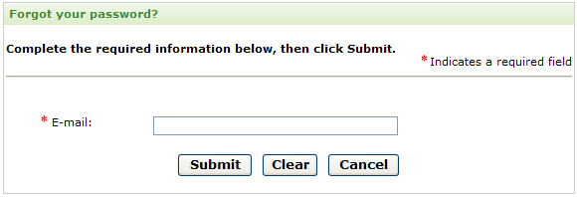
Figure 2—G

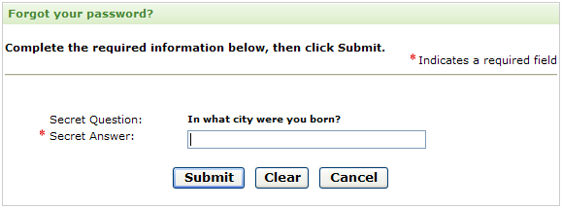
Figure 2—H

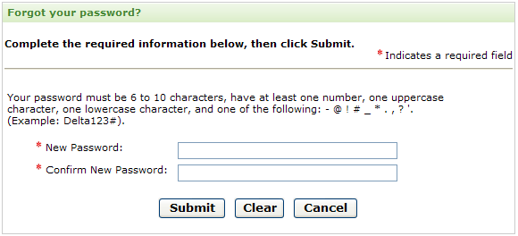
Figure 2—I

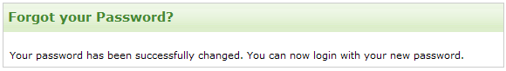
Figure 2—J

Reset Password

Column Name | Column Label | Entity | Figure | List of Values
E-Mail | E-mail | Person | Figure 2—K | N/A
Password | Current Password | Person | Figure 2—K | N/A
Secret Question | Secret Question | Person | Figure 2—K | Secret questions
Secret Answer | Secret Question Answer | Person | Figure 2—K | N/A
Table 2.5

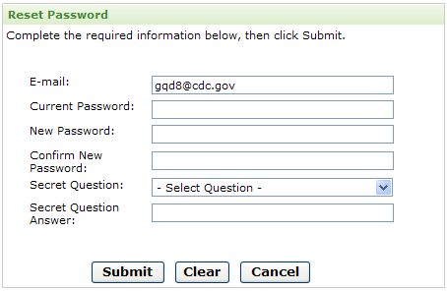
Figure 2—K

Electronic Consent

Column Name | Column Label | Entity | Figure | List of Values
Consent | Electronic Consent | Alumni | Figure 2—KA | N/A
Table 3
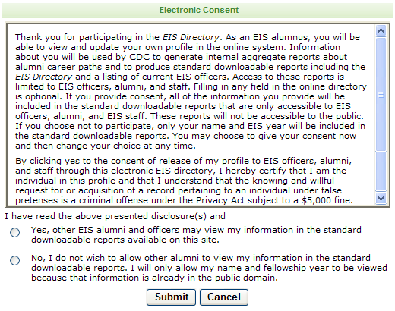
Figure 3—A

Contact Information

Column Name | Column Label | Entity | Figure | List of Values
First name |  | Person | Figure 5—A | N/A
Last name |  | Person | Figure 5—A | N/A
Current last name | Current last name | Person | Figure 5—A | N/A
Other name | Name you go by | Person | Figure 5—A | N/A
Program year | EIS entry year | Alumni | Figure 5—A | N/A
Photograph | Photo | Person | Figure 5—A | N/A
Permanent address line 1 | Address | Person | Figure 5—A | N/A
Permanent address line 2 |  | Person | Figure 5—A | N/A
Permanent address line 3 |  | Person | Figure 5—A | N/A
Permanent address country | Country | Person | Figure 5—A | Countries
Permanent address state | State | Person | Figure 5—A | States
Permanent address city | City | Person | Figure 5—A | N/A
Permanent address zip code | Zip/Postal code | Person | Figure 5—A | N/A
Email | Login/E-mail | Person | Figure 5—A | N/A
Phone country code | Country code | Person | Figure 5—A | Countries
Phone number | Daytime phone | Person | Figure 5—A | N/A
Work phone number | Permanent | Person | Figure 5—A | N/A
Alternate Email | Alternate E-mail | Person | Figure 5—A | N/A
Mailing address line 1 | Address | Person | Figure 5—A | N/A
Mailing address line 2 |  | Person | Figure 5—A | N/A
Mailing address line 3 |  | Person | Figure 5—A | N/A
Mailing address country | Country | Person | Figure 5—A | Countries
Mailing address state | State | Person | Figure 5—A | States
Mailing address city | City | Person | Figure 5—A | N/A
Mailing address zip code | Zip/Postal code | Person | Figure 5—A | N/A
Spouse Name | Spouse Name | Person | Figure 5—A | N/A
Spouse Alumni | Spouse/Partner is also an EIS officer | Alumni | Figure 5—A | N/A
Children Name | Children’s name | Children | Figure 5—A | N/A
Table 4
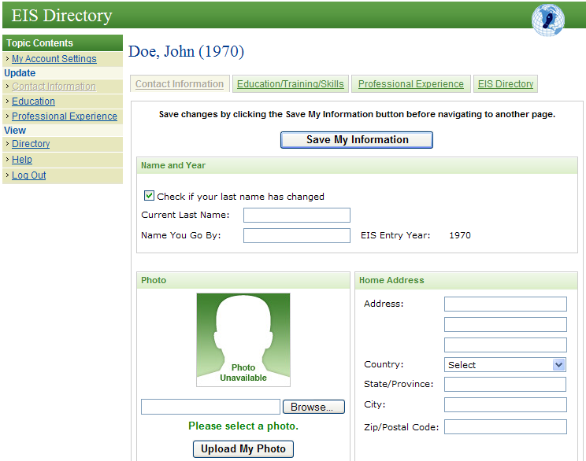
Figure 4—A
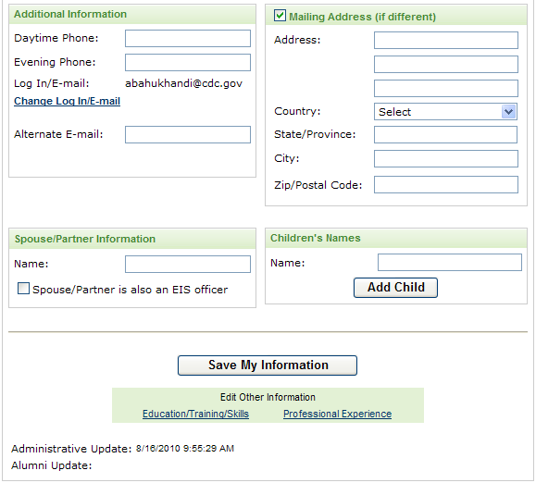
Figure 4—B

Education/Training/Skills

Figure 5

Education

Column Name | Column Label | Entity | Figure | List of Values
Country | Country | College education | Figure 5—A | Countries
State | State/Province | College education | Figure 5—A | States
City | City | College education | Figure 5—A | N/A
Name | Institution Name | College education | Figure 5—A | College names
Status | Status | College education | Figure 5—A | College education statuses
From date | Dates from | College education | Figure 5—A | N/A
To date | To | College education | Figure 5—A | N/A
Degree | Degree | College education | Figure 5—A | Degrees
Degree date expected | Date expected | College education | Figure 5—A | N/A
Major | Major | College education | Figure 5—A | N/A
Major classification | Major classification | College education | Figure 5—A | Major classifications
Table 5.1

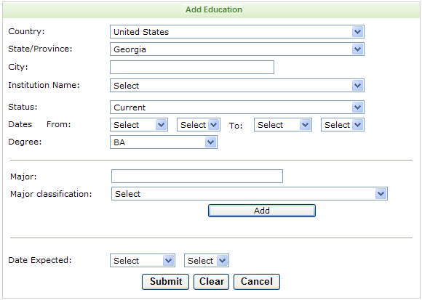
Figure 5—A

Clinical Training

Column Name | Column Label | Entity | Figure | List of Values
Title | Title | Clinical Training | Figure 5—A | Clinical title
Specialty | Specialty | Clinical Training | Figure 5—A | Specialties
Institution name | Institution name | Clinical Training | Figure 5—A | N/A
Country | Country | Clinical Training | Figure 5—A | Countries
State | State/Province | Clinical Training | Figure 5—A | States
City | City | Clinical Training | Figure 5—A | N/A
From date | Dates from | Clinical Training | Figure 5—A | N/A
To date | To | Clinical Training | Figure 5—A | N/A
Table 5.2

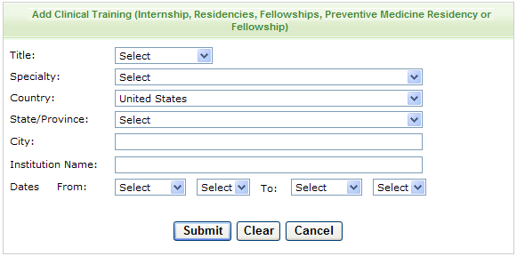
Figure 5—B

Board Certification

Column Name | Column Label | Entity | Figure | List of Values
Specialty | Specialty | Board Certification | Figure 5—A | Specialties
Most recent issuance date | Most Recent Year of Board Certification | Board Certification | Figure 5—A | N/A
Most recent expiration date | Year of Expiration | Board Certification | Figure 5—A | N/A
Table 5.3

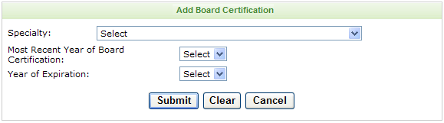
Figure 5—C

Fellowship

Column Name | Column Label | Entity | Figure | List of Values
Program name | Fellowship | Additional Training | Figure 5—A | Program names
CDC Fellowship | Check if This is a CDC Fellowship | Additional Training | Figure 5—A | N/A
CIO | CIO | Additional Training | Figure 5—A | CIO
From date | Dates from | Additional Training | Figure 5—A | N/A
To date | To | Additional Training | Figure 5—A | N/A
Table 5.4

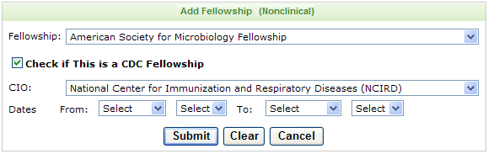
Figure 5—D

EIS Assignment

Column Name | Column Label | Entity | Figure | List of Values
Assignment Setting | Assignment Setting | Assignment | Figure 5—A | Work Settings
Organization | Organization | Assignment | Figure 5—A | Organizations
Assignment | Assignment | Assignment | Figure 5—A | N/A
Primary Content Area | Primary Content Area | Assignment | Figure 5—A | Areas of Interests
State | State/Province | Assignment | Figure 5—A | States
City | City | Assignment | Figure 5—A | N/A
From date | Dates from | Assignment | Figure 5—A | N/A
To date | To | Assignment | Figure 5—A | N/A
Table 5.5

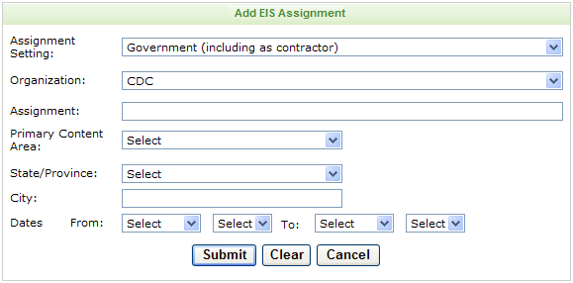
Figure 5—E

Language

Column Name | Column Label | Entity | Figure | List of Values
Language name | Secondary Language | Language | Figure 5—A | Languages
Native language | Primary Spoken Language | Language | Figure 5—A | Languages
Reading skill | Read | Language | Figure 5—A | Proficiencies
Writing skill | Write | Language | Figure 5—A | Proficiencies
Speaking skill | Speak | Language | Figure 5—A | Proficiencies
Table 5.6

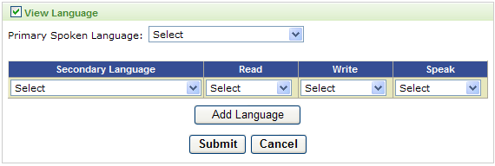
Figure 5—F

Professional Experience

Column Name | Column Label | Entity | Figure | List of Values
Work Setting | Work setting | Work experience | Figure 5—A | Work settings
Organization | Organization | Work experience | Figure 5—A | Organizations
Name | Employer | Work experience | Figure 5—A | N/A
Job title | Title | Work experience | Figure 5—A | N/A
Country | Country | Work experience | Figure 5—A | Countries
State | State/Province | Work experience | Figure 5—A | States
City | City | Work experience | Figure 5—A | N/A
From date | Dated from | Work experience | Figure 5—A | N/A
To date | To | Work experience | Figure 5—A | N/A
Job function | Job function | Work experience | Figure 5—A | Job function
Job roles | Job roles | Work experience | Figure 5—A | Job roles
Table 6

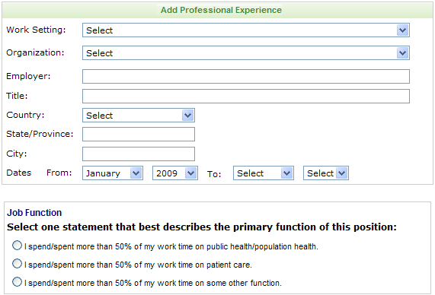
Figure 6—A

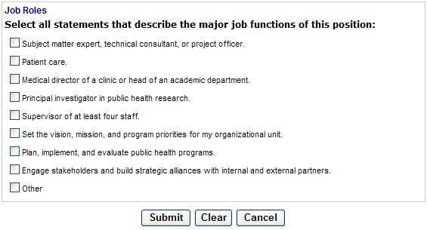
Figure 6—B

Directory
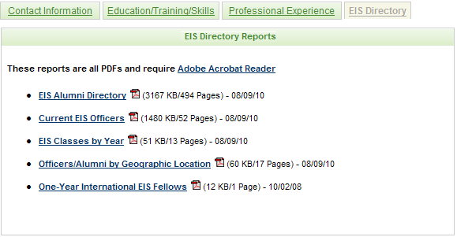
Figure 7

Current EIS Officers
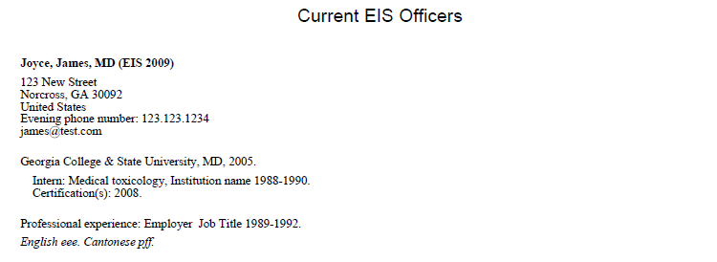
Figure 7-A

EIS Classes by Year
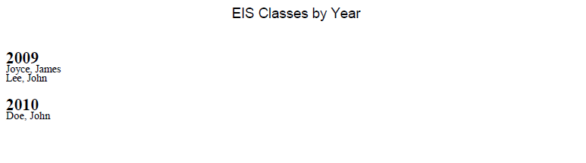
Figure 7-B

Officers / Alumni by Geographic Locations

Figure 7-C

One – Year International EIS Fellows
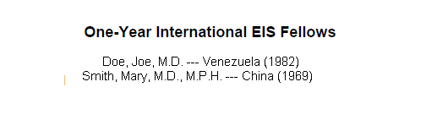
Figure 7-D

Appendix A - E-mails

Initial launch announcement and password reset
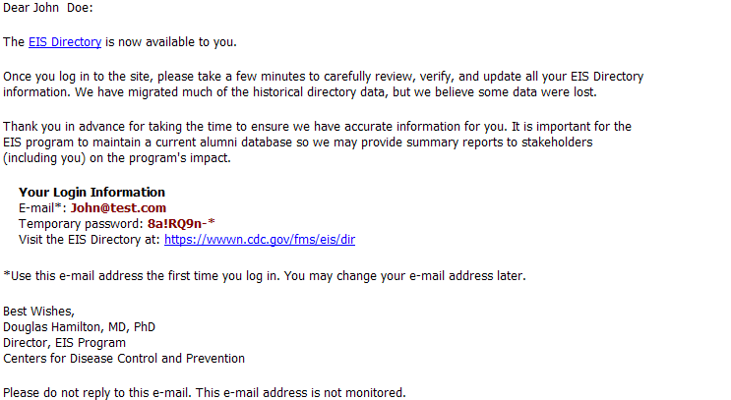
Figure 8-A

Alumni Registration Confirmation
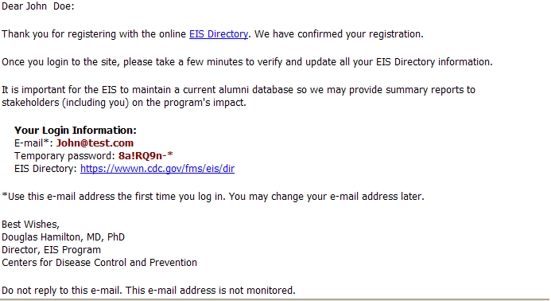
Figure 8-B

Appendix B - Changes In Other Programs

Hubert differences

Assignment
Column Name | Column Label | Figure | List of Values
Country | Country |  | Countries

PHPS differences

Certifications
Column Name | Column Label | Entity | List of Values
Title | Title | Certification | N/A
Institution name | Institution name | Certification | N/A
Country | Country | Certification | Countries
State | State/Province | Certification | States
City | City | Certification | N/A
From date | Dates from | Certification | N/A
To date | To | Certification | N/A

Appendix C – List Of Values

Countries

- Afghanistan
- Albania
- Algeria
- Andorra
- Angola
- Anguilla (U.K.)
- Antigua and Barbuda
- Argentina
- Armenia
- Aruba
- Australia
- Austria
- Azerbaijan
- Azores
- Bahamas, The
- Bahrain
- Bangladesh
- Barbados
- Belarus
- Belgium
- Belize
- Benin
- Bermuda (U.K.)
- Bhutan
- Bolivia
- Bosnia and Herzegovina
- Botswana
- Brazil
- British Indian Ocean Territory (U.K.)
- British Virgin Islands
- Brunei
- Bulgaria
- Burkina Faso
- Burma (Myanmar)
- Burundi
- Cambodia
- Cameroon
- Canada
- Canary Islands (Spain)
- Cape Verde
- Cayman Islands (U.K.)
- Central African Republic
- Chad
- Chile
- China
- Christmas Island (Australia)
- Cocos (Keeling) Islands (Australia)
- Colombia
- Comoros
- Congo, Democratic Republic of the
- Congo, Republic of the
- Cook Islands (New Zealand)
- Costa Rica
- Côte d'Ivoire
- Croatia
- Cuba
- Cyprus
- Czech Republic
- Denmark
- Djibouti
- Dominica
- Dominican Republic
- Easter Island (Chile)
- Ecuador
- Egypt
- El Salvador
- Equatorial Guinea
- Eritrea
- Estonia
- Ethiopia
- Falkland Islands (Malvinas)
- Falkland Islands (U.K.)
- Faroe Islands (Denmark)
- Fiji
- Finland
- France
- French Guiana (France)
- French Polynesia (France)
- Gabon
- Gambia, The
- Georgia
- Germany
- Ghana
- Gibraltar (U.K.)
- Greece
- Greenland (Denmark)
- Grenada
- Guadeloupe
- Guatemala
- Guinea
- Guinea-Bissau
- Guyana
- Haiti
- Honduras
- Hong Kong SAR (China)
- Hungary
- Iceland
- India
- Indonesia
- Iran
- Iraq
- Ireland
- Israel
- Italy
- Jamaica
- Japan
- Jordan
- Kazakhstan
- Kenya
- Kiribati
- Korea, North
- Korea, South
- Kosovo
- Kuwait
- Kyrgyzstan
- Laos
- Latvia
- Lebanon
- Lesotho
- Liberia
- Libya
- Liechtenstein
- Lithuania
- Luxembourg
- Macau SAR (China)
- Macedonia
- Madagascar
- Madeira Islands (Portugal)
- Malawi
- Malaysia
- Maldives
- Mali
- Malta
- Marshall Islands
- Martinique (France)
- Mauritania
- Mauritius
- Mayotte (France)
- Mexico
- Micronesia, Federated States of
- Moldova
- Monaco
- Mongolia
- Montenegro
- Montserrat (U.K.)
- Morocco
- Mozambique
- Namibia
- Nauru
- Nepal
- Netherlands Antilles
- Netherlands, The
- New Caledonia (France)
- New Zealand
- Nicaragua
- Niger
- Nigeria
- Niue (New Zealand)
- Norfolk Island (Australia)
- Northern Mariana Islands (U.S.)
- Norway
- Oman
- Other
- Pakistan
- Palau
- Panama
- Papua New Guinea
- Paraguay
- Peru
- Philippines
- Pitcairn Islands (U.K.)
- Poland
- Portugal
- Qatar
- Réunion (France)
- Romania
- Russia
- Rwanda
- Saint Helena (U.K.)
- Saint Kitts and Nevis
- Saint Lucia
- Saint Pierre and Miquelon (France)
- Saint Vincent and the Grenadines
- Samoa
- San Marino
- São Tomé and Príncipe
- Saudi Arabia
- Senegal
- Serbia
- Seychelles
- Sierra Leone
- Singapore
- Slovakia
- Slovenia
- Solomon Islands
- Somalia
- South Africa
- Spain
- Sri Lanka
- Sudan
- Suriname
- Swaziland
- Sweden
- Switzerland
- Syria
- Taiwan
- Tajikistan
- Tanzania
- Thailand
- Timor-Leste (East Timor)
- Togo
- Tokelau (New Zealand)
- Tonga
- Trinidad and Tobago
- Tunisia
- Turkey
- Turkmenistan
- Turks and Caicos Islands (U.K.)
- Tuvalu
- Uganda
- Ukraine
- United Arab Emirates
- United Kingdom
- United States
- Uruguay
- Uzbekistan
- Vanuatu
- Venezuela
- Vietnam
- Western Sahara
- Yemen
- Zambia
- Zimbabwe

States

- Alabama
- Alaska
- Arizona
- Arkansas
- California
- Colorado
- Connecticut
- Delaware
- Washington, DC
- Florida
- Georgia
- Hawaii
- Idaho
- Illinois
- Indiana
- Iowa
- Kansas
- Kentucky
- Louisiana
- Maine
- Maryland
- Massachusetts
- Michigan
- Minnesota
- Mississippi
- Missouri
- Montana
- Nebraska
- Nevada
- New Hampshire
- New Jersey
- New Mexico
- New York
- North Carolina
- North Dakota
- Ohio
- Oklahoma
- Oregon
- Pennsylvania
- Rhode Island
- South Carolina
- South Dakota
- Tennessee
- Texas
- Utah
- Vermont
- Virginia
- Washington
- West Virginia
- Wisconsin
- Wyoming
- Puerto Rico
- Guam
- American Samoa
- U.S. Virgin Islands
- Alberta
- British Columbia
- Manitoba
- New Brunswick
- Newfoundland and Labrador
- Nova Scotia
- Nunavut
- N.W.T.
- Ontario
- Quebec
- Saskatchewan
- Yukon
- Australian Capital Territory
- New South Wales
- Northern Territory
- Queensland
- South Australia
- Tasmania
- Victoria
- Western Australia
- Andra Pradesh
- Arunachal Pradesh
- Assam
- Bihar
- Chhattisgarh
- Goa
- Gujarat
- Haryana
- Himachal Pradesh
- Jammu and Kashmir
- Jharkhand
- Karnataka
- Kerala
- Madya Pradesh
- Maharashtra
- Manipur
- Meghalaya
- Mizoram
- Nagaland
- Orissa
- Punjab
- Rajasthan
- Sikkim
- Tamil Nadu
- Tripura
- Uttaranchal
- Uttar Pradesh
- West Bengal
- Andaman and Nicobar Islands
- Chandigarh
- Dadar and Nagar Haveli
- Daman and Diu
- Delhi
- Lakshadeep
- Pondicherry

Secret Questions
- In what city were you born?
- In what city was your mother born?
- In what city was your father born?
- What was the name of your first pet?
- What was your high school mascot?
- What is your favorite color?

Visa Types
- F-1
- H-1B
- J-1
- O-1
- TN

College Education Statuses
- Current
- Graduated (Degree Program)
- Completed (Nondegree Program)
- Incomplete

Degrees

- AA
- AAS
- AB
- AD
- ADN
- AM
- AS
- ASN
- BA
- BAC
- BBA
- BCE
- BDS
- BEng
- BFA
- BHB
- BIE
- BM
- BMBS
- BMed
- BNSc
- BNurs
- BPharm
- BS
- BS/BA
- BSc
- BSChE
- BScN
- BSE
- BSEE
- BSFS
- BSJ
- BSME
- BSPH
- BSN
- BVS
- BVSc
- DCH
- DDS
- DHA
- DHS
- DHSc
- DMD
- DNSc
- DO
- DPA
- DPE
- DPH
- DPhil
- DPM
- DPT
- DrPH
- DrS
- DrSc
- DSc
- DScD
- DScH
- DScVM
- DVM
- EdD
- JD
- LLB
- LLD
- MA
- MAS
- MAT
- MB
- MBA
- MBBCh
- MBBS
- MBChB
- MCPS
- MD
- MDCM
- MDiv
- MEd
- MFA
- MHA
- MHS
- MHSc
- MHSE
- MMS
- MN
- MNS
- MOH
- MOT
- MPA
- MPAS
- MPH
- MPharm
- MPhil
- MPHTM
- MPP
- MPVM
- MRP
- MS
- MSVPH
- MSc
- MScPH
- MSD
- MSHSA
- MSM
- MSN
- MSPH
- MSPM
- MSW
- MTM&H
- MUS
- MVSc
- OD
- PA
- PharmD
- PhB
- PhD
- PNP
- PsyD
- RN
- SB
- ScB
- ScD
- ScM
- SM
- SMHyg
- VMD

Major Classifications
- Biological, biomedical, or animal sciences
- Business, management
- Community health, public health
- Decision or quantitative sciences
- Economics (agricultural, applied, health)
- Engineering, industrial engineering, operations research
- Environmental, occupational sciences
- Epidemiology
- Global, international health
- Health education
- Informatics (public health, clinical, nursing)
- Health services administration, health policy analysis
- Health services research, quantitative policy analysis
- Information technology, information science, computer science
- Liberal arts, general studies, humanities, language, literature
- Maternal and child health
- Mathematical sciences, statistics, biostatistics
- Physical or chemical sciences
- Political science, law
- Public administration, policy analysis
- Social/behavior science (anthropology, social work, psychology)

License Statuses
- Received
- Expected

Languages

- Afrikaans
- Albanian
- Amharic
- Arabic (Egyptian)
- Aramaic
- Armenian
- Assamese
- Aymara
- Azerbaijani
- Basque
- Belarusian
- Bengali
- Bislama
- Bosnian
- Bulgarian
- Burmese
- Catalan
- Cebuano
- Cherokee
- Mandarin
- Croatian
- Czech
- Danish
- Dutch
- Egyptian
- English
- Estonian
- Finnish
- French
- Georgian
- German
- Greek
- Guarani
- Gujarati
- Creole (Haitian)
- Hausa
- Hawaiian
- Hebrew
- Hindi
- Hungarian
- Icelandic
- Irish
- Italian
- Japanese
- Javanese
- Kannada
- Kazakh
- Khmer
- Korean
- Lao
- Latvian
- Lithuanian
- Macedonian
- Malagasy
- Malayalam
- Marathi
- Mongolian
- Nahuatl
- Navajo
- Nepali
- Norwegian
- Oriya
- Oromo
- Farsi
- Polish
- Portuguese
- Punjabi
- Pashto
- Romanian
- Romany
- Russian
- Sanskrit
- Serbian
- Slovak
- Slovenian
- Somali
- Spanish
- Swahili
- Swedish
- Tagalog
- Tajik
- Tamil
- Telugu
- Thai
- Tibetan
- Tok Pisin
- Turkish
- Turkmen
- Ukrainian
- Urdu
- Uzbek
- Vietnamese
- Welsh
- Xhosa
- Yiddish
- Yoruba
- Zapotec
- Zulu
- Arabic (Levantine)
- Arabic (Modern Standard)
- Arabic (Moroccan)
- Indonesian (Not Specified)
- Bahasa Melayu
- Balochi
- Berber
- Cantonese
- Dari
- Ilokano
- Inuit
- Kurdi
- Kyrgyz
- Lakota
- Ojibwa
- Quechua
- Quiche
- Uyghur
- Yucatec Maya
- Arabic (Not Specified)
- Chinese (Not Specified)
- Creole (Not Specified)
- Malay

Proficiencies
- Poor
- Fair
- Good
- Excellent

Clinical Titles
- Intern
- Fellow
- Resident
- Chief Resident

Specialties

- Aerospace medicine
- Medical toxicology
- Undersea and hyperbaric medicine
- Allergy and immunology
- Clinical and laboratory immunology
- Anesthesiology
- Adult Cardiothoracic Anesthesiology
- Critical care medicine
- Pain medicine
- Pediatric anesthesiology
- Colon and rectal surgery
- Dermatology
- Dermatopathology
- Procedural dermatology
- Emergency medicine
- Medical toxicology
- Pediatric emergency medicine
- Sports medicine
- Undersea and hyperbaric medicine
- Family medicine
- Geriatric medicine
- Sports medicine
- Internal medicine
- Cardiovascular disease
- Clinical cardiac electrophysiology
- Critical care medicine
- Endocrinology, diabetes, and metabolism
- Gastroenterology
- Geriatric medicine
- Hematology
- Hematology and oncology
- Infectious disease
- Interventional cardiology
- Nephrology
- Oncology
- Pulmonary disease
- Pulmonary disease and critical care medicine
- Rheumatology
- Sports medicine
- Transplant hepatology
- Medical genetics
- Molecular genetic pathology
- Neurological surgery
- Endovascular surgical neuroradiology
- Neurology
- Child neurology
- Clinical neurophysiology
- Neuromuscular medicine
- Neurodevelopmental disabilities
- Pain medicine
- Vascular neurology
- Nuclear medicine
- Obstetrics and gynecology
- Occupational medicine
- Medical toxicology
- Undersea and hyperbaric medicine
- Ophthalmology
- Orthopaedic surgery
- Adult reconstructive orthopaedics
- Foot and ankle orthopaedics
- Hand surgery
- Musculoskeletal oncology
- Orthopaedic sports medicine
- Orthopaedic surgery of the spine
- Orthopaedic trauma
- Pediatric orthopaedics
- Otolaryngology
- Neurotology
- Pediatric otolaryngology
- Pain medicine
- Palliative and hospice care
- Pathology-anatomic and clinical
- Blood banking/transfusion medicine
- Chemical pathology
- Cytopathology
- Forensic pathology
- Hematology
- Medical microbiology
- Neuropathology
- Pediatric pathology
- Selective pathology
- Pediatrics
- Adolescent medicine
- Neonatal-perinatal medicine
- Pediatric cardiology
- Pediatric critical care medicine
- Pediatric emergency medicine
- Pediatric endocrinology
- Pediatric gastroenterology
- Pediatric hematology/oncology
- Pediatric infectious diseases
- Pediatric nephrology
- Pediatric pulmonology
- Pediatric rheumatology
- Pediatric sports medicine
- Developmental-behavioral pediatrics
- Physical medicine and rehabilitation
- Pain medicine
- Pediatric rehabilitation
- Spinal cord injury medicine
- Plastic surgery
- Craniofacial surgery
- Hand surgery
- Preventive medicine (CDC PMR/F ONLY)
- Preventive medicine (General/PH)
- Medical toxicology
- Undersea and hyperbaric medicine
- Psychiatry
- Addiction psychiatry
- Child and adolescent psychiatry
- Forensic psychiatry
- Geriatric psychiatry
- Pain medicine
- Psychosomatic medicine
- Radiation oncology
- Radiology, diagnostic
- Abdominal radiology
- Cardiothoracic radiology
- Endovascular surgical neuroradiology
- Musculoskeletal radiology
- Neuroradiology
- Nuclear radiology
- Pediatric radiology
- Vascular and interventional radiology
- Sleep medicine
- Surgery
- Hand surgery
- Pediatric surgery
- Surgical critical care
- Vascular surgery
- Vascular surgery — Integrated
- Thoracic surgery
- Congenital Cardiac Surgery
- Urology
- Pediatric urology
- Transitional year
- Internal Medicine/Pediatrics

Board Statuses
- Certified
- Eligible

Program Names
- American Society for Microbiology Fellowship
- Association of Schools of Public Health Fellowship/Internship (ASPH)
- Association for Prevention Teaching and Research (APTR) Fellowship (formerly Association for Teachers of Preventive Medicine)
- Association of Public Health Labs Environmental Laboratory Fellowship (APHL)
- The CDC Experience Applied Epidemiology Fellowship
- CSTE/CDC Applied Epidemiology Fellowship
- Emerging Infectious Disease Laboratory Program (EID)
- Emerging Leaders Program (ELP)
- Epidemiology Elective for Medical/Veterinary Students
- James A. Ferguson Emerging Infectious Diseases Summer Research Fellowship Program
- Fogarty/Ellison Overseas Fellowship in Global Health and Clinical Research Training
- Hispanic-Serving Health Professions Fellowship (HSPHS)
- Hubert Fellowship in International Health
- Presidential Management Fellowship (PMF)
- Prevention Effectiveness Fellowship Program (PEFP)
- Preventive Medicine Residency (non-CDC)
- Preventive Medicine Residency/Fellowship (PMR/F-CDC)
- Project IMHOTEP Summer Research Intern Program
- Public Health Informatics Fellowship Program (PHIFP)
- Public Health Prevention Service (PHPS)
- Public Health Sciences Institute Internship
- Public Health Summer Fellowship Program

Work Settings
- Government (including as contractor)
- Nongovernmental, community, or other organization
- Academia
- Other clinical setting
- Industry

Organizations
- CDC
- International public health (WHO, foreign ministry of health)
- Other U.S. Department of Health and Human Services
- Other federal government
- State health department
- Local health department
- Community-based organization
- Foundation
- Other organizations with mission targeting the health of the public
- School of Public Health
- School of Medicine (allopathic or osteopathic)
- School of Veterinary Medicine
- School of Nursing
- Other health sciences/health professional school
- Other university
- Hospital- or clinic-based
- Health maintenance organization
- Private practice
- Pharmaceutical company

Research Roles
- Principal Investigator
- Co-Investigator
- Investigator
- Evaluator

Research Grant Amounts
- $0 to $5,000
- $5,001 to $10,000
- $10,001 to $50,000
- $50,001 to $100,000
- $100,001 to $500,000
- $500,001 to $1,000,000
- $1,000,001 or more

Job Functions
- I spend/spent more than 50% of my work time on public health/population health.
- I spend/spent more than 50% of my work time on patient care.
- I spend/spent more than 50% of my work time on some other function.

Job Roles
- Subject matter expert, technical consultant, or project officer.
- Patient care.
- Medical director of a clinic or head of an academic department.
- Principal investigator in public health research.
- Supervisor of at least four staff.
- Set the vision, mission, and program priorities for my organizational unit.
- Plan, implement, and evaluate public health programs.
- Engage stakeholders and build strategic alliances with internal and external partners.
- Conducts education and training in public health informatics.
- Organizational leadership (chairperson of an academic department, medical director of a clinic).
- Participates in applied public health informatics research for new insights and innovative solutions to health problems.
- Supports development of strategic direction for public health informatics within the enterprise.
- Communicates with cross-disciplinary leaders and team members.
- Participates in development of knowledge management tools for the enterprise.
- Implements solutions that assure confidentiality, security, and integrity while maximizing availability of information for public health.
- Uses standards / supports standards development processes.

Honor Types
- Civil
- Military
- Uniformed Services

Hear About Us Options
- Administrator, career advisor, or professor at school
- Information session, career fair, or conference exhibit
- EIS website
- LISTSERV
- MMWR
- EIS alumni
- Announcement in newsletter or other publication
- Friend or colleague (not EIS alumni)
- EIS recruiting presentation
- National meeting

Areas Of Interests
- Birth defects and developmental disabilities
- Chronic disease (e.g., maternal/child health, stroke, heart disease, nutrition, obesity)
- Environmental health
- Genomics
- Health statistics
- HIV, Hepatitis, STDs, TB
- Immunizations
- Infectious diseases
- Injuries
- Occupational health
- Infectious diseases (e.g., HIV, hepatitis, STDs, TB, etc.)
- Preparedness and emergency response
- Health policy and diplomacy
- Injury prevention and control
- International health
- Occupational safety and health
- Maternal and child health
- Health disparities and vulnerable populations
- Global Health
- General/consulting
- General - public health practice

CIO
- Coordinating Office for Global Health
- Coordinating Office for Terrorism Preparedness and Emergency Response
- National Center for Environmental Health/ Agency for Toxic Substances and Disease Registry
- National Center for Injury Prevention and Control
- National Center for Health Marketing
- National Center for Health Statistics
- National Center for Public Health Informatics
- National Center on Birth Defects and Developmental Disabilities
- National Center for Chronic Disease Prevention and Health Promotion
- Agency for Toxic Substances and Disease Registry
- Office of Genomics and Disease Prevention
- National Center for HIV/AIDS, Viral Hepatitis, STD, and TB Prevention
- National Center for Immunization and Respiratory Diseases
- National Center for Preparedness, Detection, and Control of Infectious Diseases
- National Center for Zoonotic, Vector-Borne, and Enteric Diseases
- National Institute for Occupational Safety and Health
- OD/ Immunization Safety Office
- OD/ Office of Workforce and Career Development
- EIS Field Assignments Branch
- Office of the Chief Science Officer
- National Office of Public Health Genomics
- Office of the Chief Information Security Officer
- Office of Strategy and Innovation
- OD/ Office of Workforce and Career Development
- Office of Chief of Public Health Practice
- Office of Health and Safety
- National Center for Emerging and Zoonotic Infectious Diseases
- Center for Global Health

