Form Approved
OMB No. 0920-0910
Exp. Date 03/31/2018

National Tobacco Prevention and Control Public Education Campaign:
Rough Cut Testing of Television, Radio, Print, and Digital Advertisements for the 2016 Tips Campaign

Screener Questionnaire

Public reporting burden of this collection of information is estimated to average 4 minutes per response, including the time for reviewing instructions, searching existing data sources, gathering and maintaining the data needed, and completing and reviewing the collection of information. An agency may not conduct or sponsor, and a person is not required to respond to a collection of information unless it displays a currently valid OMB control number. Send comments regarding this burden estimate or any other aspect of this collection of information, including suggestions for reducing this burden to CDC/ATSDR Information Collection Review Office, 1600 Clifton Road NE, MS D-74, Atlanta, Georgia 30333; ATTN: PRA (0920-0910).
On behalf of the Centers for Disease Control and Prevention (CDC), we're conducting a study about health and smoking-specific advertising that you see in the media. Your opinions are very important to us! Please be assured that the purpose of this survey is to gather feedback regarding health and smoking-specific advertising. We will not report your answers individually and will only report the results from this survey for all participants combined. Thank you for taking the time to help us!
Your participation in this survey is voluntary.

Section: Screening Items

Demographic Information
{PREAMBLE}
Please indicate your race or ethnic background. Are you….?

SELECT ONE

DEMO6. Ethnicity
- Hispanic or Latino
- Not Hispanic or Latino

SELECT ONE OR MORE

DEMO7. Race:
- White
- Black or African American
- American Indian or Alaska Native
- Native Hawaiian or Other Pacific Islander
- Asian

{If Demo07.07 is selected}

LANGPREFAsian1: Do you speak a language other than English at home?
- Yes
- No

LANGPREFAsian2: What is this language?
- Chinese
- Korean {Redirect to English version of survey}
- Vietnamese {Redirect to English version of survey}
- Other Specify {Redirect to English version of survey}

{ LANGPREFAsian2 = 01}

LANGPREFChinese: In what language do you prefer to watch, read, and listen to media?
- Chinese only
- Chinese more than English
- Both Chinese and English equally
- English more than Chinese {Redirect to English version of survey}
- English only {Redirect to English version of survey}
- None of the above TERMINATE

{ LANGPREFAsian2 = 02,03,04}

LANGPREF2: In what language do you prefer to watch, read, and listen to media?
- {LANGPREFAsian2 FILL} only TERMINATE
- {LANGPREFAsian2 FILL} more than English TERMINATE
- Both {LANGPREFAsian2 FILL} and English equally {Redirect to English version of survey}
- English more than {LANGPREFAsian2 FILL} {Redirect to English version of survey}
- English only {Redirect to English version of survey}
- None of the above TERMINATE

DAGE1: What is your current age?
- Under 18 years of age {TERMINATE}
- 18-24 years of age
- 25-34 years of age
- 35-44 years of age
- 45-54 years of age
- 55-64 years of age {TERMINATE}
- 65-74 years of age {TERMINATE}
- 75 years of age or older {TERMINATE}
- Refuse to answer {TERMINATE}

DEMO5: What state do you live in?
- Alabama
- Alaska
- Arizona
- Arkansas
- California
- Colorado
- Connecticut
- Delaware
- Florida
- Georgia
- Hawaii
- Idaho
- Illinois
- Indiana
- Iowa
- Kansas
- Kentucky
- Louisiana
- Maine
- Maryland
- Massachusetts
- Michigan
- Minnesota
- Mississippi
- Missouri
- Montana
- Nebraska
- Nevada
- New Hampshire
- New Jersey
- New Mexico
- New York
- North Carolina
- North Dakota
- Ohio
- Oklahoma
- Oregon
- Pennsylvania
- Rhode Island
- South Carolina
- South Dakota
- Tennessee
- Texas
- Utah
- Vermont
- Virginia
- Washington
- West Virginia
- Wisconsin
- Wyoming
- District of Columbia
- Other

{Base = if DAGE1 = 02 & (AL (DEMO5.01) or NE (DEMO5.27))}

DAGE2. What is the year of your birth? (Please enter as YYYY)
{Open-end, Mask for YYYY}

{Terminate respondent if respondent is from AL (DEMO5.01) or NE (DEMO5.27) & is 18 or 19 years old}

Smoking Behavior – Core

{PREAMBLE}
The next questions are about cigarettes which are any roll of tobacco wrapped in paper. Below is an image of a cigarette.
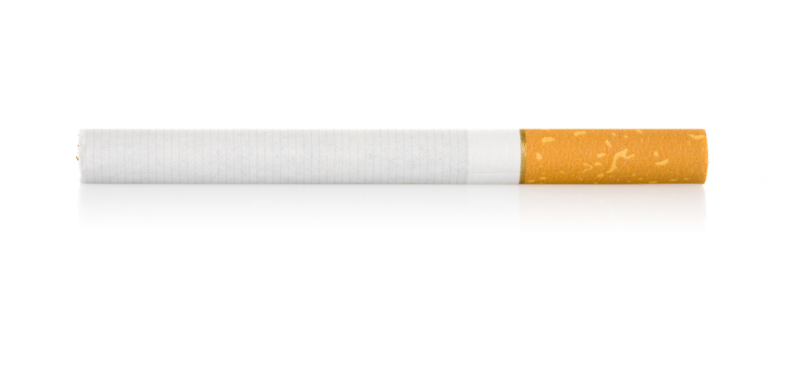
{Base = All respondents}

TS1. Have you smoked at least 100 cigarettes in your entire life?
- Yes
- No
- Don’t know/not sure
- Refused
{Base = All respondents}

TS2. Do you now smoke cigarettes every day, some days, or not at all?
- I smoke every day
- I smoke on some days
- I do not smoke at all

{Base = All respondents}

TS3: On how many of the past 30 days did you smoke cigarettes?
Enter number: _______

Programmer Instructions:
Segments | Definition | Criteria
Smokers | Smokers | Answers TS1_1 to TS1 AND (TS2_1 or TS2_2 to TS2) AND Answers TS3 > 0
Non-Smokers | Non-Smokers | Answers TS1_2 to TS1 AND (TS2_3 to TS2) AND Answers TS3 = 0
Non-Smokers | Former Smokers | Answers TS1_1 to TS1 AND (TS2_3 to TS2) AND Answers TS3 = 0

Smoking Behavior – Electronic Vapor Products

{Base = Current Cigarette Smokers}

{PREAMBLE}
The next questions are about electronic vapor products. These are devices that usually contain a nicotine-based liquid that is vaporized and inhaled. You may also know them as e-cigarettes, vape-pens, hookah-pens, electronic hookahs (e-hookahs), electronic cigars (e-cigars), electronic pipes (e-pipes), or e-vaporizers. Some brand examples are Blu, NJOY, Vuse, MarkTen, and Starbuzz.

Smoking Behavior – Electronic Vapor Products

E1a. Have you ever used electronic vapor products, even one time?
- Yes
- No
{Base = Answers Yes to E1}

E2. Do you now use electronic vapor products …
- Every day
- Some days
- Not at all

Category | SCREENING LOGIC
Current Electronic Vapor Product Users | Answers 1 to E1 & 1 or 2 to E2

{GENERAL SCREEN OUT MESSAGE}
Thank you for your participation in this study. Unfortunately, your responses indicate that you do not fit the specific criteria needed for this particular study, or that we have already reached our required quota of responses from participants similar to you. We appreciate your enthusiasm for our study and hope you will join us on future surveys!

