OMB No. 0920-0910
Exp. Date 03/31/2018

Focus Group Moderator’s Guide for
Creative Concept Testing
Dual Users

Public reporting burden of this collection of information is estimated to average 90 minutes per response, including the time for reviewing instructions, searching existing data sources, gathering and maintaining the data needed, and completing and reviewing the collection of information. An agency may not conduct or sponsor, and a person is not required to respond to a collection of information unless it displays a currently valid OMB control number. Send comments regarding this burden estimate or any other aspect of this collection of information, including suggestions for reducing this burden to CDC/ATSDR Information Collection Review Office, 1600 Clifton Road NE, MS D-74, Atlanta, Georgia 30333; ATTN: PRA (0920-0910).

DISCUSSION GUIDE

[Note to Moderator: Bolded text should not be read aloud]

INTRODUCTION and RULES OF ENGAGEMENT (5 minutes)
Hello! Welcome! I'm _____________ and I'll be leading our discussion.

Each of you currently uses traditional cigarettes. When we say “traditional cigarette”, we are talking about traditional tobacco cigarettes, which are any roll of tobacco wrapped in paper. Traditional cigarettes typically come in packs of 20 and some brand examples include Marlboro, Newport, Camel, Lucky Strike and Pall Mall. Here is an image of a traditional cigarette:

[Note to Moderator: Hold up image of a traditional cigarette]
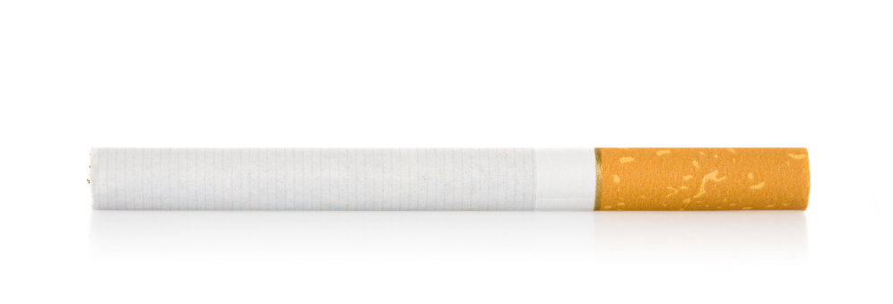
You also use electronic cigarettes. Electronic cigarettes are battery-operated devices that can deliver nicotine and other additives to the user via an aerosol. You may also know them as e-cigarettes, vapes or vape pens, hookah-pens, electronic or e-hookahs, electronic or e-cigars, electronic or e-pipes, or e-vaporizers. For the purposes of this study, we will use the word “e-cigarettes” to mean all of these products. Here are some images of e-cigarettes:

[Note to Moderator: Hold up image of e-cigarettes]

Before we begin, please silence your cell phones. Now a little about me – I work for an independent market research firm, and my job is to ask questions and understand your personal opinions and ideas - positive or negative - so please be honest in your responses. Remember, there are no right or wrong answers. No one will judge your answers.

Let’s start with some ground rules:
- Your participation is voluntary and you have the right to not answer any question or withdraw from the study at any time.
- Please speak one at a time. This session is being audio-recorded, so please speak up to ensure your comments are captured. In our discussion, we may use first names, but let’s make sure to not use last names in our conversation today. And when you leave this session, you can talk about what you did, but we ask that you not talk about what was said.
- Behind me is a one-way mirror. Behind that are some of my colleagues and people from the Centers for Disease Control and Prevention. Near the end of our conversation, I will talk with them to see if they have any last-minute questions for you. There are also project staff observing the session by live stream on the internet through a password-protected site.
- I’m not a medical doctor or an expert on smoking or tobacco, so I can’t answer specific questions.
- Most importantly, there are no right or wrong answers, and it’s important that I hear the full range of ideas, so please feel free to agree or disagree with one another. Don’t hold back on sharing your honest opinions and please respect the opinions of others.

The main purpose of our discussion is to get your feedback on some creative concepts that focus on the consequences of smoking and the benefits of quitting prior to the production of an advertisement. Your responses will help inform the development of our advertisements. Do you have any questions before we begin?

Smoking Behavior & Perceptions (5 minutes)
{Moderator Note - Objective: To set group dynamics and understand current tobacco product usage and perceptions}

I’d love to learn more about you, so let’s start with introductions. Let’s go around the room – tell me your first name, the age when you started using traditional cigarettes, and one or two reasons you smoke.

1. When did you start using e-cigarettes?
2. OPTIONAL: In general, are you aware of any advertising or tobacco education campaigns against smoking, tobacco products, or tobacco companies that are now taking place?
- Probe: What do you remember about these ads or campaigns?

Creative Concept Exploration

{Moderator Note - Objective: To evaluate participants’ reactions to creative concepts}

{Overview (3 minutes)}
Today, I’m going to show you concepts for new TV ads about educating consumers about the harmful effects of traditional cigarettes. These are not actual commercials, though, they are just ideas of what future commercials could look like.

- The first step in developing television ads is creating what are called “storyboards.” In this next section, you will see some storyboards that represent TV ads. We call them ads, or concepts, interchangeably in this group.

  - Storyboards are like a TV ad that has been printed: they tell a story frame-by-frame.

  - You can get an idea of a TV ad in this format before it is made into a video version.

  - So the final ad will have real people in real settings in a taped format just like you normally see on television.

- When I show you the storyboards, I’ll ask that you use your imagination to “fill in the blanks” – to imagine what it would look like as a finished ad and to react to that image.

- To help you imagine the concept, I’ll play two short audio clips that accompany the storyboards.
- We will see a number of concepts, but I will show you only one concept first, and then ask you questions about that concept.

- We will use your input to create final advertisements. Try not to get too caught up in the small details, just focus on the overall idea.

We are going to review those audio clips now and show the storyboards. After we review the concept, I’m going to ask you what you think about the concept or ads. After I show you each concept, we will discuss as a group. We will talk about each of them individually and then compare them to each other at the end. Any questions?

[Moderator Note: CONCEPT ORDER WILL BE RANDOMIZED. AFTER THE FIRST CONCEPT, REMOVE THE CONCEPT FROM THE PARTICIPANTS’ VIEW]

Single Concept Evaluation (60 minutes – averaging 15 minutes per execution)

[Moderator Note: SHOW CONCEPT – and PLACE THUMBNAIL IMAGE of CONCEPT up on WHITEBOARD]

First, let’s turn to the questionnaire in front of you. Please write “Ad Concept X” at the top where indicated, and Focus Group X. Please do not put your name on any of the documents. We’ll use this questionnaire later on in this session, but for now, let’s talk freely.

Note to moderator:
- Provide one participant feedback questionnaire per participant
- The participant feedback questionnaire has five pages - the cover page and one page per concept

3. What would you say the main message of the ad or concept is?
Probe: What is the ad or concept asking you to do, if anything?

4. (Only for “Smoking Ironies concept” only) Do you think that the ad was about the risk of painful or deadly health conditions caused by smoking, or by the dangerous job the person in the ad had?
Probe: Do you think that the person’s health condition was caused in part because of their job?
Probe: If smoking caused the person’s health condition, do you think that is only true for certain health conditions related to their job (e.g., lung cancer in “Ironworker” spot vs. stroke in “Firefighter” spot)?
Probe: How risky do you view the job of Ironworker or Firefighters?

5. Who is the intended audience for this ad?

6. (Only for “The Stronger Than You Think” concept) , How does the parent and child relationship impact you emotionally, when compared to a friend?

7. What, if anything, did this ad tell you that you didn’t know before?

8. How believable did you find this ad? Why or why not?
9. Does the ad fit with your previous experience with or knowledge about the health risks of smoking?
10. Do you find anything confusing or vague about this ad? How so?

11. What, if anything, about the ad was particularly meaningful?

12. What, if anything, about the ad would you change?

13. What can you relate to the most in the ad? What do you not relate to?

14. (Only for “Smoking Ironies” concept) Do you relate to the job shown in the concept?

15. Do you identify with the people shown in the concept? Why or why not?

16. Are there things about the ads that bother you in any way? If so, what bothers you and why?

17. Would this ad get your attention? If so, what caught your attention about this ad? Why?

18. Is the information in this ad helpful to you? Why or why not?

19. [Ensure that this question is asked in all focus groups] Does this ad make you think differently about smoking traditional cigarettes? If so, in what way?

20. [Ensure that this question is asked in all dual use focus groups] Does this ad make you think differently about using e-cigarettes? If so, in what way?

21. After viewing this ad, what would you most likely do? Is there any action you would take because of the ad that you hadn’t thought of before seeing the ad?

22. Do you think that this ad would motivate nonsmokers to talk to their family members about the dangers of smoking? Why or why not.

23. Does the ad give you a sense of urgency around the need to quit smoking traditional cigarettes completely?

[Note to Moderator: Ask participants to open up their Participant Feedback Questionnaire and go to the page with the heading for the current concept, giving the correct page number, and answer all questions on the single page]

[Note to Moderator: Repeat for the next three concepts.]

Selection of Preferred Ads (10-15 minutes)

[Note to moderator: Place all boards around the room and then ask the questions listed below]
Ok, now take a moment to look at all these ads again.

24. Which ad is the most memorable?

25. We know that some of these ads may be disturbing; we are not asking which ad do you like, but which one is most motivating to you to stop smoking traditional cigarettes completely? Why?

26. What are the key elements that make this ad the most motivating to you to stop smoking traditional cigarettes completely?

27. Which ad do you think will motivate other smokers to quit smoking traditional cigarettes the most? Why?
28. Which concept do you think is weakest in terms of motivating smokers to quit smoking traditional cigarettes? Why is that?

29. Please rank all of the ads in order of most motivating to you to stop smoking traditional cigarettes completely, to least likely to motivate you to stop smoking traditional cigarettes completely?

Probe: Earlier, you said “X Concept” was the most motivating. Is this still the case, when looking at all these ads?

Probe: Earlier, you said “Y Concept” was the least motivating. Is this still the case, when looking at all these ads?

Probe: What about these two concepts? Where do they fall in the ranking?

{Note to moderator: Affirm the ranking}

30. Before we wrap up, is there anything else you wanted to say about any of these concepts?

Close/Follow-up (1 minute)

I would like to thank you for coming here today and participating in this discussion. This research was sponsored by the Centers for Disease Control and Prevention, also known as the CDC. CDC would like to thank you for sharing your opinions as they will be very useful in helping them to understand people’s reactions and thoughts about the concepts we have talked about. Please turn in your questionnaires now. After you turn in your questionnaires, you can walk back to where you signed in to check out and collect your $75. Thanks again!

