**Attachment D: Project Overview**

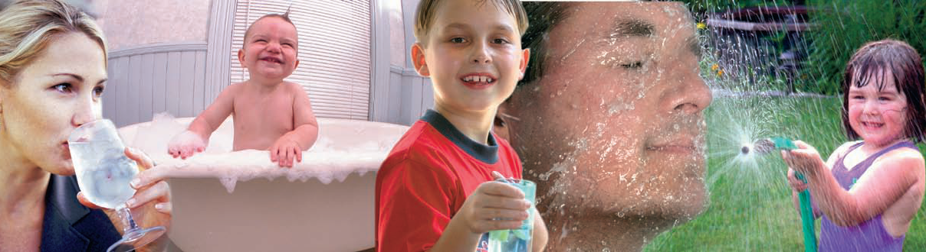

**Evaluation of Interventions to Prevent Exposure to Contaminants in Drinking Water**

There have been many state, local, and tribal outreach programs by environmental health staff to educate the owners of private wells about the risks involved with well water. In most cases, information on the success of these programs is not available.

The National Ground Water Association (NGWA) secured a contract from CDC to help address this information gap.

This information collection will:

Identify and describe existing public outreach campaigns that promote well testing and treatment by gathering information from the program managers indicative of program success from their perspective.

Interview key government personnel to provide additional context, depth and nuance to our overall assessment of private well owner-focused public outreach efforts. We will conduct face-to-face and/or telephone interviews.

Gain valuable information about two major problematic constituents in groundwater in two regions—arsenic, which is prevalent in portions of the northeastern United States, and nitrate, which is prevalent in certain large agricultural areas in southern California. This portion of the information collection will examine strategies and tactics specific to arsenic and nitrate, and how large-scale public outreach programs approach educating private well owners.

This information collection will contribute to a larger project effort, the findings of which will be presented in a written report to be provided to CDC. The report will include:

1. **An analysis of the predominant components of private well outreach programs**: Components will correspond to program strategies (i.e. news media initiative), and tactics to achieve strategy goals (i.e. news events, news releases, editorial board meetings).
2. **A composite profile of a multi-faceted program**: This will represent a model program that optimally combines the predominant components of public outreach campaigns to well owners.
3. **Case examples of noteworthy private well outreach programs**: The case examples selected as “noteworthy” will stand out in ways that are particularly helpful in illustrating the program development, implementation and/or assessment.
4. **Key program considerations**: The project will develop an outline of common considerations and corresponding strategies and tactics used in private well owner public outreach.