Attachment F- Instrument Web Version

RSB Product and STLT Preparedness Assessment

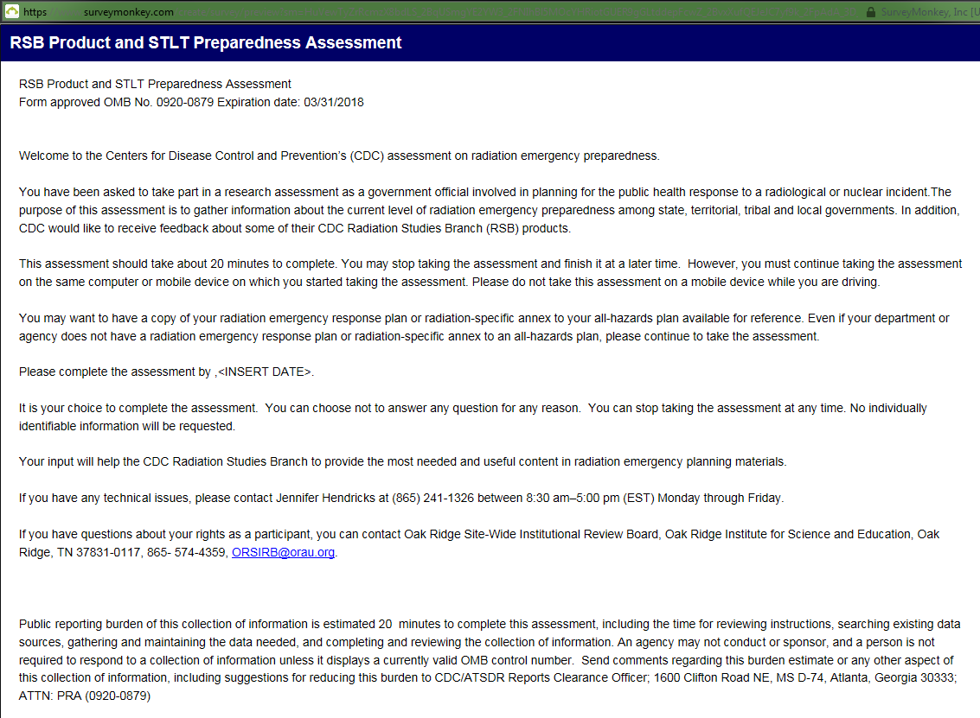

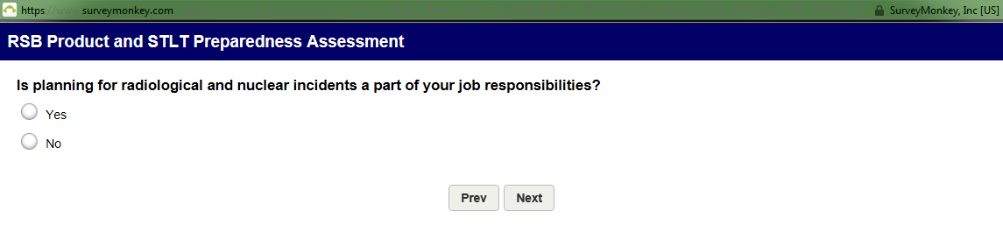

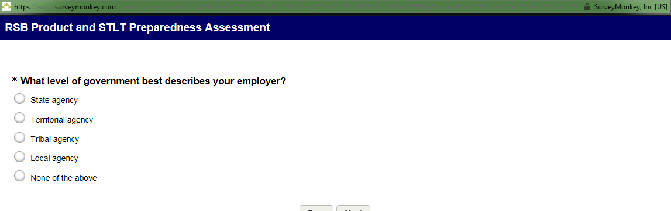

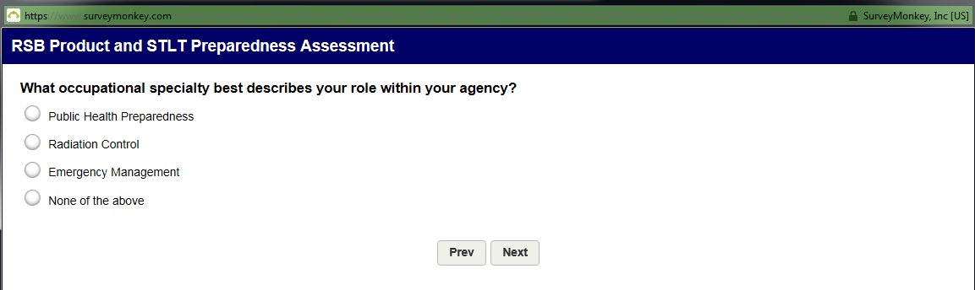

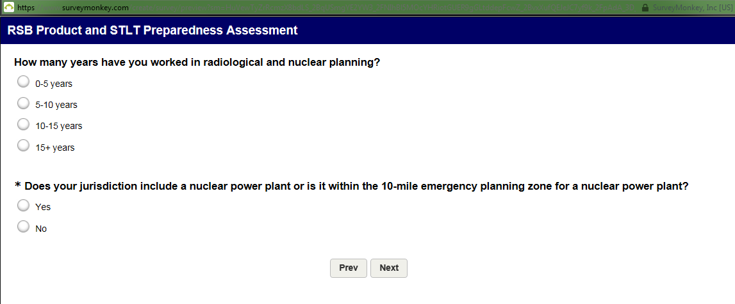

IF Yes: Does your juristiction include a nuclear power plant or is it within the 10-mile emergency planning zone for a nulcear power plant:
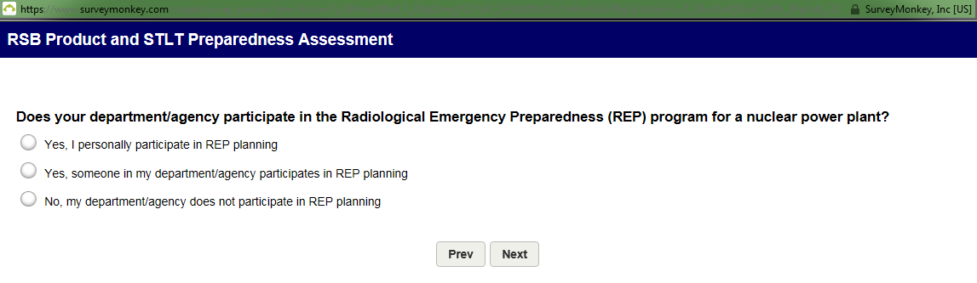
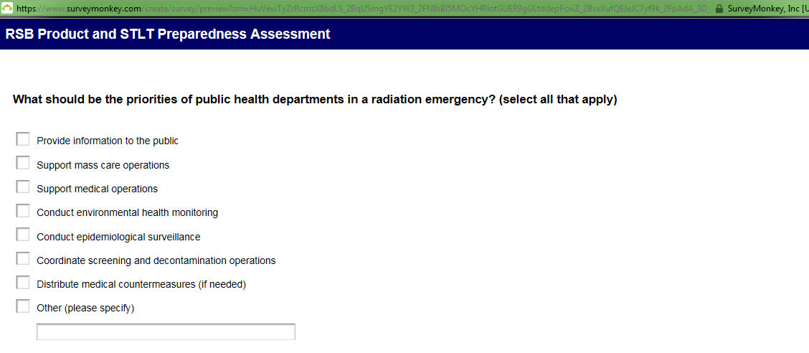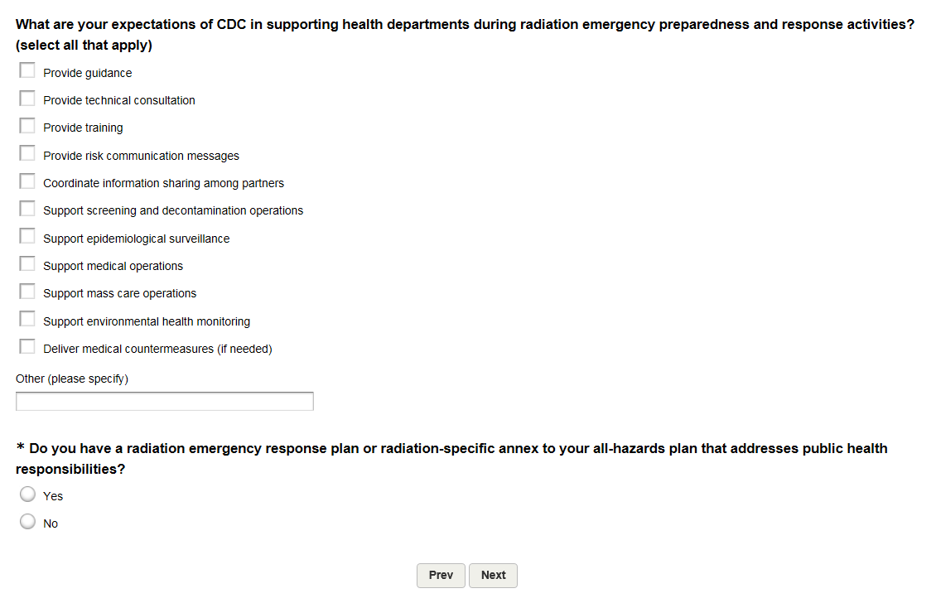
If No: Do you have a radiation emergency response plan or radiation-specific annex to your all-hazards plan that addresses public health responsibilities?
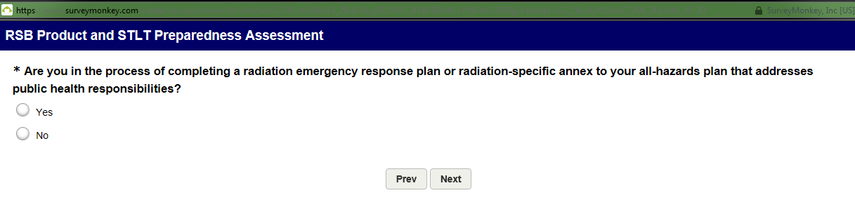
If No: Are you in the process of completing a radiation emergency response plan or radiation-specific annex to your all-hazards plan that addresses public health responsibilities
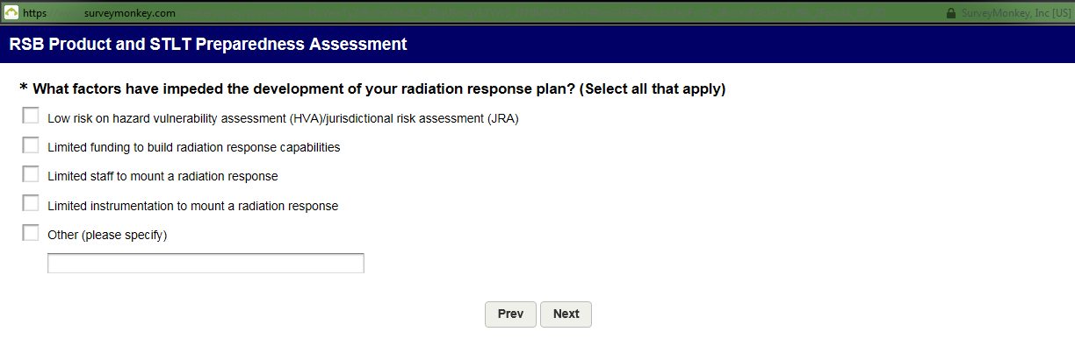
If Yes: Are you in the process of completing a radiation emergency response plan or radiation-specific annex to your all-hazards plan that addresses public health responsibilities
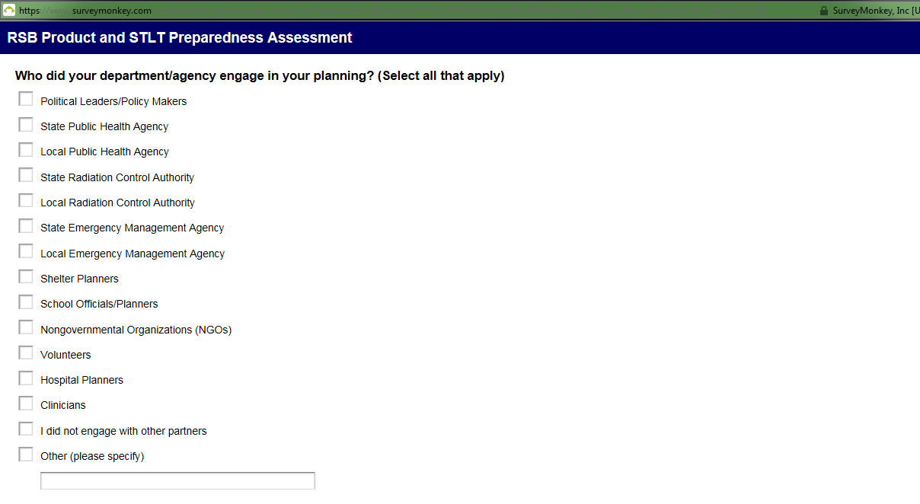
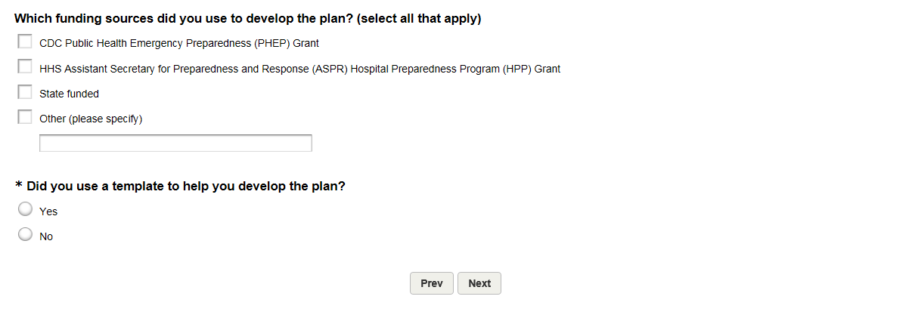
IF Yes: Did you use a template to help develop the plan:
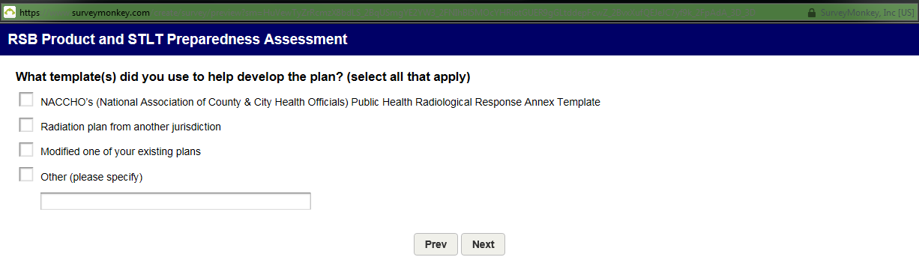

If Yes: Do you have a radiation emergency response plan or radiation-specific annex to your all-hazards plan that addresses public health responsibilities?
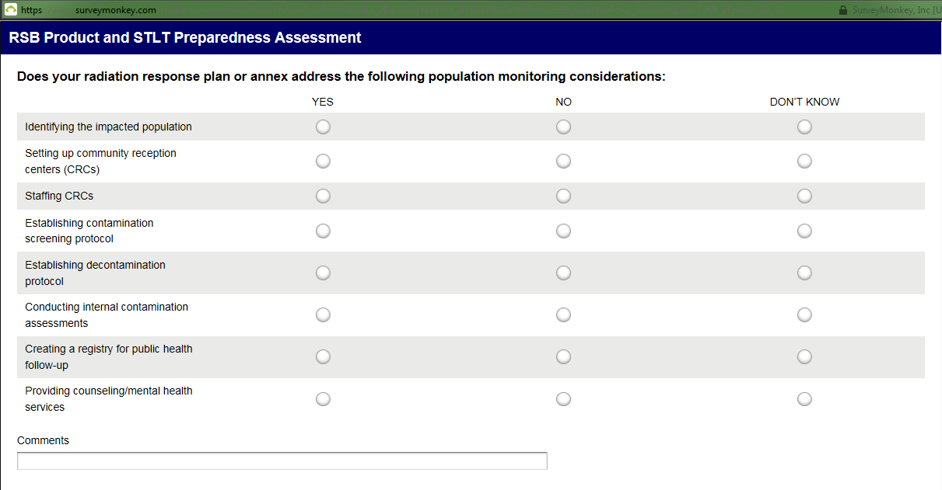
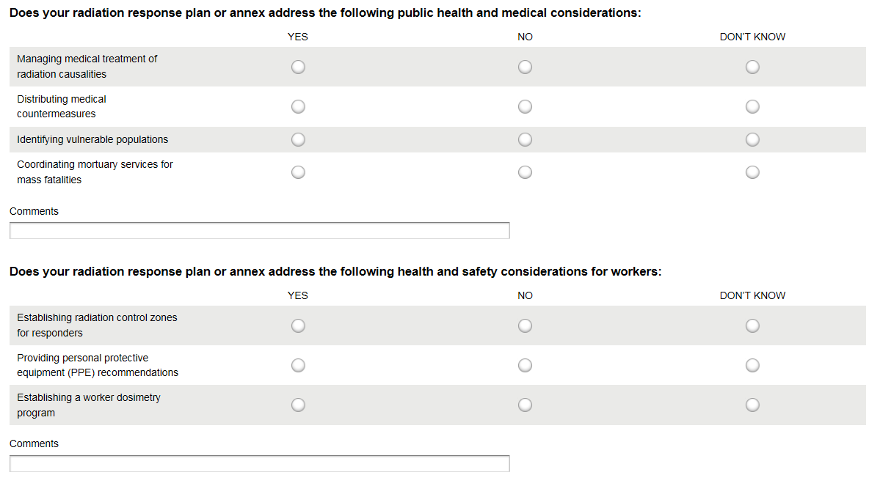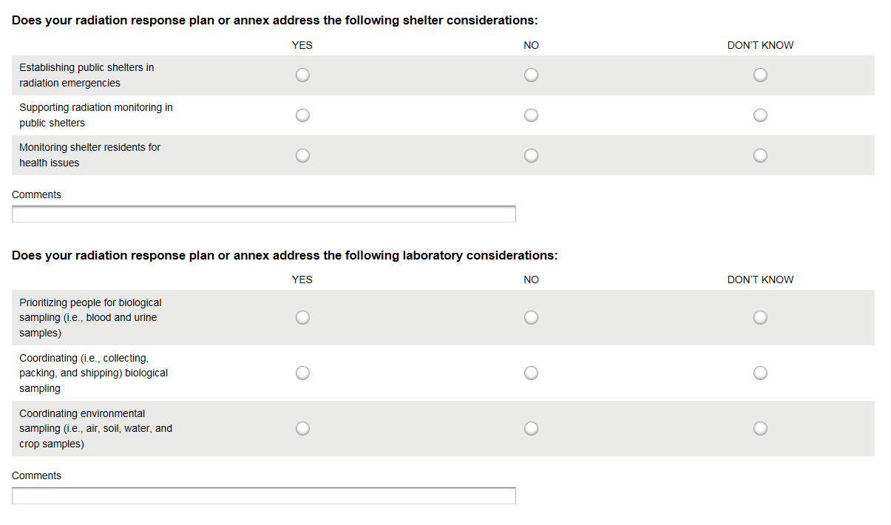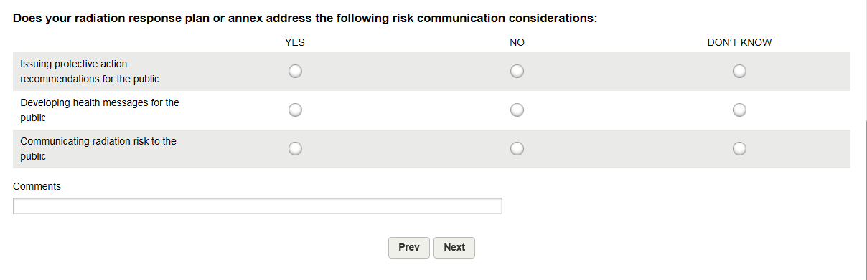
IF Yes: Did you use a template to help develop the plan:
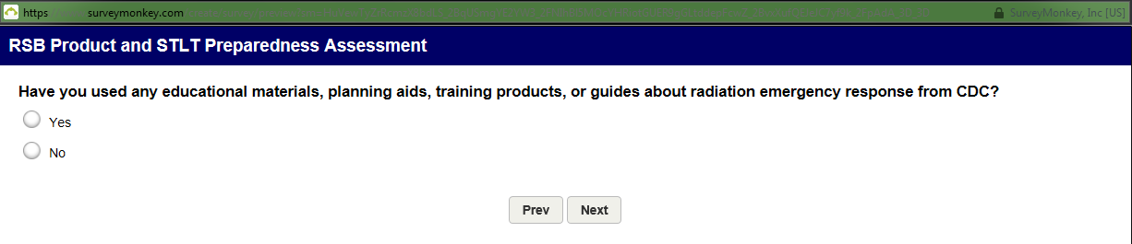

If Yes: Have you used any educational materials, planning aids, training products, or guides about radiation emergency response from CDC?
