Cc: Marty Cetron, MD



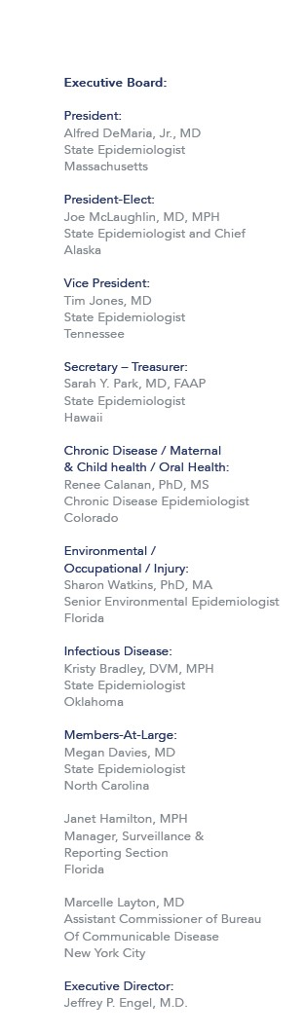

June 11

, 2015

Jeanette Rainey,

MPH, PhD

Senior Epidemiologist

Community Interventions for Infection Control Unit

Division of Global Migration and Quarantine

Centers for Disease Control and Prevention

Dear

Dr.

Rainey

,

The Council of State and Territorial Epidemiologists

has reviewed

the

*Mass Gathering*

*-*

*related Respiratory Disease Ou*

*tbreaks*

a

ssessment t

ool

and

agrees to

continue our

collaboration on the

proj

ect. We approve of the assessment tool

and related

communications.

Sincerely,

Jeffrey P. Engel, M.D.

Executive Director

Council of State and Territorial Epidemiologists

Kristy Bradley

,

DVM, MPH

Infectious Disease Steering Committee Chair

Council of State

and

Territorial Epidemiologists

