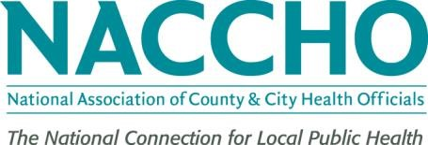

July 1, 2015

Jeanette J. Rainey, MPH, PhD

Epidemiologist

Division for Global Migration and Quarantine

1600 Clifton Road

Centers for Disease Control and Prevention

Atlanta, GA 30333

Dear Dr. Rainey:

I am writing to state the National Association of County and City Health Officials (NACCHO) support for your assessment regarding outbreaks of acute respiratory infections at mass gatherings. This work aligns well with current efforts underway to build surveillance capacity to detect disease outbreaks at mass gatherings and to respond appropriately to any detected outbreak. This is a large concern for our members as they prepare for upcoming events including the Pope’s visit to the U.S. NACCHO is happy to assist with this effort.



If you require additional information or have questions, please contact me at (202) 957-5710 or at caldridge@naccho.org.

Sincerely,



Chris Aldridge

Senior Director Infectious Disease and Informatics