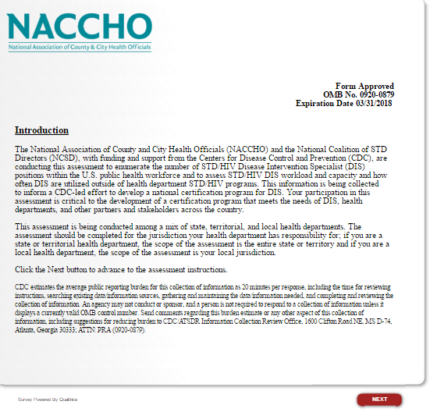
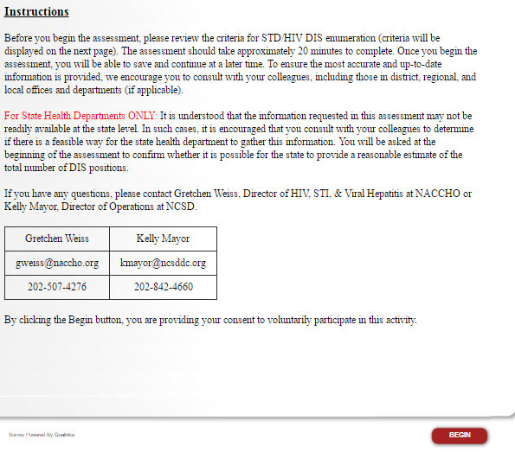

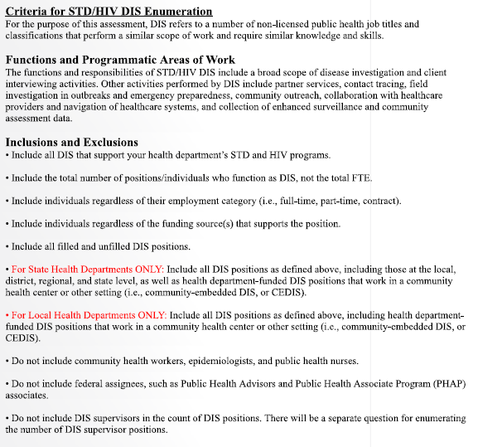
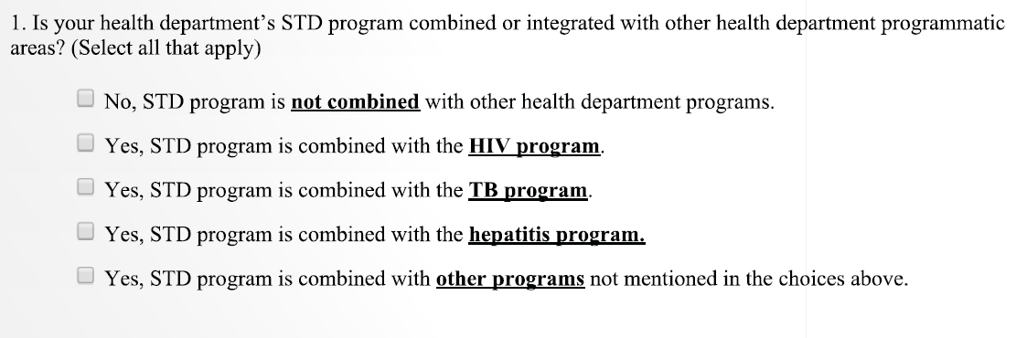

If you are a state health department, please answer question, 2. If you are a local health department, please skip questions 2-3 and proceed to question 4.

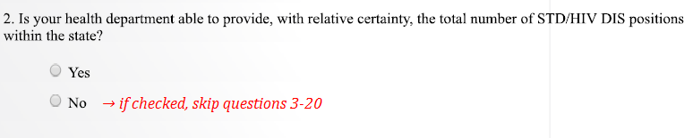

For states with a city or county health department that receives direct funding from the CDC for STD and/or HIV prevention, please answer questions 3. Otherwise, go to question 4.

States that should answer question 3 are California (Los Angeles and San Francisco), Georgia (Fulton County), Illinois (Chicago), Maryland (Baltimore), New York (New York City), Pennsylvania (Philadelphia), and Texas (Houston).

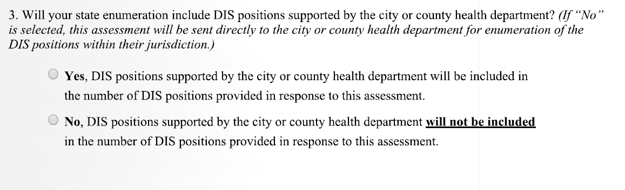

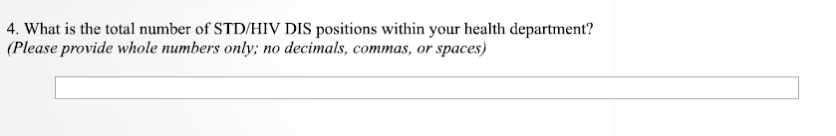

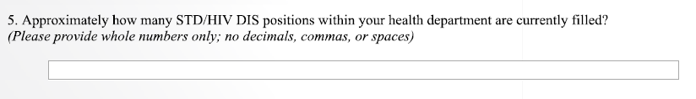

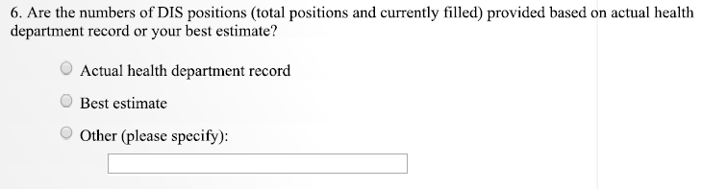

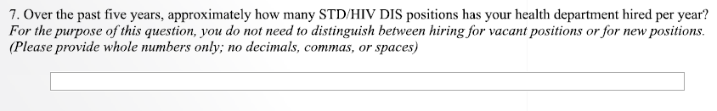

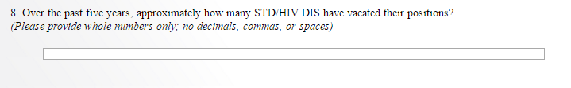

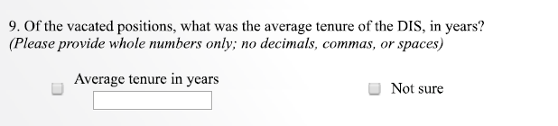

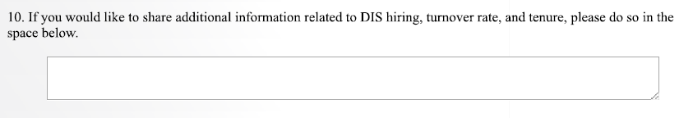

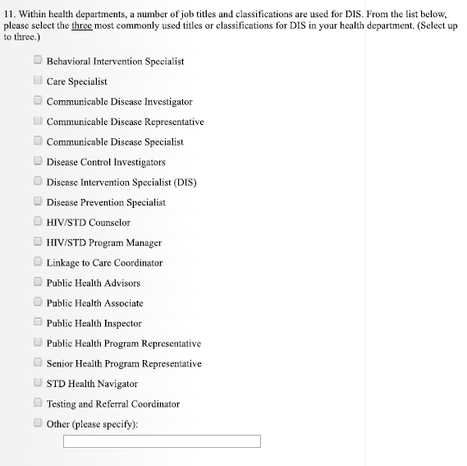

If you are a state health department, please answer question 12. If you are a local health department, please skip question 12 and proceed to question 13.

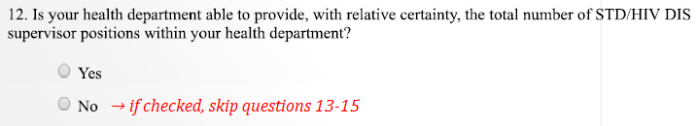

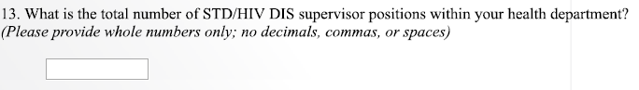

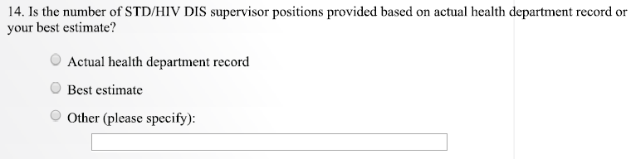

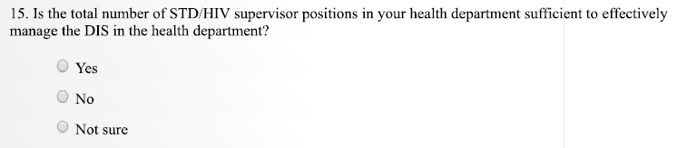

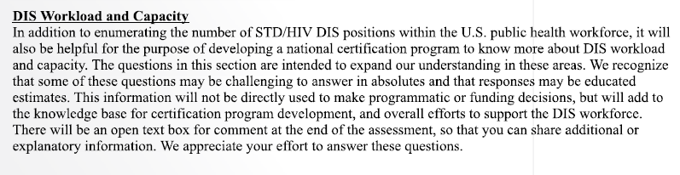

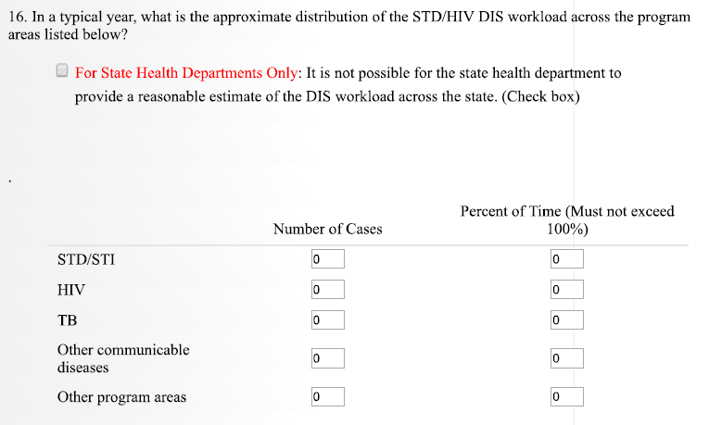

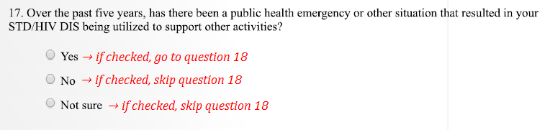

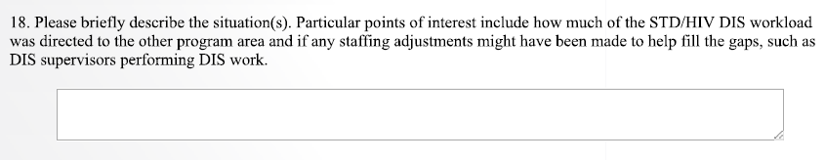

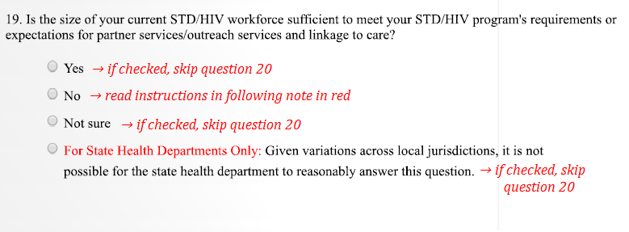

For respondents who reported fewer currently filled positions (in question 5) than the total number of positions in the health department (in questions 4) AND indicated that their DIS workforce is not sufficient (“No” for question 19), answer question 20. Otherwise, go to question 21.

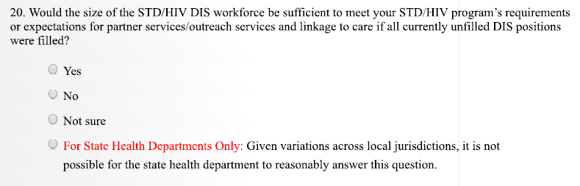

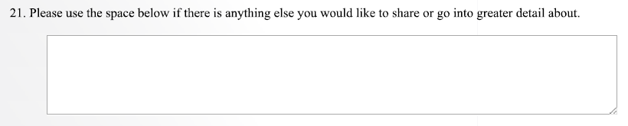

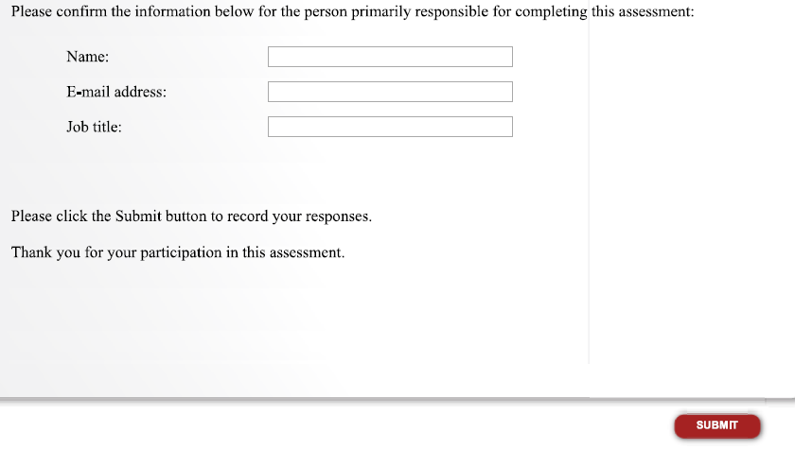

For State Health Departments that selected “No” for question 2 (Is your health department able to provide, with relative certainty, the total number of STD/HIV DIS positions within the state?), please read following note.

