Introduction
Thank you for participating in this questionnaire about the State, Tribal, Local, and Territorial Public Health Professionals Gateway (also known as the “STLT Gateway”) website. The purpose of this assessment is to learn more about the usefulness of the STLT Gateway, your information needs as a public health professional, and how the website can help meet those needs.
The STLT Gateway was developed by the Centers for Disease Control and Prevention’s Office for State, Tribal, Local and Territorial Support to serve as a hub for public health data, information, and news targeted specifically to state, tribal, local, and territorial public health leaders and professionals. Please know that you do not need to be familiar with the website to participate. Your feedback will inform improvements to the STLT Gateway.
Participation in this assessment is voluntary, and it will take approximately 5 minutes to complete. Your responses to all questions will be kept secure. CDC will share only aggregated data.
If you have any questions or concerns about the assessment, please contact us at ostltsfeedback@cdc.gov.

Visited STLT Gateway [All Respondents]
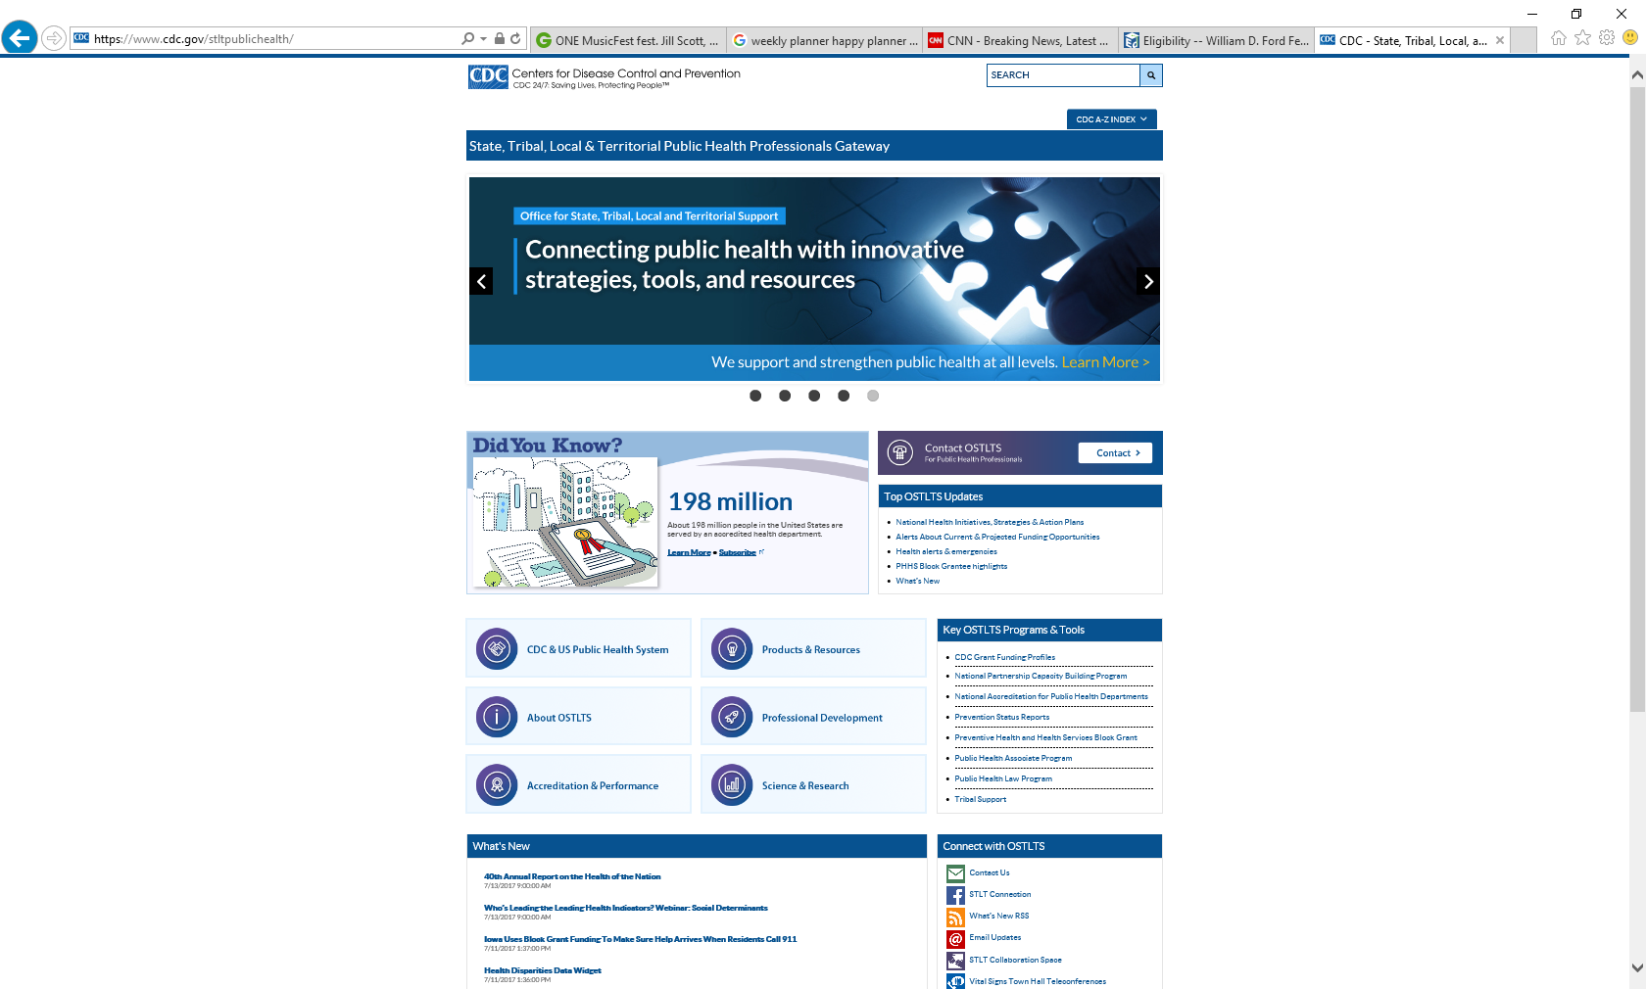
- Have you ever visited the State, Tribal, Local, and Territorial Public Health Professionals Gateway website (www.cdc.gov/stltpublichealth), also known as the “STLT Gateway”?
- Yes
- No [Skip to question 9]

User Needs [ONLY Respondents Who Have Visited Website]
- How often do you visit the STLT Gateway for work-related purposes?
- Frequently visit (more than once a week)
- Often visit (a few times per month)
- Occasionally/sometimes visit (a few times per quarter)
- Rarely visit (a few times per year or less) [go to question a]

- Why don’t you visit the STLT Gateway more often? (Select all that apply.)
- I need information from the website only a few times a year
- The content isn’t relevant to my job
- The website doesn’t have new information I need
- The website doesn’t have information useful to me
- It’s hard to find what I need
- Other, please specify_________________________

Rate the degree to which you agree or disagree with the following statements about the STLT Gateway:

- The information on the website is useful.
Strongly Disagree | Disagree | Neither Agree nor Disagree | Agree | Strongly Agree
  - (If marked “Disagree” or “Strongly Disagree” for “is useful”)
What are some reasons the website isn’t useful to you? __________________________

- The information on the website is up to date.
Strongly Disagree | Disagree | Neither Agree nor Disagree | Agree | Strongly Agree

- The information on the website meets my needs.
Strongly Disagree | Disagree | Neither Agree nor Disagree | Agree | Strongly Agree
  - (If marked “Disagree” or “Strongly Disagree” for “meets my needs”)
What are some reasons the website doesn’t meet your needs? ___________________

- The information on the website is easy to understand.
Strongly Disagree | Disagree | Neither Agree nor Disagree | Agree | Strongly Agree

- What information and resources are you looking for most often when you visit the STLT Gateway? (Select up to five topics.)
- Accreditation information for state, tribal, local, and territorial (STLT) health agencies
- Community health assessment and improvement resources
- Performance management and quality improvement resources
- Information about CDC (e.g., organizational structure, CDC budget)
- Information about CDC’s Office for State, Tribal, Local and Territorial Support (OSTLTS) or its programs
- Technical assistance or consultation from CDC leaders or experts
- Opportunities to connect with peers
- Data and scientific information for planning and evaluation
- Federal funding opportunities for STLT health agencies or organizations
- Training and professional development opportunities and tools
- Best practices and success stories from STLT health agencies
- Health-related laws and policies of states, territories, localities, or tribes
- Information about STLT health agencies and health officials
- Other ______________

- Complete this sentence:
I would visit the STLT Gateway more often if I knew I could find ______there.
(List up to five examples of information or resources that would help you perform your job more effectively.)
a. ___________________
b. ___________________
c. ___________________
d. ___________________
e. ___________________

[Skip to question 11]

User Needs [ONLY Respondents Who Have Not Visited Website]
- Which of the following topics are most useful to you in helping you do your job more effectively? (Select up to five topics.)
- Accreditation information for state, tribal, local, and territorial (STLT) health agencies
- Community health assessment and improvement resources
- Performance management and quality improvement resources
- Information about CDC (e.g., organizational structure, CDC budget)
- Information about CDC’s Office for State, Tribal, Local and Territorial Support (OSTLTS) or its programs
- Technical assistance or consultation from CDC leaders or experts
- Opportunities to connect with peers
- Data and scientific information for planning and evaluation
- Federal funding opportunities for STLT health agencies or organizations
- Training and professional development opportunities and tools
- Best practices and success stories from STLT health agencies
- Health-related laws and policies of states, territories, localities, or tribes
- Information about STLT health agencies and health officials
- Other ______________
- Complete this sentence:
I would visit a CDC website designed for state, tribal, local, and territorial public health professionals if I knew I could find ______there.
(List up to five examples of information or resources that would help you perform your job more effectively.)
a. ___________________
b. ___________________
c. ___________________
d. ___________________
e. ___________________

User Needs [All Respondents]
- When you look for public health information online, which of these formats are you most likely to use? (Select up to 5.)
- Research reports (e.g., surveillance summaries, evaluation reports, reports of evidence-based research findings)
- Journal articles
- White papers (e.g., position papers, policy or recommendations reports)
- Guidance documents
- Web pages with plain language summaries of research, programs, or policies
- Resource lists
- Videos
- Podcasts
- Webinars
- Infographics
- Interactive tools (e.g., interactive maps)
- Customizable materials you can adapt for your own needs (e.g., fact sheets, presentations)
- Content you can add to your website for free
- None of these formats
- Other (please specify) _______________

- Which of the following email updates or newsletters do you subscribe to? (Select all that apply.)
- Updates for State, Tribal, Local and Territorial Public Health Professionals
- Did You Know?
- Have You Heard? Facts from the Field
- CDC Vital Signs Town Hall Teleconference
- Prevention Status Reports
- Public Health Law News
- Prospective Public Health Associate Program Host Sites
- Tribal Support
- None of the above
- I’m not sure

RESPONDENT CHARACTERISTICS [All Respondents]

- Which best describes the type of public health agency or department in which you work? [Select one]
- State health department
- Local (city, town, county, district, region) health department
- Tribal agency/organization
- Territorial agency/organization
- Other, please specify:_____________

- Which of the following best describes the level of your position within your organization?
- Agency executive leader or manager (e.g., health official, public health director, senior deputy, or other executive leader)
- Division, branch, or unit leader or manager
- Program manager, administrator, or coordinator
- Non-manager

- Which of the following best describes your job?
- Accreditation coordinator
- Behavioral health professional
- Community health worker
- Economist
- Emergency preparedness and response professional
- Environmental health professional
- Epidemiologist
- Financial/Budget analyst
- Fiscal officer
- Grants specialist
- Health communicator/Public information officer
- Health educator
- Health scientist/Researcher
- Laboratory scientist/aide/technician
- Lawyer
- Nurse
- Nutritionist
- Quality improvement/Performance improvement specialist
- Physician/Medical officer
- Program evaluator
- Policy analyst
- Statistician
- Web manager/developer
- Other, please describe:_______________________

Thank You!
Thank you for participating in this assessment. Your input will help improve the usefulness of the STLT Gateway website for public health professionals.

