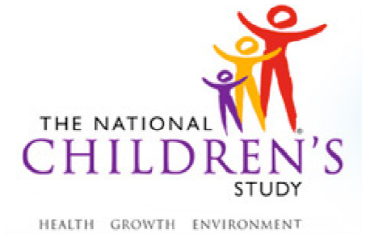

Assessment of Executive Function for the

National Children’s Study

Dear Parent,

We are writing to invite families with children 2 to 5 years of age to learn more about a project to develop measures of thinking skills and child personality for the National Children’s Study. This study is being conducted by child development professors at the University of Minnesota. The National Children’s Study is the largest study ever planned to study a national sample of children in the United States from before birth to adulthood. To get ready for this large national study, we are helping to design short and appealing measures for parents and preschoolers, with the help of families in Minnesota.

Parents who participate will complete questionnaires about their child’s behavior and do brief game-like computer activities. Children will do a variety of computer games and tasks or puzzles that measure school readiness. Family sessions take about an hour. To thank them for their help, parents who participate will be given a $25 gift card and children will receive toys, stickers, or books. If parents travel to the test site, they will be paid an extra $25 travel allowance. This study is completely voluntary and will not affect any relationships or services with this agency or the University of Minnesota.

You can learn more about this project by ... [relevant information for each site will be included here] or by calling us at our University of Minnesota office, (612) 625-1308.

Study conducted by

Professors Ann Masten, Philip Zelazo, and Stephanie Carlson

Institute of Child Development, University of Minnesota