Introduction

*Thank you for helping us to improve our Earth Science data discovery services. We welcome your input on our main Earthdata website (earthdata.nasa.gov) and our main data search and discovery tool, Earthdata Search (search.earthdata.nasa.gov). The results will help us identify and prioritize improvements to the Earthdata Website and Earthdata Search.*

*Your answers are voluntary, but your opinions are very important for this research. Your responses will be kept completely confidential, and you will never be identified by name.  CFI Group, a third-party research and consulting firm, is administering this survey via a secure server.  The time required to complete this survey will depend on how certain questions are answered, but will likely take about 10 minutes.  This survey is authorized by Office of Management and Budget Control No. 1090-0007, which expires May 31, 2018.*

Demographics

1. What country do you work from when you use our systems? __________________

2. What is your field or area of interest? ____________________

Website

*The Earthdata website (*[*https://earthdata.nasa.gov*](https://earthdata.nasa.gov)*) is intended to be the primary resource for information about NASA* *Earth Science information and datasets. It should be easy and intuitive to use. Thinking about the Earthdata website, please let us know what features work best for you and what features do not work.*

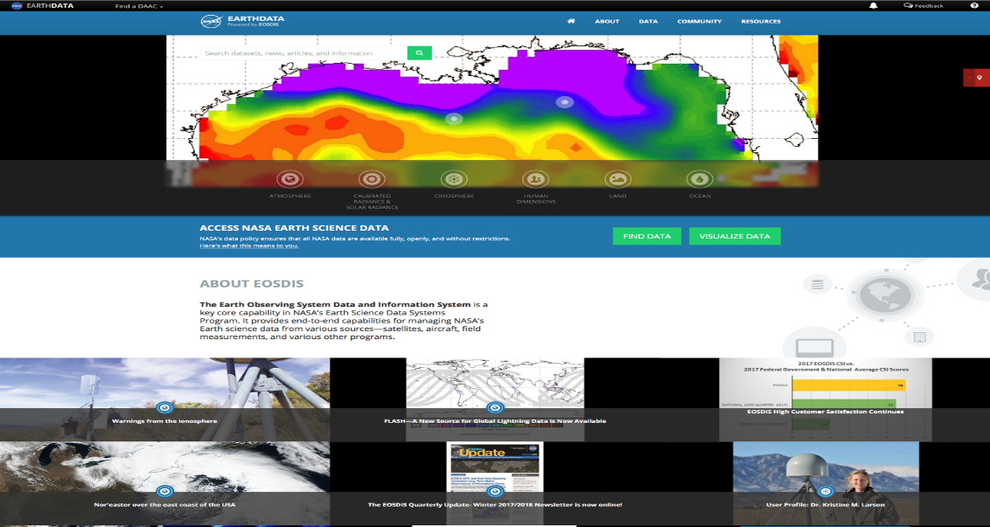

3. Why do you go to the Earthdata website? Select all that apply.

1. To find, get, or learn about data
2. To look for interesting images or visualizations
3. To look for information about a NASA mission or instrument
4. To look for information about a science discipline or topic
5. To read news and events
6. Other, please specify __________________

4. How often do you visit the Earthdata website?

1. Every day or frequently
2. Every week or so
3. Every month or so
4. Once or rarely

User Satisfaction Index Questions

5a. Please consider your overall experiences during the past year with the Earthdata website. Using a 10-point scale on which “1” means “very dissatisfied” and “10” means “very satisfied,” how satisfied are you with the Earthdata website?

5b. To what extent has the Earthdata website met your expectations?   
Please use a 10-point scale on which "1" means "not met your expectations" and "10" means, "exceeds your expectations."

5c. Now, imagine the ideal earth science information service. How well does Earthdata compare with that ideal?   
Please use a 10-point scale on which "1" means "Not very close to the ideal" and "10" means "Very close to the ideal."

Earthdata Features

6. Please rate the following features of the Earthdata website using a 10-point scale where “1” is “poor” and “10” is “excellent.”

1. Finding data
2. Finding information
3. Imagery and visualizations
4. Access to articles that are interesting and relevant
5. Access to information on science disciplines
6. Featured image on homepage with context
7. Overall website organization
8. Overall website look and feel

Earthdata Search

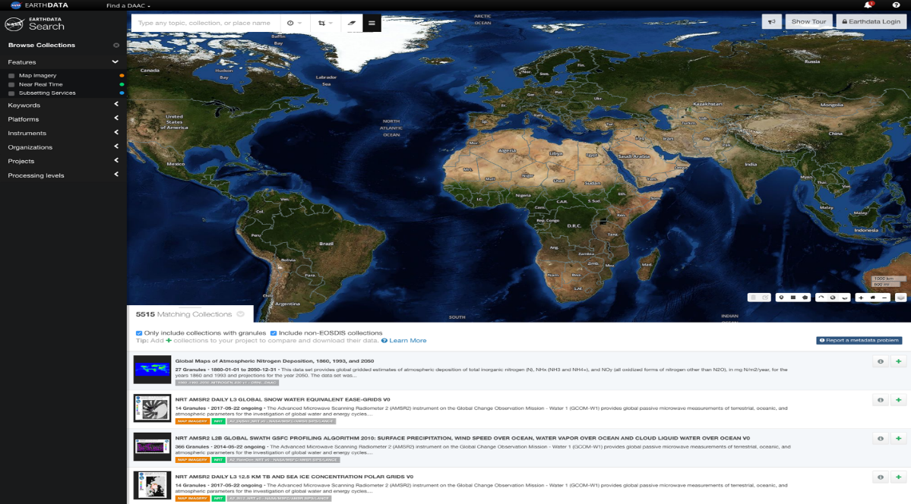

7a. Have you ever used Earthdata Search to search for data?

Yes (continue to Q7b)

No (skip to Q15a)

7b What was your primary goal in using Earthdata Search?

1. to download specific datasets
2. to browse available datasets
3. to discover related datasets
4. Other, please specify________________________________________

*At EOSDIS, we have focused on the need to organize data and information around ‘science discipline’ topics. Disciplines topics include cryosphere, ecology, oceanography, atmosphere chemistry, atmosphere dynamics, socio-economics, and so on.*

7c. How useful are the disciplines in searching data using a 10-point scale where “1” is “not useful at all” and “10” is “very useful.”

____________________________________________________

8a. When you use Earthdata Search, how often are you able to find data that you are interested in?

1. Always
2. Usually
3. Sometimes
4. Rarely or never

8b. Earthdata Search employs relevancy ranking techniques to ensure that the most relevant search results are shown at the top of the page. When you use Earthdata Search, how often are the most relevant results for you shown at or near the top of the page?

1. Always
2. Usually
3. Sometimes
4. Rarely or never

**(8c and 8d appear only if rarely or never to 8a)**

*Please help us improve our relevancy ranking by detailing your search query and expected results. You will need to refer to a search that did not produce the expected results*.

8c. If possible please cut and paste the entire search query URL from your browser.

8d. Please tell us what you expected to find in that search query compared to what the search query actually produced.

9. When you find the data you are interested in, how often are you able to download those data?

1. Always
2. Usually
3. Sometimes
4. Rarely or never

10. When you use Earthdata Search, the facets on the left side of the screen are intended to help you narrow your search or discover other possibilities. How useful are the following facets using a 10-point scale where “1” is “not useful at all” and “10” is “very useful.”

1. Keyword
2. Platforms
3. Instruments
4. Organizations
5. Projects
6. Processing Levels
7. I want a different facet: ________________________________

11) Are you able to manipulate (pan and zoom) the map at the top of the screen? (Yes/No)

1. Does the map work the way you want it to work? (Yes/No. Please explain __)

b) Do you find the map useful? (Yes/No. Please explain __)

c) I wish the map could: _______________________

12. If you have used Earthdata Search, has there been a time when you were confused or frustrated? –

Yes, please describe. _________________________________________

No

13. What one improvement to Earthdata Search would make it more useful or easier to use? ___________________________________________________________________

14. What type of training or documentation would you take advantage of if offered? Choose all that apply.

1. Virtual group training. Example: GoToMeeting, WebEx, Adobe Connect, etc...
2. Recorded video tutorials
3. Training manuals
4. Tool tips or Tool recipes within Earthdata Search
5. Other ______________________________________________________

Future Behaviors

15a. If asked how likely would you be to recommend the Earthdata website to others? Please use a 10-point scale where “1” means “Not Very Likely” and “10” means “Very likely.”

15b. How likely are you to continue to use the Earthdata website in the future?   
Please use a 10-point scale where “1’ means “Not Very Likely” and “10” means “Very Likely.”

16. Is there any other feedback, positive or negative, that you’d like to provide that was not previously covered in this survey?

___________________________________________________________________