# Current

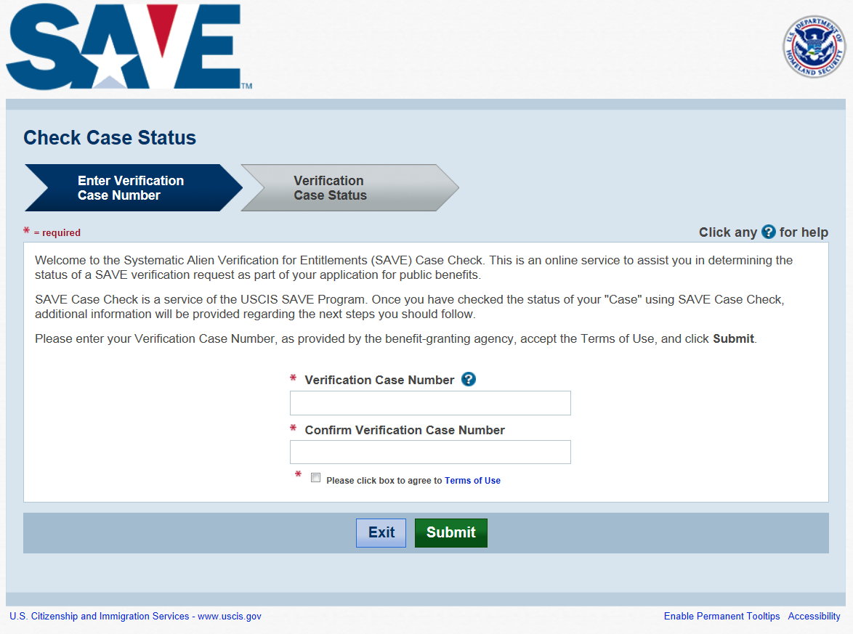

# C:\Users\dascott\Pictures\Case Check 1.PNGImproved