Appendix F
Respondent Communication Materials –
Institutions and Students
Note: The materials included in this appendix reference the field test study to be conducted in 2015. These materials will also be updated for use during for the full-scale study.

Brochure Text 2
Student Lead Letter 4
Parent Letter 5
Incentive Letter 6
DATA COLLECTION E-MAIL 7
E-MAIL REMINDER 1 - EXAMPLE 8
E-MAIL REMINDER 2 - EXAMPLE 9
E-MAIL REMINDER 3 - EXAMPLE 10
E-MAIL REMINDER 4 - EXAMPLE 11
E-MAIL REMINDER 5 - EXAMPLE 12
E-MAIL REMINDER 6 - EXAMPLE 13
REINTERVIEW REMINDER LETTER/EMAIL FOR CATI COMPLETES 14
REINTERVIEW LETTER/EMAIL FOR WEB COMPLETES 15
EXAMPLE OF TYPE OF STUDENT RECORD INSTRUCTIONS THAT WILL BE PROVIDED TO INSTITUTIONS 16
STUDENT RECORDS REQUEST LETTER TO INSTITUTION COORDINATOR 19
POSTSECONDARY DATA PORTAL FREQUENTLY ASKED QUESTIONS (FAQS) 21
NPSAS:2016 STUDENT RECORDS FREQUENTLY ASKED QUESTIONS (FAQS) 23
ONLINE POSTING ABOUT THE NCES POSTSECONDARY DATA PORTAL 26
SCREENSHOT OF POSTSECONDARY DATA PORTAL TASK MENU 27
DISCLOSURE NOTICE FOR NPSAS 28
STUDENT RECORDS REMINDER EMAIL 1 TO INSTITUTION COORDINATOR 29
STUDENT RECORDS REMINDER EMAIL 2 TO INSTITUTION COORDINATOR 30

Brochure Text
What is NPSAS?
The National Postsecondary Student Aid Study (NPSAS) field test is a national survey of approximately 4,500 undergraduate and graduate students who were enrolled during the 2014-2015 academic year. In order to have a complete picture of the costs and benefits of postsecondary education, it is important that we include students from a wide variety of schools and backgrounds.
NPSAS will collect information about students’ enrollment and employment history, income and educational expenses, and future plans. We also collect financial aid, student record, and related information from your institution and other sources, such as student loan databases and admissions testing agencies.
Why am I being asked to participate?
You are being asked to participate in NPSAS because you were enrolled in postsecondary education during the 2014-2015 academic year. Postsecondary education is any education beyond high school, including career and technical school, college, and graduate school.
Why is my participation important?
Your survey responses help educators, researchers, and policymakers at the local, state, and national levels understand national trends in enrollment patterns, education goals, employment, and backgrounds of students who pursue education after high school. Your experiences are unique, and if you choose not to participate in NPSAS, no one else can be substituted for you.
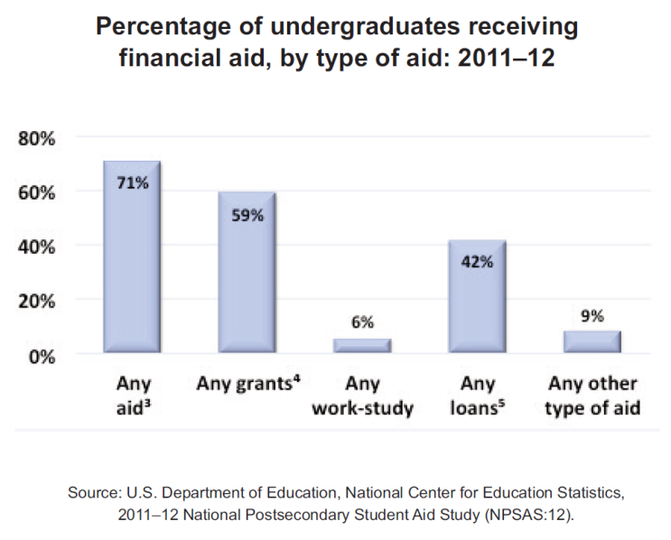
Did you know? About 71 percent of all undergraduates received some form of financial aid in the 2011-2012 school year. Nearly 60 percent of undergraduates received grant aid, and 42 percent took out loans to pay for their education.

What happens to the results?
As with results from previous rounds of NPSAS, results from the current study are scheduled to be released in [spring 2017] and will be posted on the NCES website (http://nces.ed.gov/surveys/npsas/) as soon as they are available. Your responses will be combined with those of other students and will be presented in summary form only. No individually-identifying information will be published.

Researchers will use NPSAS data to explore a wide variety of topics, including student loan debt and persistence in postsecondary education.
Who is conducting NPSAS?
The 2015-16 National Postsecondary Student Aid Study is conducted under the authority of the Higher Education Opportunity Act (HEOA) of 2008 (20 U.S.C. § 1015) and the Education Sciences Reform Act (ESRA) of 2002 (20 U.S.C. § 9543), which authorize NCES to collect and disseminate information about education in the United States.
NPSAS data are being collected under contract by RTI International, a nonprofit research organization based in North Carolina.
How will my information be protected?
NCES is required to follow strict procedures to protect personal information in the collection, reporting, and publication of data. All individually identifiable information supplied by individuals or institutions may be used only for statistical purposes and may not be disclosed or used in identifiable form for any other purpose, except as required by law (20 U.S.C. § 9573).
Data security procedures for NPSAS:16 are reviewed and approved by NCES data security staff. Your answers are secured behind firewalls and are encrypted during internet transmission using Secure Sockets Layer (SSL) protocol. All data entry modules are password protected and require the user to log in before accessing confidential data. Project staff is subject to large fines or imprisonment if individual responses are disclosed.
How do I participate?
You can complete the NPSAS interview online or over the phone.
ONLINE
Log onto the study website at https://surveys.nces.ed.gov/npsas/ using the Study ID and password provided in your welcome letter. The survey is mobile-optimized, so it can be easily completed on a mobile device.
OVER THE PHONE
Call our Help Desk at 1-877-677-2766 to speak to one of our professional interviewers.
Contact Us
NPSAS HELP DESK
1-877-677-2766

npsas@rti.org
https://surveys.nces.ed.gov/npsas/

Jennifer Wine, Ph.D.
NPSAS Project Director (RTI)
jennifer@rti.org
1-877-225-8470

Tracy Hunt-White, Ph.D.
NPSAS Project Officer (NCES)
tracy.hunt-white@ed.gov
1-202-502-7438

Student Lead Letter

NPSAS  Endorsed by  American Association of  Collegiate Registrars and  Admissions Officers  American Association of Community Colleges  American Association of State Colleges and Universities  American Council on Education  Association for Institutional Research  Association of American Colleges and Universities  Association of Catholic Colleges and Universities  Association of Private Sector Colleges and Universities  Association of Public and  Land-Grant Universities  Association of Schools of Allied Health Professions  The Carnegie Foundation for the Advancement of Teaching  The College Board  Council of Graduate Schools  The Council of Independent Colleges  Hispanic Association of Colleges and Universities  Midwestern Higher Education Compact  National Accrediting Commission of Cosmetology Arts and Sciences  National Association of College and University Business Officers  National Association for Equal Opportunity in Higher Education  National Association of Independent Colleges and Universities  National Association of Student Financial Aid Administrators  New England Board of Higher Education  Southern Regional Education Board  State Higher Education Executive Officers  The United Negro College Fund  Western Interstate Commission for Higher Education | February 10, 2015  «casenamenosuffixALLCAPS»  Study ID: «caseID»  Password: «password»m  «addr1»  «addr2»  «city», «state» «zip»  Dear «casenamenosuffix»:  I am writing to inform you that you have been selected to participate in the 2015-16 National Postsecondary Student Aid Study (NPSAS) field test, an important study that will help determine how students and their families meet the cost of education beyond high school.  Students from all types of institutions and all financial situations have been randomly selected for NPSAS. Many types of students are selected for NPSAS, ranging from first-time students to doctoral students, even if they are no longer enrolled in postsecondary education. Your survey responses will represent other students enrolled at <Duke University> who were not selected to participate in NPSAS. Therefore, your participation is critical to the success of the study.  If you complete the survey, you will receive $<incamt> as a token of our appreciation.  To complete the mobile-optimized survey:  - Go to: https://surveys.nces.ed.gov/npsas/.  - Type the Study ID and password (provided below) on the Home/Login page.  - Click “Login” to begin the survey.  Please complete the survey by March 10, 2015.  On average, the survey takes about <time> minutes to complete, depending on your answers. Your participation in this study is voluntary and will not affect any aid or other benefits you receive.  The enclosed brochure answers many common questions about the study and contains additional information on laws and procedures that protect the confidentiality of your responses. If you have questions about the study, or prefer to complete the survey over the phone, call the NPSAS help desk at 1-877-NPSAS-NOW (1-877-677-2766), or send an e-mail to npsas@rti.org. You can also learn more by visiting the study website at https://surveys.nces.ed.gov/npsas/.  I thank you in advance for your participation in this important study. Your cooperation is greatly appreciated.  Sincerely,  To complete the NPSAS survey:  https://surveys.nces.ed.gov/npsas/  Your Study ID: «caseID»  Your password: «password»m  Peggy G. Carr  Associate Commissioner  National Center for Education Statistics  Enclosures  «panelinfo» / «controlID»

Parent Letter

March 10, 2015

Parent or Guardian of «casenamenosuffix»
«addr1»
«addr2»
«city», «state» «zip»

Dear Parent or Guardian,

We are pleased to inform you that your student, «casenamenosuffix», has been selected to participate in the 2015-16 National Postsecondary Student Aid Study (NPSAS) field test, an important study that will help determine how students and their families meet the cost of education beyond high school.

Approximately 4,500 students from about 300 schools across the nation have been selected to participate in NPSAS. Students are being asked to complete a survey about their enrollment during the 2014-2015 academic year, including questions about [fname]’s degree, field of study, financial aid, employment while enrolled, educational experiences, and background. The survey only takes about <time> minutes, and «fname» will receive $<incamt> as a token of our appreciation for participating.

NPSAS is sponsored by the National Center for Education Statistics, part of the U.S. Department of Education. RTI International, an independent nonprofit research organization based in North Carolina, is conducting NPSAS data collection for NCES. Participation in NPSAS is voluntary and will not affect any aid or benefits [fname] may receive.

[Fname]’s responses are important to ensure that the results of NPSAS accurately reflect the circumstances of all types of students. Please help us today by encouraging «fname» to participate, and by calling the NPSAS Help Desk at 1-877-677-2766 to provide us with a phone number or email address that we can contact «fname». The survey is mobile-optimized and can be completed online or over the phone.

The enclosed brochure provides more information about the study, including information about confidentiality procedures. If you have any questions about NPSAS, please visit the NPSAS website at https://surveys.nces.ed.gov/npsas/, call the NPSAS Help Desk toll-free at 1-877-677-2766, or email npsas@rti.org.

I thank you in advance for your cooperation in this important research.

Sincerely,

Peggy G. Carr
Associate Commissioner
National Center for Education Statistics
Enclosures

Incentive Letter

March 25, 2015

«casename»
Study ID: «caseID»
«addr1»
«addr2»
«city», «state» «zip»

Dear «casename»:

On behalf of the National Center for Education Statistics in the U.S. Department of Education’s Institute of Education Sciences and the staff of the 2015-16 National Postsecondary Student Aid Study field test (NPSAS), we would like to thank you for completing your NPSAS survey. Your participation in this study is very important to its success. IF CHECK: [Enclosed you will find a check for $<incamt>].

IF SM AGREED TO REINTERVIEW: [We would also like to thank you for agreeing to complete the Quality Control Interview. We will contact you soon when your Quality Control Interview is available.]

Please do not hesitate to contact us directly at 1-877-677-2766 if we can provide any additional information or assistance.

Again, thank you for your time and willingness to participate.

Sincerely,

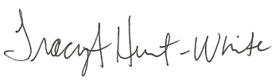
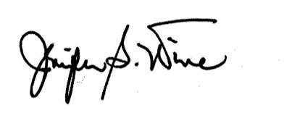
Jennifer Wine, Ph.D. Tracy Hunt-White, Ph.D.
Project Director, NPSAS Project Officer, NPSAS
RTI International National Center for Education Statistics

FS310/62483/1004

DATA COLLECTION E-MAIL

SUBJECT: The National Postsecondary Student Aid Study (NPSAS)
Congratulations [FNAME], you have been selected to participate in the 2015-16 National Postsecondary Student Aid Study (NPSAS) field test, an important study that will help determine how students and their families meet the cost of education beyond high school.
For your participation in NPSAS, we are asking you to complete a mobile-optimized survey. The survey will take about [time] minutes to complete, depending on your answers.
Click here to start your survey on our secure website.
If you complete the survey, you will receive $[incamt] as a token of our appreciation [ - payable by PayPal or check]. Please complete the survey by [March 10, 2015].
If you’d like more information about NPSAS, visit the study website at https://surveys.nces.ed.gov/npsas/, or call the NPSAS Help Desk at 1-877-NPSAS-NOW (1-877-677-2766). You can also complete the survey over the phone if you prefer.
Thank you for helping to make NPSAS a success.
Jennifer Wine, Ph.D. Tracy Hunt-White, Ph.D.
Project Director, NPSAS Project Officer, NPSAS
RTI International National Center for Education Statistics
jennifer@rti.org tracy.hunt-white@ed.gov
877-225-8470 202-502-7438

You can log in at https://surveys.nces.ed.gov/npsas/ using the Study ID and password provided below.
Study ID = [case id]
Password = [password]e

E-MAIL REMINDER 1 - EXAMPLE

SUBJECT LINE; The NPSAS Survey Needs Your Participation

[Fname], we still need you for NPSAS to be a success!

I noticed that you haven’t yet participated in the 2015-16 National Postsecondary Student Aid Study (NPSAS) field test. As a [student type], your participation is critical to the success of the study, so I hope you will participate soon. As a reminder, the survey is mobile-optimized and can be done completely online, and you’ll receive $<incamt> for participating [, payable by PayPal or check].

I understand that you may have questions or concerns about NPSAS – and we’re here to help! I’ve listed the answers to some of the most frequently asked questions about NPSAS below.

How can I participate in NPSAS?
It’s easy! Just [click here] to start to online survey, or go to https://surveys.nces.ed.gov/npsas/ and log in:
Study ID: [caseid]
Password: [password]
Or, complete the survey over the phone at 1-877-677-2766.

I’m enrolled in [graduate school]. Can I participate in NPSAS?
Yes! NPSAS includes students enrolled in all levels of postsecondary education, including [graduate and professional schools.] Your participation is important to making sure that the NPSAS results represent all types of students.

What if I don’t have time to complete the entire survey right now?
No problem! You can start the survey now and finish it later – you’ll pick up right where you left off.
If you have other questions, please contact the NPSAS Help Desk at 1-877-677-2766 or email us at npsas@rti.org. Thank you in advance for making NPSAS a success.

Jennifer Wine, Ph.D.
Project Director, NPSAS
RTI International

E-MAIL REMINDER 2 - EXAMPLE

SUBJECT: NPSAS Data Collection Continues…

…and it won’t be a success without you, [FNAME]!

Data collection for the 2015-16 National Postsecondary Student Aid Study (NPSAS) field test continues! The survey – which can easily be completed on your mobile device - takes approximately [time] minutes to complete, and when you complete your survey, you will receive $<incamt> as a token of our appreciation [, payable by PayPal or check].

To access the online survey on our secure website, click here.

Need help accessing the online survey? Prefer to complete the survey by telephone? Please call our Help Desk at 1-877-677-2766.

Thank you in advance for your participation in this very important study.

Sincerely,

Jennifer Wine, Ph.D.
Project Director, NPSAS
RTI International

Your secure login credentials:
https://surveys.nces.ed.gov/npsas/
Study ID: [caseid]
Password: [password]

E-MAIL REMINDER 3 - EXAMPLE

SUBJECT: Don’t Forget to Complete Your NPSAS Survey!

[FName], start it on your mobile device today!

We still need you to participate in the 2015-16 National Postsecondary Student Aid Study (NPSAS) field test for the U.S. Department of Education.

It only takes about <time> minutes and, once you’ve completed the survey, you’ll receive $<incamt>[, payable by PayPal or check]! Click here to get started right away!
You can complete the survey by phone by calling 1-877-677-2766, and find more information on the study website at https://surveys.nces.ed.gov/npsas/.
Thanks!

Jennifer Wine, Ph.D.
Project Director, NPSAS
RTI International
jennifer@rti.org
877-225-8470

YOUR SECURE LOGIN CREDENTIALS:
https://surveys.nces.ed.gov/npsas/
Study ID: [caseid]
Password: [password]

E-MAIL REMINDER 4 - EXAMPLE

SUBJECT: Don’t Delay! Participate in NPSAS Today!

We’ve been contacting you and other students at [NPSAS school] about participating in NPSAS, [Fname]!
NPSAS is an important study that will help policymakers understand the experiences of students enrolled in education after high school.
We know that you have a lot of demands on your time, but we need your help to make sure that the study is representative of all types of students. The survey takes only [time] minutes to complete, and we will send you $incamt for doing it -- just click here to get started!
You can also log in at our secure website:
https://surveys.nces.ed.gov/npsas/
Study ID: <caseID>
Password: <password>
Call 1-877-677-2766 to get more information about NPSAS or complete the survey by phone.
Thank you for considering participating in this important study. We hope you will – NPSAS won’t be the same without you.
Thanks!
Jennifer Wine, Ph.D.
Project Director, NPSAS
RTI International
jennifer@rti.org

E-MAIL REMINDER 5 - EXAMPLE

SUBJECT: NPSAS Needs You

[FName], NPSAS needs your help!

NPSAS only takes about <time> minutes and is easy to complete on your mobile device. And, when you complete the survey, you’ll receive $<incamt>[, payable by PayPal or check]!

To get started, just click here!
You can complete the survey by phone by calling 1-877-677-2766, and find more information on the study website at https://surveys.nces.ed.gov/npsas/.
Thanks!

Jennifer Wine, Ph.D.
Project Director, NPSAS
RTI International
jennifer@rti.org
877-225-8470

YOUR SECURE LOGIN CREDENTIALS:
https://surveys.nces.ed.gov/npsas/
Study ID: [caseid]
Password: [password]

E-MAIL REMINDER 6 - EXAMPLE

SUBJECT: Only You Can Make NPSAS A Success

NPSAS is easy to complete, <Fname>!

NPSAS can be completed on your mobile device! The survey only takes about <time> minutes. And, when you complete the survey, you’ll receive $<incamt>[, payable by PayPal or check]!

Click here to get started right away!
You can complete the survey by phone by calling 1-877-677-2766, and find more information on the study website at https://surveys.nces.ed.gov/npsas/.
Thanks!

Jennifer Wine, Ph.D.
Project Director, NPSAS
RTI International
jennifer@rti.org
877-225-8470

YOUR SECURE LOGIN CREDENTIALS:
https://surveys.nces.ed.gov/npsas/
Study ID: [caseid]
Password: [password]

REINTERVIEW REMINDER LETTER/EMAIL FOR CATI COMPLETES

«date»

«fname» «mname» «lname» «suffix» | Study ID: «caseid»
«addr1» | «panelinfo»
«addr2»
«city», «state» «zip»

Dear «fname» «lname»:

You may recall recently completing the National Postsecondary Student Aid Study (NPSAS) survey with a telephone interviewer. Thank you for your participation!

At the end of your survey, you were randomly selected for and agreed to participate in a quality control survey. This second survey will take just 10 to 15 minutes to complete and will determine how well our questions collected reliable information.

Please call 1-877-677-2766, provide our interviewer with the Study ID number listed below, and inform them that you are calling in reference to the quality control survey.

Study ID = «caseid»

If you have any questions or need assistance, you can call us toll-free at 1-877-225-8470 or e-mail us at npsas@rti.org.

If you have already received a telephone call and have completed this quality control survey, please disregard this message. Again, thank you for your time and willingness to participate.

Sincerely,
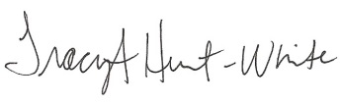
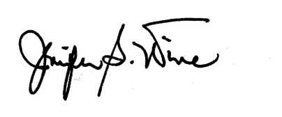
Jennifer S. Wine, Ph.D. Tracy Hunt-White, Ph.D.
Project Director, NPSAS Project Officer, NPSAS
RTI International National Center for Education Statistics

REINTERVIEW LETTER/EMAIL FOR WEB COMPLETES

«date»

«fname» «mname» «lname» «suffix» | Study ID: «caseid»
«addr1» | «panelinfo»
«addr2»
«city», «state» «zip»

Dear «fname» «lname»:

You may recall recently completing the National Postsecondary Student Aid Study (NPSAS) web survey. Thank you for your participation!

At the end of your survey, you were randomly selected for and agreed to participate in a quality control web survey. This second survey will take only about 10 to 15 minutes to complete, and will determine how well our questions collected reliable information.

To complete the quality control survey, please log in to our secure website at https://surveys.nces.ed.gov/npsas/ using the Study ID and password provided below:

Study ID = «caseid»
Password = «password»

If you have any questions or need assistance, you can visit our web site at https://surveys.nces.ed.gov/npsas/, you can call us toll-free at 1-877-225-8470, or you can e-mail us at npsas@rti.org.

If you have already completed this quality control survey, please disregard this message.

Again, thank you for your time and willingness to participate.

Sincerely,
Jennifer S. Wine, Ph.D. Tracy Hunt-White, Ph.D.
Project Director, NPSAS Project Officer, NPSAS
RTI International National Center for Education Statistics

EXAMPLE OF TYPE OF STUDENT RECORD INSTRUCTIONS THAT WILL BE PROVIDED TO INSTITUTIONS
From NPSAS:12 Student Record Instructions
In order to provide student records for the National Postsecondary Student Aid Study (NPSAS), you will need to access the secure NPSAS Student Records System at https://surveys.nces.ed.gov/NPSASschool. Log in using the username and password printed on the letter you received from RTI and you will see the Data Entry Tasks menu.
NOTE: You will need your institution’s username and password each time you, or other users at your institution, log in to the website. To ensure the security of your student data, it is important that you log off when you are going to be away from your computer and when you are finished with a data entry session.
Before you begin providing student records data, we need to collect some information about your institution, including term start and end dates, types of placement exams for entering students, and the most prevalent institution aid programs. From the Data Entry Tasks menu, click Provide Institution Information. Then click on each of the buttons, such as Term Information and Institution Aid, to provide your institution’s information, then click Save and Continue. When you have entered information in all three sections, click the Submit button on the Institution Information page. After clicking Submit, the information can be viewed, but not changed, because it is then loaded into the student-level component of the system. The link changes to View Institution Information and the Submit button disappears. For institutions with continuous enrollment, the Term Information button will be disabled.
There are 2 steps for providing and submitting student records data.
1 Provide Student Records Data
The student-level data we are requesting include contacting information, budget, enrollment during the study year (July 1, 2011-June 30, 2012), and financial aid awarded. You can find details on what data NPSAS needs from the Forms/Instructions link on the NPSAS website.
From the Data Entry Tasks menu, click Provide Student Records Data to route to the Student Records Data page. Data can be provided via the NPSAS Student Records System by either entering data online or preparing data offline and then uploading completed data files. Specifically, there are four options to choose from, described below.
Entering Student Records online
Option A: Case-Mode. Enter data online for one student at a time. Click on Case Mode, then select a student and a section to begin keying. After you have entered those data, you can set the Navigate Using button to either move to another section for that student or remain in the section and select another student. Validation can be performed at any time by clicking Validate. This will highlight missing data as well as data values that are out of the expected range or type.
Option B: Grid-Mode. Enter data online for multiple students at a time, in a format resembling a spreadsheet. Click on Grid Mode and select one or more students and a section to begin keying. After you have entered those data, you can either move to another section for those students or select other students in the same section. Some fields allow you to cut and paste data. Validation can be performed at any time by clicking Save. This will highlight missing data as well as data values that are out of the expected range or type and list these issues below the grid.
Preparing Student Records offline and then uploading data files
Option C: Upload Data Files Created From Our Excel Template. You may download an Excel template, fill in the requested data, and then upload the data. There is a button on the Student Records Data page to request the template. Because it must be customized for your institution, once you request it, the file will be prepared overnight. When the file is ready, you will be able to click Download Your Excel Template and an e-mail will be sent to your institution’s NPSAS coordinator to alert him/her. You will need to enable macros so that the validations can be performed and so the data will be formatted in the way we can process. If you need assistance enabling macros, contact the Help Desk (information below) or view the tutorial available from the Forms/Instructions link on the study website. Each of the four Student Records sections has its own worksheet in the template file. If you key in the data, it will be validated as you enter it. If you cut and paste, the data will not be checked for errors until you click Validate or upload to the website. When keying is complete, click Generate Contact Information CSV on the Contact Information worksheet of the template and note where the file that is created will be saved. Do this for each of the worksheets. Then, click Upload on the Student Records Data page and follow the instructions.
Option D: Upload Data Files a Programmer Creates. A programmer can create and upload four data files following the specifications that are accessed from the Student Records Data page. We can only accept comma separated values (CSV) formatted files. Institutions with programming capability and relatively large sample sizes may prefer this option. When the files are ready, click Upload on the Student Records Data page and follow the instructions.
For Option C and Option D, when a file is uploaded, it is checked for errors such as values outside of expected ranges. When errors are detected, they are displayed onscreen. Please correct these errors before attempting to upload the file again. The Upload Status table contains indicators for whether the file was uploaded successfully and with or without errors.
Regardless of the way in which you provide student records data, you may review and edit your data onscreen in the NPSAS Student Records System in either Case-Mode or Grid-Mode.
2 Finalize and Submit Student Records Data
Review Progress and Edit Data. When you click Review Summary Data on the Student Records Data page, you will be routed to the Student Records Summary page where each student has his/her own row and each section has its own column. Note the links No Data and Data Saved in the four section columns (e.g., Contact Information). No Data indicates that nothing has been saved (or uploaded) for the section. Please review these carefully before locking the data for a student. Data Saved indicates that the section has been accessed and the Save button pushed (or that one or more data elements were uploaded), but does not necessarily indicate that all data have been provided. If you need to edit or key data, click on the No Data or Data Saved link to route to Case-Mode for that student and section where you can enter or edit data as needed. If you prefer Grid-Mode, return to the Student Records Data page and select Grid Mode.
Change Student Study Eligibility. If you discover that a student does not meet the eligibility criteria for NPSAS (found by clicking the criteria on the Student Records Summary page), indicate this by unchecking the box in the Student is Eligible column in the student’s row. Then check the box(es) next to the reason(s) on the screen that appears and click Mark Ineligible. This action will alert us to not expect Student Records data for the student.
Lock Cases (Students). After you have provided and validated a student’s data, you will need to lock the case by clicking Lock in the Action column of that student’s row. Locking indicates that the data for that student are final and ready to be processed by RTI. You can also click Lock all in the column header to indicate that all available data have been provided for all students.
Submit Data. When you have provided data for all of your students and the cases are locked, please alert us by clicking the Submit (Process My Records) button on the Student Records Data page. Clicking the button will generate an e-mail to your institution’s NPSAS coordinator confirming submission of the data.
Additional information is available on the NPSAS website, including a tutorial for using the system from the Forms/Instructions link. If you need assistance, please contact the Help Desk toll-free at 1-888-677-2741 or via e-mail at NPSASrecords@rti.org

STUDENT RECORDS REQUEST LETTER TO INSTITUTION COORDINATOR
The text of the letter is also sent in an e-mail.

<date>
«salutation» «fname» «lname»
«Title»
«entity_name»
«phys_addr1»
«phys_addr2»
«phys_city», «phys_state» «phys_zip»

Your IPEDS UNITID: «entity_id»
Your password: «password»
Student Records Data Due: «expected_Date_curr»
Dear «salutation» «lname»,
Thank you for your continued participation in the 2015-16 National Postsecondary Student Aid Study (NPSAS) field test. We have finished processing the student enrollment file you provided, and have selected a random sample of [# sampled] students from your institution for participation in NPSAS. We now ask that you provide student record data for your sampled students using our secure Web application. Please complete the record abstraction and provide the requested data for these students on or before [DUE DATE]. We will send separate correspondence to the sampled students asking that they complete the NPSAS survey either online or by telephone interview.
We have developed an Internet-based Student Records System through which you (or someone on your staff) will be able to provide data for your selected students. The Student Records System is located on the same secure website that you have used for prior components of the study: https://surveys.nces.ed.gov/portal.
To assist you with the process of providing student record data, we have enclosed a Quick Guide to Providing Student Records Data describing how to access and use the Student Records software. You can find details on what data are needed for each sampled student from the Reference Materials page on the portal website. A list of your sampled students can also be found on the website, and you can easily print a hardcopy if you would like one.
There are three different methods available for providing the student data through the Student Records System:
- Case-mode – enter data online for one student at a time.
- Upload a data file created from our template – download an Excel template, fill in the requested data for all students, and upload the completed file.
- Upload data files created by an institution programmer – create and upload data files following the specifications on the portal website.

Please be assured that the security of your students’ data is of the utmost importance, and the Student Records software has been developed with this in mind. The system encrypts all data, with the latest technologies, before transmitting them over the Internet to NCES. In addition, access to the list of students (and to the forms used to enter their data) will require authentication using your IPEDS UNITID and unique password. They are printed near the top of this letter for your convenience. Please ensure that access is given only to those at your institution who will provide student records data.
Soon, we will call you to confirm your receipt of this material and the completion date for providing student records data. Help Desk staff will be available from 9:00 a.m. to 6:30 p.m. ET, Monday through Friday, to answer any questions you may have about the study or about using the Student Records System. You may contact the Help Desk at 1-855-500-1441, toll-free, or via e-mail at PortalHelp@rti.org.
Again, thank you for your continued participation in this important study.
Sincerely,
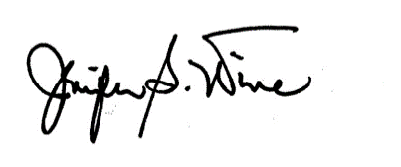
Jennifer Wine, Ph.D. Tracy Hunt-White, Ph.D.
Project Director, NPSAS Project Officer, NPSAS
RTI International National Center for Education Statistics
jennifer@rti.org tracy.hunt-white@ed.gov
1-855-500-1441 1-202-502-7438

Your institution’s response to the National Postsecondary Student Aid Study may be completed online at:

https://surveys.nces.ed.gov/portal

To access the Student Records System, log in using the IPEDS
UNITID below as your Username and enter the password below.

Your IPEDS UNITID: «entity_id»
Your password: «password»

POSTSECONDARY DATA PORTAL
FREQUENTLY ASKED QUESTIONS (FAQS)

- Who is collecting these data?

The National Center for Education Statistics (NCES), in the United States Department of Education's Institute of Education Sciences, has contracted with RTI International to collect data for the studies that use this website. The studies are listed on the Home page. RTI International is an independent, nonprofit research organization located in Research Triangle Park, NC that was established as a joint action of the three major universities in North Carolina: University of North Carolina at Chapel Hill, North Carolina State University, and Duke University. RTI International began operations in 1958 and has provided contract support to NCES on postsecondary education research since 1971.

- By what authority does NCES collect this information?

Congress has authorized (20 U.S.C. § 9543) the National Center for Education Statistics within the U.S. Department of Education to conduct these studies in compliance with the Education Sciences Reform Act of 2002 (20 U.S.C. § 9573), the Federal Statistical Confidentiality Order of 1997, the Privacy Act of 1974 (5 U.S.C. § 552a), and the E-Government Act of 2002. Each study has been approved by the U.S. Office of Management and Budget (OMB).

- Do we need to have the student’s permission before providing this information?

No. Student or parental consent is not required for release of student record information for the purposes of these studies. The data request conforms fully to the requirements of the Family Educational Rights and Privacy Act of 1974 (FERPA) (34 CFR Part 99). Under FERPA’s general consent rule, NCES is authorized to obtain student level data from institutions for any study-eligible student, without prior consent, if the disclosure is to an organization conducting studies for, or on behalf of, NCES. Student data are subject to strict protections that are adhered to by NCES and its contractor organizations. You can review this legislation on the U.S. Department of Education's website at http://www2.ed.gov/policy/gen/reg/ferpa.

FERPA regulations also stipulate that all disclosures be reported in the student record, with an indication of who received the information and their legitimate interests in the information. For schools without electronic student record systems, a Disclosure Notice may also be printed after log in from the Reference Materials page. These notices fulfill the requirements of 34 CFR 99.32(a) pursuant to the Family Educational Rights and Privacy Act (20 U.S.C. 1232g). Electronic student record systems will require the insertion of a similar statement.

- Are the data secure when sending via the portal website?

Yes. Secure Sockets Layer (SSL) protocol is used to encrypt the data transmitted over the Internet. All data entry modules are password-protected and require users to log in before they are allowed access to confidential data. The system automatically logs the user out after 20 minutes of inactivity. These safeguards prevent unauthorized access to the password-protected site.

The forms that gather data on the website require session cookies to run. RTI upholds the U.S. Department of Education's privacy policy with respect to the use of cookies. Web servers will send a cookie containing a unique session ID to the Web user in order to remember the user as he or she moves from page to page during a session. The cookie does not get written to the user's hard disk, nor does it contain personal data about the user. At the end of the session, the cookie is deleted when the user closes his/her browser. The most recent versions of Microsoft Internet Explorer, Google Chrome, and Mozilla Firefox allow for rejecting all cookies other than those required for session tracking.

- What about confidentiality of the data collected?

Both NCES and RTI International follow strict procedures to protect the privacy and confidentiality of study participants. All project staff members have signed confidentiality agreements and affidavits of nondisclosure. Any data released to the public will be in aggregate form (e.g., statistical tables, graphs). Information obtained may be used only for statistical purposes and may not be disclosed or used in identifiable form for any other purpose, except as required by law (Education Sciences Reform Act of 2002, 20 U.S.C. § 9573).

- How do we provide the data?

The data are submitted by either uploading a data file generated from your system or entering information into a web form or Excel template. After logging in, you will see a list of what is needed on the Postsecondary Data Portal Task Menu. You can click on any active menu option.

- What assistance is available from RTI staff?

The Help Desk at RTI International is available to answer your questions about the studies and using this website. Please call 1-855-500-1441 or e-mail PortalHelp@rti.org with your concerns. Help Desk staff are available from 9:00 a.m. to 6:30 p.m. Eastern time, Monday - Friday.

NPSAS:2016 STUDENT RECORDS
FREQUENTLY ASKED QUESTIONS (FAQS)

- Who is collecting these data?

The National Center for Education Statistics (NCES), in the United States Department of Education's Institute of Education Sciences, has contracted with RTI International to collect data for the studies that use this website. The studies are listed on the Home page. RTI International is an independent, nonprofit research organization located in Research Triangle Park, NC that was established as a joint action of the three major universities in North Carolina: University of North Carolina at Chapel Hill, North Carolina State University, and Duke University. RTI International began operations in 1958 and has provided contract support to NCES on postsecondary education research since 1971.

- By what authority does NCES collect this information?

Congress has authorized (20 U.S.C. § 9543) the National Center for Education Statistics within the U.S. Department of Education to conduct these studies in compliance with the Education Sciences Reform Act of 2002 (20 U.S.C. § 9573), the Federal Statistical Confidentiality Order of 1997, the Privacy Act of 1974 (5 U.S.C. 552a), and the E-Government Act of 2002. Each study has been approved by the U.S. Office of Management and Budget (OMB).

- How was my institution selected?

The National Postsecondary Student Aid Study (NPSAS) scientifically samples institutions from all Title IV institutions included in the Integrated Postsecondary Education Data System (IPEDS). For the longitudinal studies, sample members have identified which institutions they attended when completing the student interview; this information may also come from other administrative data sources. Transcripts and financial aid records are collected from the postsecondary institutions attended by sample members.

- Why is participation important?

The quality and affordability of postsecondary education are vital concerns for students and their families. The National Postsecondary Student Aid Study (NPSAS) is designed to describe how students meet the cost of education beyond high school and it provides comprehensive data on the enrollment status, education goals, employment, and demographic characteristics of postsecondary students.

The longitudinal studies collect data from transcripts, financial aid records, and/or student interviews to provide much-needed information on the course of study of today’s college students as they begin, leave, and re-enter postsecondary study, transfer between institutions, and complete programs at all levels of institutions. The combination of transcripts and other study data collected through interviews, file matching, and record abstraction affords researchers the opportunity to summarize the undergraduate and graduate paths taken by sample members and provides them with an important link between academic performance and outcomes.

- Do we need to have the student’s permission before providing this information?

No. Student or parental consent is not required for release of student record information for the purposes of these studies. The data request conforms fully to the requirements of the Family Educational Rights and Privacy Act of 1974 (FERPA) (34 CFR Part 99). Under FERPA’s general consent rule, NCES is authorized to obtain student level data from institutions for any study-eligible student, without prior consent, if the disclosure is to an organization conducting studies for, or on behalf of, NCES. Student data are subject to strict protections that are adhered to by NCES and its contractor organizations. You can review this legislation on the U.S. Department of Education's website at http://www2.ed.gov/policy/gen/reg/ferpa.

FERPA regulations also stipulate that all disclosures be reported in the student record, with an indication of who received the information and their legitimate interests in the information. For schools without electronic student record systems, a Disclosure Notice may also be printed after log in from the Reference Materials page. These notices fulfill the requirements of 34 CFR 99.32(a) pursuant to the Family Educational Rights and Privacy Act (20 U.S.C. 1232g). Electronic student record systems will require the insertion of a similar statement.

- Are the data secure when sending via the portal website?

Yes. Secure Sockets Layer (SSL) protocol is used to encrypt the data transmitted over the Internet. All data entry modules are password-protected and require users to log in before they are allowed access to confidential data. The system automatically logs the user out after 20 minutes of inactivity. These safeguards prevent unauthorized access to the password-protected site.

The forms that gather data on the website require session cookies to run. RTI upholds the U.S. Department of Education's privacy policy with respect to the use of cookies. Web servers will send a cookie containing a unique session ID to the Web user in order to remember the user as he or she moves from page to page during a session. The cookie does not get written to the user's hard disk, nor does it contain personal data about the user. At the end of the session, the cookie is deleted when the user closes his/her browser. The most recent versions of Microsoft Internet Explorer, Google Chrome, and Mozilla Firefox allow for rejecting all cookies other than those required for session tracking.

- What about confidentiality of the data collected?

Both NCES and RTI International follow strict procedures to protect the privacy and confidentiality of study participants. All project staff members have signed confidentiality agreements and affidavits of nondisclosure. Any data released to the public will be in aggregate form (e.g., statistical tables, graphs). Information obtained may be used only for statistical purposes and may not be disclosed or used in identifiable form for any other purpose, except as required by law (Education Sciences Reform Act of 2002, 20 U.S.C. § 9573).

- Where do I go for the information requested?

The information needed for each of the sampled students is typically collected from three distinct sources at your institution: the Admissions or Registrar’s Office, the Bursar’s or Business Office, and the Financial Aid Office. If you require assistance after reviewing the Quick Guide to Providing Student Records Data, please contact the Help Desk with your questions at 1-855-500-1441, toll-free, or via e-mail at PortalHelp@rti.org.

- How long does it take to collect student records data for NPSAS?

Our estimates indicate that providing the requested student records data will take about [{if field test}13 / {if full-scale} 20] hours on average. If you have any concerns with the amount of time it is taking you to provide the requested data, please call the Help Desk at 1-855-500-1441, toll-free. RTI will work with you to successfully complete this data collection effort.

- How do we provide the data?

There are three methods available for providing the student records data through the online NPSAS Student Records System: keying data into the system, filling in and then uploading an Excel template, or uploading data files created by an institution programmer.

- Can I provide a data file instead of using the online data entry option?

Yes. You can download an Excel template to create the data file we need, or a programmer can create data files according to the specifications available on the Student Records Data page of the website. If you have questions, please contact the Help Desk at 1-855-500-1441 or e-mail PortalHelp@rti.org.

- Do I need to supply the student’s Social Security Number (SSN) in NPSAS Student Records if we already provided it on the student enrollment list?

No. If your institution provided each student’s SSN on the student enrollment list, it will be displayed in the Student Records System so that you can be sure you are entering data for the correct student. Please correct the SSN if needed. The student’s SSN is needed to perform file matches to other data sources, including the Central Processing System (CPS).

- What assistance is available from RTI staff?

The Help Desk at RTI International is available to answer your questions about the studies and using this website. Please call 1-855-500-1441 or e-mail PortalHelp@rti.org with your concerns. Help Desk staff are available from 9:00 a.m. to 6:30 p.m. Eastern time, Monday - Friday.

ONLINE POSTING ABOUT THE NCES POSTSECONDARY DATA PORTAL

Welcome to the NCES Postsecondary Data Portal
About this website
This website serves as a portal for institutions to provide data for studies sponsored by the National Center for Education Statistics (NCES), United States Department of Education. Each of the studies collects data that are used by NCES for reporting and analysis. Any data released to the public will be in aggregate form (e.g., statistical tables, graphs). Review the FAQs or log in to learn more. Background information on each study can be accessed from the Home page.
The Education Sciences Reform Act of 2002 (ESRA) (20 U.S.C. § 9543) authorizes NCES to collect and disseminate information about education in the United States. NCES is the primary federal entity for collecting and analyzing data related to education in the U.S. and other nations. NCES is located within the Institute of Education Sciences of the U.S. Department of Education. NCES fulfills a Congressional mandate to collect, collate, analyze, and report complete statistics on the condition of American education; conduct and publish reports; and review and report on education activities internationally.
NCES has contracted with RTI International* to conduct these studies. RTI is an independent, nonprofit contract research organization located in Research Triangle Park, NC, that was established by a joint action of three major universities in North Carolina: University of North Carolina at Chapel Hill, North Carolina State University, and Duke University. RTI began operations in 1958 and has provided contract support to NCES on postsecondary research that dates back to 1971.
Annually, NCES also conducts a system of interrelated surveys entitled the Integrated Postsecondary Education Data System (IPEDS) through a different website. IPEDS gathers information from every college, university, and technical and vocational institution that participates in the federal student financial aid programs. These data are made available to students and parents through the College Navigator college search Web site and to researchers and others through the IPEDS Data Center.
*RTI International is a registered trademark and trade name of Research Triangle Institute.

SCREENSHOT OF POSTSECONDARY DATA PORTAL TASK MENU

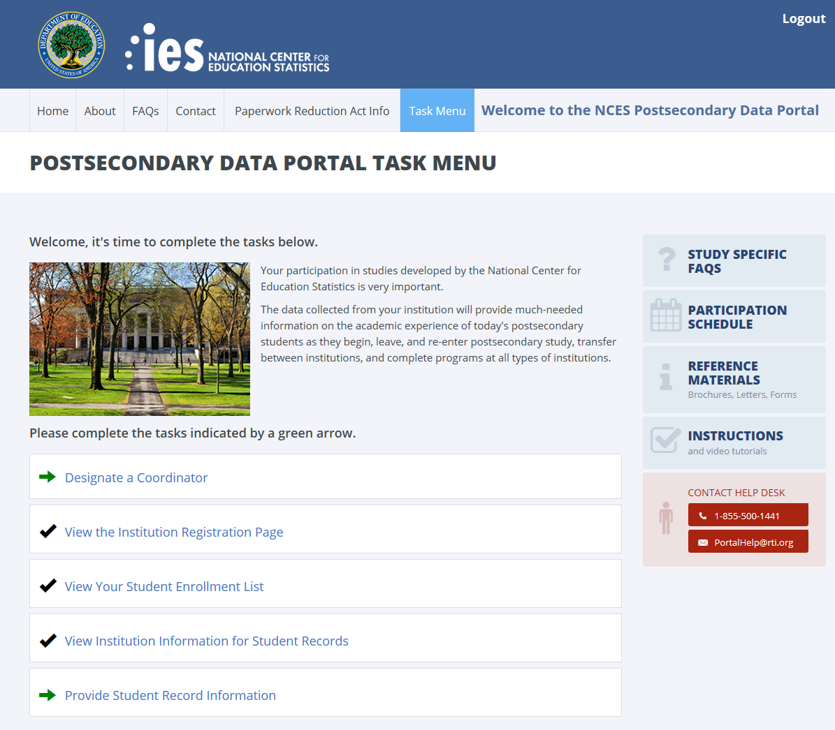
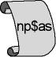
2015-16 National Postsecondary Student Aid Study
(NPSAS:16) Field Test

DISCLOSURE NOTICE FOR NPSAS

Information from student records for this individual has been provided to RTI International, a data collection agent for the U.S. Department of Education for NPSAS. This disclosure statement fulfills the requirement of 34 CFR 99.32(a) pursuant to the Family Educational Rights and Privacy Act of 1974 (20 U.S.C. 1232g).
This individual is included in the sample for the 2015-16 National Postsecondary Student Aid Study (NPSAS) field test. Strict protection of all information obtained from individuals selected for participation in NPSAS is assured by current federal laws and regulations. All responses that relate to or describe identifiable characteristics of individuals may be used only for statistical purposes and may not be disclosed or used in identifiable form for any other purpose, except as required by law (20 U.S.C. § 9573).
March 2015
OMB # 1850-(insert number)
Expiration Date: (insert date)

STUDENT RECORDS REMINDER EMAIL 1 TO INSTITUTION COORDINATOR

Dear «salutation» «lname»:

I am writing as a follow-up to the package you should have received recently that included a letter from me about NPSAS Student Records data collection, which is the final institutional component of the 2015-16 National Postsecondary Student Aid Study (NPSAS) field test. The letter requests that you log on to the secure website and provide student records data for sampled students through the Student Records System.

NPSAS data collection is being conducted for the National Center for Education Statistics (NCES), U.S. Department of Education by RTI International, a not-for-profit research organization. The data your institution provides are very important to the success of the study.

Please find below a link to the NCES Postsecondary Data Portal website as well as the username and password needed to access the site and provide data.

Website: https://surveys.nces.ed.gov/portal
Your IPEDS UNITID: «entity_id»
Your PASSWORD: «password»

If you have any questions about the study or procedures involved, please contact the Help Desk at 1-855-500-1441 or via e-mail at PortalHelp@rti.org.

Thank you again for your cooperation.

Sincerely,
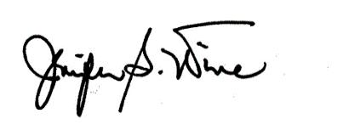
Jennifer Wine, Ph.D.
Project Director, NPSAS
RTI International

STUDENT RECORDS REMINDER EMAIL 2 TO INSTITUTION COORDINATOR

Dear «salutation» «lname»:

I am writing to remind you about the 2015-16 National Postsecondary Student Aid Study (NPSAS) field test that your institution is participating in this [spring/summer]. Data collection is conducted by RTI International for the National Center for Education Statistics in the U.S. Department of Education’s Institute of Education Sciences. By providing student records data for the sampled students, you make an important contribution to research that will help determine how students and their families meet the cost of education beyond high school.

If you are currently preparing the data, thank you. If you have not begun, please do so. We need representation of all the types of institutions and students to compile the most valuable, accurate data.

Please find below a link to the NCES Postsecondary Data Portal website as well as the username and password needed to access the site and provide data.

Website: https://surveys.nces.ed.gov/portal
Your IPEDS UNITID: «entity_id»
Your PASSWORD: «password»

If you have any questions about the study or procedures involved, please contact the Help Desk at 1-855-500-1441 or via e-mail at PortalHelp@rti.org.

Thank you for your participation in this important study.

Sincerely,
Jennifer Wine, Ph.D.
Project Director, NPSAS
RTI International

