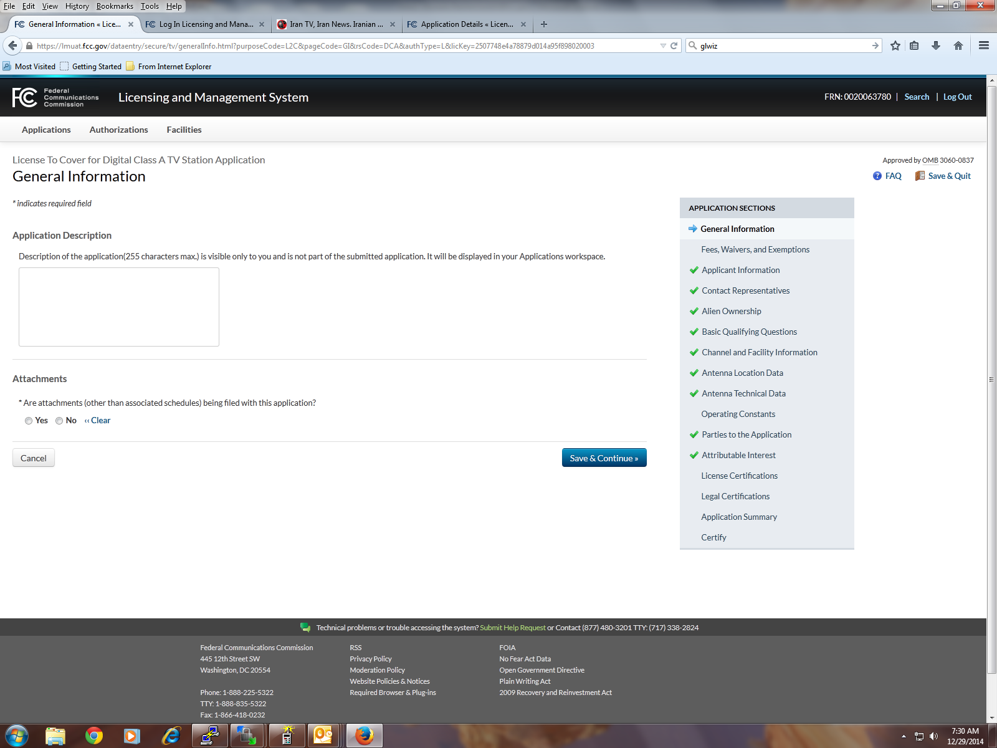

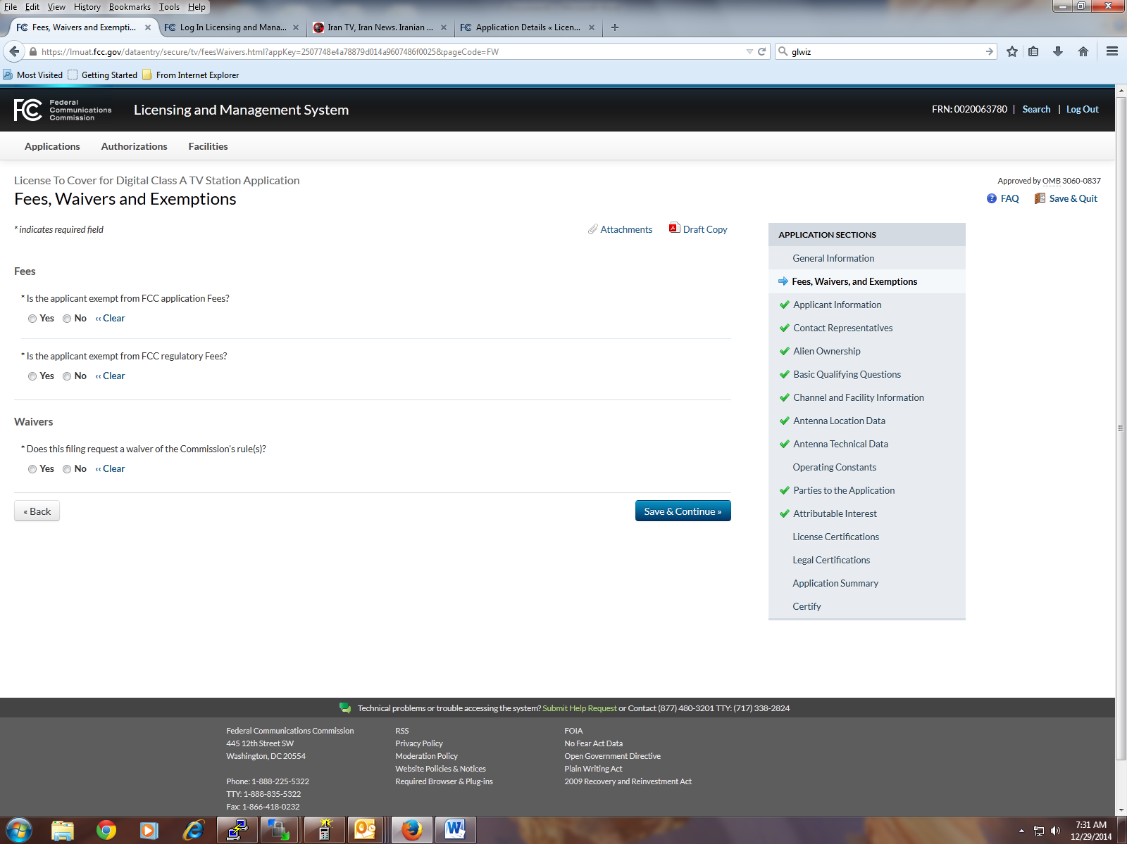

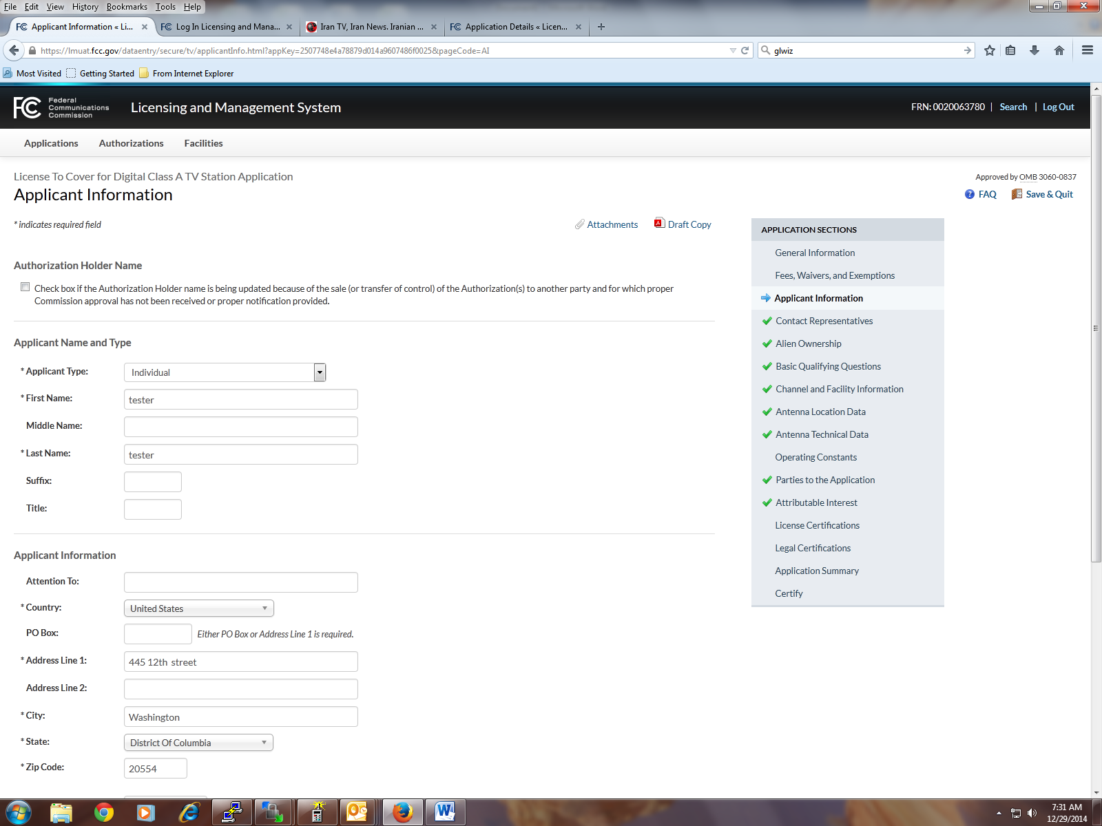

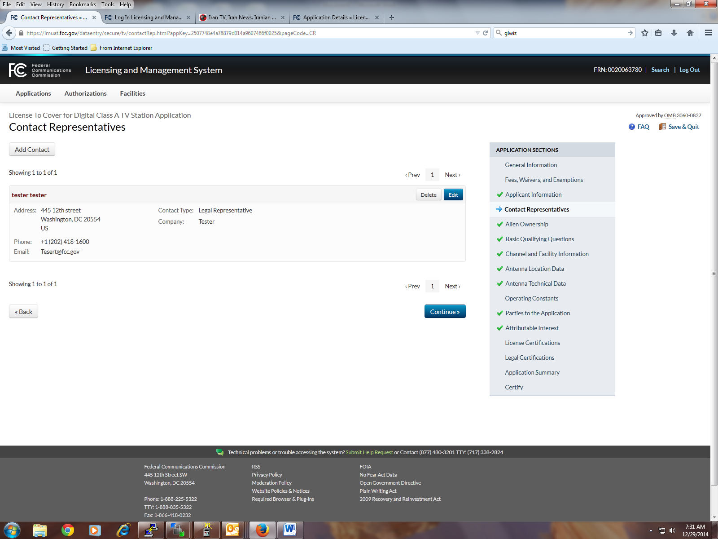

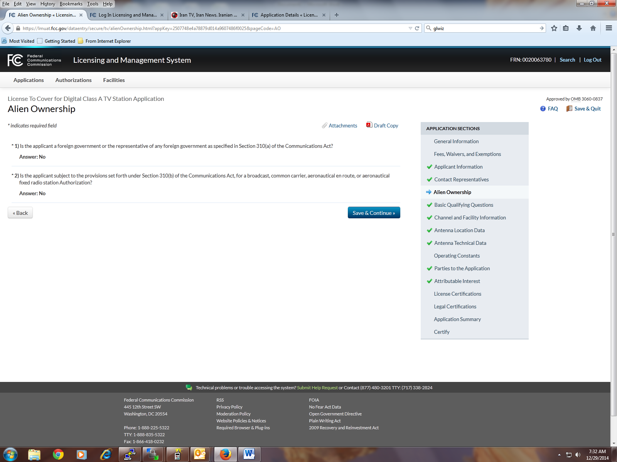

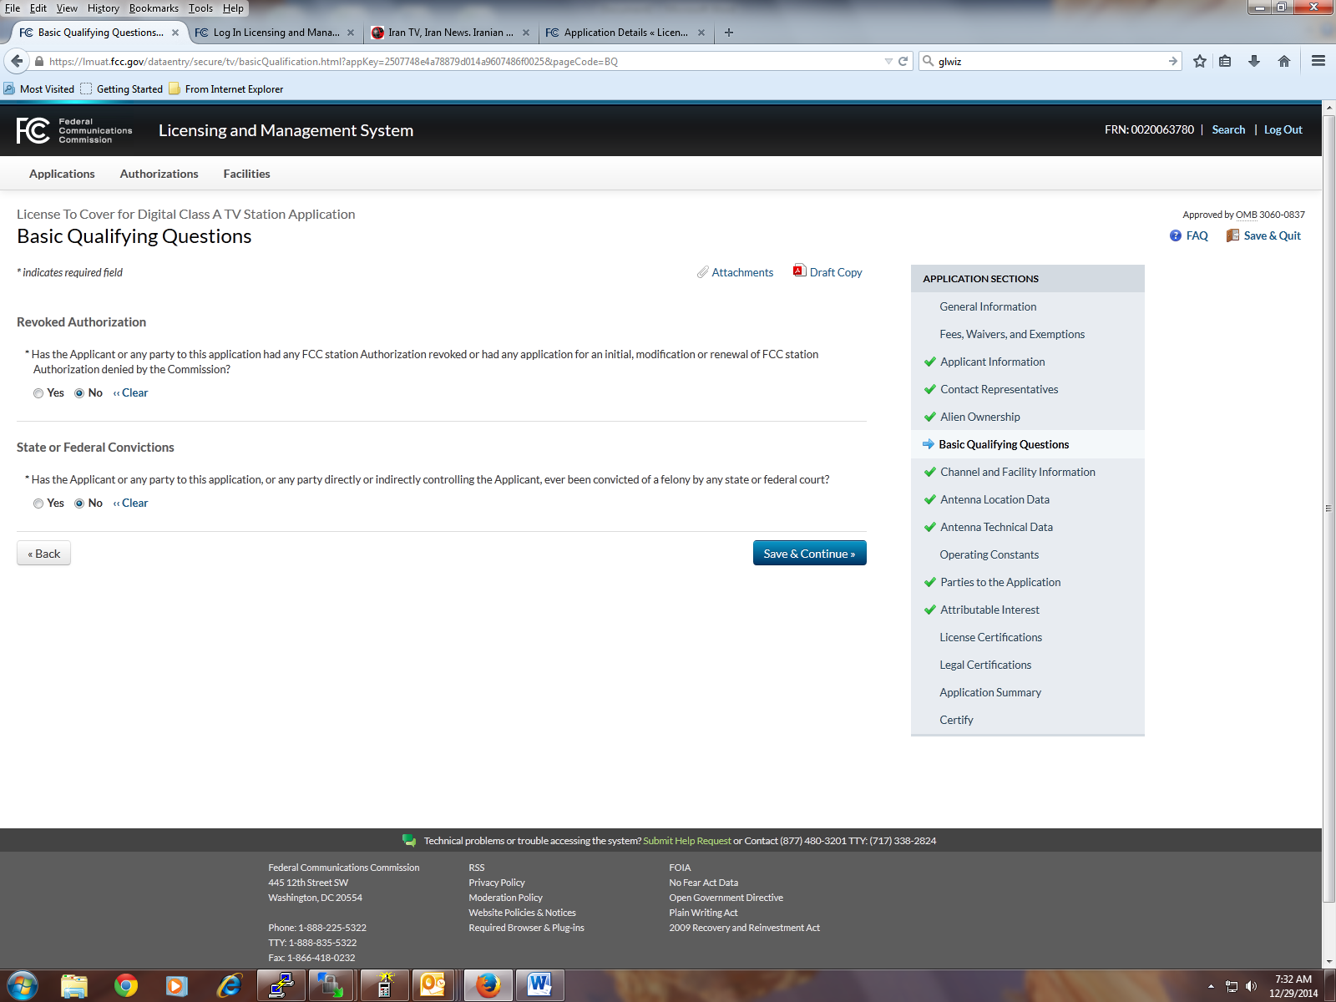

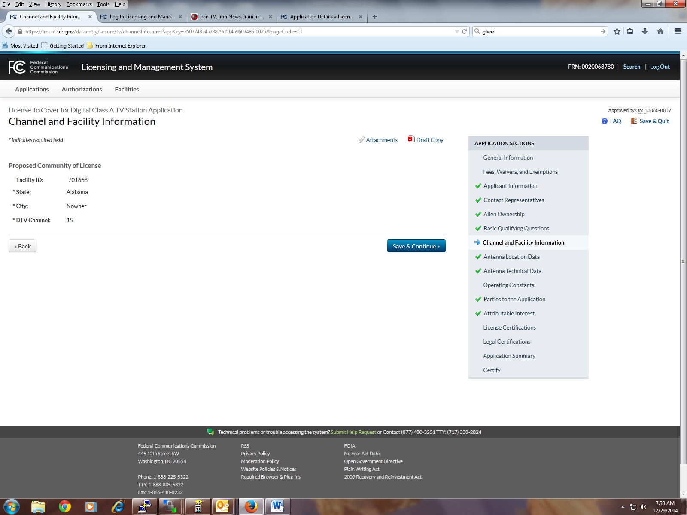

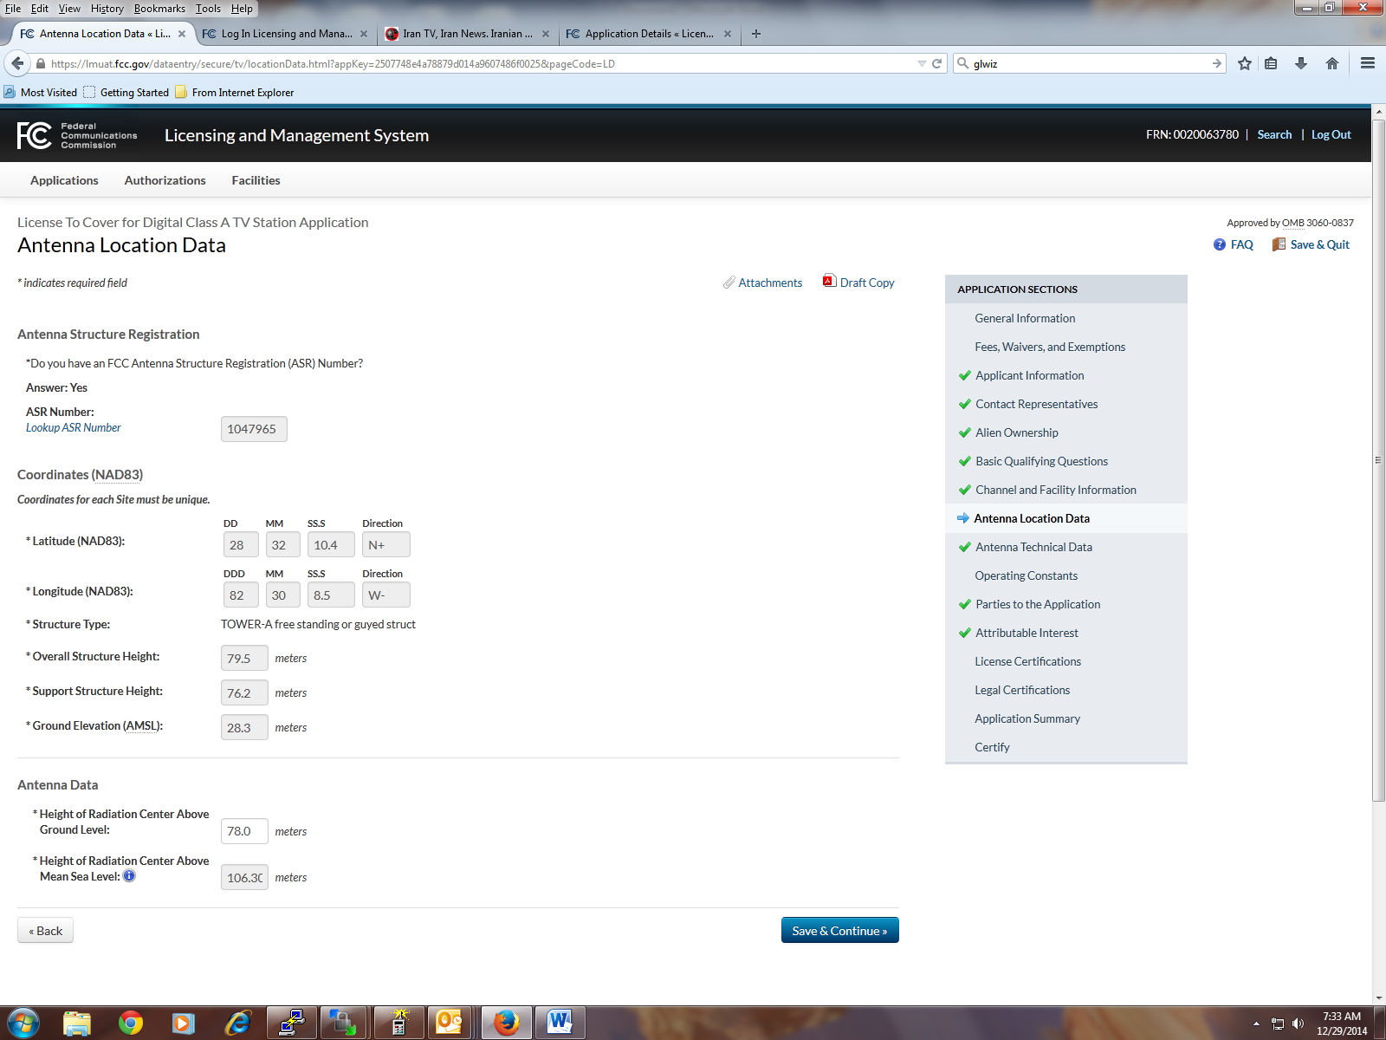

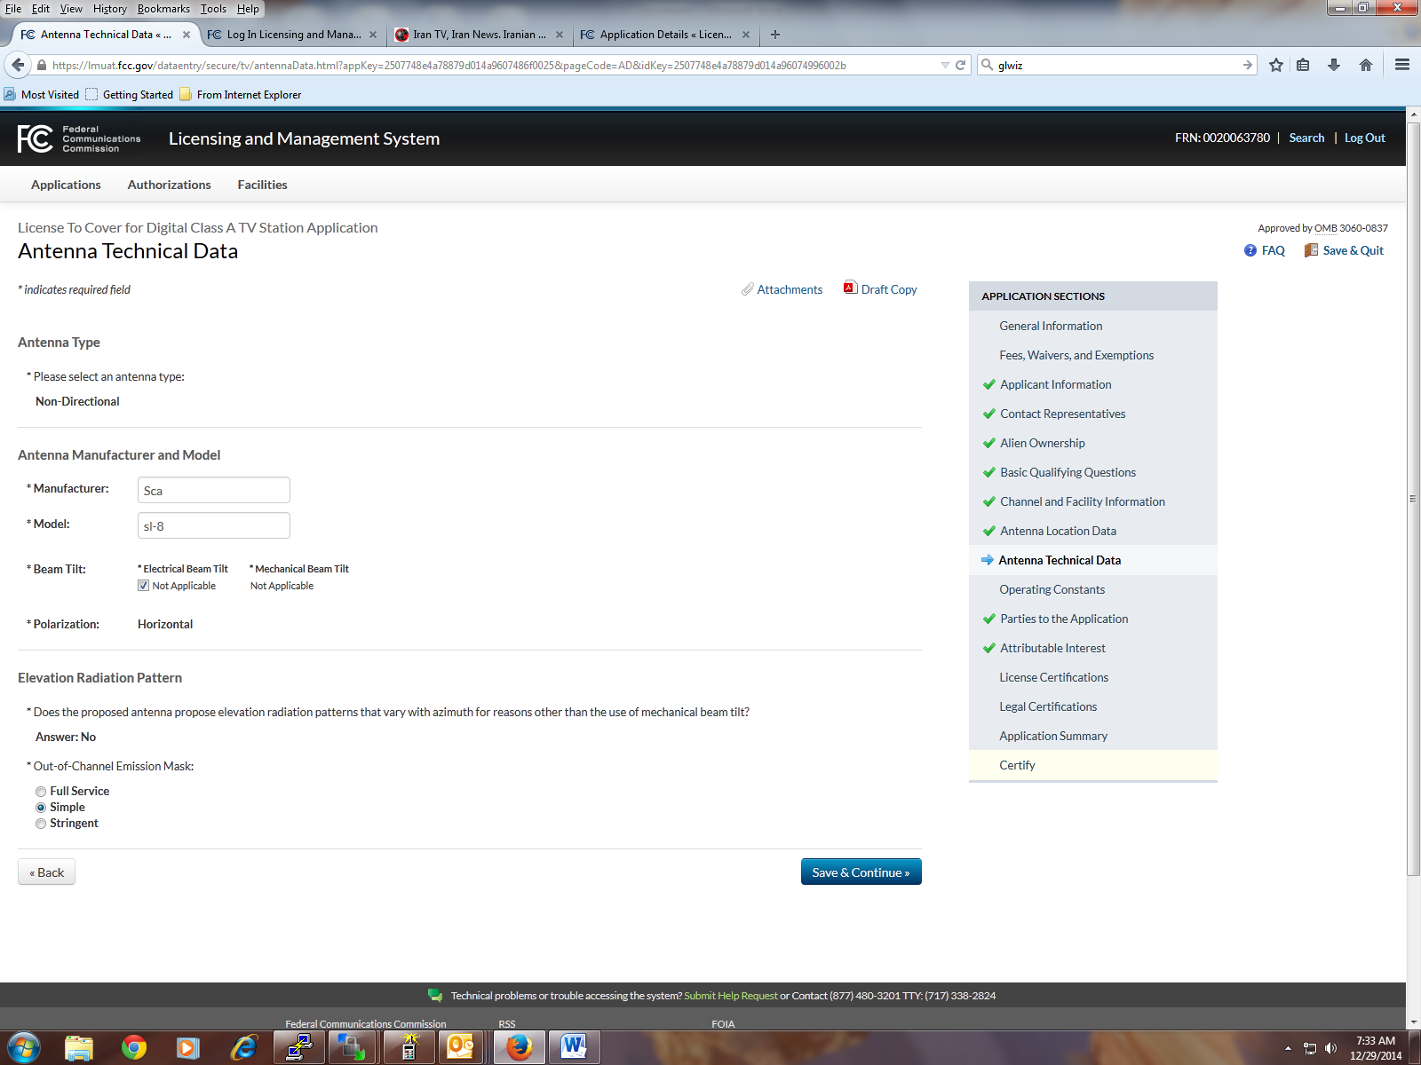

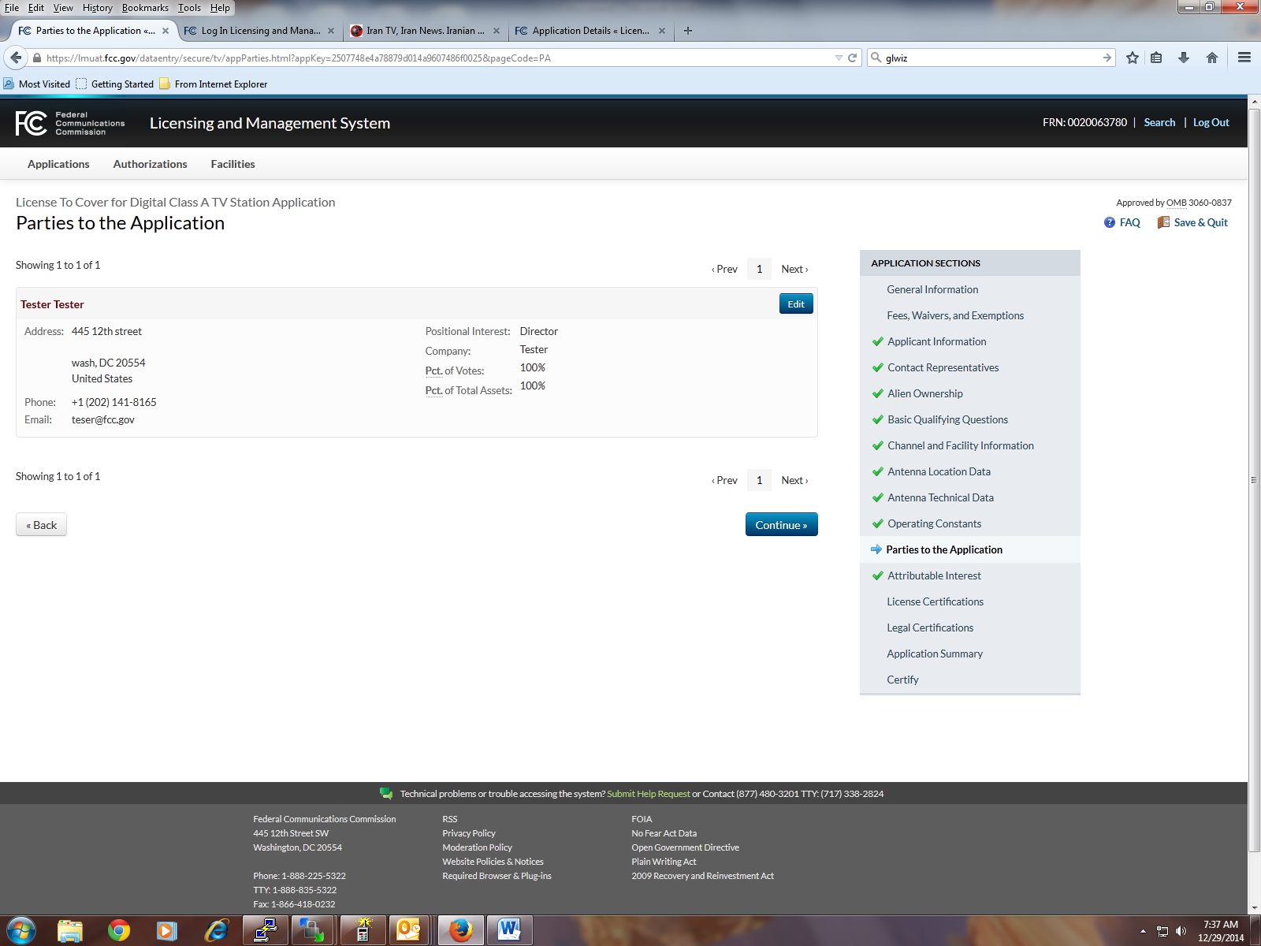

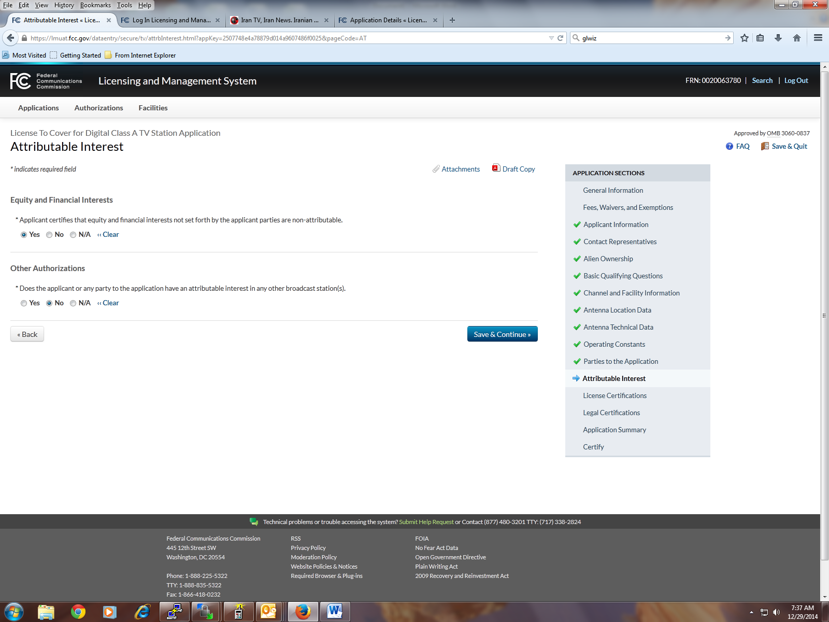

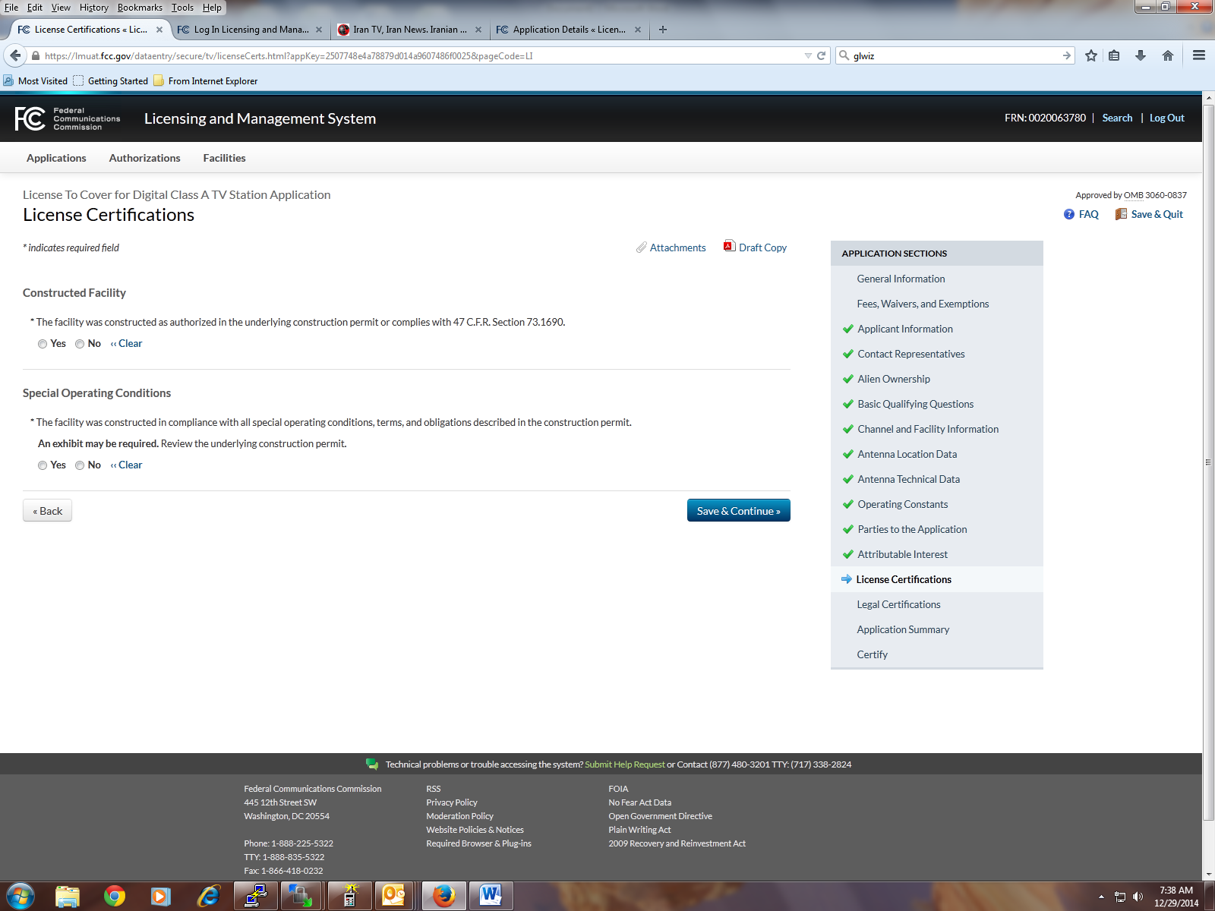

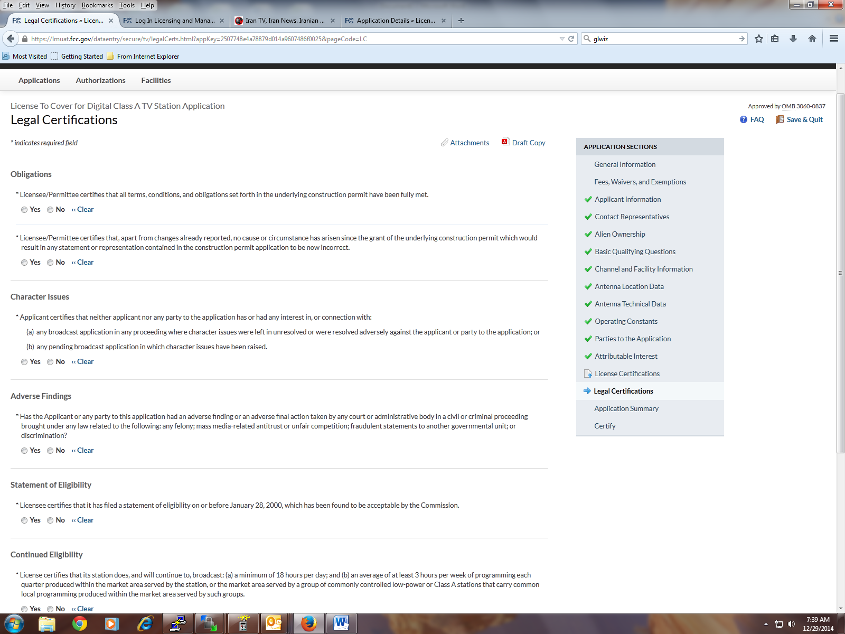

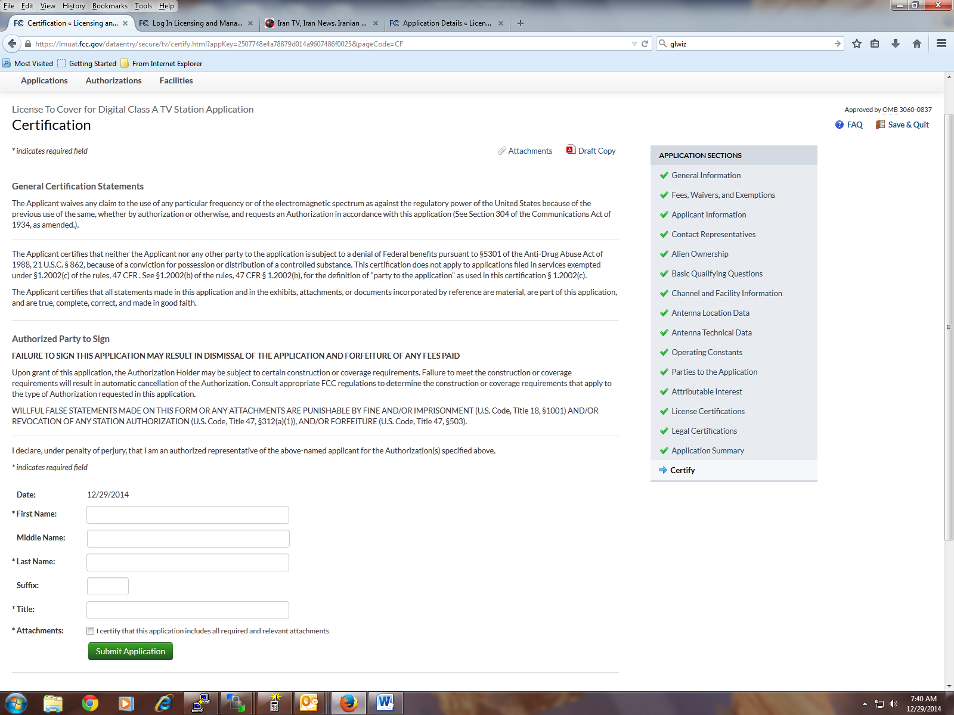
FCC NOTICE TO INDIVIDUALS REQUIRED BY THE
PAPERWORK REDUCTION ACT
We have estimated that each response to this collection of
information will take 2 hours. Our estimate includes the time to
read the instructions, look through existing records, gather and
maintain the required data, and actually complete and review the
form or response. If you have any comments on this burden
estimate, or on how we can improve the collection and reduce
the burden it causes you, please e-mail them to pra@fcc.gov or
send them to the Federal Communications Commission, AMDPERM,
Paperwork Reduction Project (3060-0928),
Washington, DC 20554. Please DO NOT SEND
COMPLETED APPLICATIONS TO THIS ADDRESS.
Remember - you are not required to respond to a collection of
information sponsored by the Federal government, and the
government may not conduct or sponsor this collection, unless it
displays a currently valid OMB control number of if we fail to
provide you with this notice. This collection has been assigned
an OMB control number of 3060-0928.
THE FOREGOING NOTICE IS REQUIRED BY THE
PAPERWORK REDUCTION ACT OF 1995, P.L. 104-13,
OCTOBER 1, 1995, 44 U.S.C. Section 3507.

