**Attachment B.4: Feasibility Study Survey Screenshots**

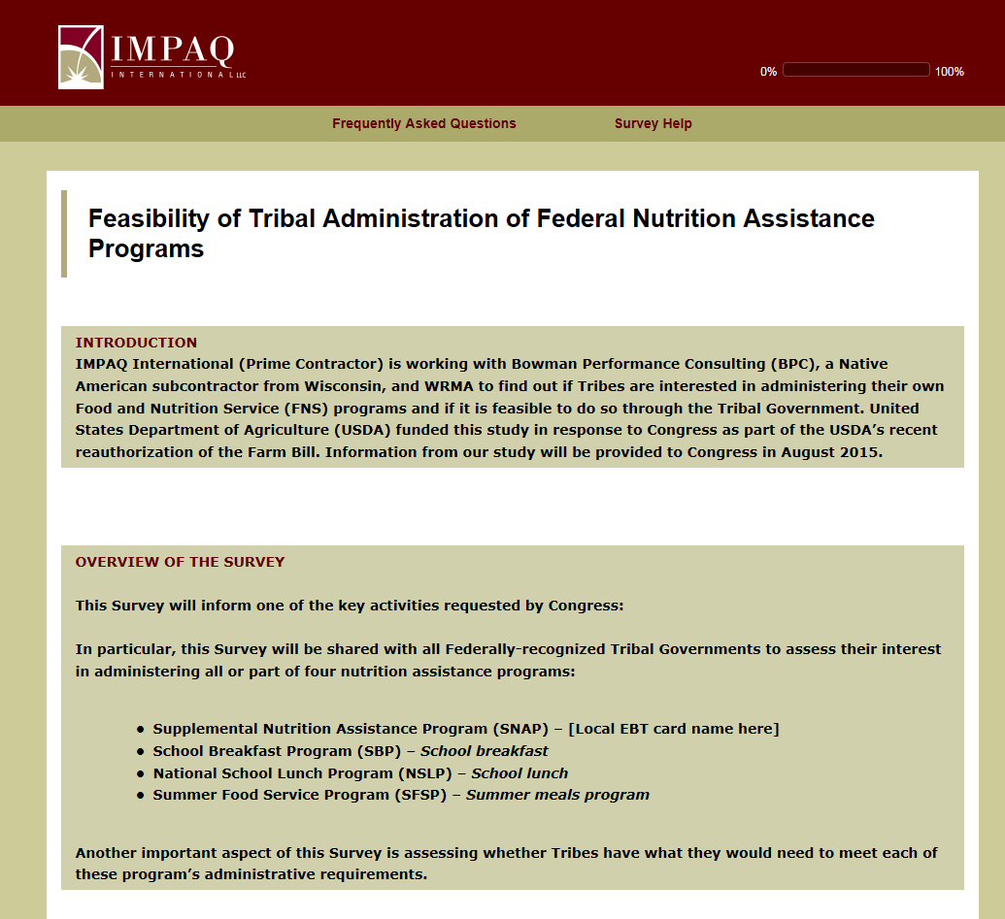

The OMB Control Number for this information collection is 0584-XXXX and the expiration date is XX/XX/XXXX.

According to the Paperwork Reduction Act of 1995, an agency may not conduct or sponsor, and a person is not required to respond to, a collection of information unless it displays a valid OMB control number. The valid OMB control number for this information is [Insert OMB control number]. The time required to complete this information collection is estimated to average 30 minutes per response, including the time for reviewing instructions, searching existing data sources, gathering and maintaining the data needed, and completing and reviewing the collection of information.

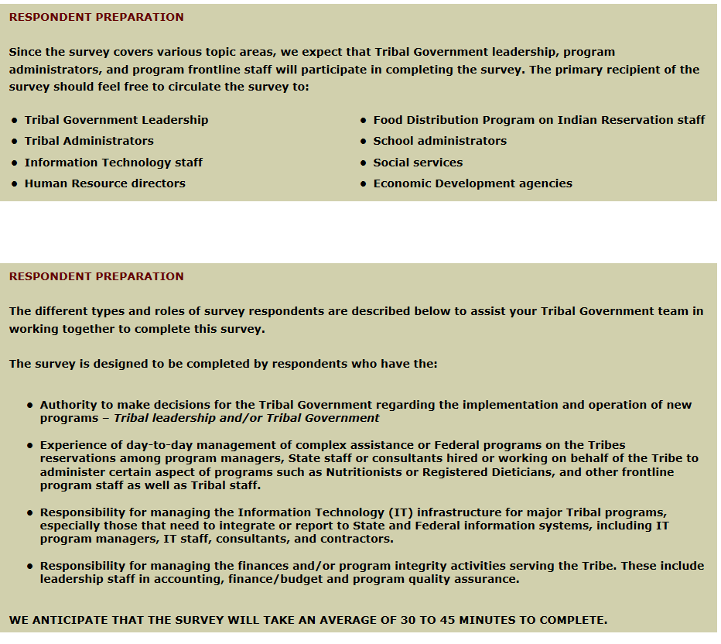

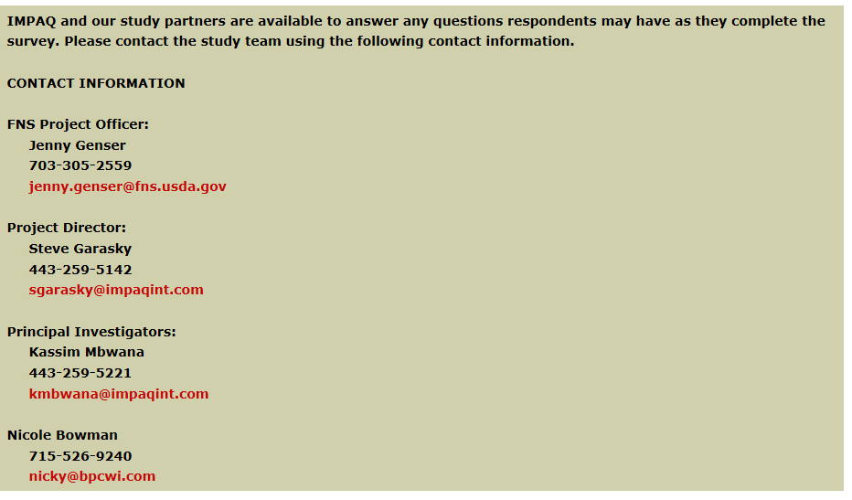

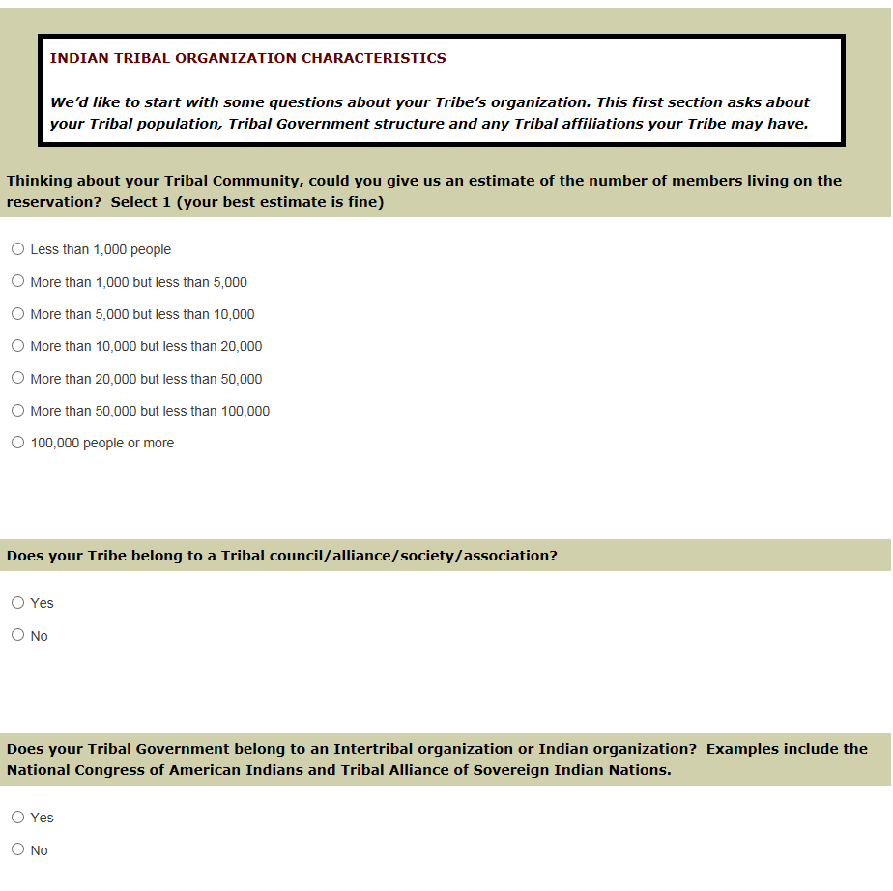

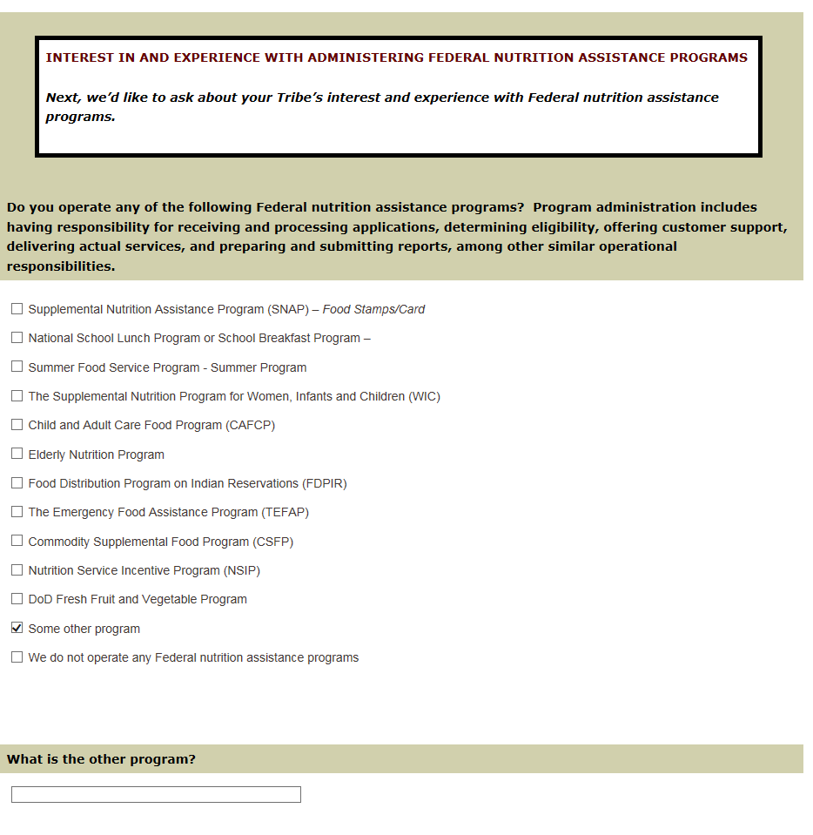

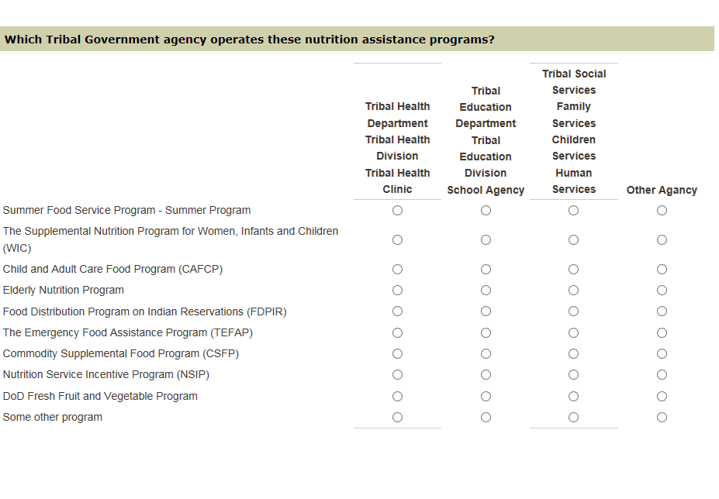

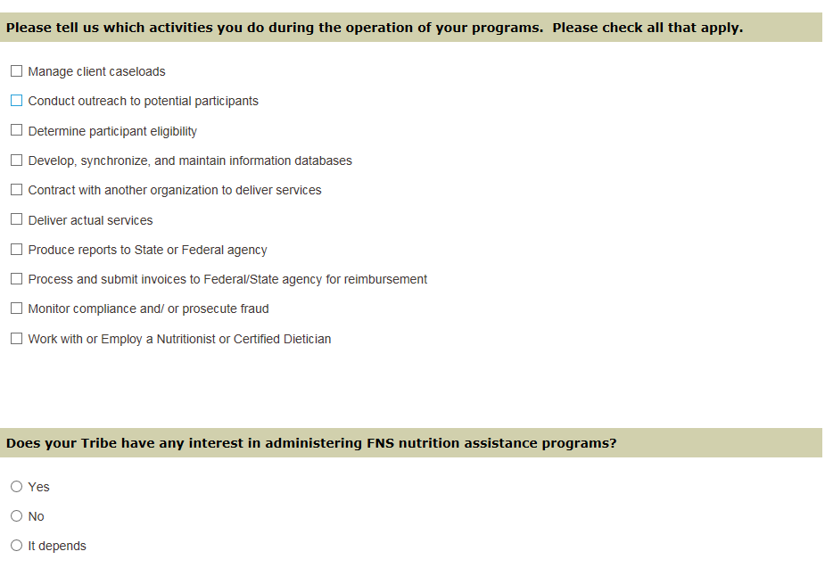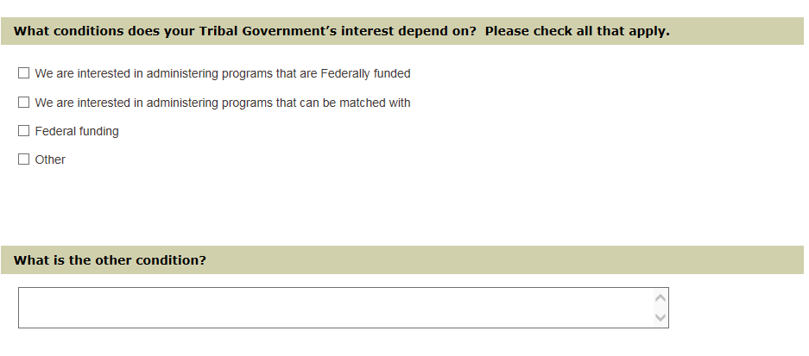

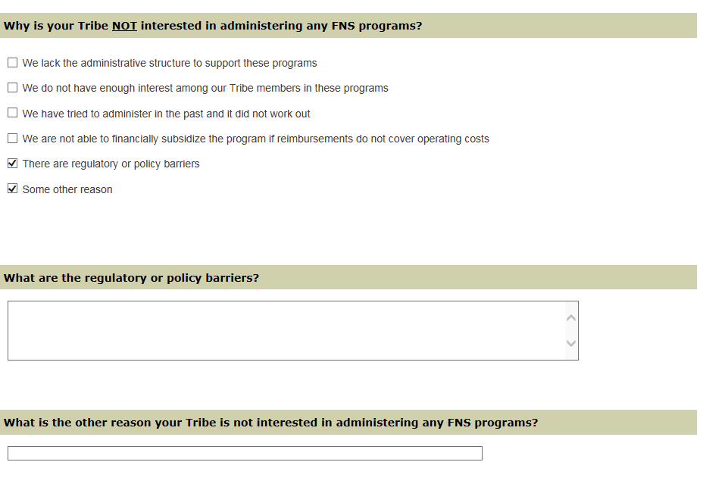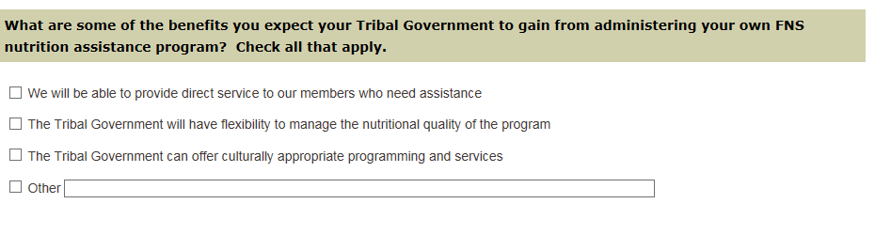

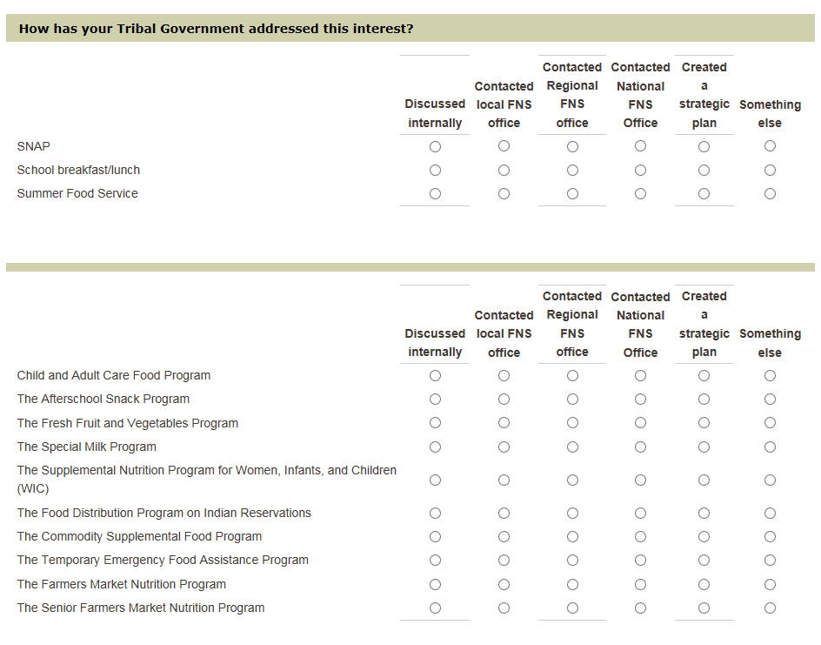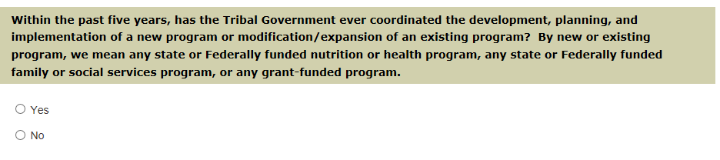

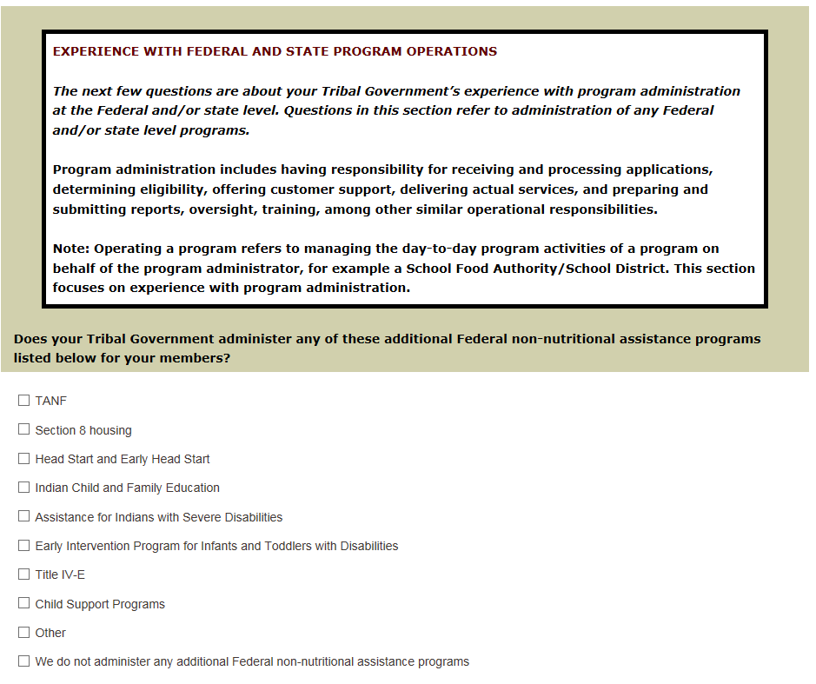

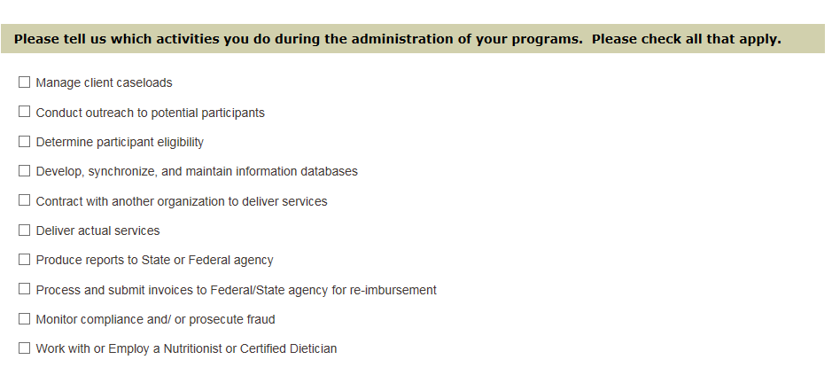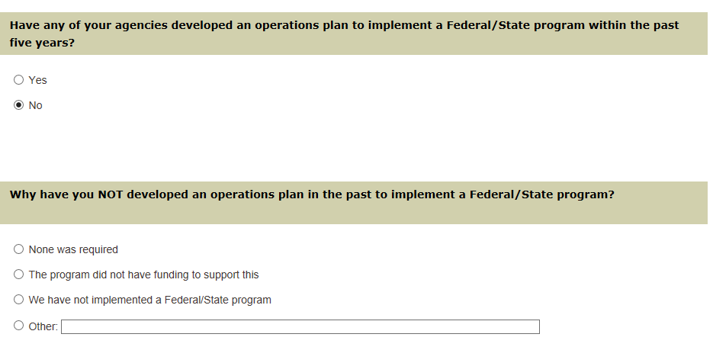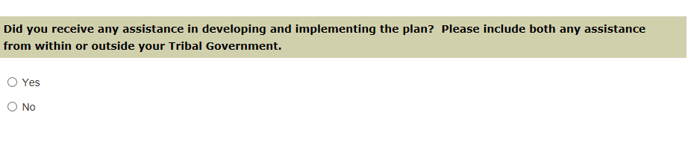 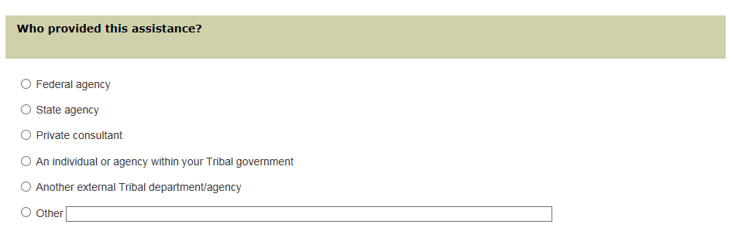

 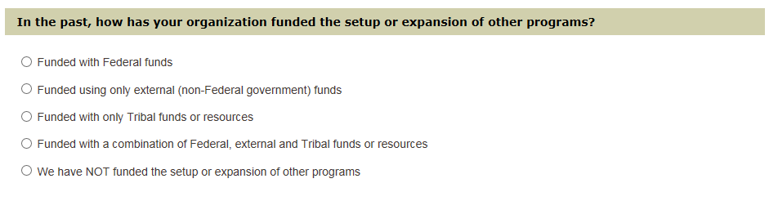 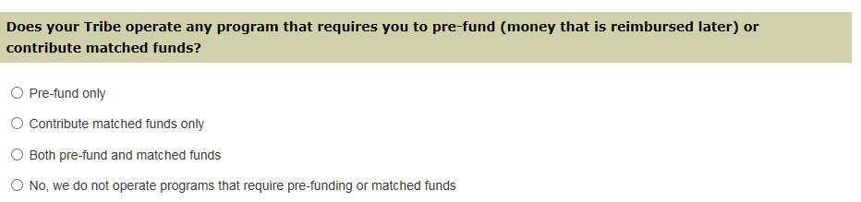 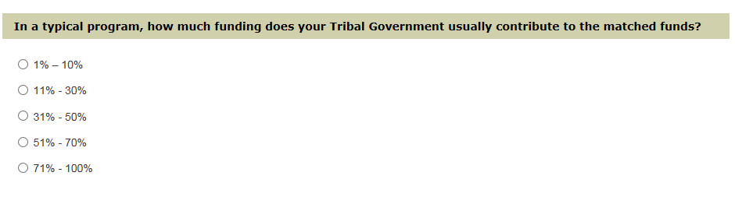 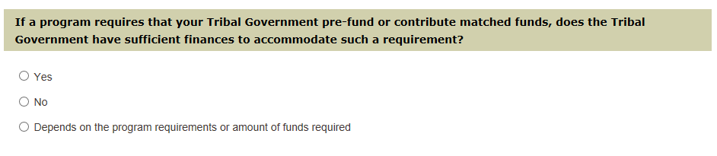 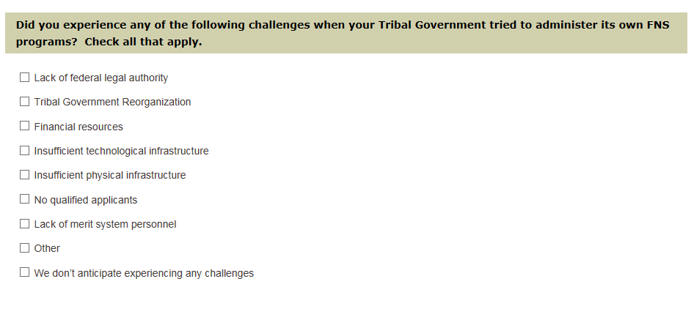 

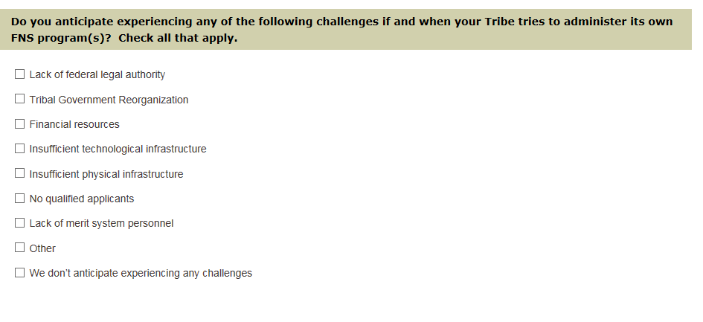 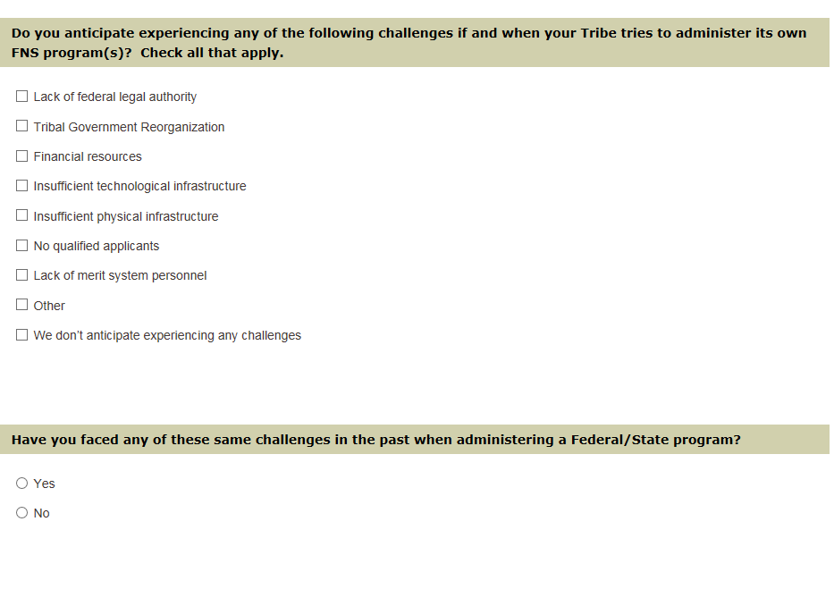 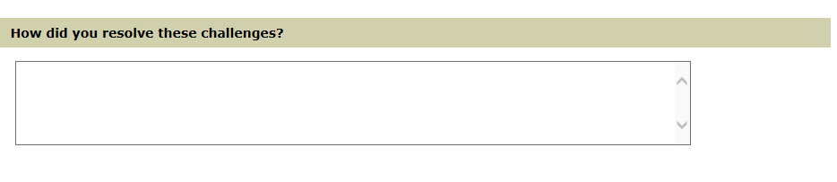 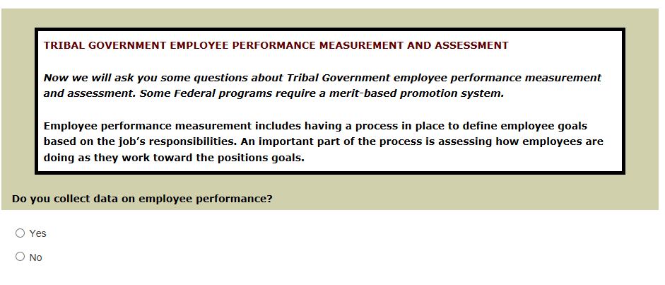 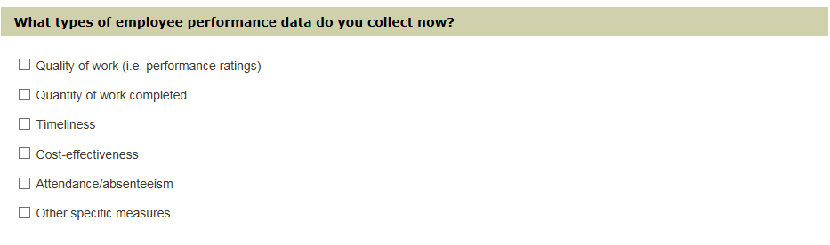 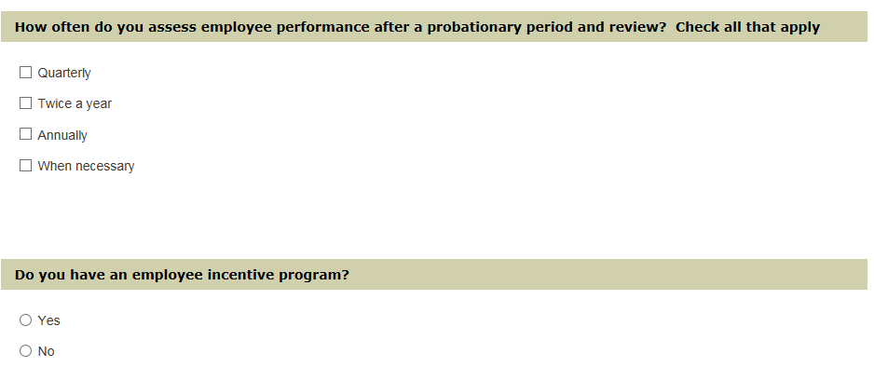 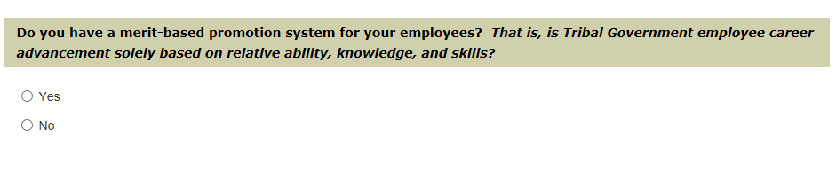 

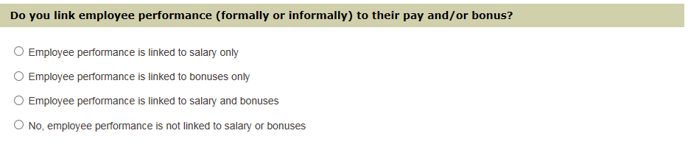

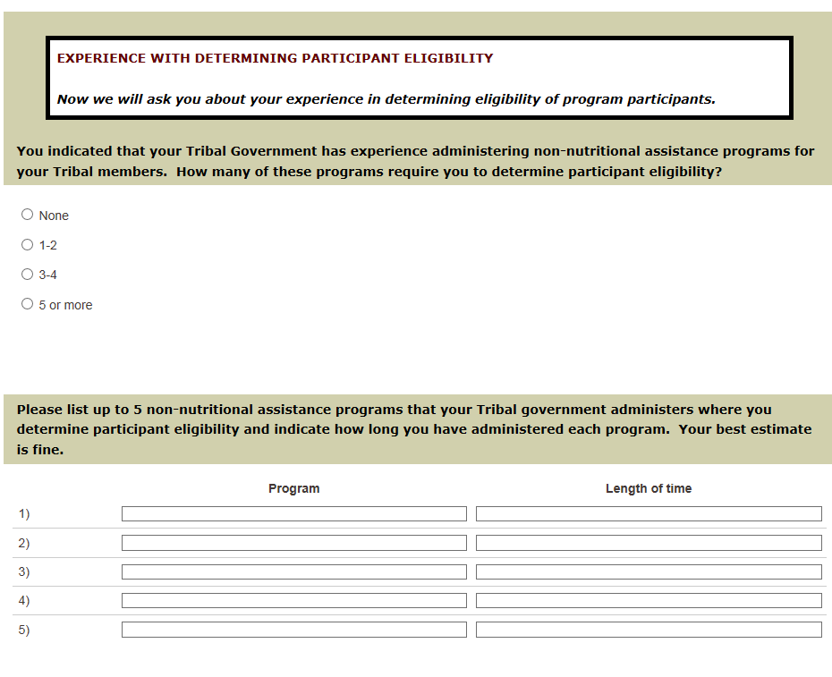 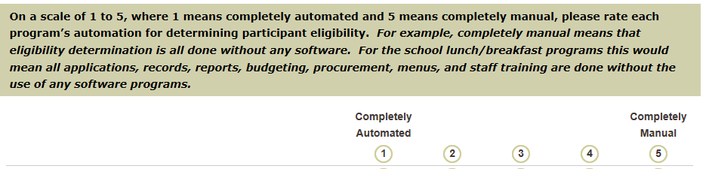

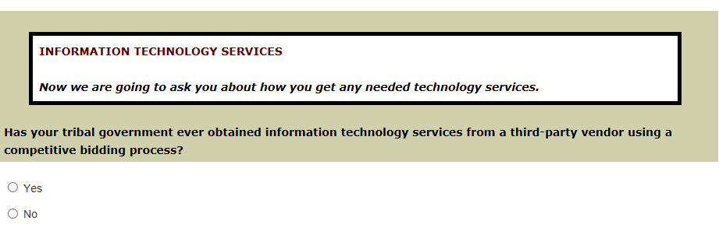 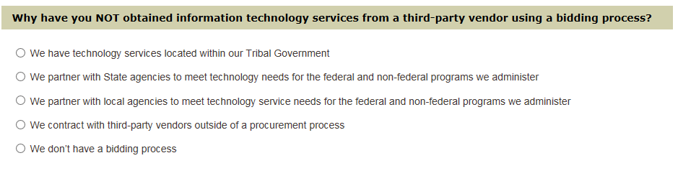 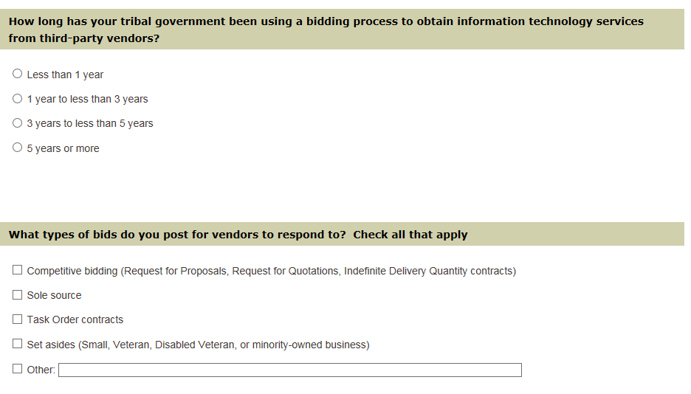

 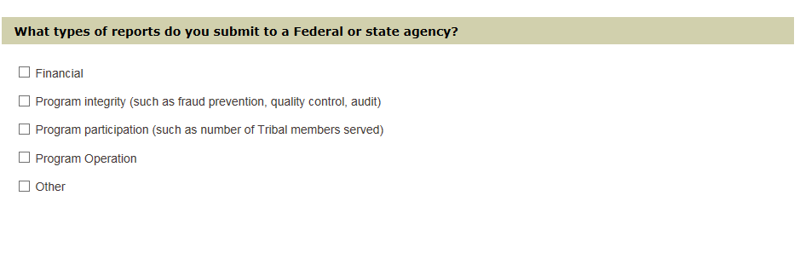  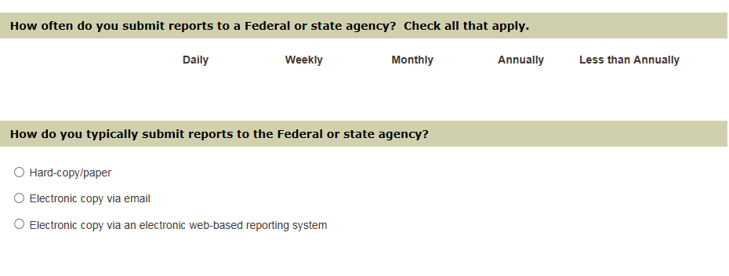

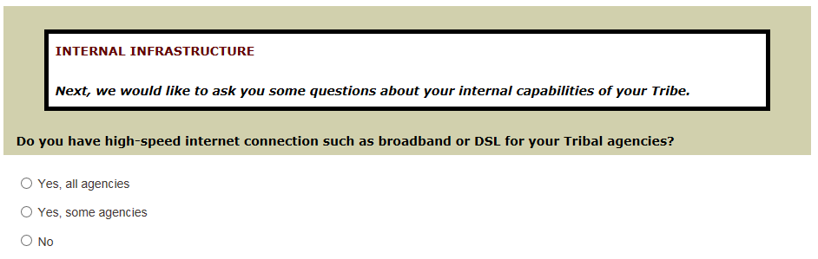 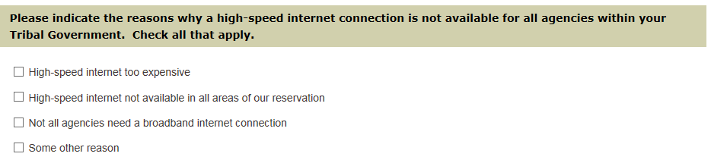  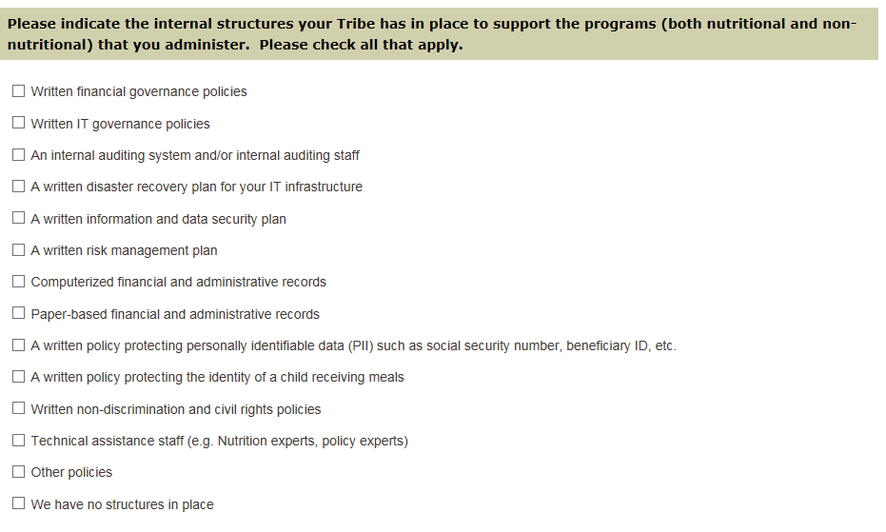 

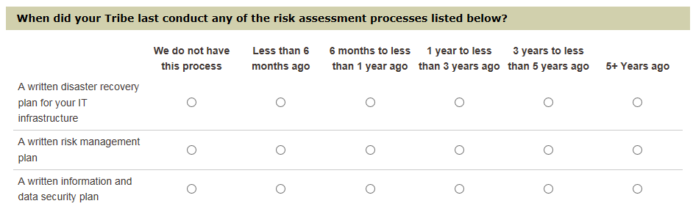

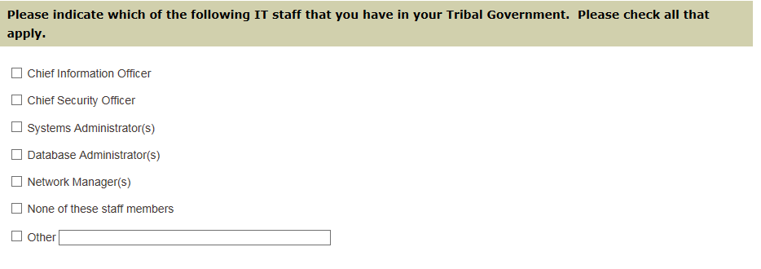





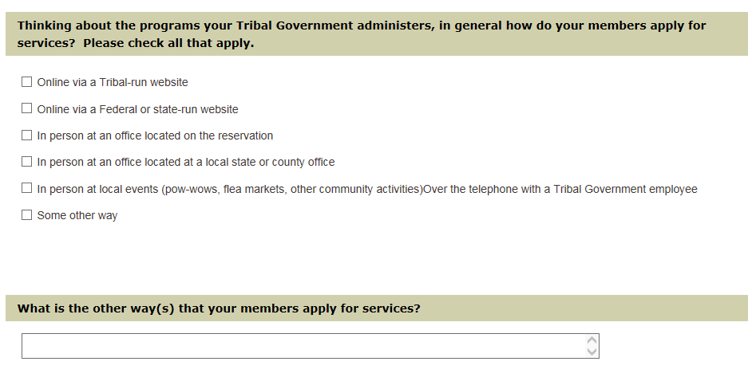

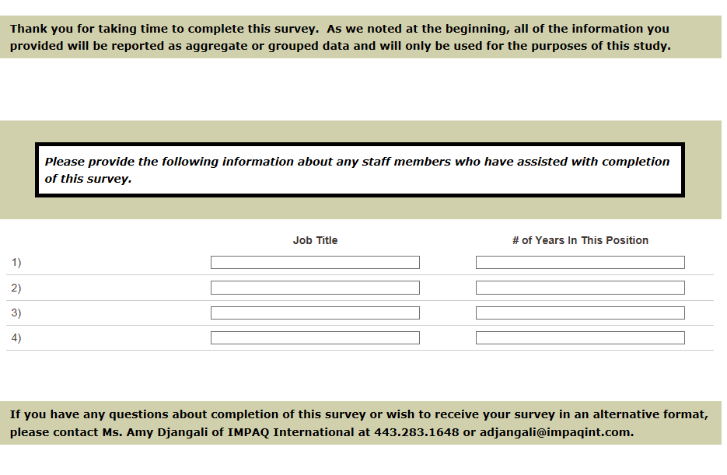

**Paperwork Reduction Act Statement**

According to the Paperwork Reduction Act of 1995, an agency may not conduct or sponsor, and a person is not required to respond to, a collection of information unless it displays a valid OMB control number. The valid OMB control number for this information collection is 0584-XXXX. The time required to complete this information collection is estimated to average [insert time] minutes [or hours] per response, including the time for reviewing instructions, searching existing data sources, gathering and maintaining the data needed, and completing and reviewing the collection of information.

OMB Control Number: XXXX-XXXX Expiration Date: XX/XX/XXXX