Audience Research on Self-Management Education

Attachment 5 to the HMTS Expedited Review Form

Contents
Material 1: Freedom Through Control (A) 1
Material 2: Freedom Through Control (B) 2
Material 3: Choice Path (A) 3
Material 4: Choice Path (B) 4
Material 5: Choice Path (C) 5
Material 6: You Determine (A) 6
Material 7: You Determine (B) 7
Material 8: Triumph 8
Material 9: Strength 9
Material 10: Freedom Through Control Messages 10
Material 11: Choice Path Messages 11
Material 12: Defiance/Overcome Adversity Messages 12
Material 13: Triumph Everyday/It’s Possible Messages 13
Material 14: Empowerment Messages 14

Attachment 5: Materials for Testing
Audience Research on Self-Management Education

Attachment 5a to the HMTS Expedited Review Form
May 16, 2013

Material 1: Freedom Through Control (A)

Material 2: Freedom Through Control (B)
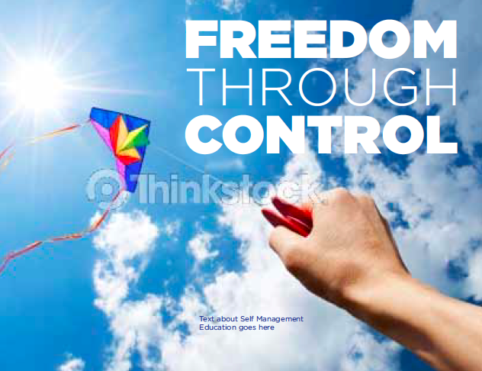

Material 3: Choice Path (A)
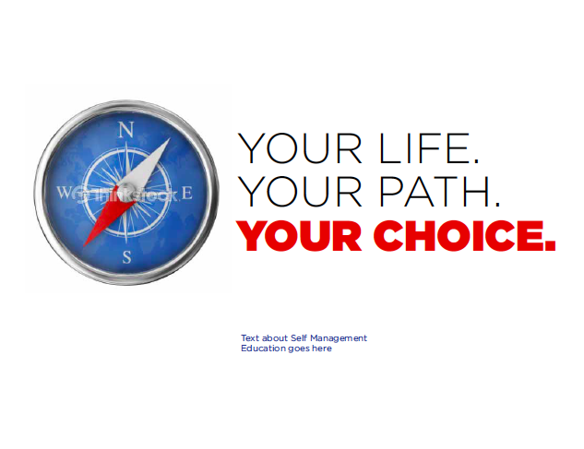

Material 4: Choice Path (B)

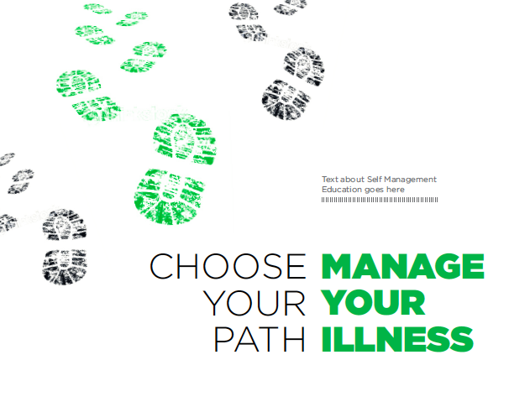

Material 5: Choice Path (C)

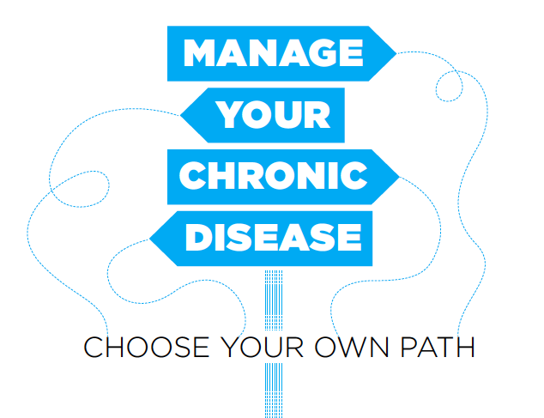

Material 6: You Determine (A)

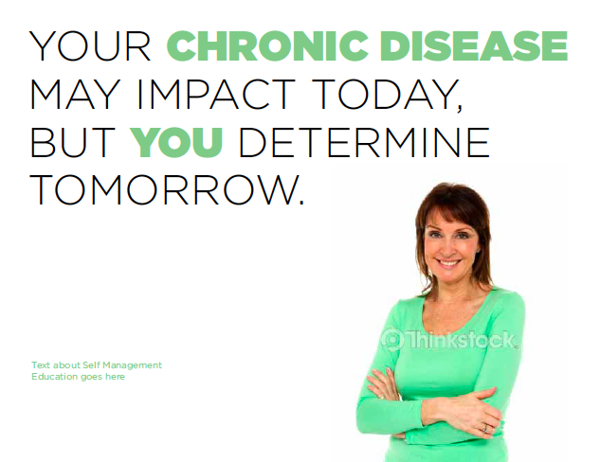

Material 7: You Determine (B)

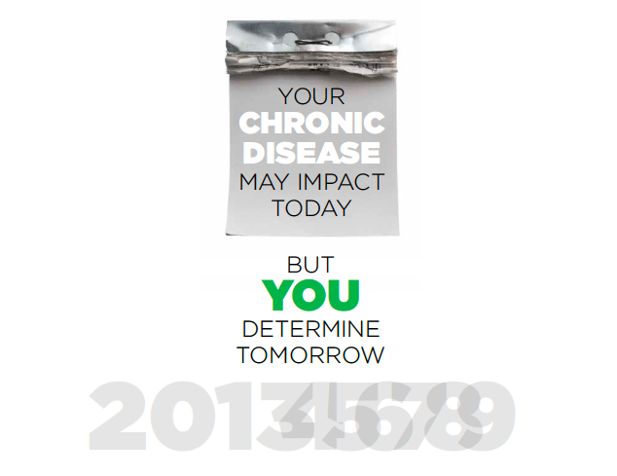

Material 8: Triumph

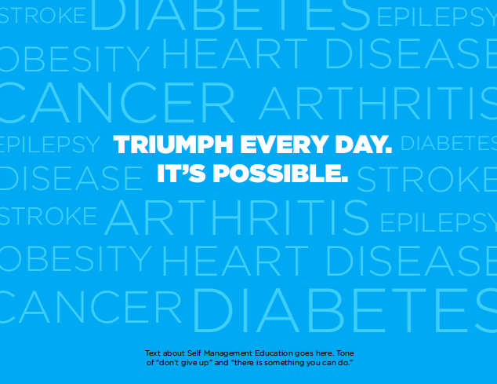

Material 9: Strength

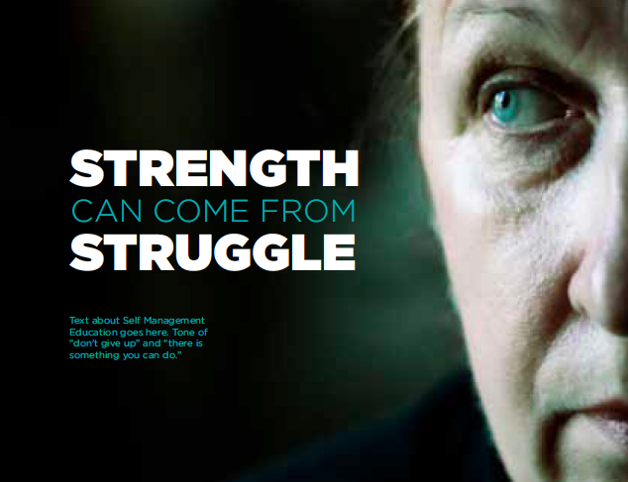

Material 10: Freedom Through Control Messages

FREEDOM THROUGH CONTROL

Copy
1a | Free yourself from your ongoing health problem [chronic disease] and gain back the independence you always had. Self-management education teaches you skills such as goal setting, decision making, problem solving, and self-monitoring, that allows you to control your health. Try a self-management education program.
1b | Don’t let your ongoing health problem take over your life. Gain back your independence and do the things you want to do. Self-management education gives you the skills to control your health through goal setting, decision making, problem solving, and self-monitoring. Find out more about self-management education.

Material 11: Choice Path Messages

MANAGE YOUR CHRONIC DISEASE CHOOSE YOUR OWN PATH

Copy
2a | Nearly 1 in 2 Americans have an ongoing health condition [chronic disease]. Don’t let your chronic disease take over your life. [Self-management education gives you the skills to control your health through goal setting, decision making, problem solving, and self-monitoring.] Choose a healthier future, choose self-management education.
2b | It’s never too late to manage your ongoing health condition [chronic disease]. [Self-management education gives you the skills to control your health through goal setting, decision making, problem solving, and self-monitoring.] Improve your day to day activities so you can enjoy a healthy, happier life through self-management education.
- In 2005, 133 million Americans had at least one chronic illness. That means one out of every two adults lives with a condition that impacts their lives and their daily activities

Material 12: Defiance/Overcome Adversity Messages

STRENGTH CAN COME FROM STURGGLE

Copy
3a | Don’t let your ongoing health problem [chronic disease] control your life. There’s something you can do. Self-management education can give you the skills you need to manage your chronic condition and live the life you want to live.
3b | You are not alone. Chronic disease affects 1 in 2 Americans but there is something you can do. Self-management education can give you the confidence and skills you need to manage your chronic condition and live a healthy life.

Material 13: Triumph Everyday/It’s Possible Messages

TRIUMPH EVERYDAY. IT'S POSSIBLE

Copy
4a | The average American employee takes about 10 sick days off a year. What if you have an ongoing health problem [chronic disease] on top of that? Take charge of your condition and take those healthy days back through self-management education.
4b | Each day is a fight when you have an ongoing health problem [chronic disease]. Don’t give up; there is something you can do. Self-management education can give you the independence, confidence and skills needed to live a happy, healthy life.

- U.S. workers took an average of 14 sick days in 2007.
- On average, employees took 10 days off because they were sick or injured and four to care for family members, according to the U.S. Agency for Healthcare Research and Quality

Material 14: Empowerment Messages

YOUR CHRONIC DISEASE MAY IMPACT TODAY, BUT YOU DETERMINE TOMORROW

Copy
5a | Chronic disease does not have to define who you are. Managing your long term health condition [chronic disease] through self-management education can give you more energy and less stress, allowing you the time to do the things you want.
5b | Today may be a struggle, but tomorrow doesn’t have to be. Self-management education can help you develop the skills you need to manage your chronic condition and live the life you want to live. Give yourself a healthier tomorrow and a healthier future.

