Form Approved
OMB No. 0920-0572
Exp. Date: 2/28/2015

ATSDR Task Order 15-4 Storyboard Testing

Attachment 4

Moderator’s Guide: Tweens

Welcome/Opening Remarks (10 minutes)

**Note: All participants will be accompanied by a parent or guardian at the beginning of the focus group session. Parents will stay through the introduction and consent process. Once parents have signed a consent form, and participants have signed an assent form, parents will leave the room.

[The moderator will greet participants as they arrive, directing everyone to sign in and create a personal name badge with first names only. The moderator will offer participants refreshments and point out directions to the restrooms.

When all the participants are seated comfortably, the moderator will begin the session with the following introduction.]

Thank you for joining us today. My name is _______ and this is our note taker [name note taker]. We also have on the phone/in the viewing room [name others from CommunicateHealth listening in or viewing if in-person]. The Agency for Toxic Substances and Disease Registry (ATSDR) is a part of the U.S. Government that helps protect people from dangerous chemicals.
ATSDR is going to make some TV commercials in the near future. Today, we’re going to show you what these commercials might look like and ask what you think about them. We’re also going to ask you questions about how we can make these commercials better.

Public reporting burden of this collection of information is estimated to average 1.5 hours per response, including the time for reviewing instructions, searching existing data sources, gathering and maintaining the data needed, and completing and reviewing the collection of information. An agency may not conduct or sponsor, and a person is not required to respond to a collection of information unless it displays a currently valid OMB control number. Send comments regarding this burden estimate or any other aspect of this collection of information, including suggestions for reducing this burden to CDC/ATSDR Information Collection Review Office, 1600 Clifton Road NE, MS D-74, Atlanta, Georgia 30333; ATTN: PRA (0920-0572).
We’ll also show you some ways that ATSDR could share important information with you. Sometimes, we call these important pieces of information “messages.” We’re going to ask you for your feedback and opinions on these messages — and talk to you about how ATSDR could make them as helpful and clear as possible. We want your honest opinions, good or bad!
Before we get started, I’m going to take a few minutes to go over some things you need to know about our discussion. Then I’ll explain how it will work.

- We’re not trying to sell you anything.

- There are no right or wrong answers — we’re just looking for your opinions. I don’t work for ATSDR or HHS, and I didn’t write anything we will be looking at today. This information was written by other people working on the project, so I won’t be offended by any opinions you share with me.
- We’ll be taking notes and audio recording the discussion. We have to write a report about your suggestions for ATSDR. Recording the discussion will help us write the report. We will not share the recordings with anyone outside of CommunicateHealth. We will not use your names in the report. We’ll only share the report with people working on this project at ATSDR, and CommunicateHealth.

- To make sure that we hear and understand what everyone has to say, it’s important that you speak one at a time. I may interrupt you if 2 or more people are talking at once.
- Our discussion will take about an hour and a half. I don’t want to keep you here longer than that, so I may interrupt you to keep us on track.
- Please turn off your cell phones, or put the ringer on silent. Feel free to go to the restroom during the discussion, but we’d appreciate it if you would go one at a time.

[The moderator will distribute to each participant 2 copies each of informed consent form for parents, and assent form for participants. The moderator will talk through each form with an explanation to include the following.]

Your participation in this discussion is voluntary. In other words, you’re choosing to be here. That means you can leave the group at any time if you want to. Your names will not be used in any report. The audio recording is only to be sure that we get all your opinions and ideas. The recording will not be shared with CDC or ATSDR.

Do you have any questions about this consent form or about how this discussion will work?

Parents, if you understand everything I’ve said and you agree to have your child participate, please read, sign, and date the informed consent form. Participants, if you understand everything I’ve said and you agree to talk with us today, please read, sign and date the assent form. There are 2 copies — please sign both of them. Keep one copy for yourself and give the other one back to me.

[Participants will then read and sign the informed consent statement assuring them that information provided during the discussion group will be kept confidential and will only be used for the development of messages and concepts. The statement will also contain language explaining that signing the form confers permission to be audio recorded. Parents/guardians will leave the room after the consent process is complete.]

Introduction and Warm-up (10 minutes)

We’re going to start with a few warm-up questions.

77d. How do you usually learn about environmental issues? Who or what is your main source of trusted information about community issues? Is there adequate information out there? How do these sources compare to [ATSDR]?

16c. Have you heard about [Name of abandoned site]?
17c. What can you tell me about [Name of abandoned site]?

Channels (10 minutes)

69d. Where do you get your information about [general news or information you’re interested in]?
- probe for sources such as media, family, friends, church, school

52a. Do you ever use the Internet for health information?

14c. About how often do you use the Internet? [Moderator will ask for a show of hands and note numbers]
- Several times a day
- About once a day
- 3-5 days a week
- 1-2 days a week
- Every few weeks
- Less often
- Never
- Don’t know

11f. If you saw a [name of abandoned site] story (on television, in newspapers, or on the Internet), how likely would you be to pay close attention to it?

Storyboard Testing (25 minutes)

Let’s start by taking a look at this [moderator hands out copies of storyboards]. It’s called a storyboard and has a few ideas of what will later become an ad that may be shown on TV or published in a magazine or newspaper. This is something that’s not completely done, and we need your help to finish it. I’ll give you a few minutes to review it before we talk about it.

[Moderator will show full storyboard and ask for general impressions first before asking about specific pieces/messages.]

Comprehension

1d. What is the main idea that this message is trying to get across, in your own words?

3d. Is it trying to get people to do something?
- What action would the message prompt you to take?

6d. Is there anything confusing, unclear, or hard to understand?

Audience and Personal Relevance

24d. Who would you say they are trying to reach?
- Does it seem like this message is talking to you, and people like you? Or someone else?
- What in the message suggested it was talking to you and people like you or someone else?

26d. Do you see yourself doing this…or something like it? Why/why not?

47E. Where would you want to see an ad such as this one?

Behavior Change

30d. If you saw or heard this message, would it get your attention? Why or why not?

22d. Did you think any of these [messages/screens about abandoned site] was effective to motivate you or someone else to [stay out of abandoned site]?
- Yes
- No
20d. Do you think you will talk about any of these [messages/screens about abandoned site] with others?
- Yes
- No

Language and Believability

17d. What additional information would you need in order to more strongly believe this message?

94d. If you were trying to influence a friend to [stay out of abandoned site], what would you say?
- Probe for benefits and ways to overcome barriers

Story Board Ranking/Rating Activity (10 minutes)

[Moderator will hand each participant a separate activity sheet [See appendix D] and read through the instructions. Moderator will read through each question/line with participants and give them a few minutes to complete each ranking before asking the remaining questions out loud.]

43e. What other comments would you like to make about this ad?

Message Testing (20 minutes)

[Moderator will distribute a set of messages (Appendix E) to each participant and ask them to read over each one. Moderator will then read through each message with participants and ask questions about the full set and then each one in turn as necessary to clarify responses.]

[For each message in turn]:

7d. How would you sum up in just a few words your first impressions of this message? Do you like it? Not like it? What makes you say that?

11d. How does it make you feel?

12d. Was this a new idea or something that you’ve heard before?

1f. Does this message make you want to do anything?
- Does this motivate you to take action?
- Would this make you interested in finding out about [abandoned sites] in your community?

[In reference to all messages together]

108d. Looking over all of the different messages we have discussed, which two or three are the most effective?
- Probe: What makes it most effective?

111d. Which one is most believable?

112d. Now looking at just the top two or three messages, which one message is the most important to you to help you [stay out of abandoned sites] and that you have the greatest likelihood of doing?

10f. Is there anything that could be changed to make it more likely you would be motivated to [stay out of abandoned sites]?

13f. How likely would you be to talk about [abandoned sites] with your friends in the next week or so?

81d. What are some places in particular that you would be most likely to notice and pay attention to these messages?

Thank You and Closing (5 minutes)

[Moderator will thank each participant for his or her time and contribution and wrap up each session by doing an informal ranking using show of hands. Moderator will draw the response options (strongly agree = 1, to strongly disagree = 5 on the white board).]

Appendix A: Storyboard

Storyboard page 1

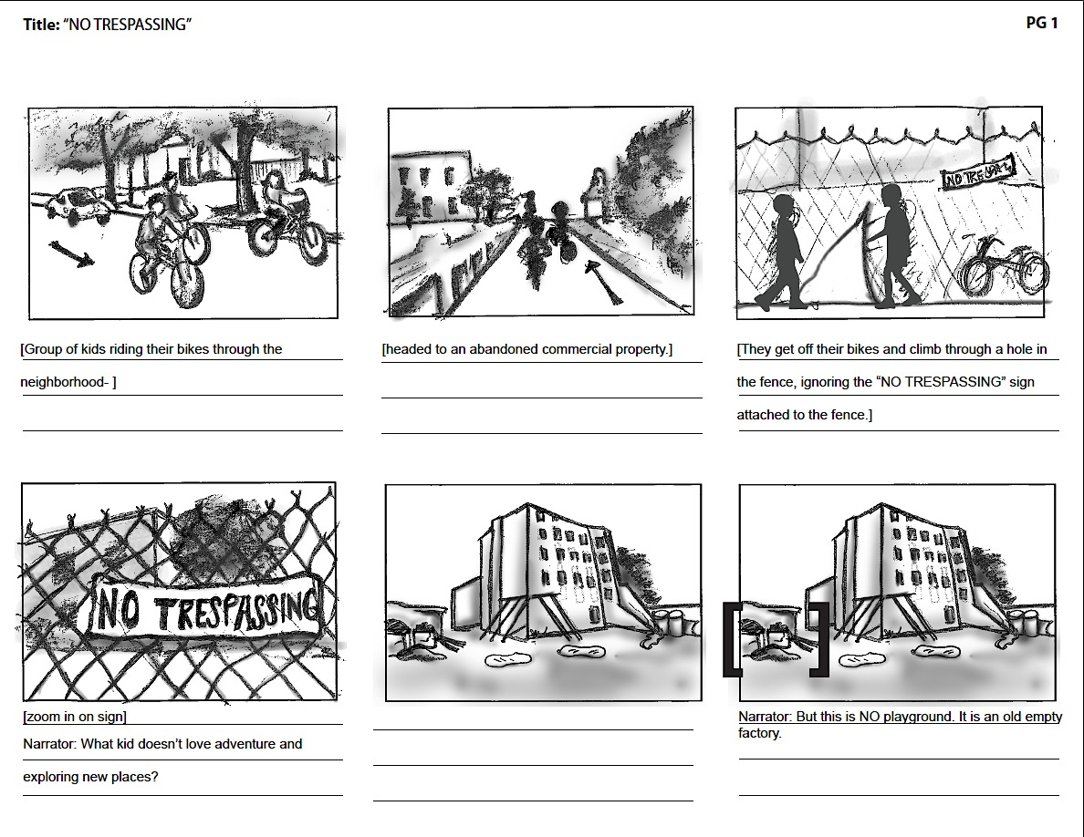

Storyboard page 2

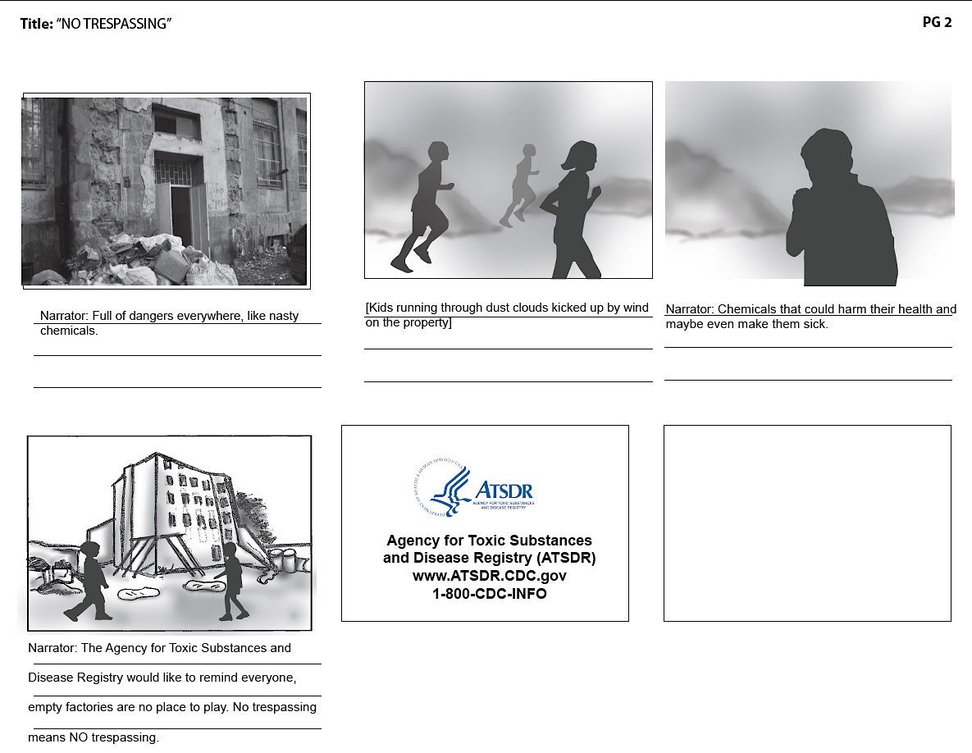

Appendix B: Ranking/Rating Activity

32e. This ad was made (written) for a person like me
Strongly Disagree |  |  |  | Strongly Agree
1 | 2 | 3 | 4 | 5

35e. I would look at this ad if I saw it
Strongly Disagree |  |  |  | Strongly Agree
1 | 2 | 3 | 4 | 5

36e. I am interested in this ad’s topic
Strongly Disagree |  |  |  | Strongly Agree
1 | 2 | 3 | 4 | 5

39e. I trust the information in this ad
Strongly Disagree |  |  |  | Strongly Agree
1 | 2 | 3 | 4 | 5

41e. I will do what this ad suggests
Strongly Disagree |  |  |  | Strongly Agree
1 | 2 | 3 | 4 | 5

68e. This [ad] was convincing
Strongly Disagree |  |  |  | Strongly Agree
1 | 2 | 3 | 4 | 5

69e. This [ad] said something important to me.
Strongly Disagree |  |  |  | Strongly Agree
1 | 2 | 3 | 4 | 5

70e. I liked this [ad] overall.
Strongly Disagree |  |  |  | Strongly Agree
1 | 2 | 3 | 4 | 5

75e. This [ad] spoke to me.
Strongly Disagree |  |  |  | Strongly Agree
1 | 2 | 3 | 4 | 5

76e. I do not like this [ad]
Strongly Disagree |  |  |  | Strongly Agree
1 | 2 | 3 | 4 | 5

78e. The message about [staying out of abandoned sites] was persuasive
Strongly Disagree |  |  |  | Strongly Agree
1 | 2 | 3 | 4 | 5

79e. The message was dumb
Strongly Disagree |  |  |  | Strongly Agree
1 | 2 | 3 | 4 | 5

80e. The message was weak
Strongly Disagree |  |  |  | Strongly Agree
1 | 2 | 3 | 4 | 5

Appendix C: Messages

Example messages for kids ages 10 to 13:
- Going inside abandoned buildings can be dangerous.
- You can get in trouble with the police if you hang out in empty buildings.
- Set an example for younger kids by staying away from empty buildings.
- Hanging out on abandoned properties has another name: trespassing. It's not safe — and it's against the law.
- You don't just walk into a stranger's house to hang out. Same rules apply to abandoned property — don't trespass.
- You wait for an invitation to go to someone's house, right? Same rules apply to abandoned property — no invitation, no trespassing.
- Treat abandoned properties how you'd treat a neighbor's house.
- “Abandoned" isn't an invitation. Don't trespass.

