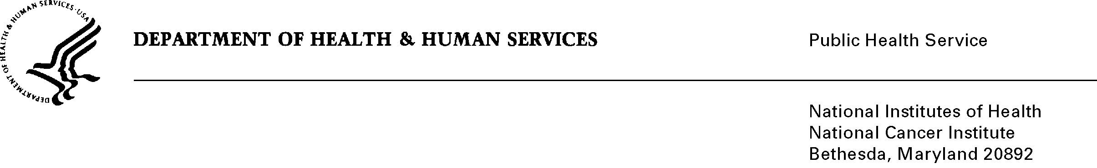
Date: October 25, 2013

To: Office of Management and Budget (OMB)

Through: Keith Tucker, Reports Clearance Officer, HHS
Seleda Perryman, Project Clearance Officer, NIH
Vivian Horovitch-Kelley, PRA Project Liaison, NCI

From: Michael Montello, Pharm.D.
National Cancer Institute/NIH

Subject: Revision to “Cancer Trials Support Unit (CTSU) (NCI)”
(OMB No. 0925-0624, Expiration Date: 12/31/2013)

The Public Health Service Act, and Section 413 (42 USC § 285a-2) authorizes Cancer Therapy Evaluation Program (CTEP) to establish and support programs to facilitate the participation of qualified investigators on CTEP-supported studies, and to institute programs that minimize redundancy among grant and contract holders, thereby reducing overall cost of maintaining a robust treatment trials program. Currently guided by the efforts of the Clinical Trials Working Group (CTWG) and the Institute of Medicine (IOM) recommendations to revitalize the Cooperative Group program, CTEP has funded the Cancer Trial Support Unit (CTSU).

CTSU collects annual surveys of customer satisfaction for clinical site staff using the CTSU Help Desk and the CTSU web site. An ongoing user satisfaction survey is in place for the Oncology Patient Enrollment Network (OPEN). A forth user satisfaction survey, is sent out to individuals who use the services and customer support at the Protocol and Information Office (PIO). User satisfaction surveys are compiled as part of the project quality assurance activities and are used to direct improvements to processes and technology.

Three additional surveys have been added that are clinical trial related and are sent to health care professionals to be completed. Two surveys assess the interest and potential issues in opening and accruing to a clinical trial, and a third survey assesses the reasons for low accrual to a clinical trial that is already open.

In addition, the CTSU collects standardized forms to process site regulatory information, changes to membership, patient enrollment data, and routing information for case report forms. It is estimated that there will be 22,785 respondents per year and 25,205 burden hours. Burden estimates are based on the number of forms at the site level that are returned, making it difficult to calculate the number of respondents and their frequency of responses. Additionally, not all institutions and CTSU members take part in all services and protocols.

