Final Justification Submission Function

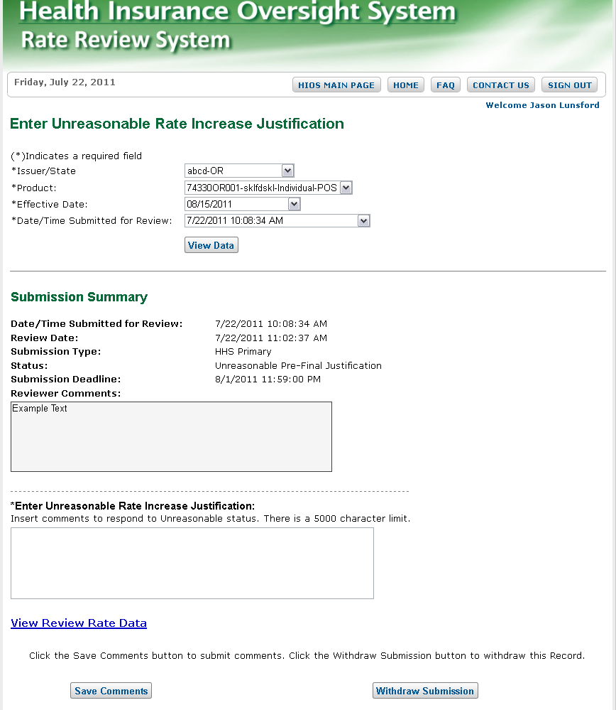

Withdraw Function

