iClaim-i3368 Marriage (3rd Party): Screen Package 0.2

Table of Contents

1. Ent002_Welcome Page (DIB) 3
2. Ent001_Welcome Page (RIB) 4
3. Ent001_Welcome Page (RIB) Secure Session 5
4. Who is Completing This Application? (DIB Path) 6
5. Who is Completing This Application? (RIB Path) 8
6. Ent004_Return to Saved Application Process 10
7. Ini002-d3_Information About You (DIB with no navigation) 11
8. Ini002-d3_Information About You (RIB with no navigation) 12
9. Ini002-d3_Information About You (DIB with navigation) 13
10. Ini002-r3_Information About You (RIB with navigation) 14
11. Ini001-d3 & r3_Preparer’s Contact Information (DIB & RIB Paths) 15
12. Ini003-3_Contact Information 16
13. Ini003-3_Birth and Citizenship Information 18
14. Apn001-d3_Re-entry Number 19
15. Apn001-d3_Re-entry Number (SSI Definition link expanded) 20
16. Adi001-3_Other SSNs and Names 21
17. Fam001-3_Marriage Information 23
18. Fam002-3_Prior Marriages 24
19. Fam003-d3_Children 25
20. Mil001-3_Military Details 26
21. Ear001-3_Employer Details 27
22. Ear002-3_Self-Employment 29
23. Ear003-3_Supplemental Information 30
24. Ear004-d3-b_Total Earnings 31
25. Ear005-d3-b_Other Pensions/Annuities 32
26. Wst002-3_Direct Deposit Details 33
27. Bni001-3_Benefit Information 35
28. Bni002-3_Health Insurance 37
29. Bni005-3_Group Health Plan Insurance 38
30. Dsq001-3_Ability To Work 38
31. Dsq002-3_Disability Payments 40
32. Dsq003-3_Dependents 41
33. Dsq004-3_Authorization 42
34. Rem001_Remarks 43
35. Ovs001-d3-b_Review and Sign (iClaim) 44
36. Rcm001-3_Preparer’s Contact Information 48
37. Rcm001-3_Preparer’s Contact Information (i3368 only) 49
38. Pin001-3_Contact Information 50
39. Pin001-3_Contact Information (i3368 only) 52

40. Re-entry Number 54
41. Re-entry Number (i3368 only) 55
42. Confirm Your Identity On Re-entry (1st party to 3rd party) 56
43. Confirm Your Identity On Re-entry (3rd party to a different 3rd party) 57
44. Alg001-3_Conditions 58
45. Con001-3_Someone Who Knows About Your Condition 60
46. Doc001-3_Doctors and Healthcare Professionals 62
47. Doc002-3_Doctors and Healthcare Professionals Details 63
48. Hos001-3_Hospitals and Clinics 66
49. Hos002-3_Hospitals and Clinics Details 67
50. Tst001-3_Medical Tests 71
51. Tst002-3_Medical Test Details 72
52. Med001-3_Medicines 74
53. Med002-3_Medicine Details 75
54. Msc001-3_Other Medical Records 77
55. Msc002-3_Other Medical Record Details 78
57. Win001-3_Work Status 80
58. Wac001-3-sw_Work Activity 81
59. Wac001-3-cw_Work Activity 82
60. Wac001-3-nw_Work Activity 83
61. Job001-3-sw_Job History 84
62. Job 001-3-cw_Job History 87
63. Job 001-3-nw_Job History 90
64. Edu001-3_Education and Training 91
65. Rmk001-3_Remarks 92
66. Rvw001-3_Review (i3368) 93
67. Mrf003-3_Medical Release Form 98
68. Wtn001-d3_Confirmation 99
69. Cov001-3_Cover Sheet pop-up 100
70. Rec001-3_Receipt Pop-up 101

- Rcm001-3_Preparer’s Contact Information
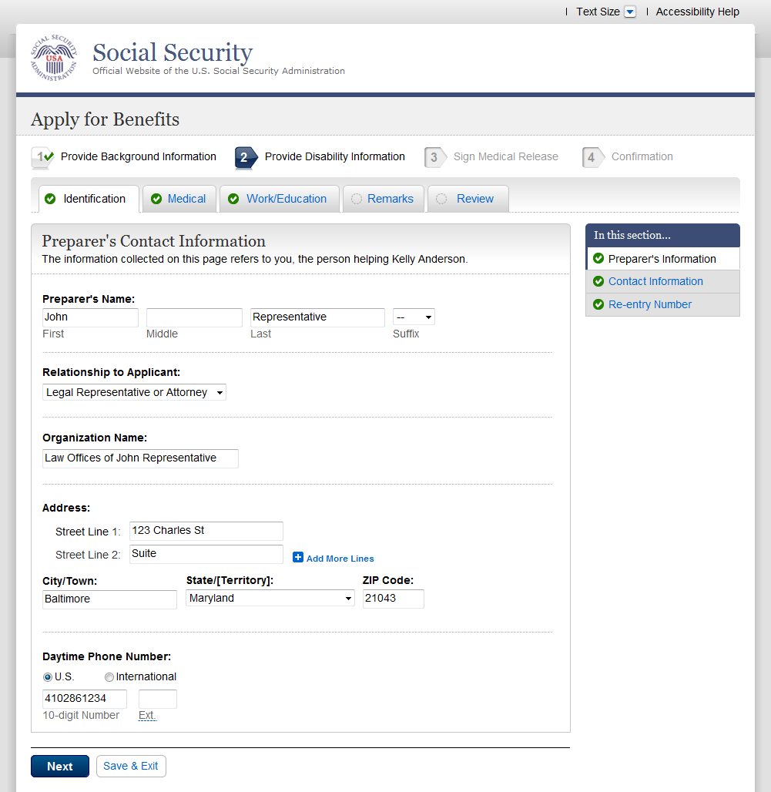

- Rcm001-3_Preparer’s Contact Information (i3368 only)
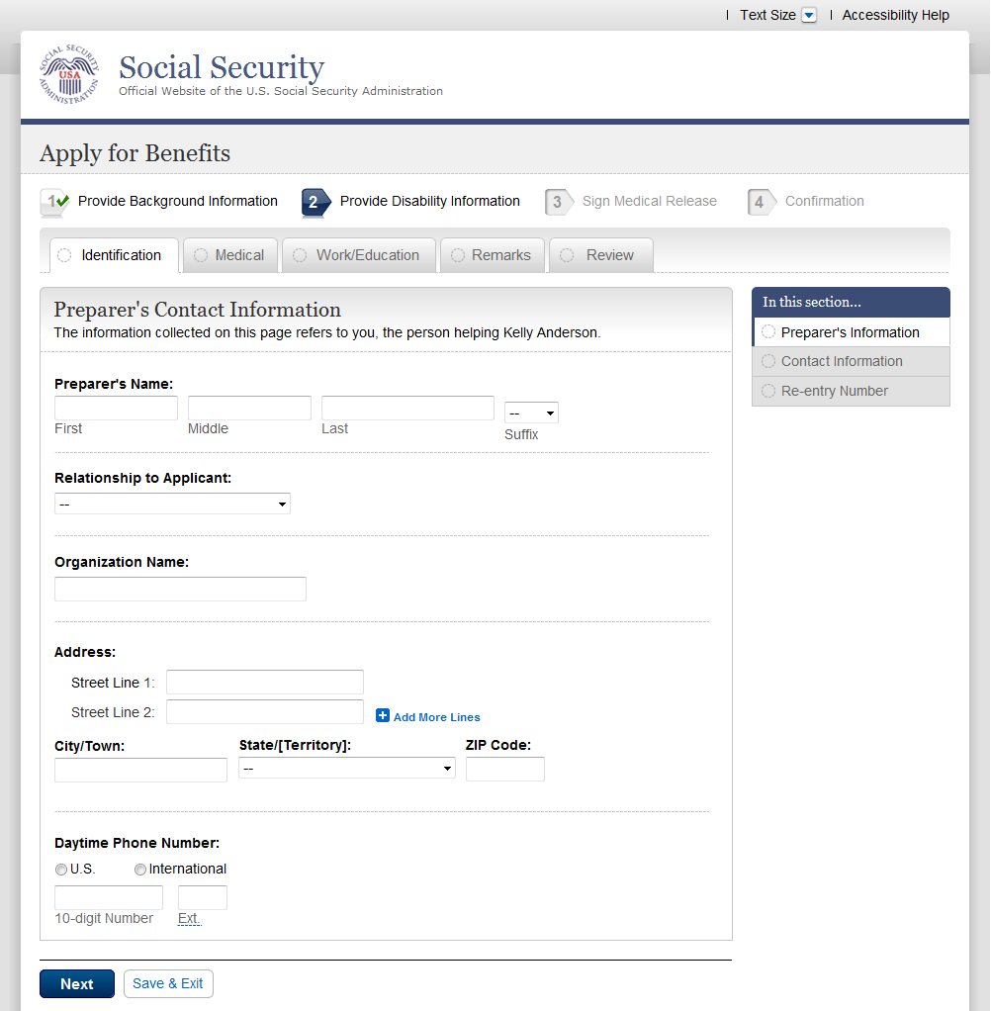

- Pin001-3_Contact Information
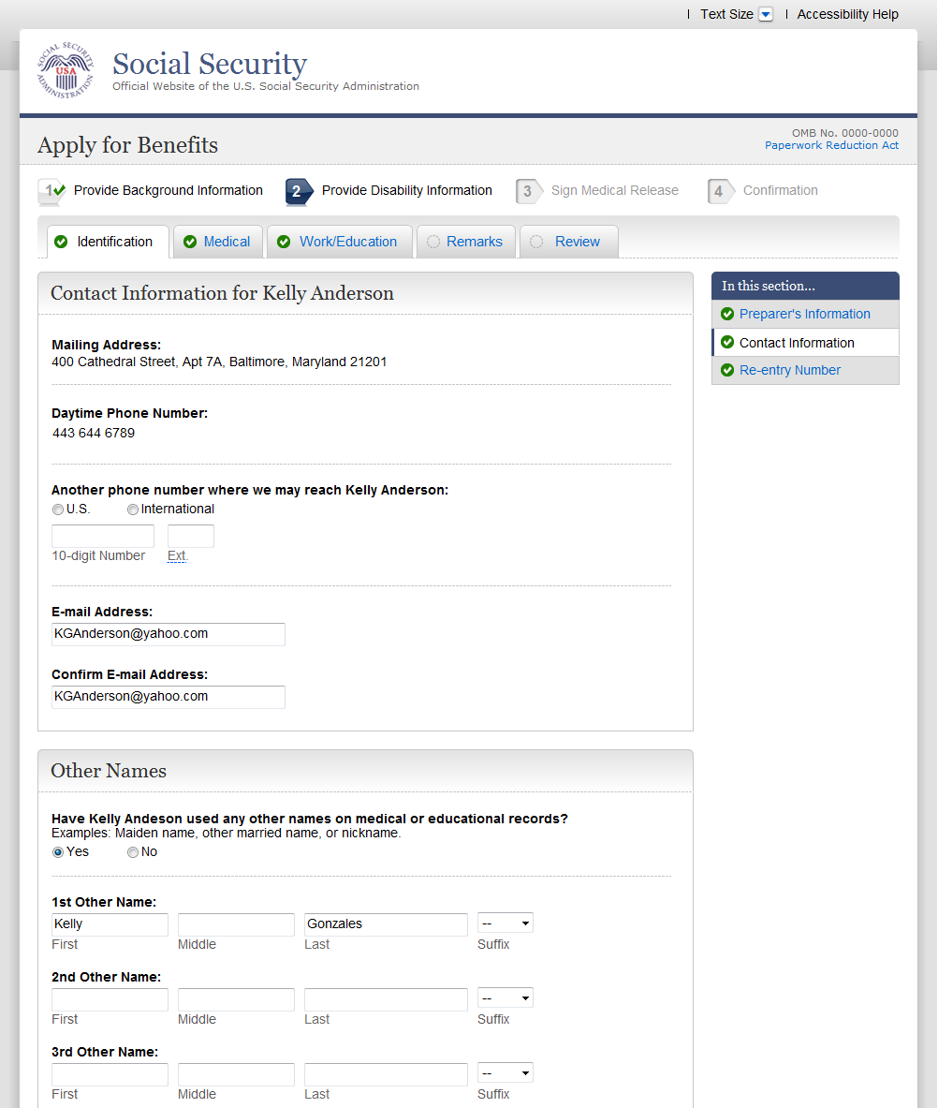

- Pin001-3_Contact Information (i3368 only)
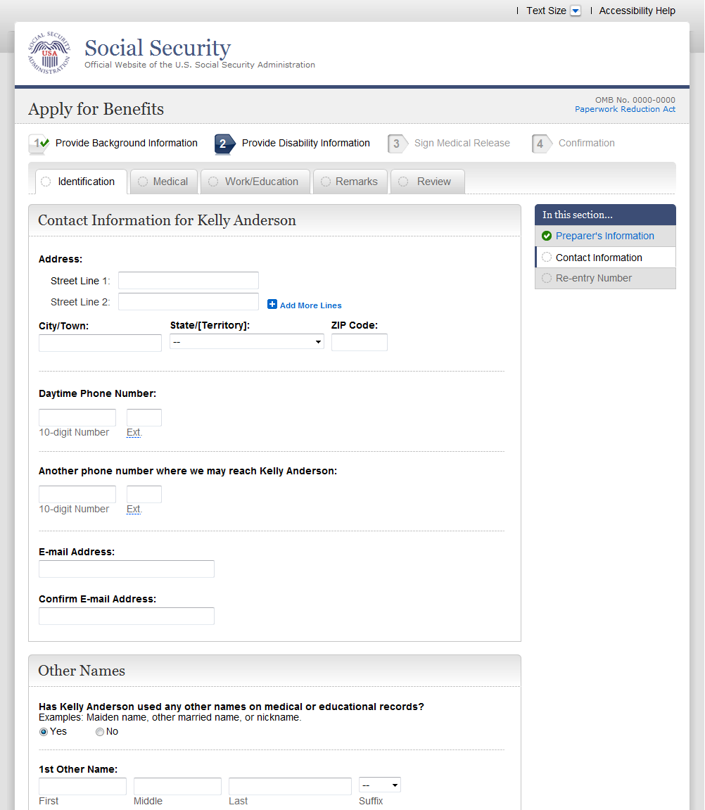

- Re-entry Number
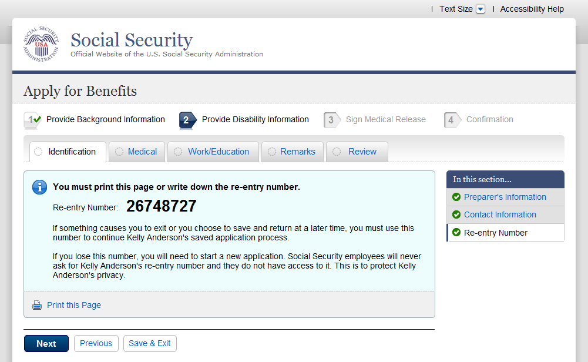

- Re-entry Number (i3368 only)
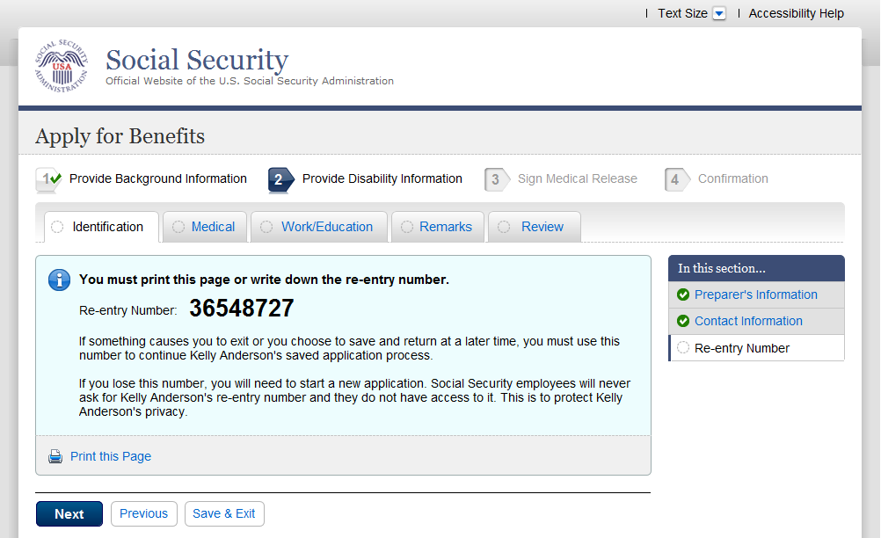

- Confirm Your Identity On Re-entry (1st party to 3rd party)
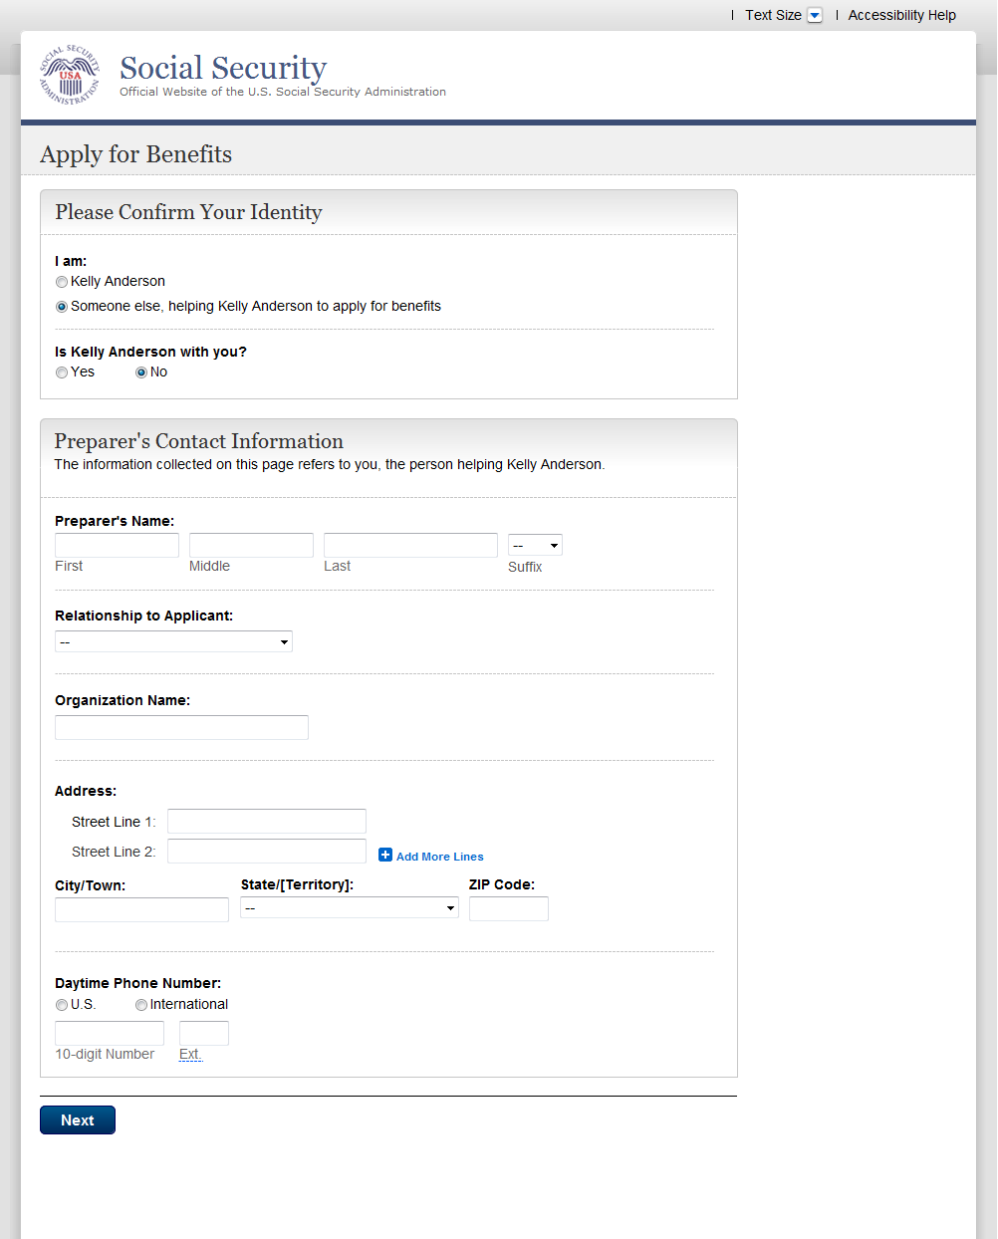

- Confirm Your Identity On Re-entry (3rd party to a different 3rd party)
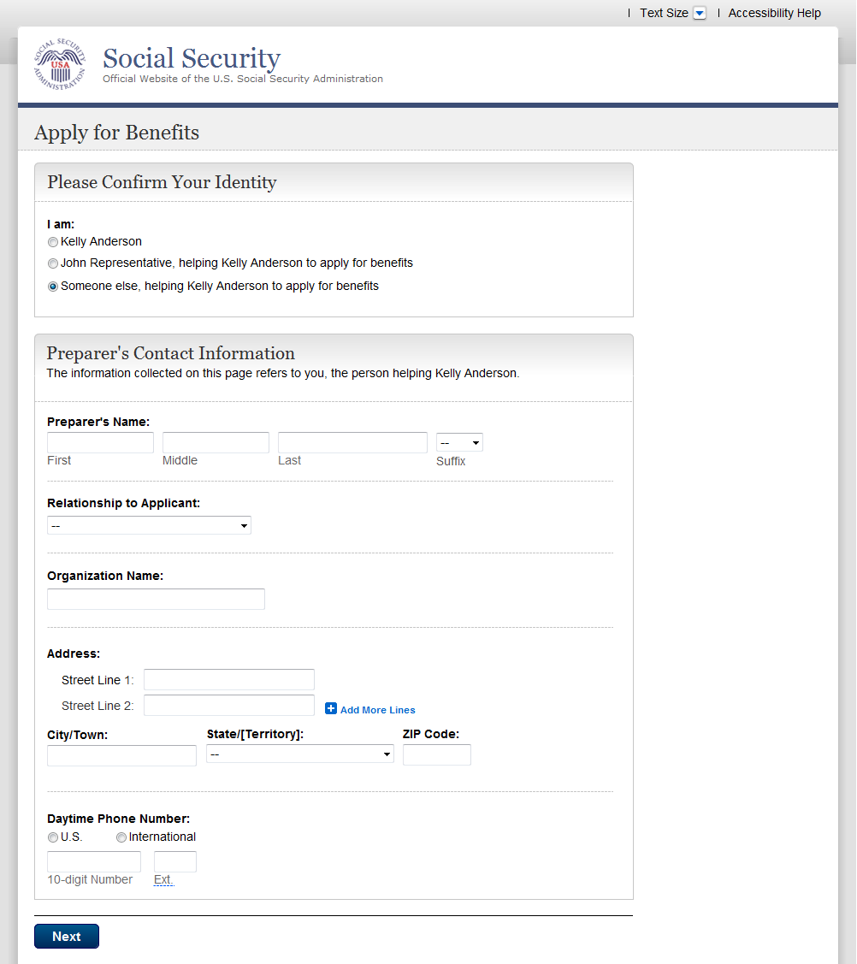

- Alg001-3_Conditions
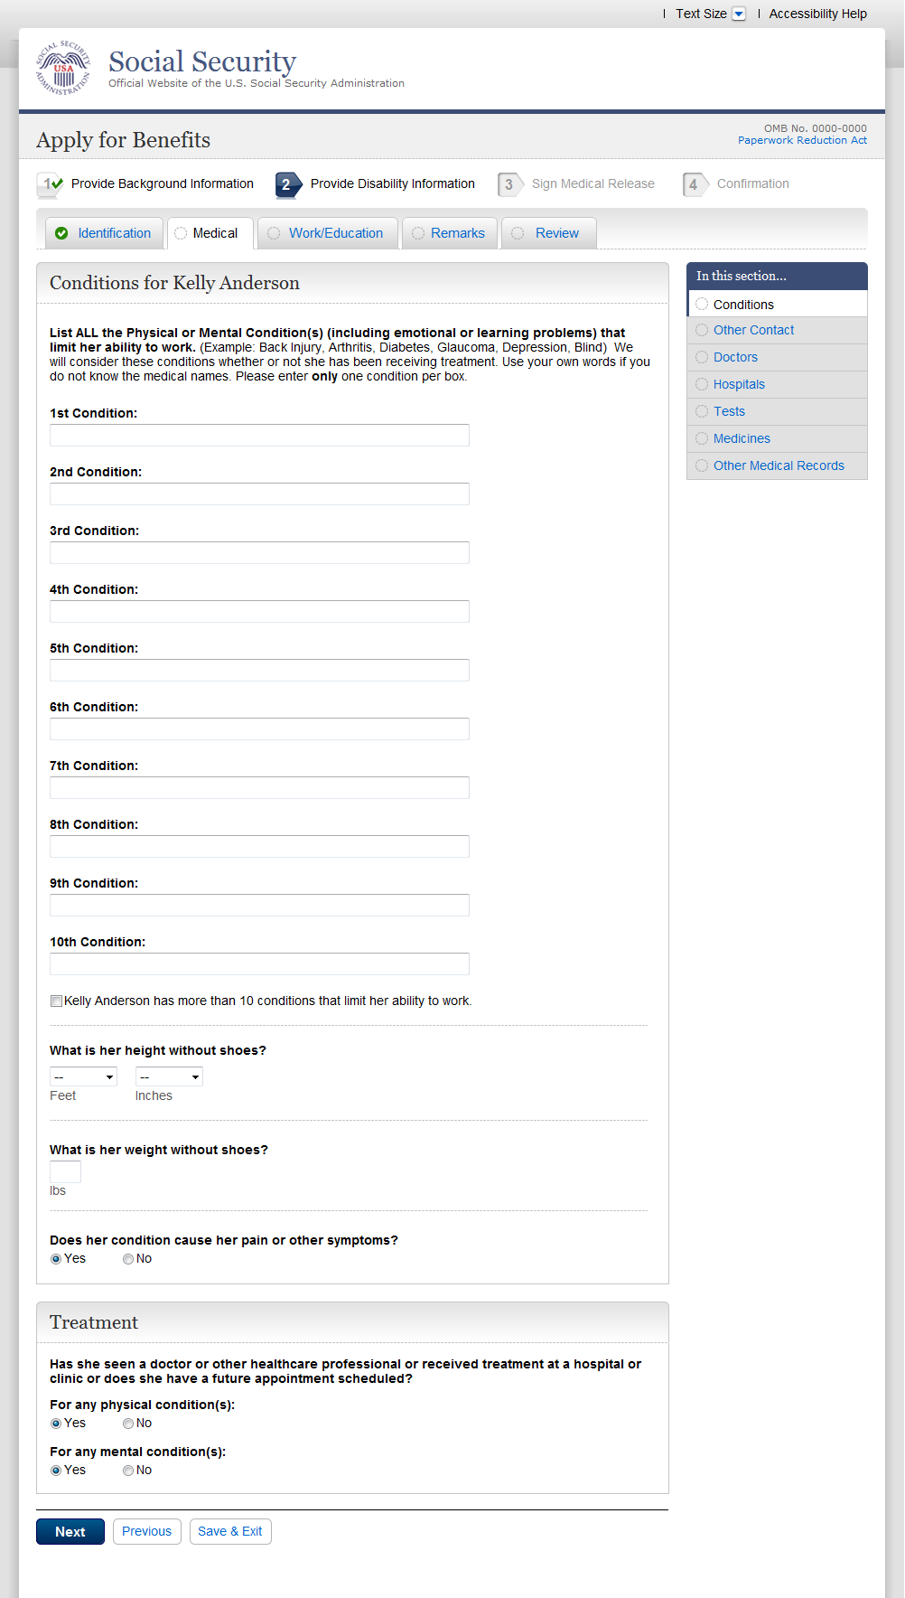

- Con001-3_Someone Who Knows About Your Condition
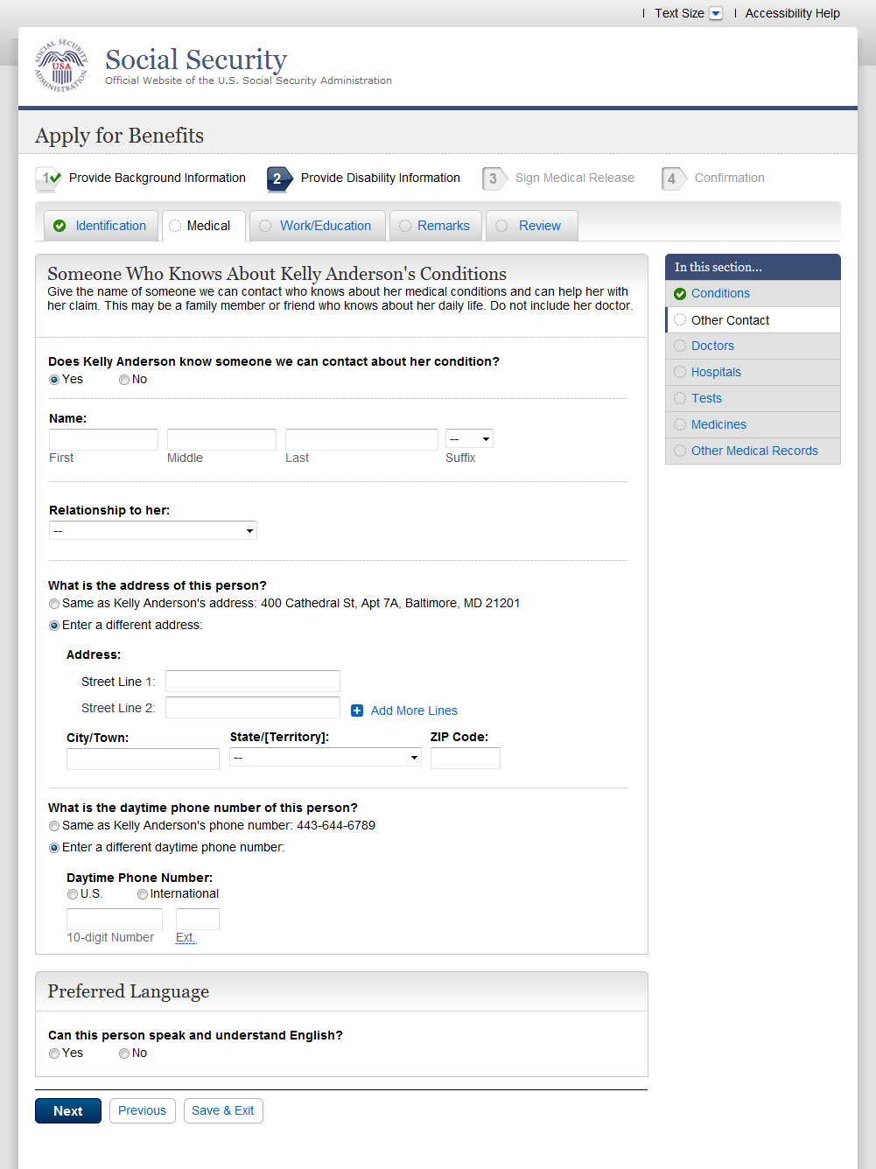

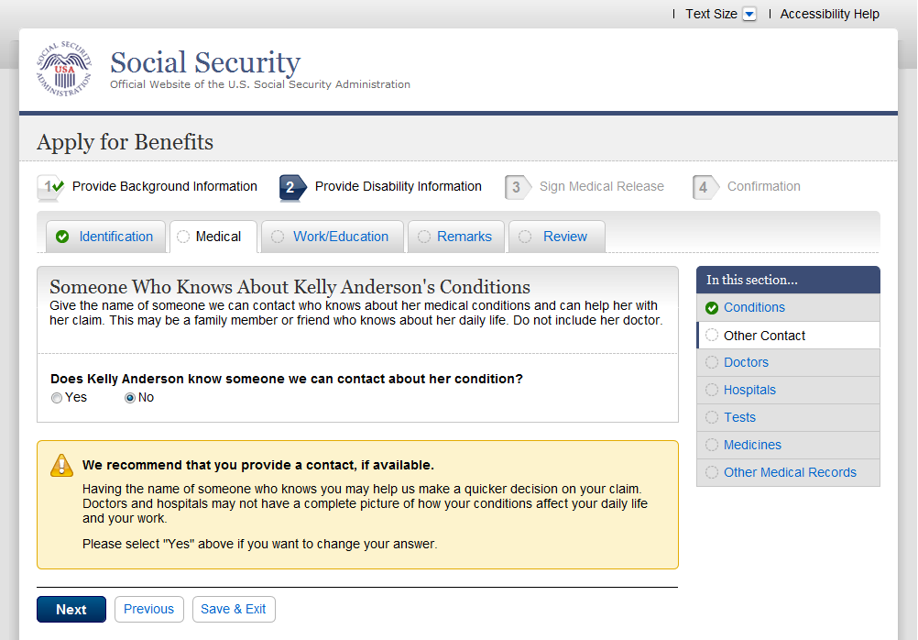

- Doc001-3_Doctors and Healthcare Professionals
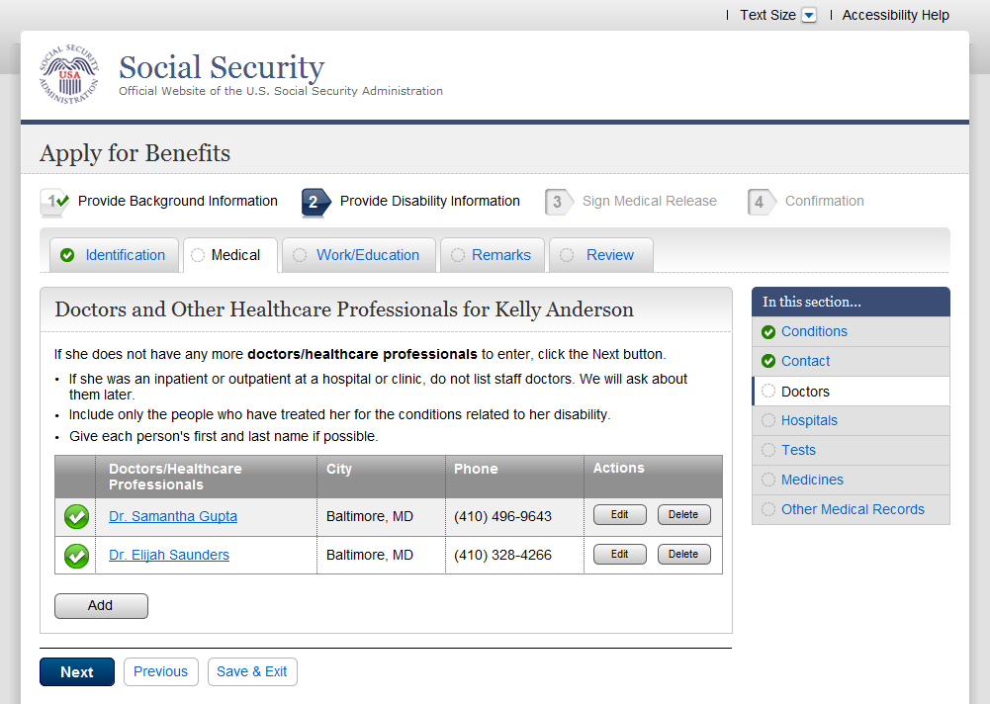

- Doc002-3_Doctors and Healthcare Professionals Details

- Hos001-3_Hospitals and Clinics
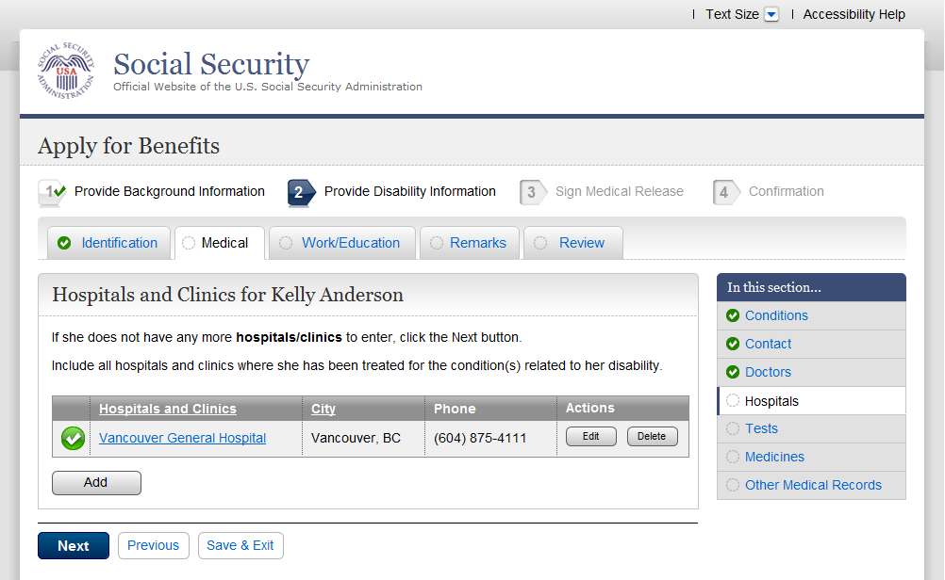

- Hos002-3_Hospitals and Clinics Details

- Tst001-3_Medical Tests
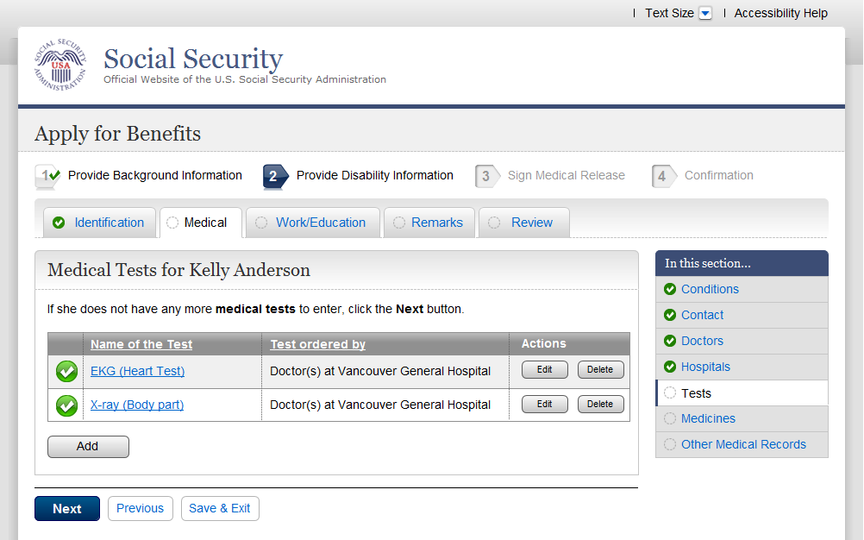

- Tst002-3_Medical Test Details
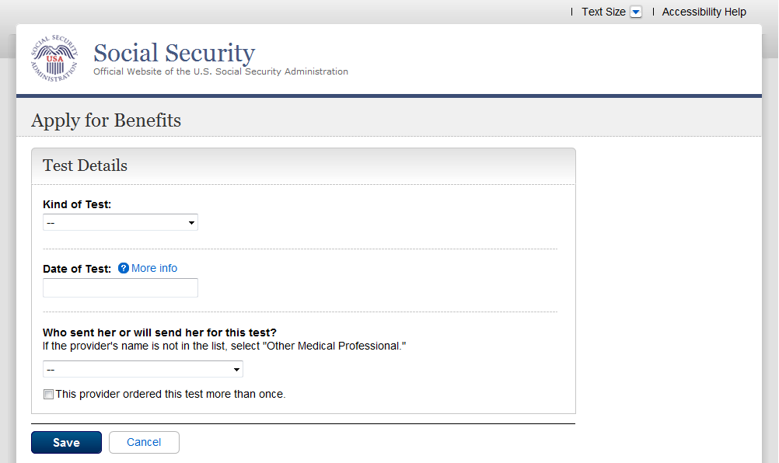

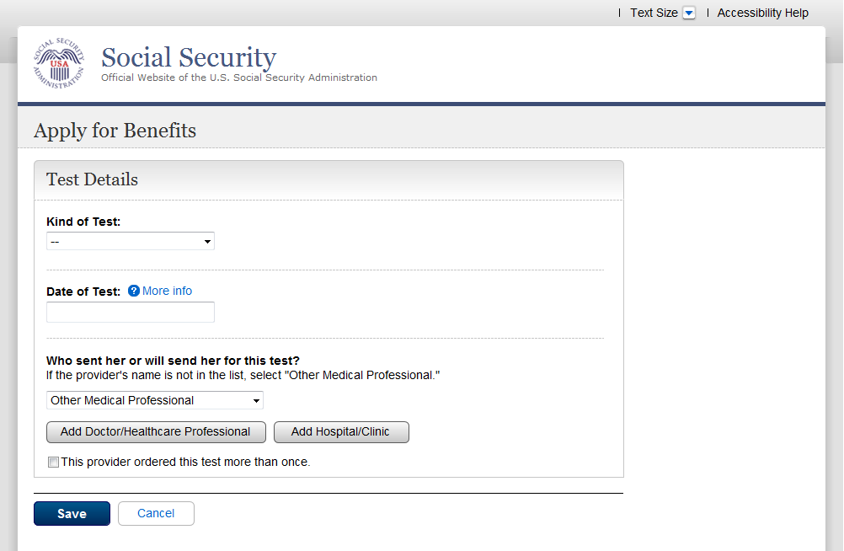

Note: When user selects “Other Medical Professional” in the dropdown for “Who sent you…”, the buttons “Add Doctor/Healthcare Professional” and “Add Hospital/Clinic” are displayed on the screen. It is mandatory for the user to select either of the buttons in order to continue.

When user selects either of the buttons, he is taken to Doctor or Hospital details page. Any action on the Doctor or Hospital details page should navigate them to the Tests page (Tst001-3_Medical tests)

- Med001-3_Medicines
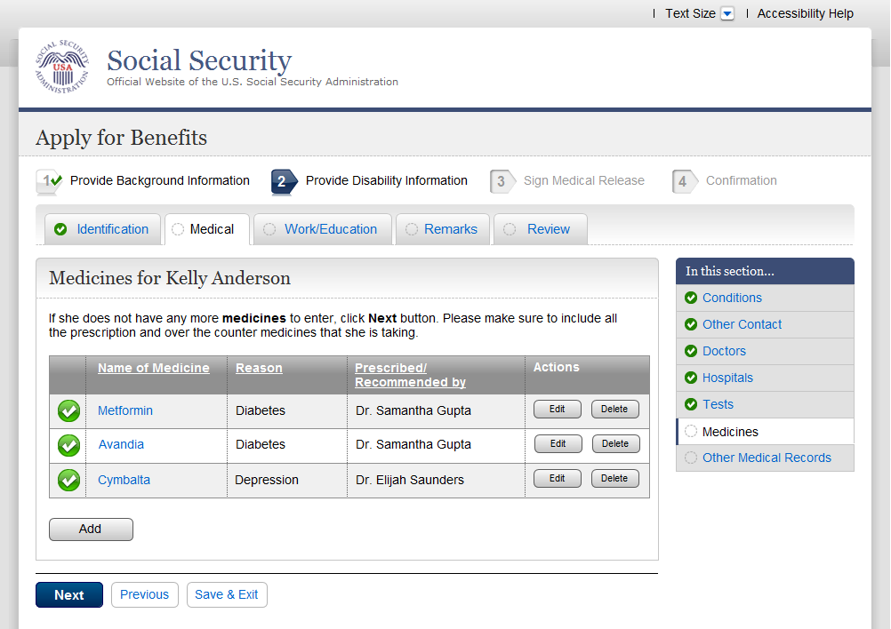

- Med002-3_Medicine Details
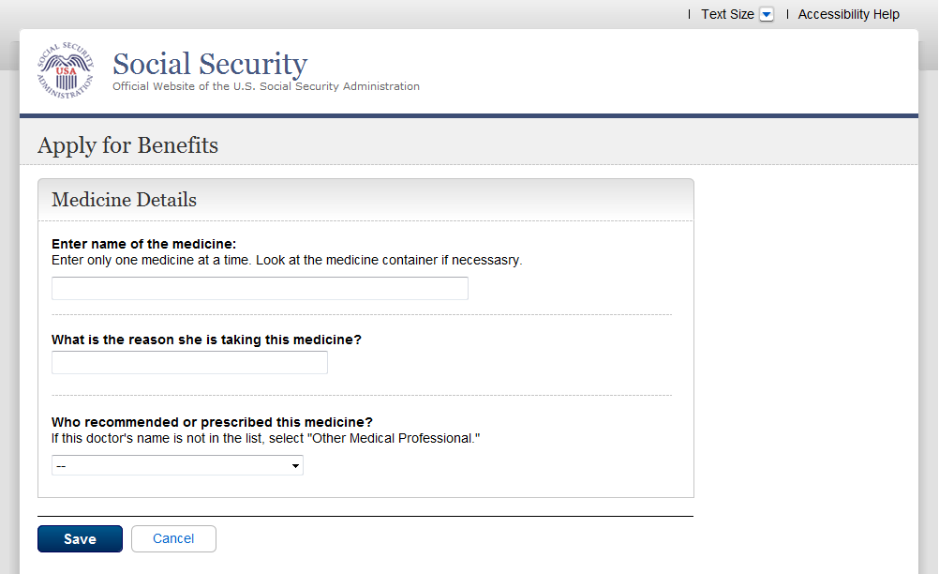

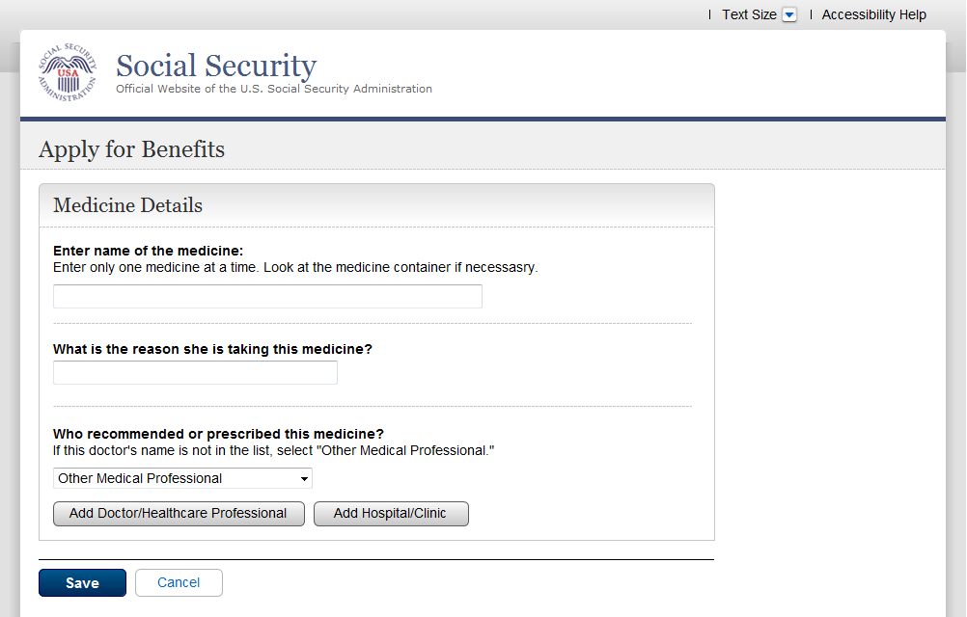

Note: When user selects “Other Medical Professional” in the dropdown for “Who recommended…”, the buttons “Add Doctor/Healthcare Professional” and “Add Hospital/Clinic” are displayed on the screen. It is mandatory for the user to select either of the buttons in order to continue.

When user selects either of the buttons, he is taken to Doctor or Hospital details page. Any action on the Doctor or Hospital details page should navigate them to the Medicines page (Med001-3_Medicines)

- Msc001-3_Other Medical Records
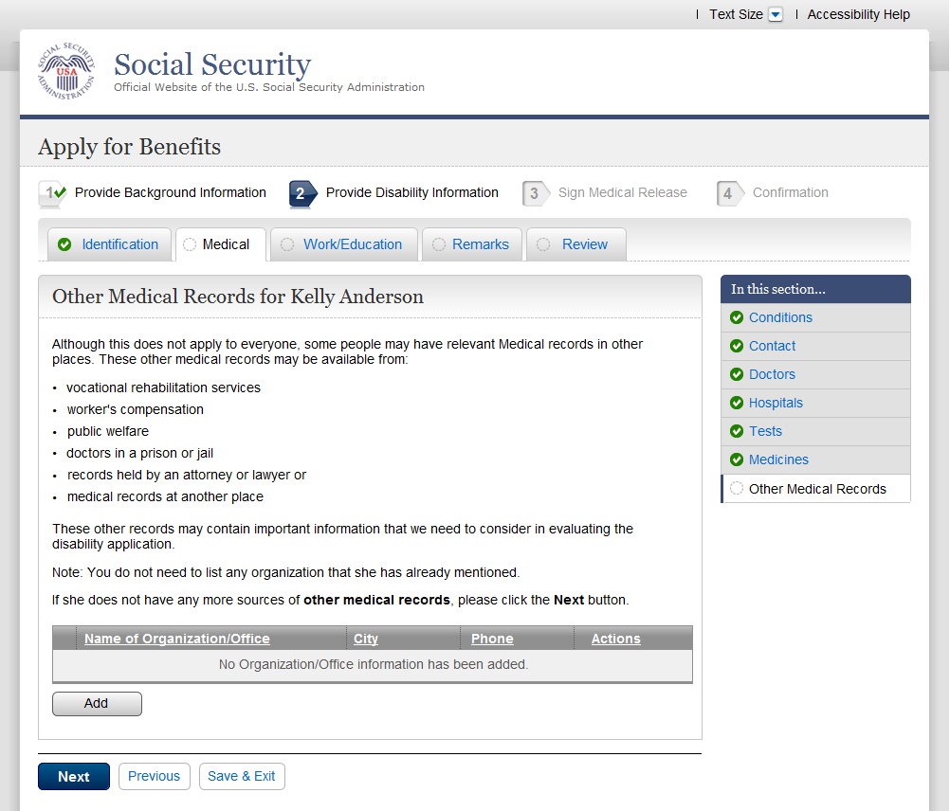

- Msc002-3_Other Medical Record Details
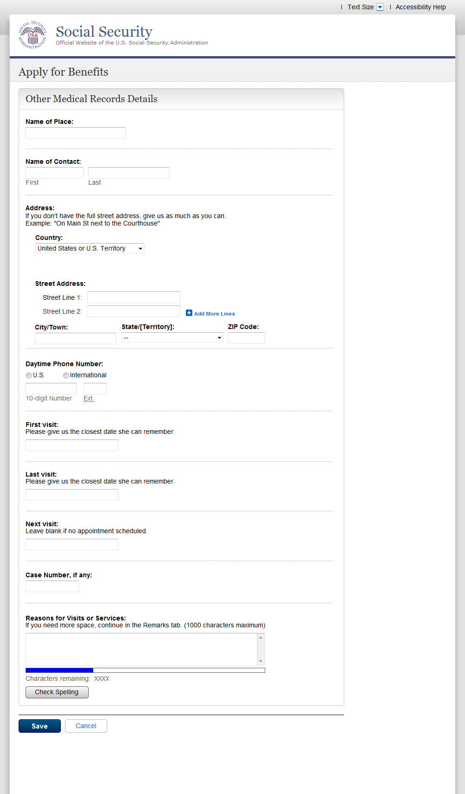

- Win001-3_Work Status
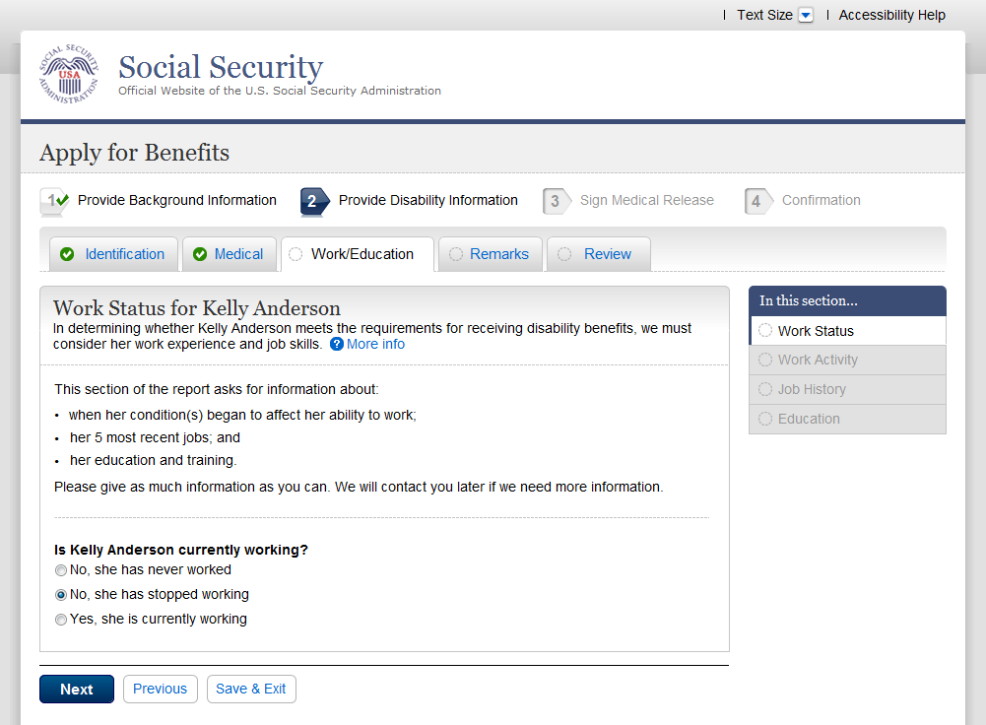

- Wac001-3-sw_Work Activity
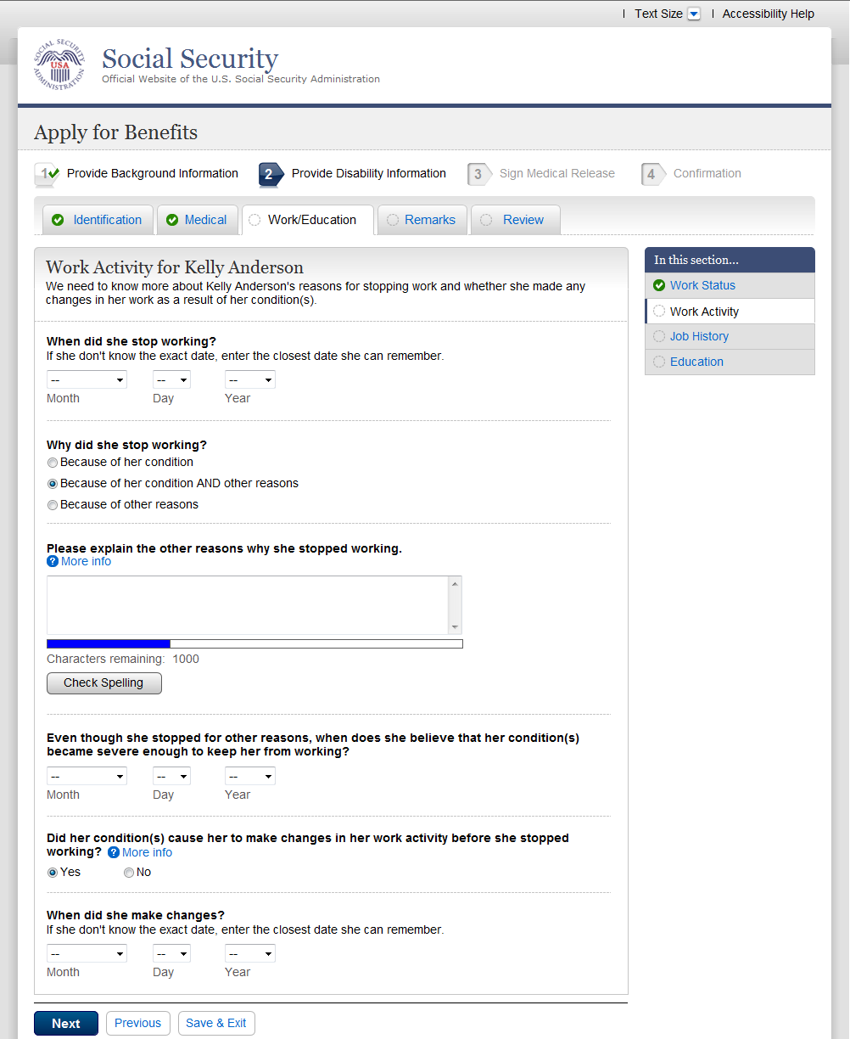
- Wac001-3-cw_Work Activity
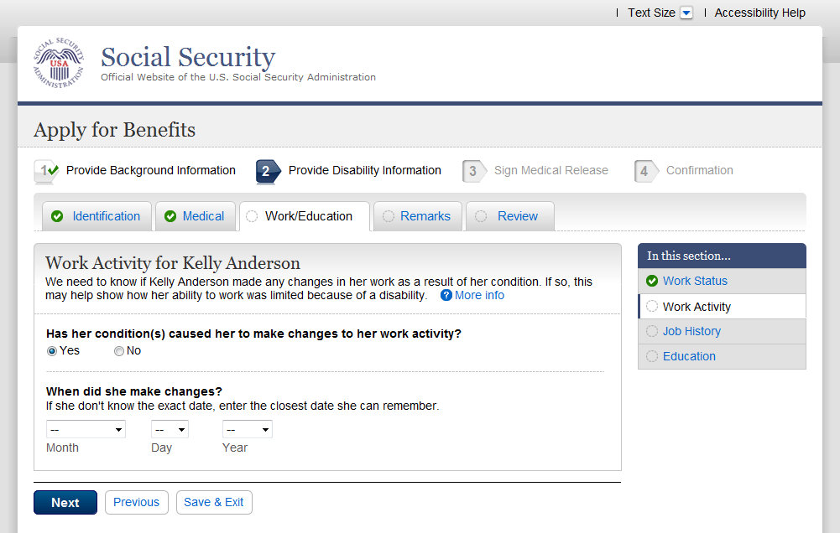

- Wac001-3-nw_Work Activity
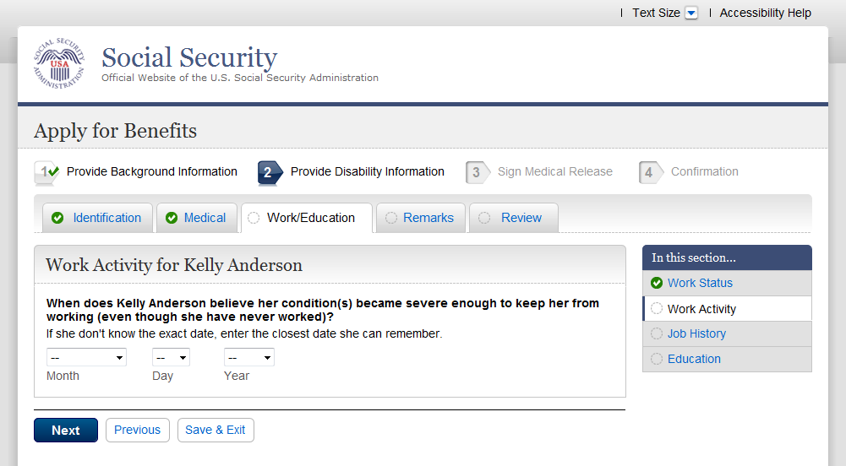

- Job001-3-sw_Job History

- Job 001-3-cw_Job History

- Job 001-3-nw_Job History
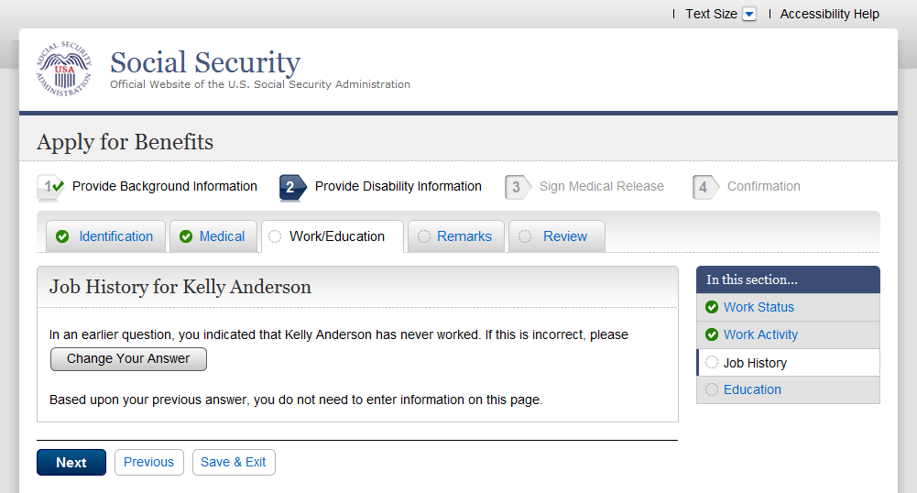

- Edu001-3_Education and Training
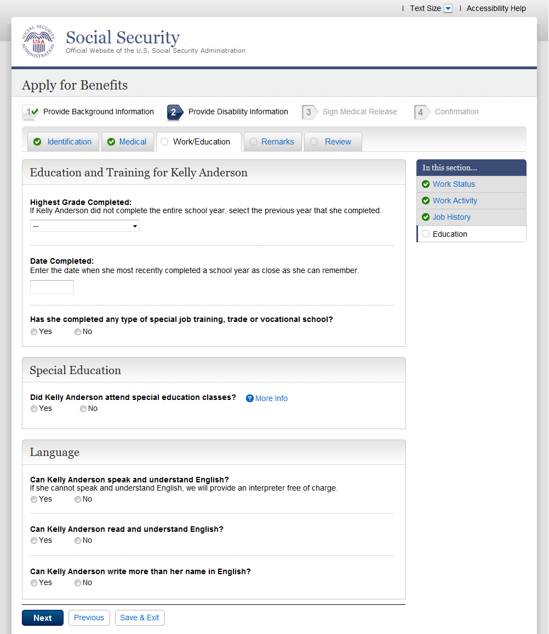

- Rmk001-3_Remarks
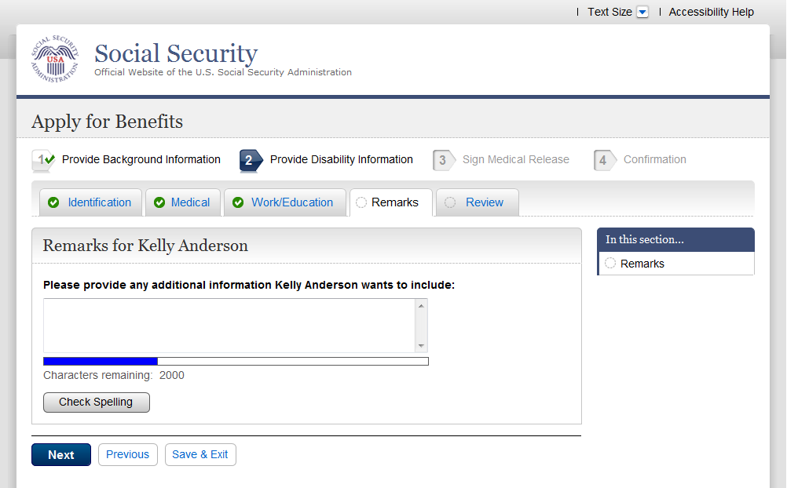

- Rvw001-3_Review (i3368)

