iratDHS.gov

 |  |  | Select a Language: English Français Español | Q&A: Frequently Asked Questions


July 10, 2013
Effective June 27, 2013, CBP will no longer issue windshield decal stickers for vehicles using the SENTRI lanes.
If you had a pending application for a replacement decal sticker, your application will be cancelled. If you had an appointment scheduled to receive the decal, your appointment will be cancelled.
A refund will be initiated on your behalf for the $25 fee if you submitted your application through GOES. This refund may take up to six months to process.
Welcome to GOES - the Official U.S. Government Web Site
The Global Online Enrollment System allows registered users to enter their own applications for U.S. Customs and Border Protection (CBP) Trusted Traveler Programs, and approved members to edit their information as needed (mistakes on the original application cannot be corrected once the application is certified - your mistakes will need to be brought to the attention of CBP during your interview).
Once a completed application is certified by the applicant and the non-refundable payment is successfully processed, CBP will review it and determine whether or not to conditionally approve the application. If your application is conditionally approved, your GOES account will be updated to instruct you to schedule an appointment for an interview. Every individual who would like to apply for membership - children included and multiple applicants in one household- must create a separate account within GOES, submit a separate application, and schedule a separate interview appointment upon conditional approval.
For more information regarding the CBP Trusted Traveler Programs, please click on the logos below. Thank you for your interest in Customs and Border Protection.
 |  |  |  |  |  |  | 

  Registered GOES users can log in here  Forgot your password or user ID? | If you are a new GOES user then you will need to provide some personal information and Trusted Traveler Membership Number (if already enrolled) to register.
    GOES User ID:
    Password:
  
  Click on the Activate Membership Card button to activate trusted traveler cards received by mail.
Paperwork Reduction Act Statement: An agency may not conduct or sponsor an information collection and a person is not required to respond to this information unless it displays a current valid OMB control number and an expiration date. The control number for this collection is 1651-0121. The estimated average time to complete this application is 40 minutes. If you have any comments regarding the burden estimate you can write to U.S. Customs and Border Protection, Office of Regulations and Rulings, 90 K Street, NE., Washington DC 20229. Expiration 2/28/2015

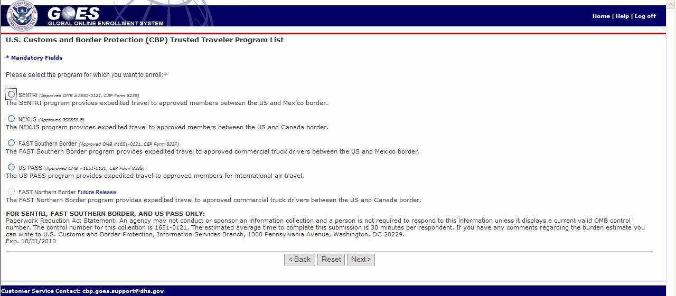

––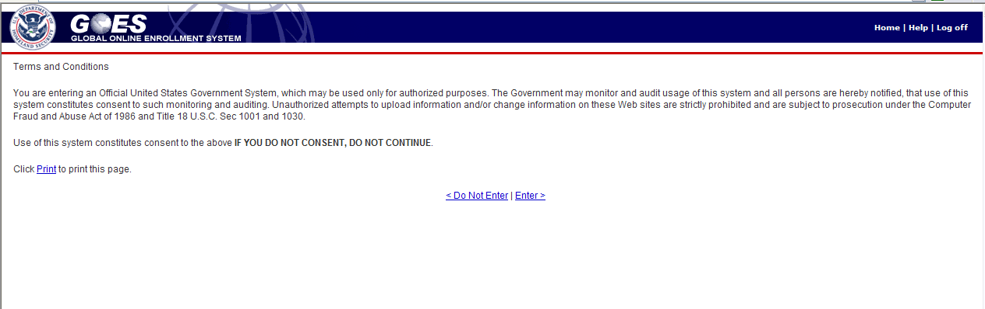
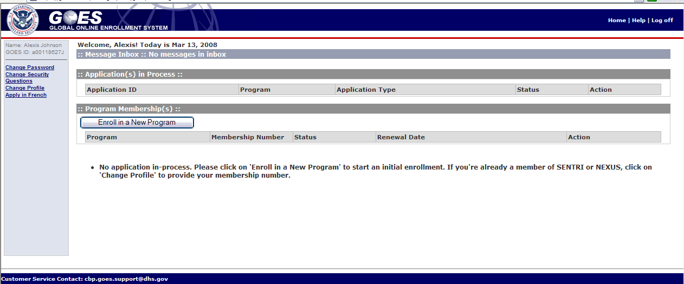

Personal Information
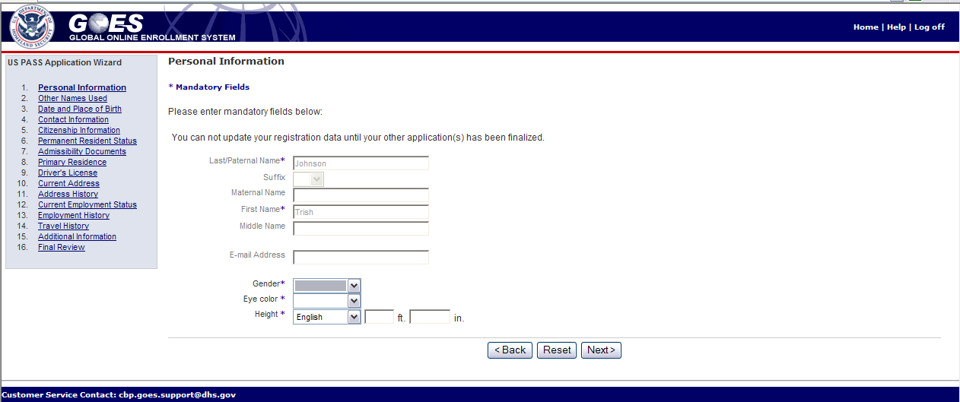

Date and Place of Birth
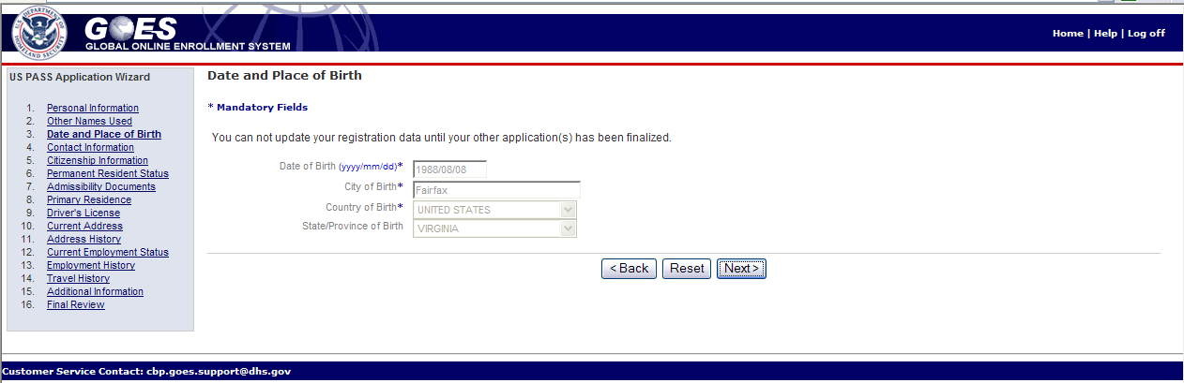

Citizenship Information
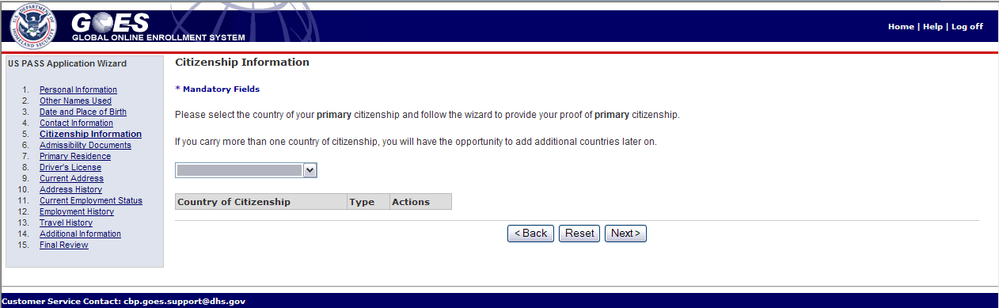

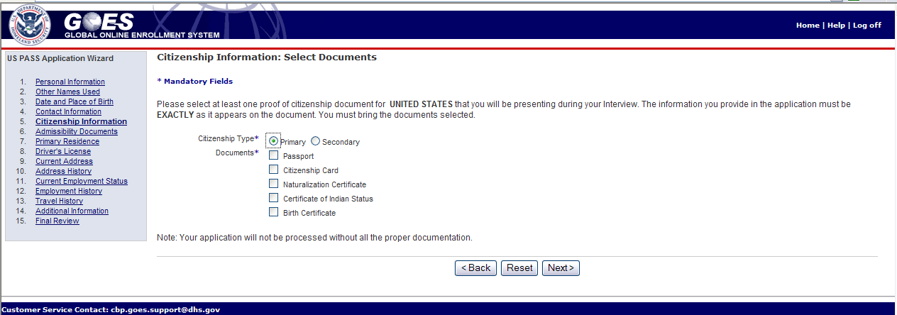

Admissibility Information
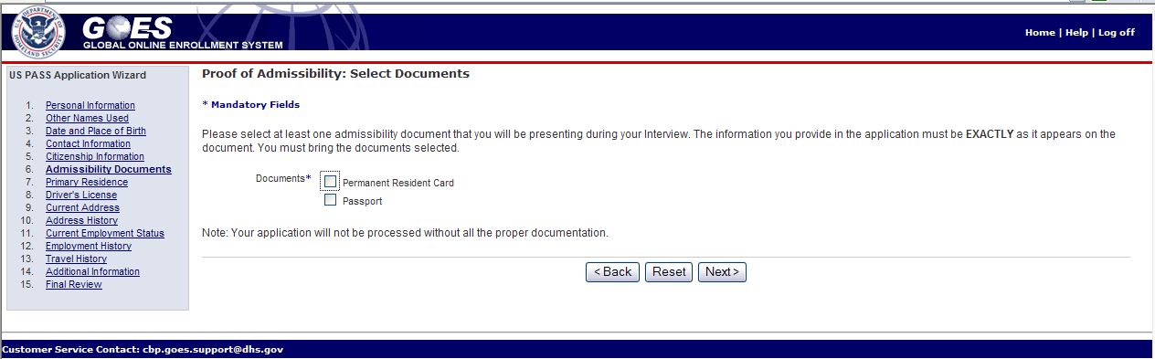

Primary Residence
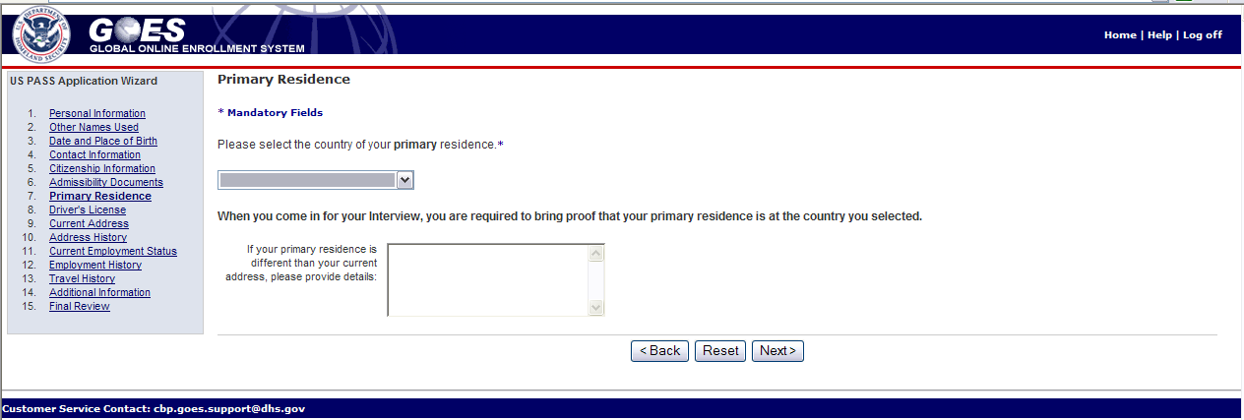

Current Address
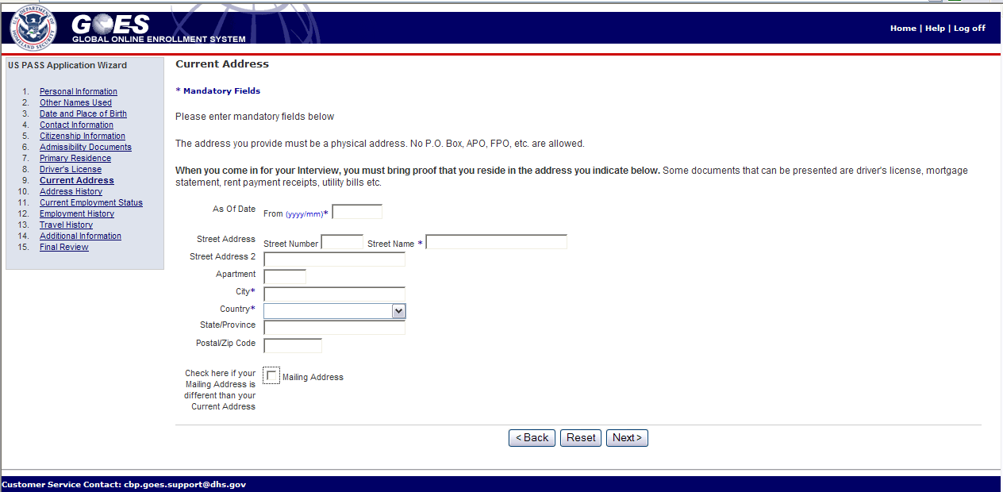

Address History
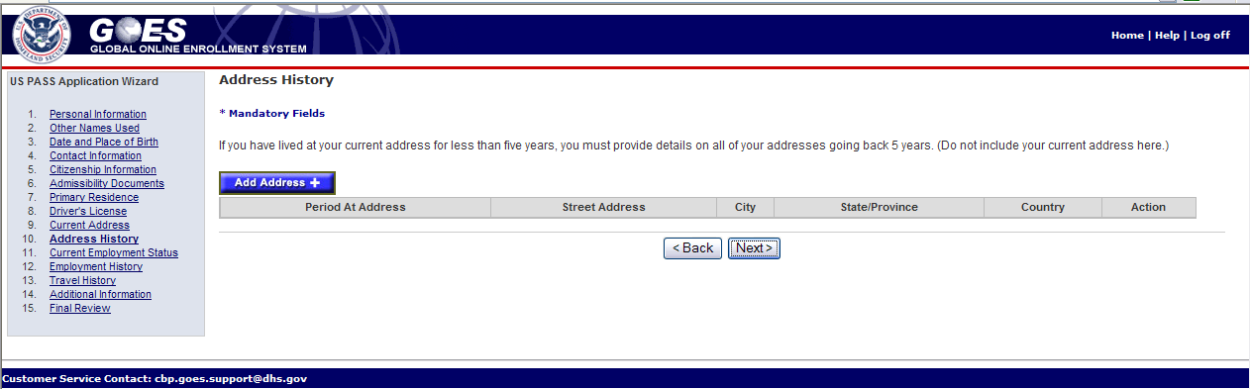

Employment History
