School official applies for SEVP certification by completing Form I-17, “Petition for Approval of School for Attendance by Nonimmigrant Student,” via SEVIS. [Page 1 of 5]
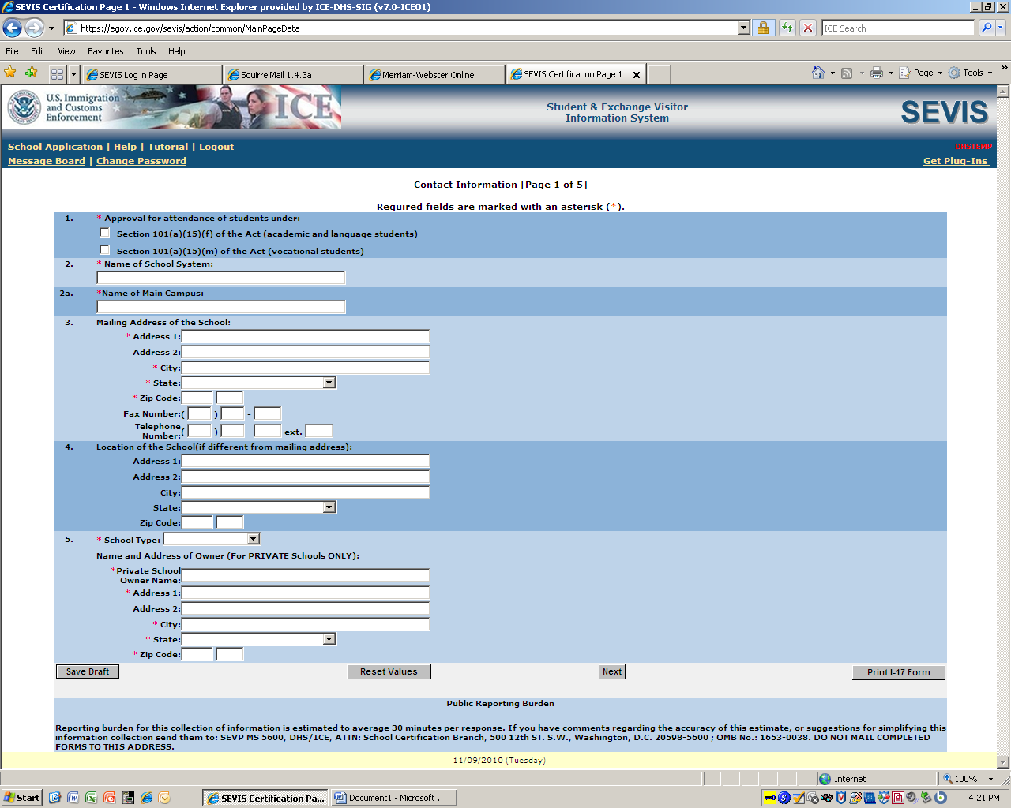
Program/course information [Page 2 of 5]
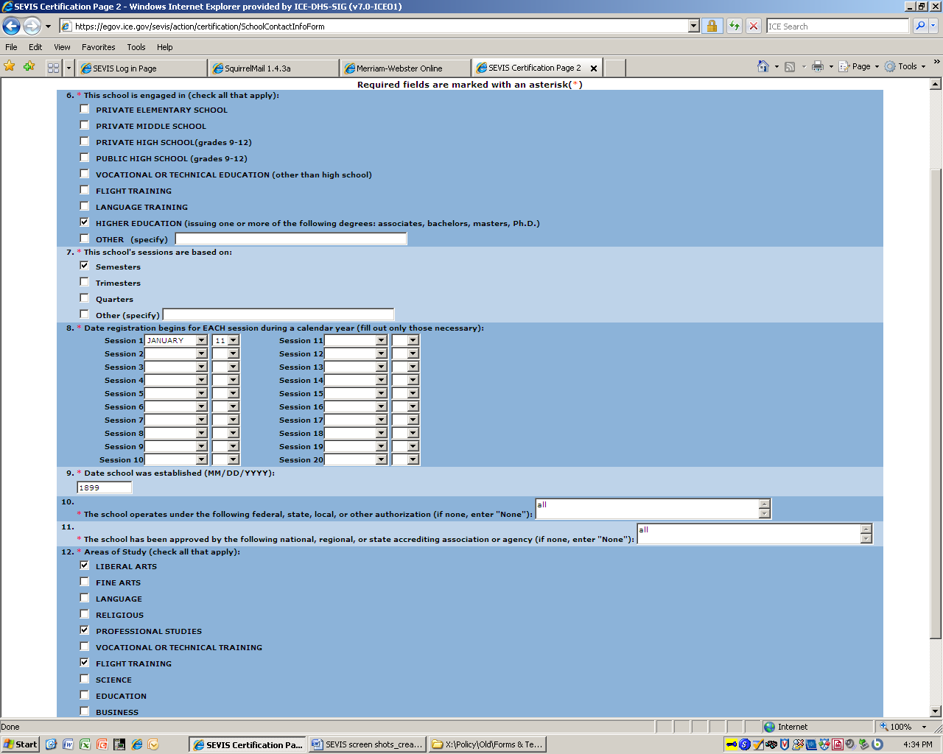
Program/course information [top portion of Page 3 of 5]
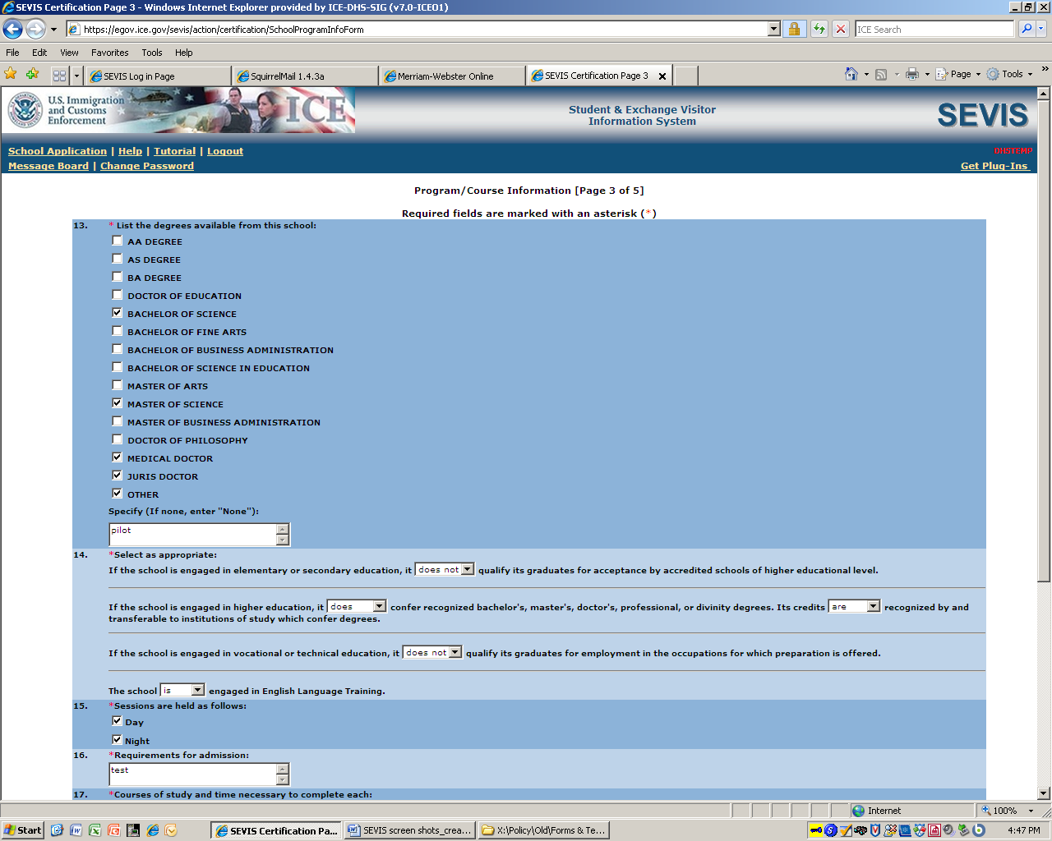

Program/course information [bottom portion of Page 3 of 5]
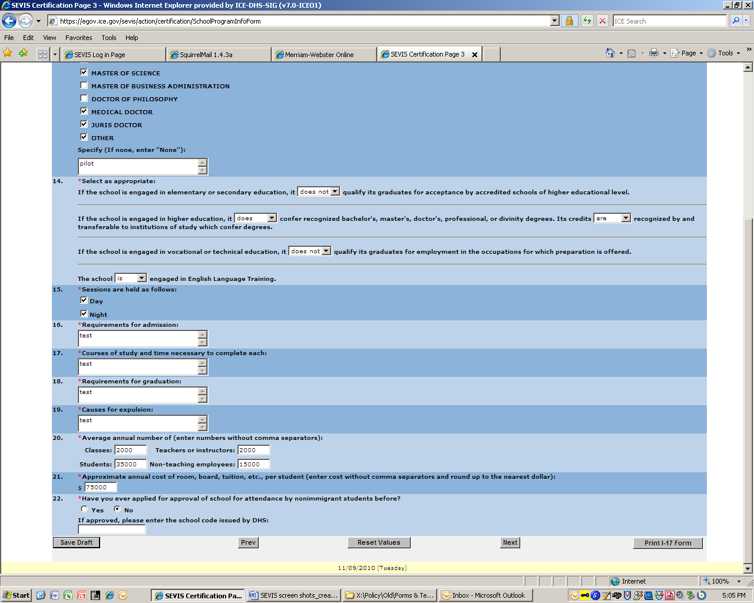
Add school official information [Page 4 of 5]

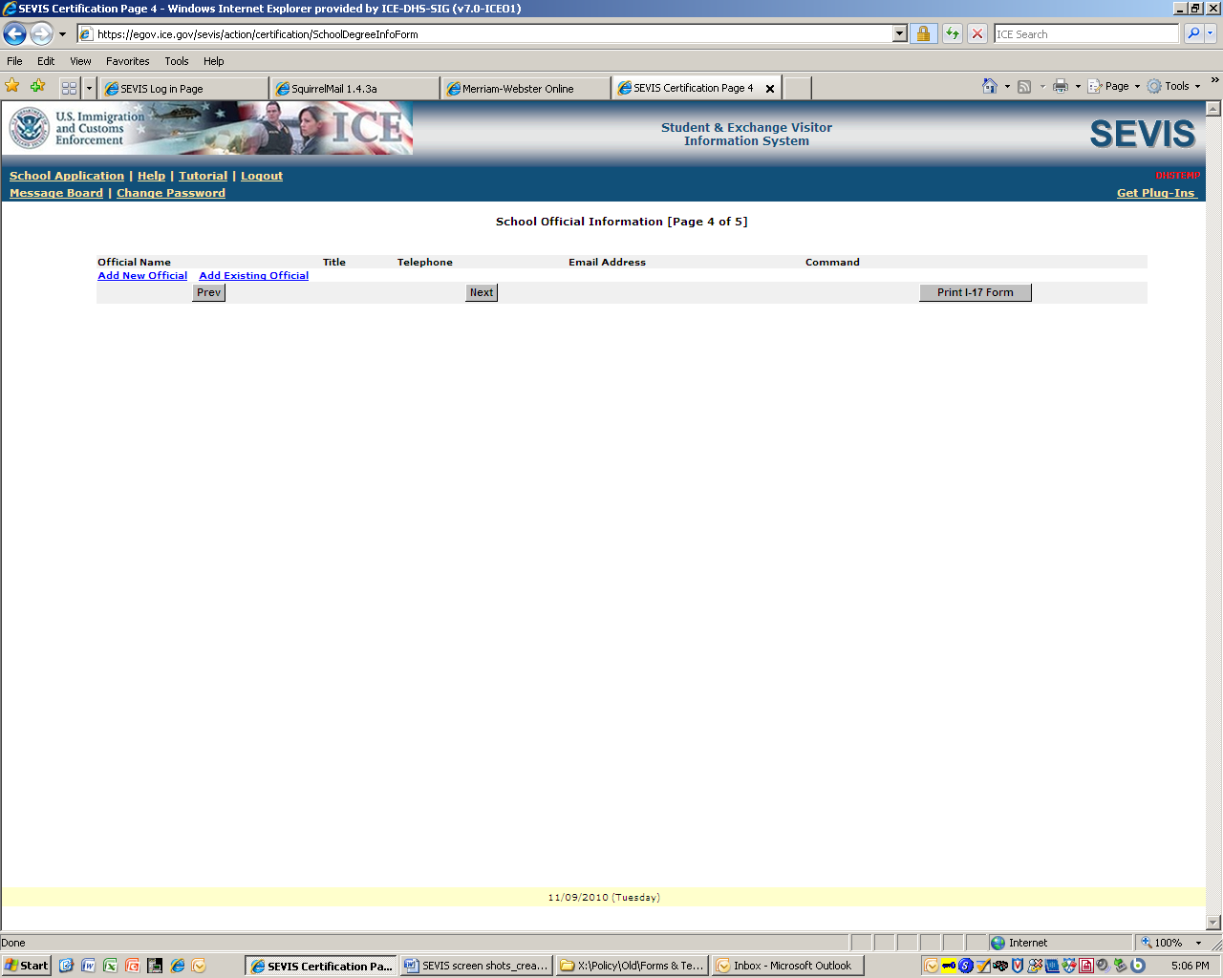

Add a designated school official
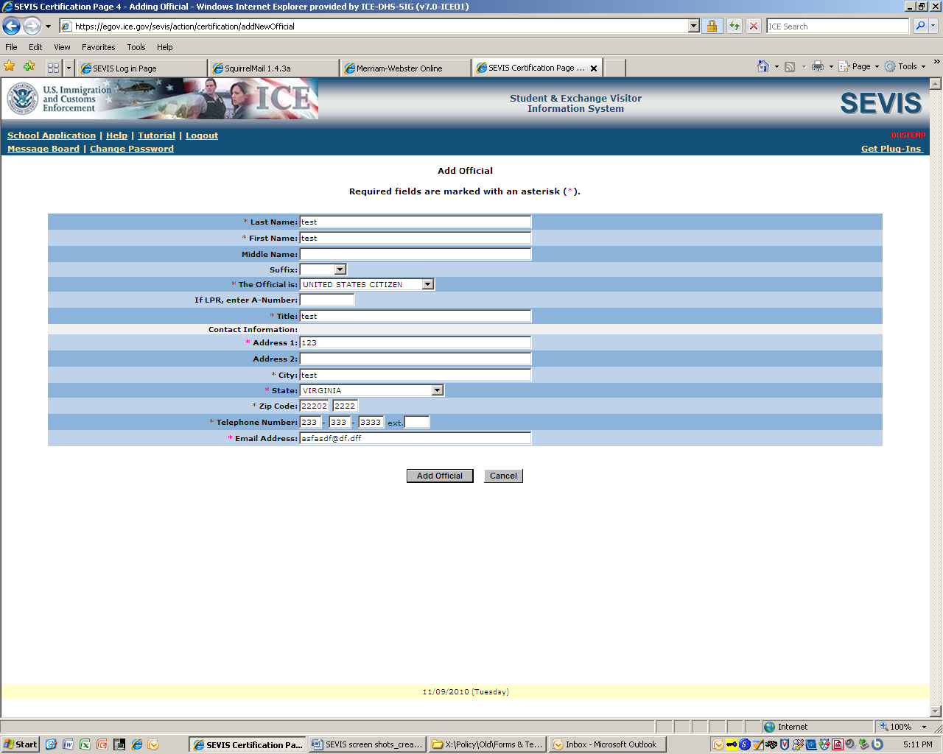

Campus information [Page 5 of 5]
At this screen, the school representative completing Form I-17 assigns primary designated school official and designated school official roles by clicking on the “Officials” link.

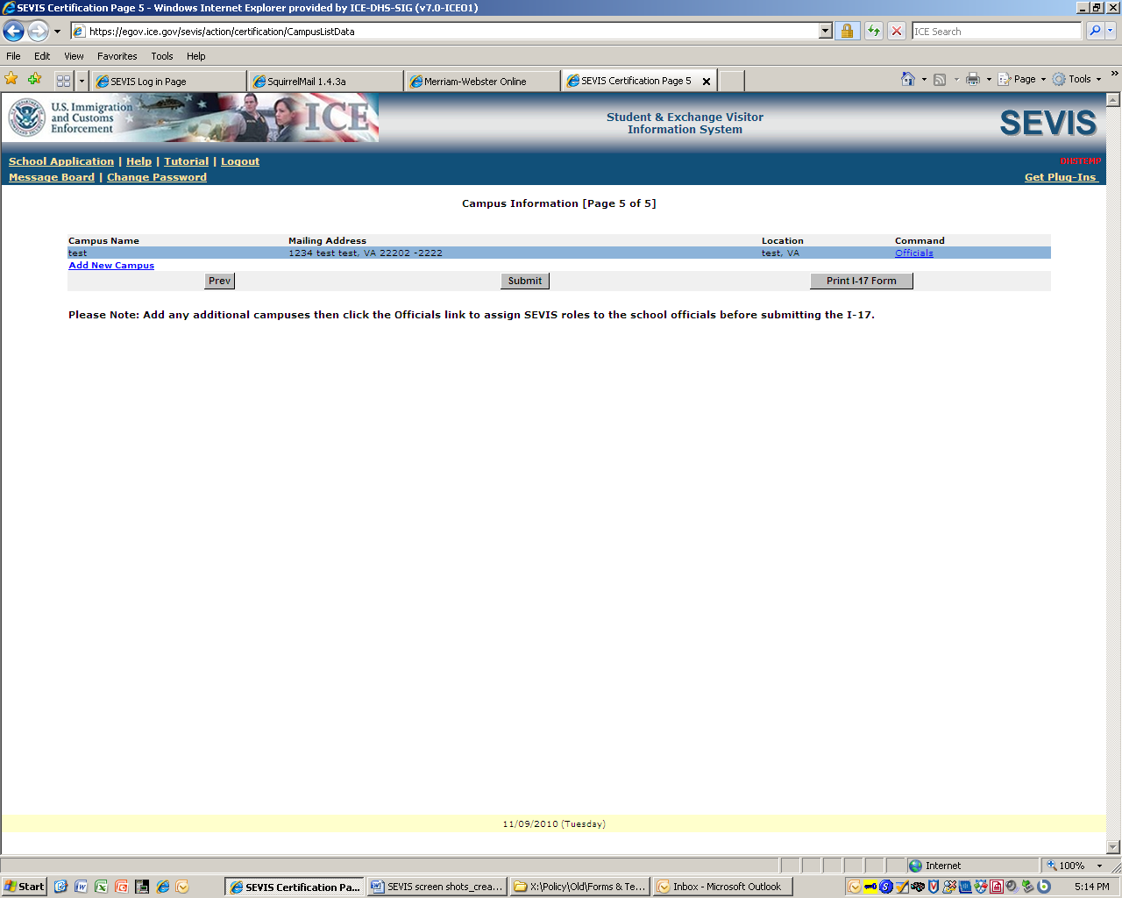

Assign primary designated school official (PDSO) and designated school official (DSO) roles.
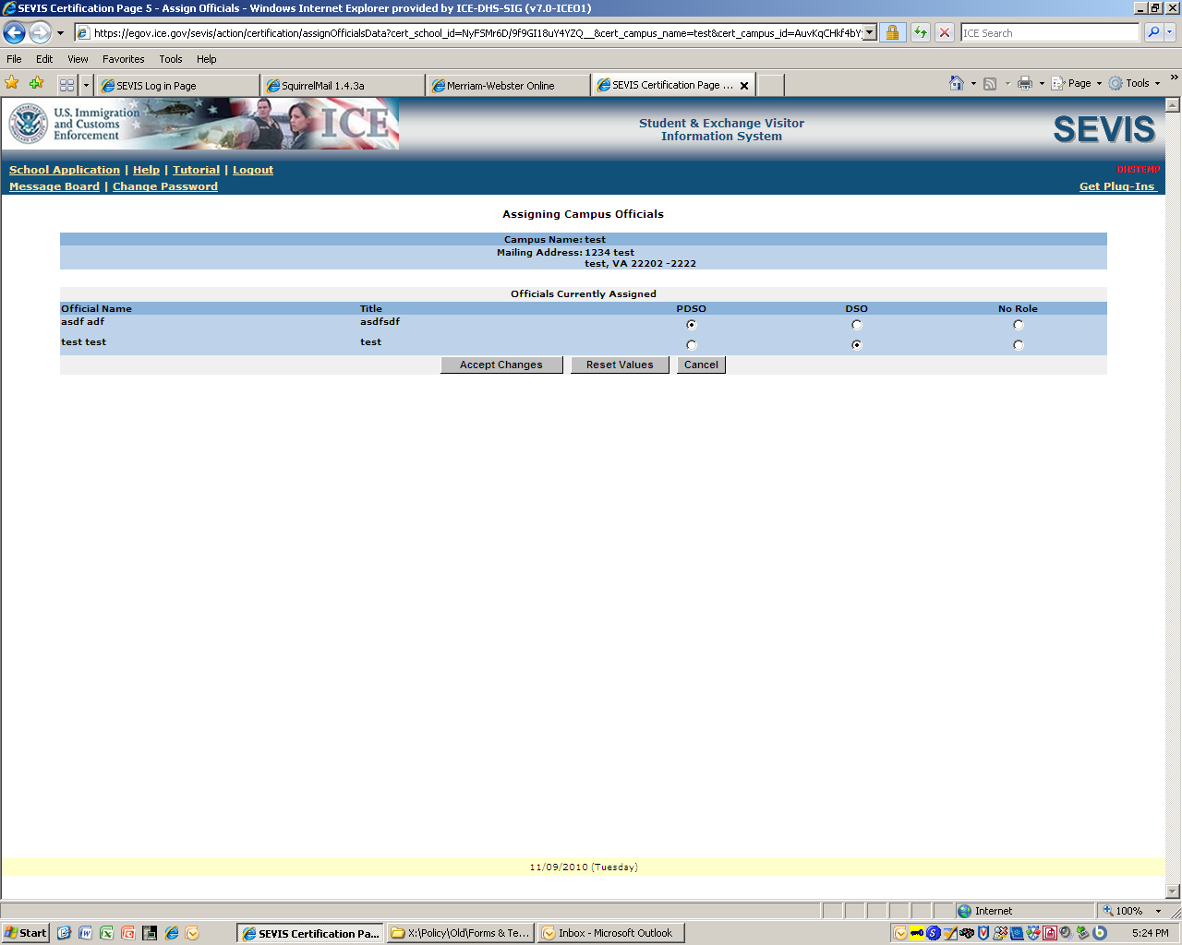
Applicant submits Form I-17
