Data entry screens for an F-1 Student SEVIS Record
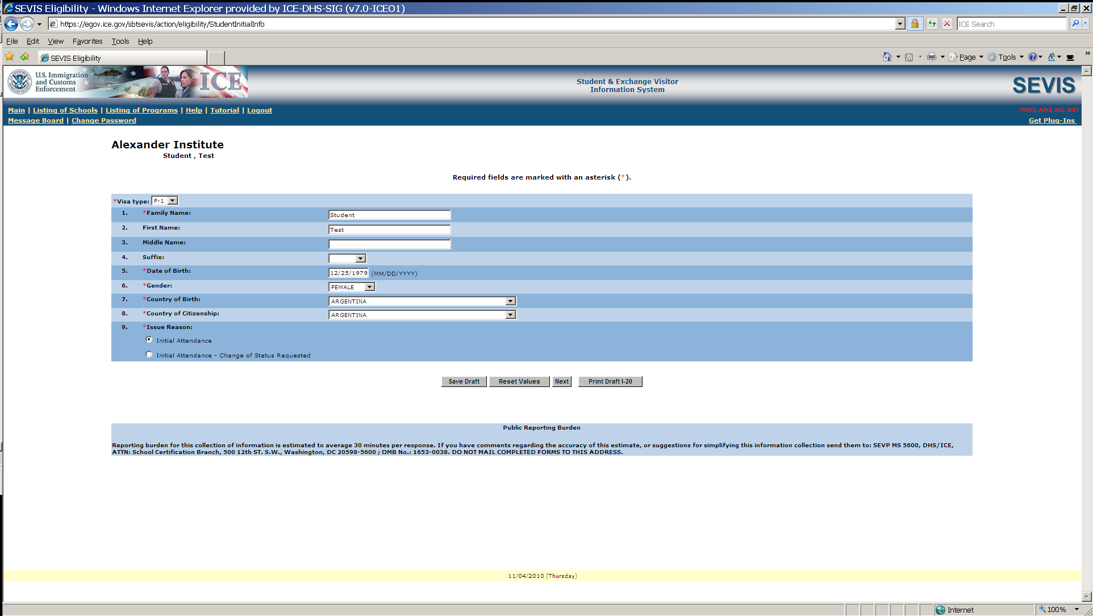

Data entry of personal and program information
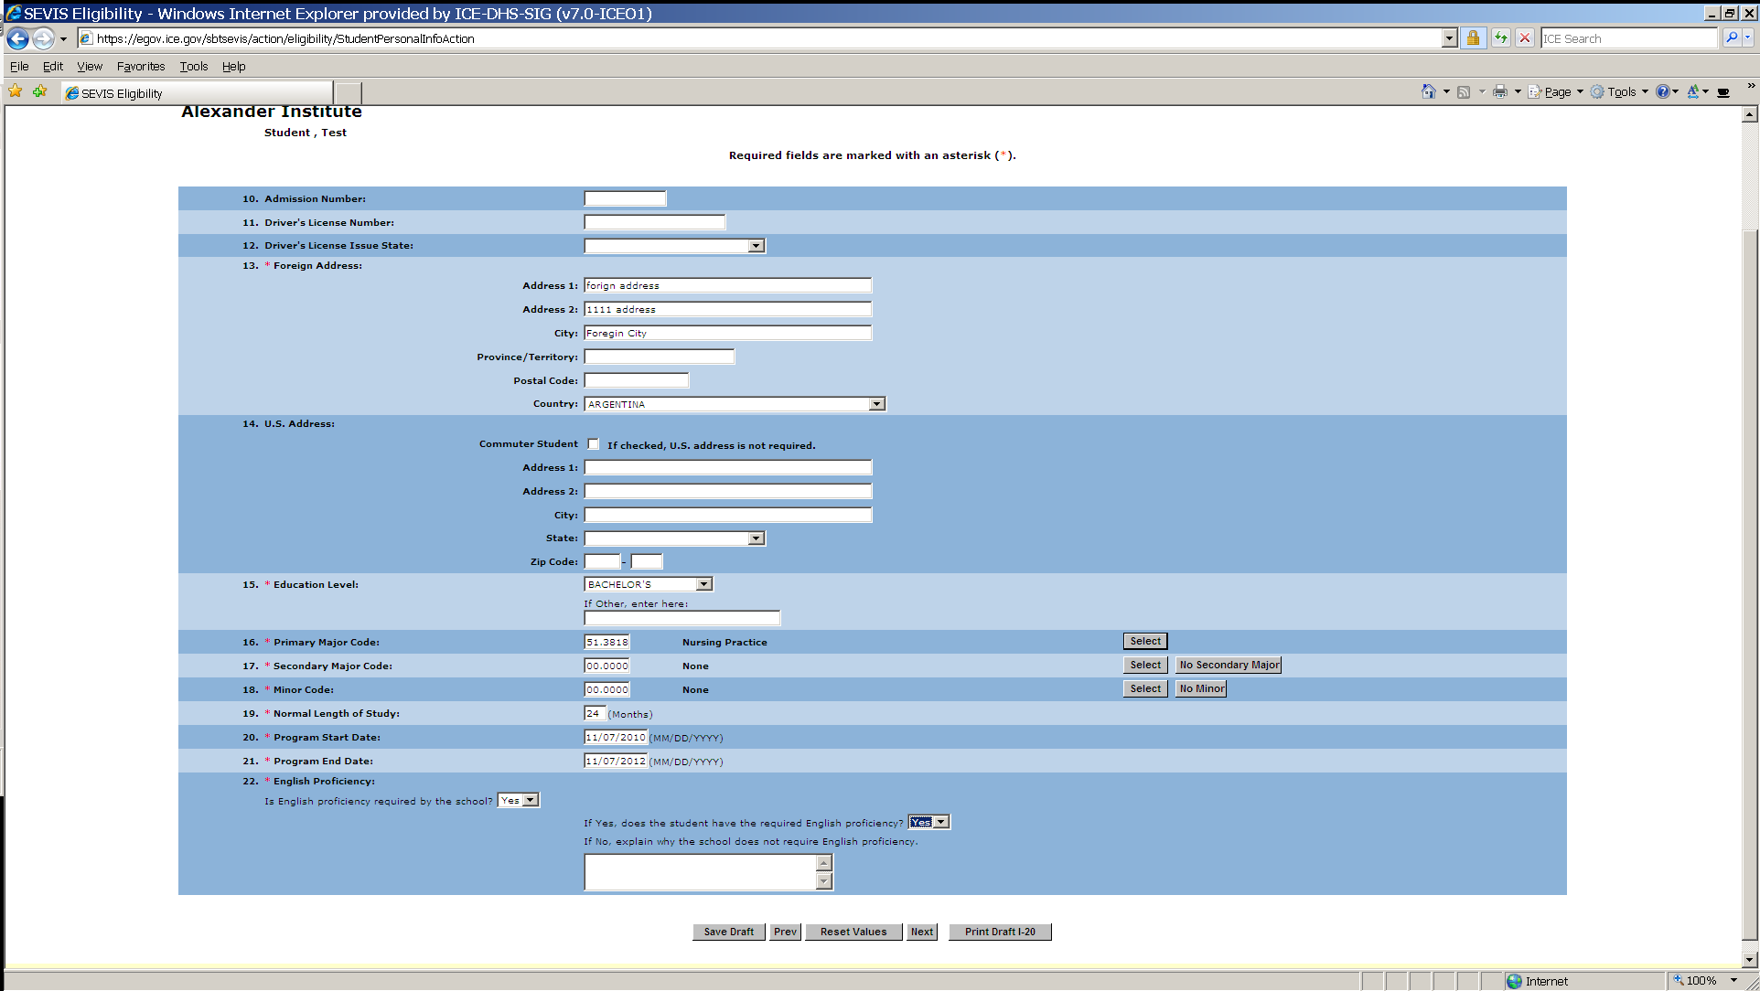

Financial information screen for student and dependent (an F-2) if applicable
(Funds must equal or exceed expense amount entered.)
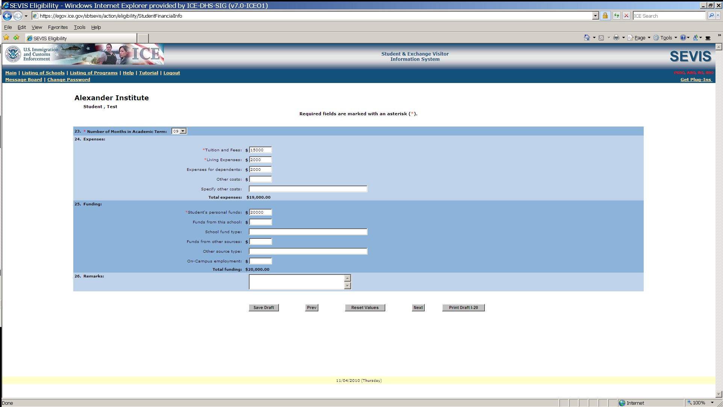
F-2 dependent information entry screen
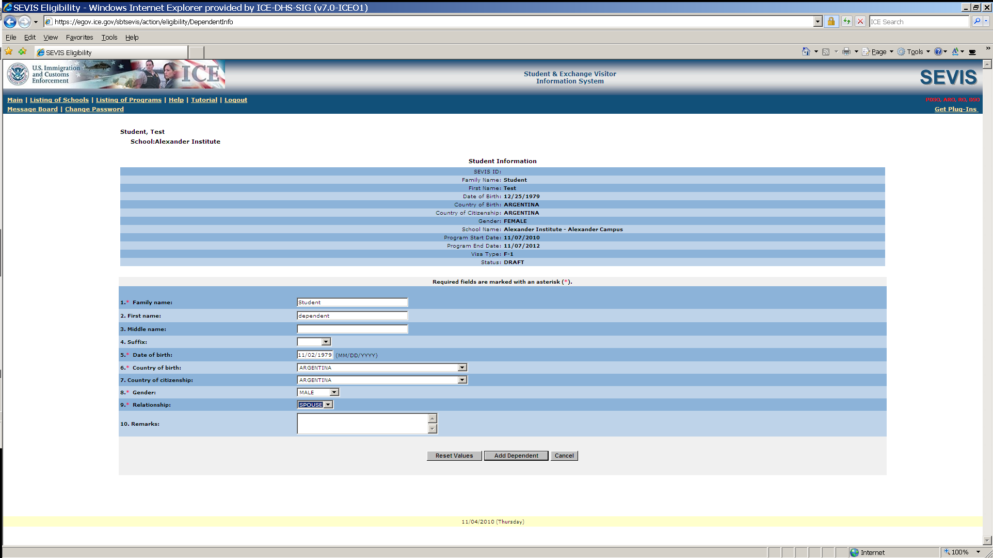

Steps above produce an F-1 Student SEVIS Record in Initial status.
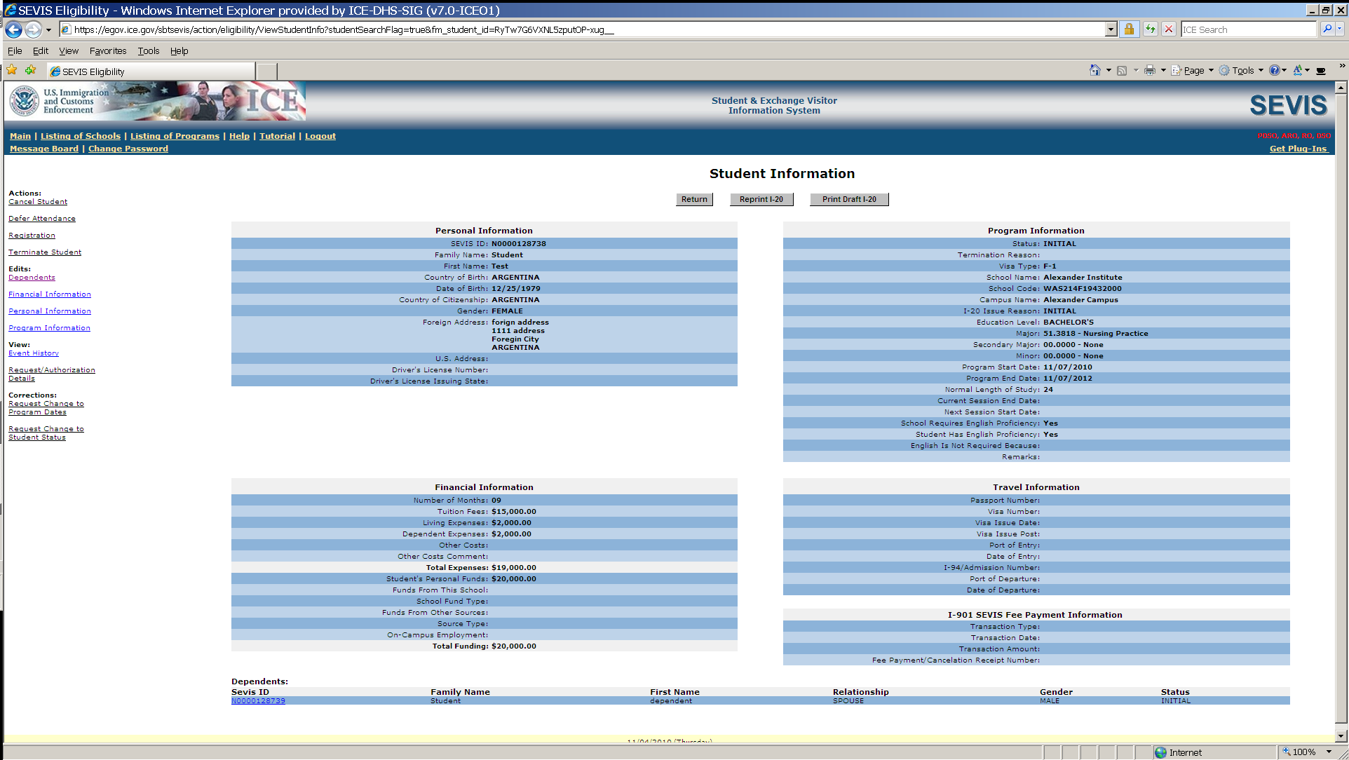

Student arrives at school. The designated school official enters registration information.
Registration includes current session, next session start date, and U.S. address.
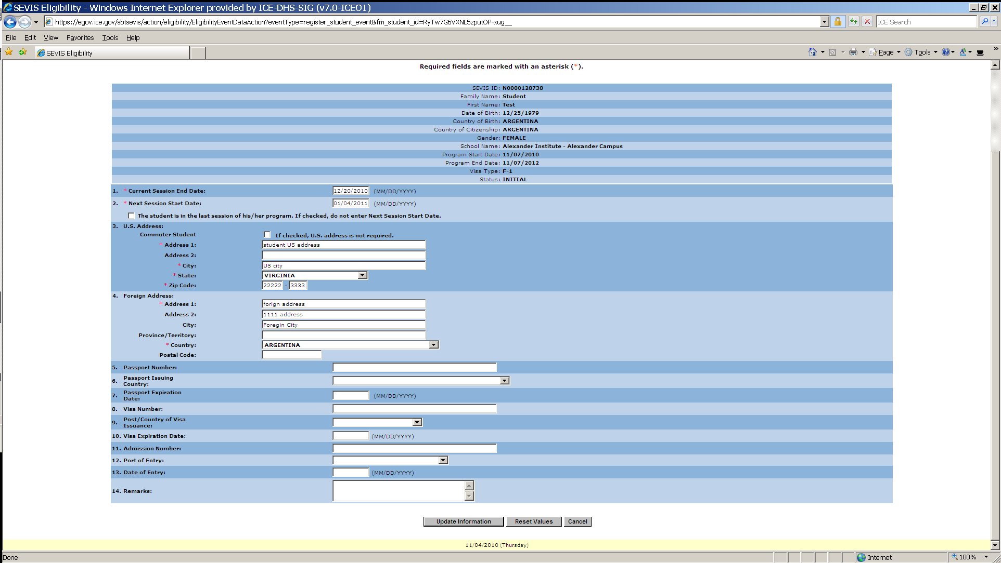

This is an Active Student SEVIS Record.
Designated school official clicks on the Optional Practical Training (OPT) link located on left-side navigation to complete an OPT employment request.
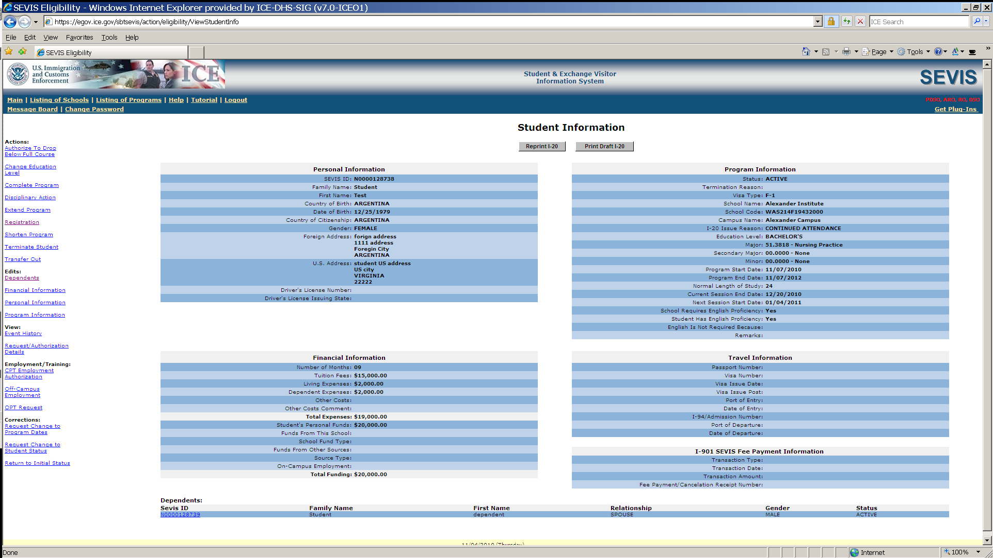
OPT Employment request screen
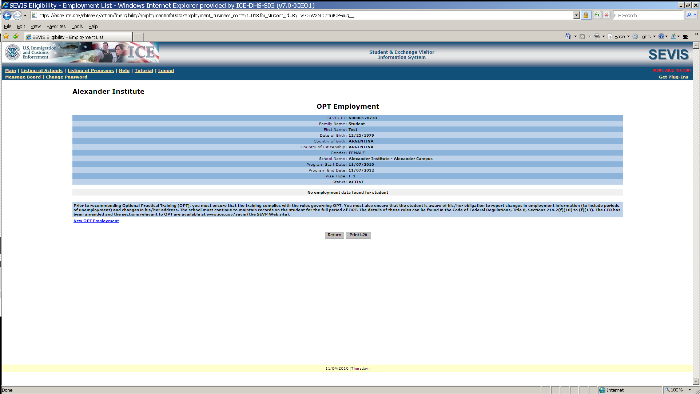

Add OPT Employment information to an F-1 Student SEVIS Record
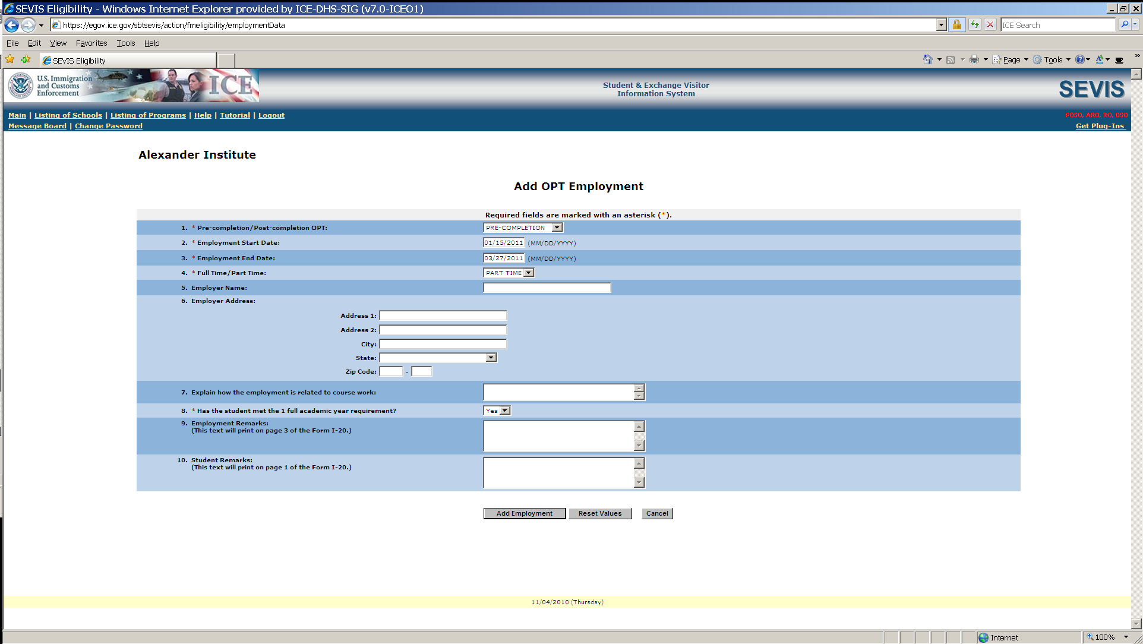

View OPT Employment information
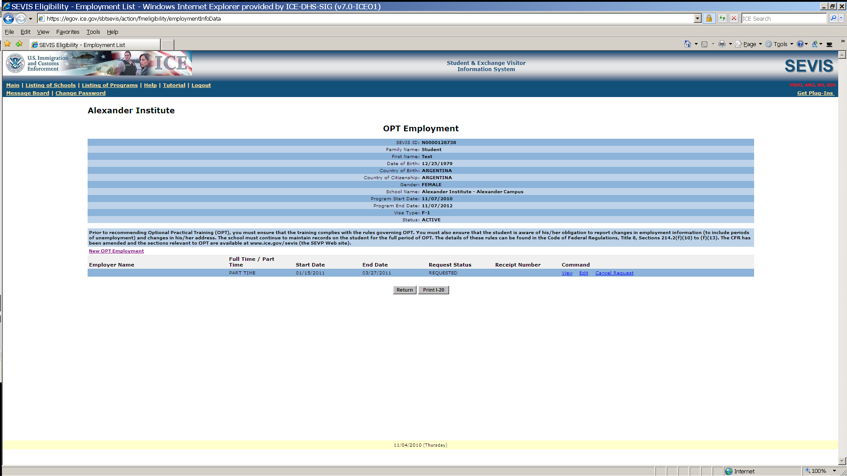

F-1student SEVIS Record Information Screen
Notice OPT request and dependent information links.
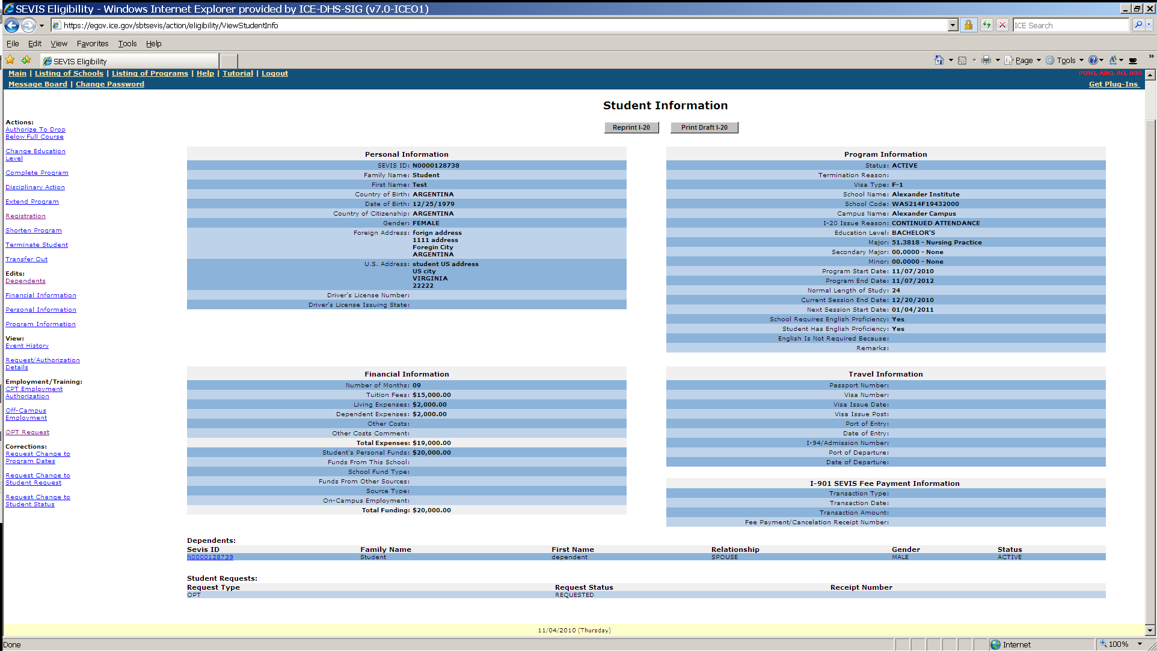

To extend an F-1 student’s OPT Employment see link in bottom right. (STEM extension)
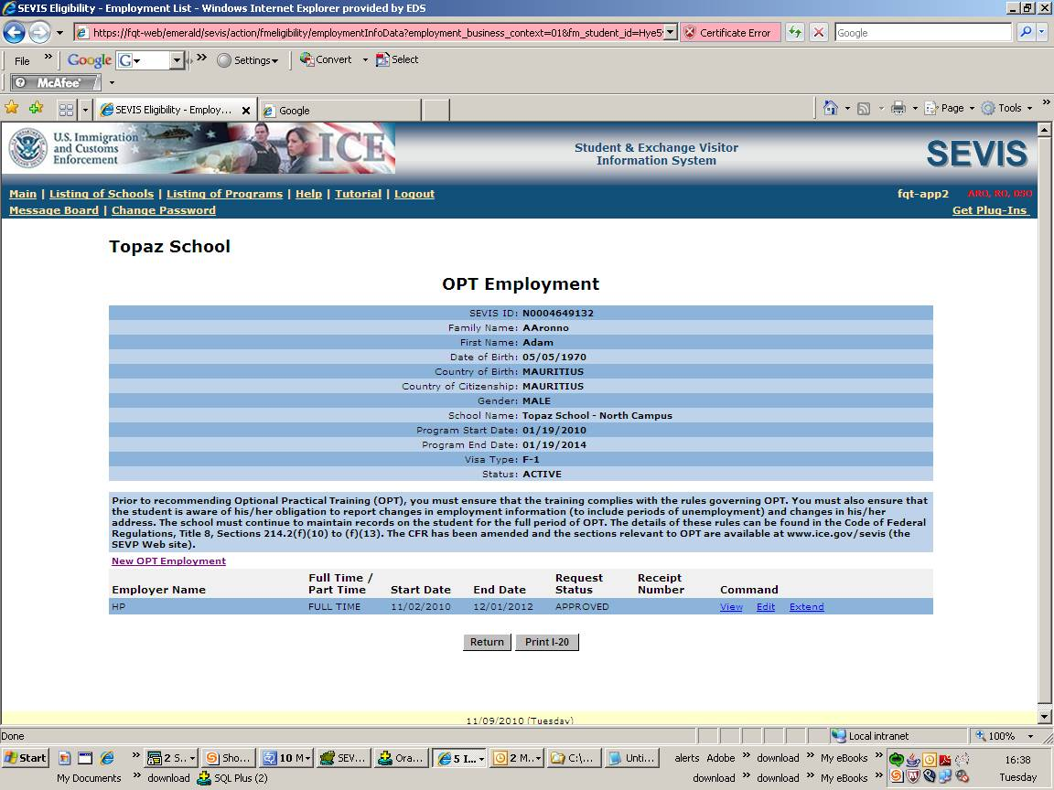
Extend OPT Employment (STEM extension)
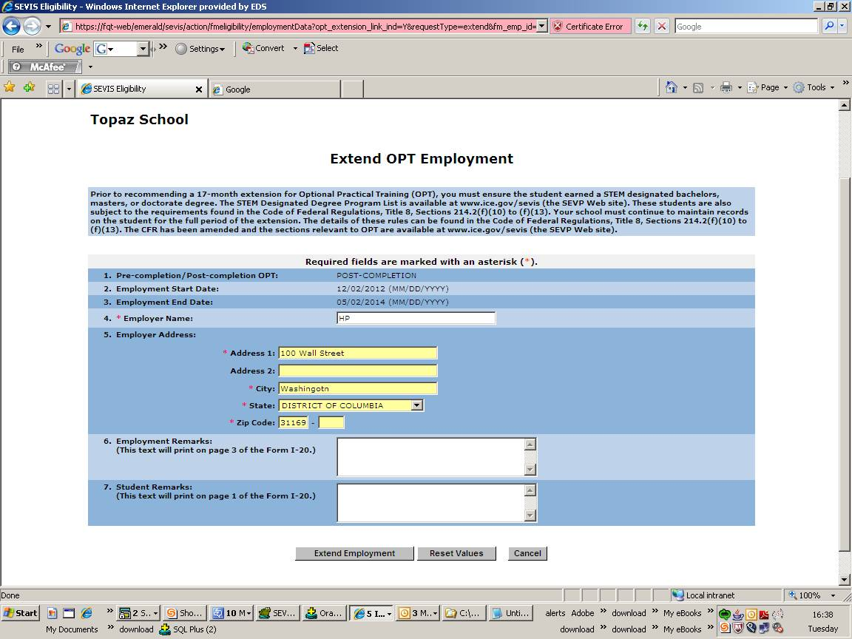
Extend OPT employment (STEM extension)
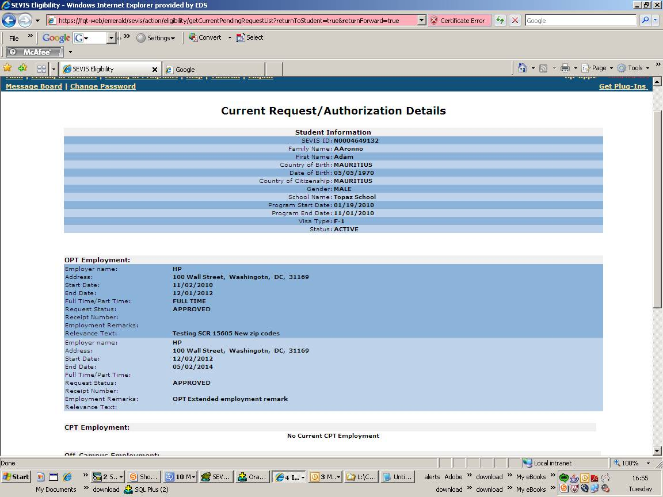
Data entry screen for an M-1 Student SEVIS Record
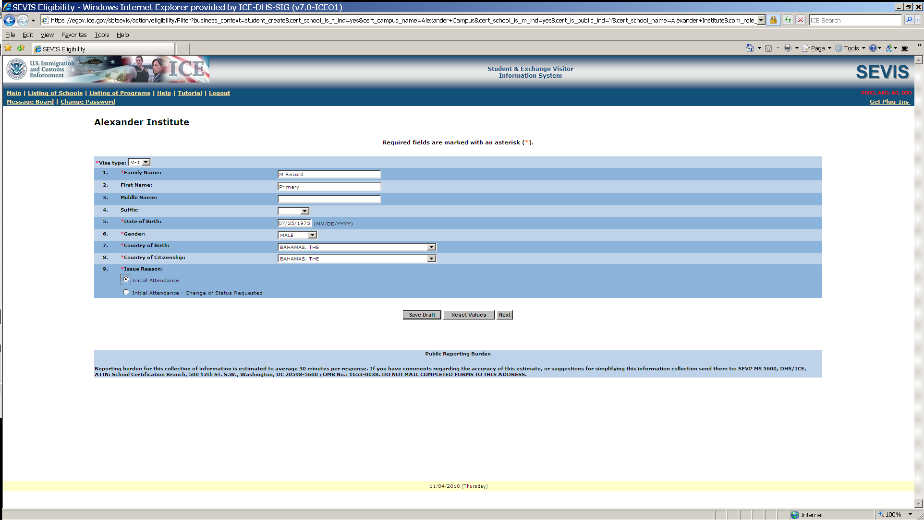

Data entry of personal and program information for M-1
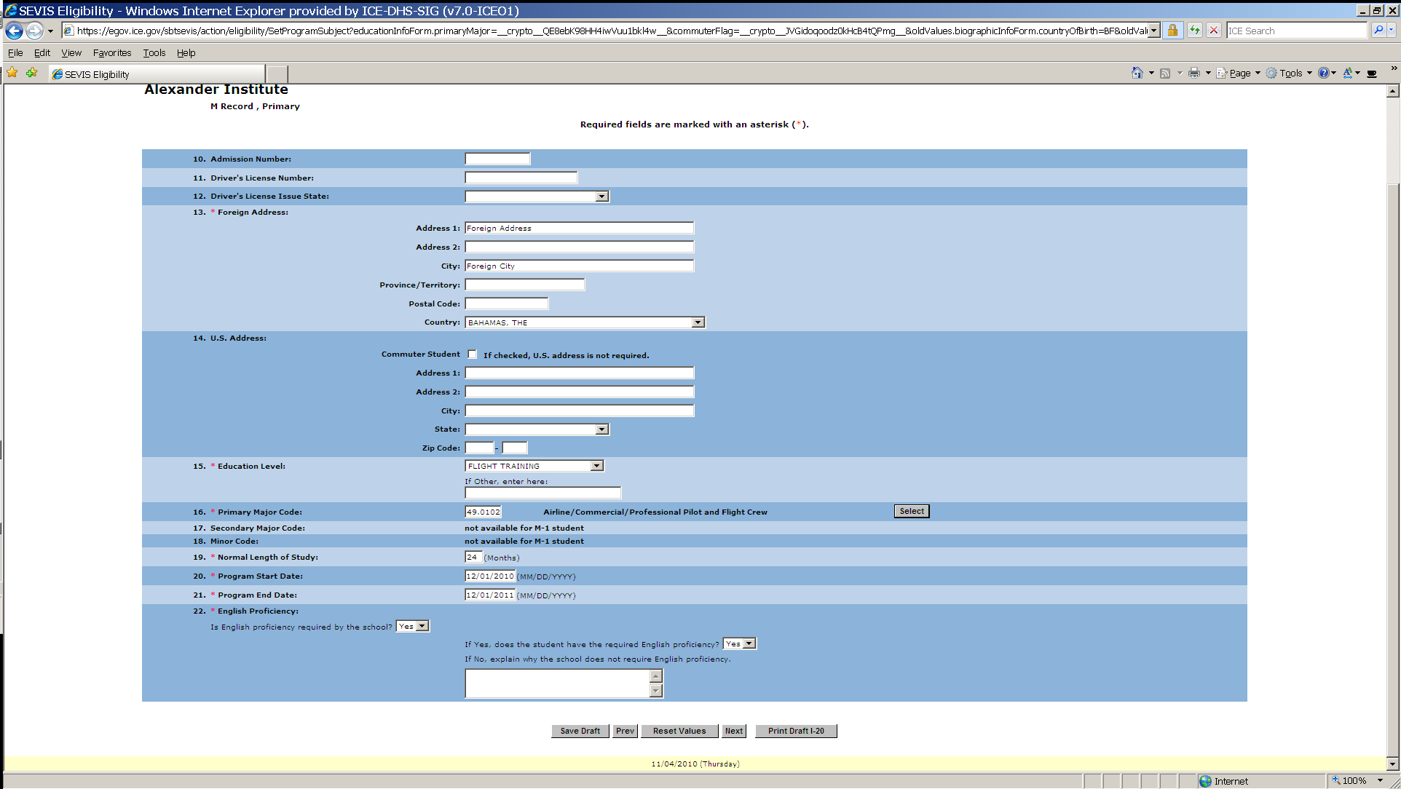

Financial information screen for M-1 and dependent (an M-2) if applicable
(Funds must equal or exceed expense amount entered.)
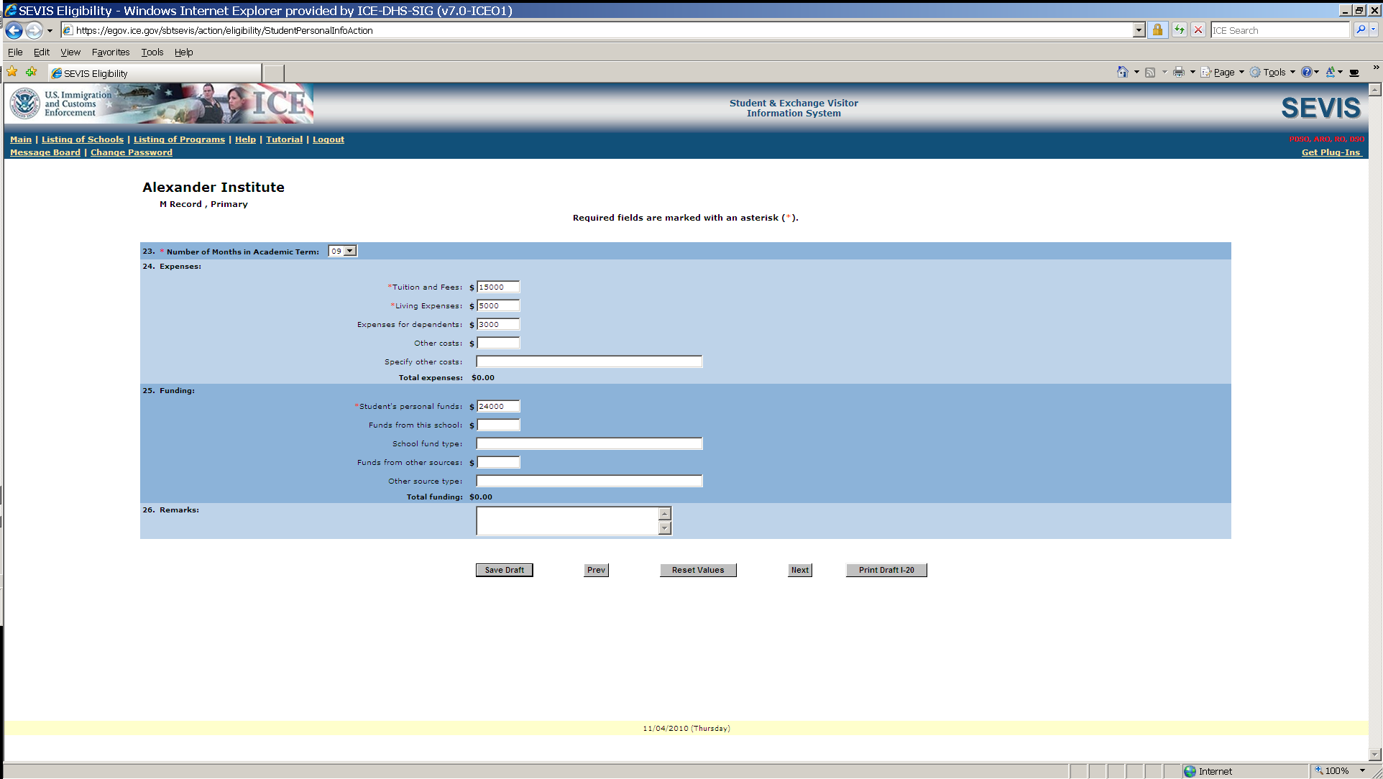

M-2 dependent information entry screen
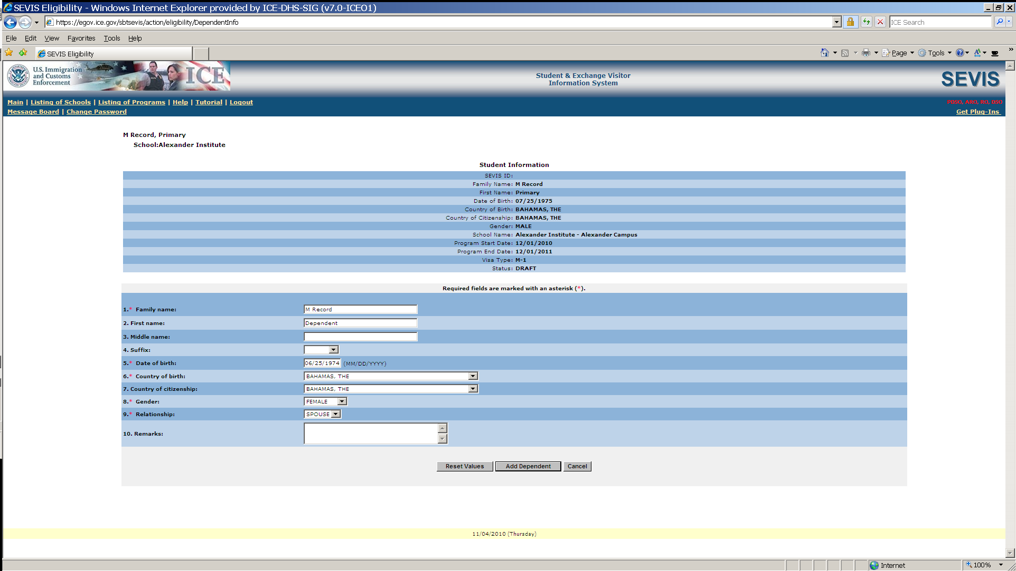

Screen requires affirmation of compliance with Federal Aviation Administration Flight School regulation. Designated school official must check the Yes box.
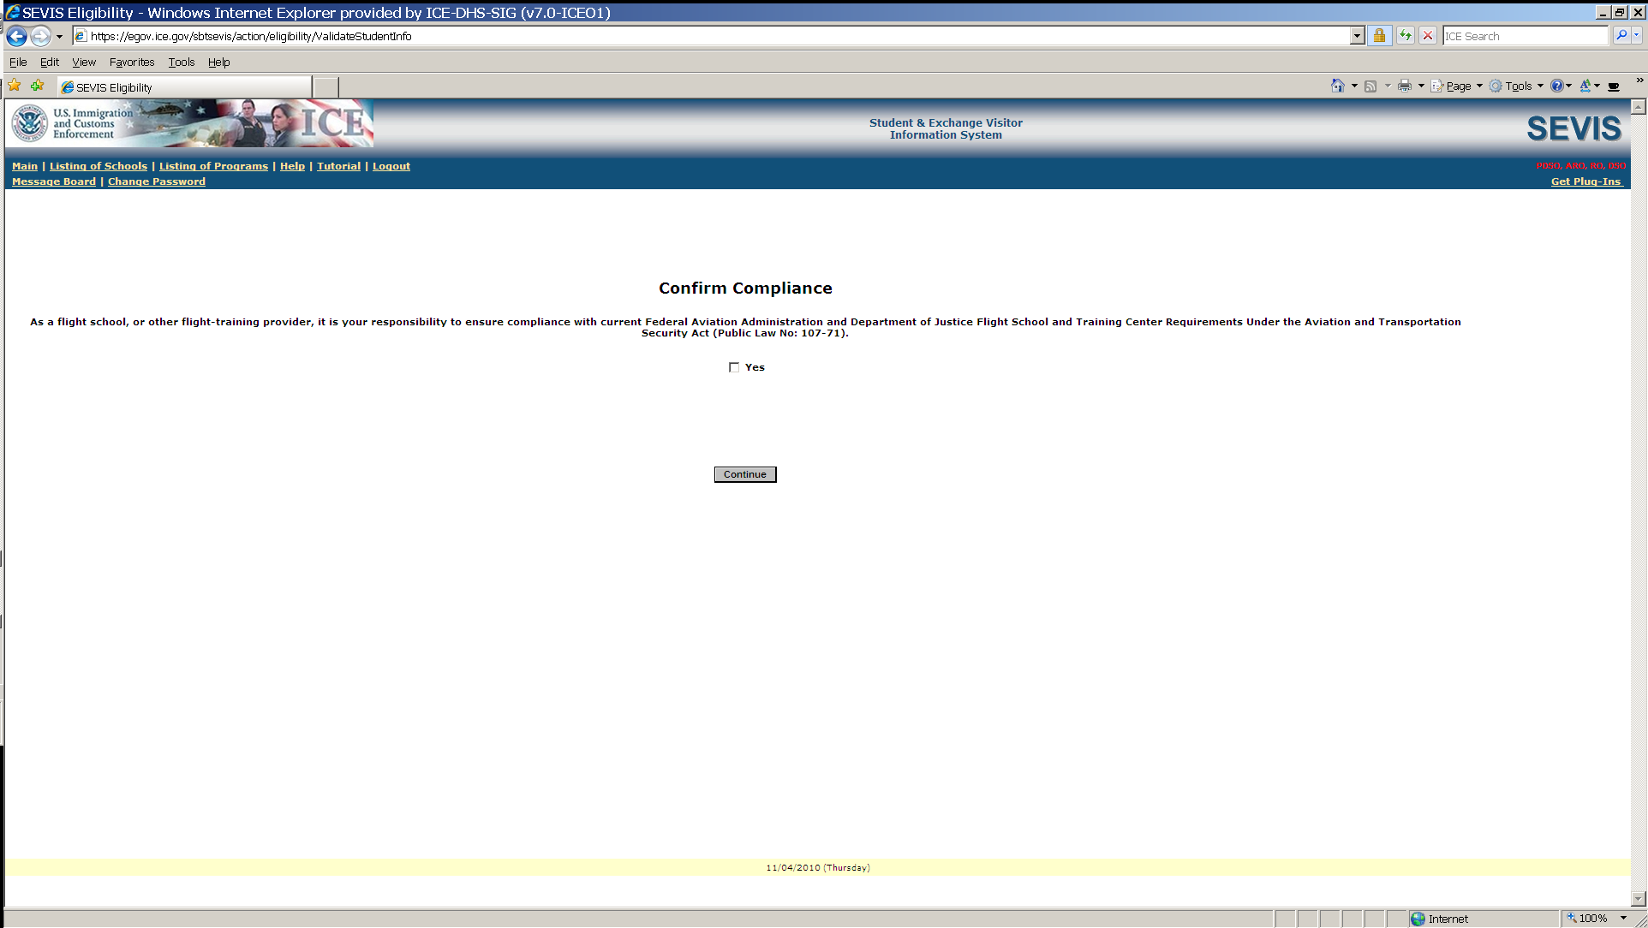

Steps above produce this M-1 Student SEVIS Record in Initial status.
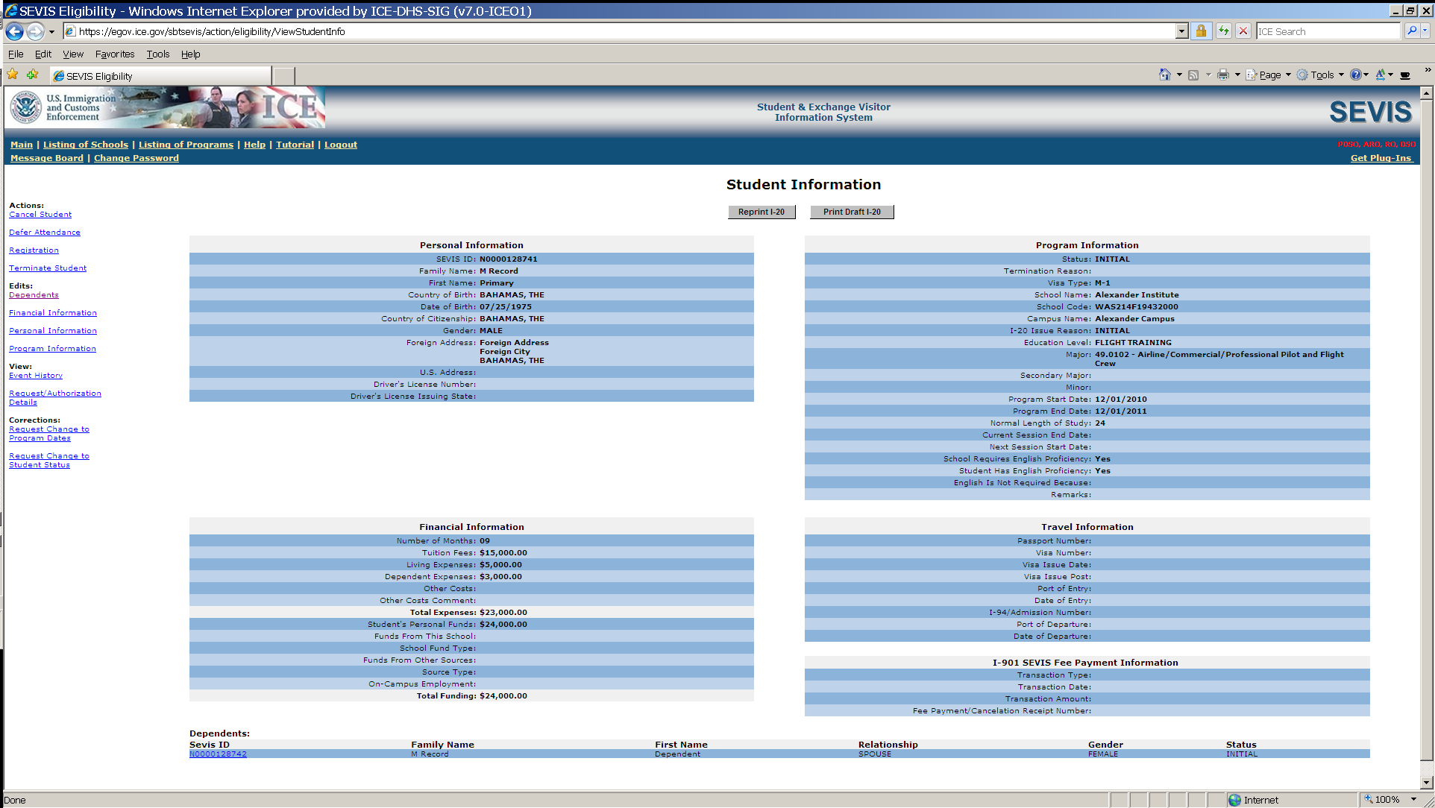

M-1 student arrives at school. The designated school official enters registration information. Includes current session, next session start date, and U.S. address.
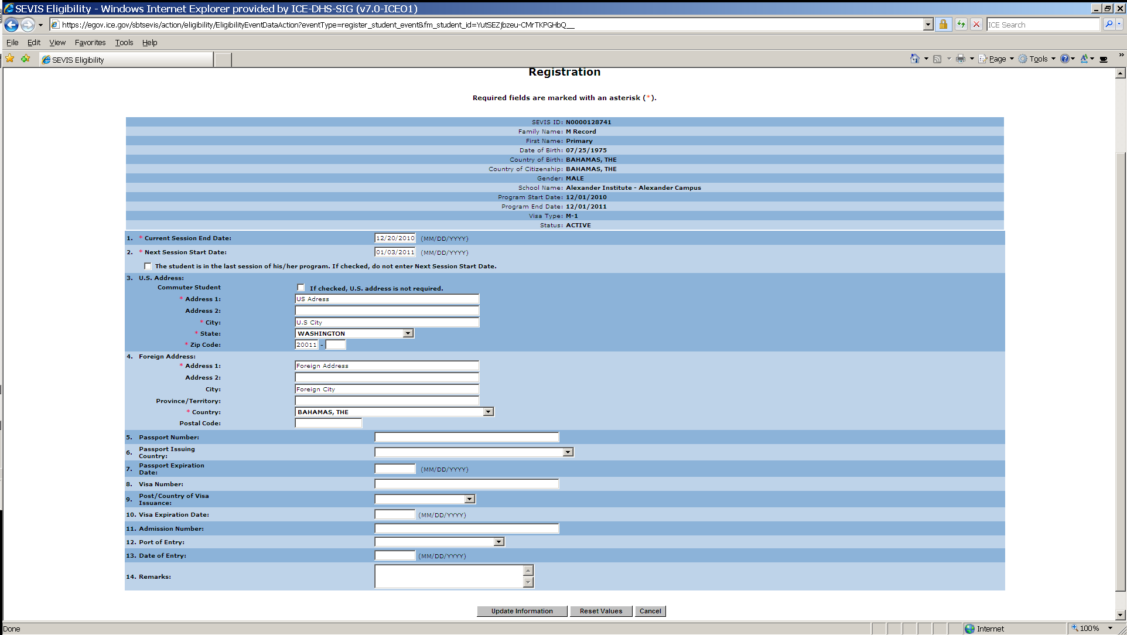

M-1 student OPT Employment request screen
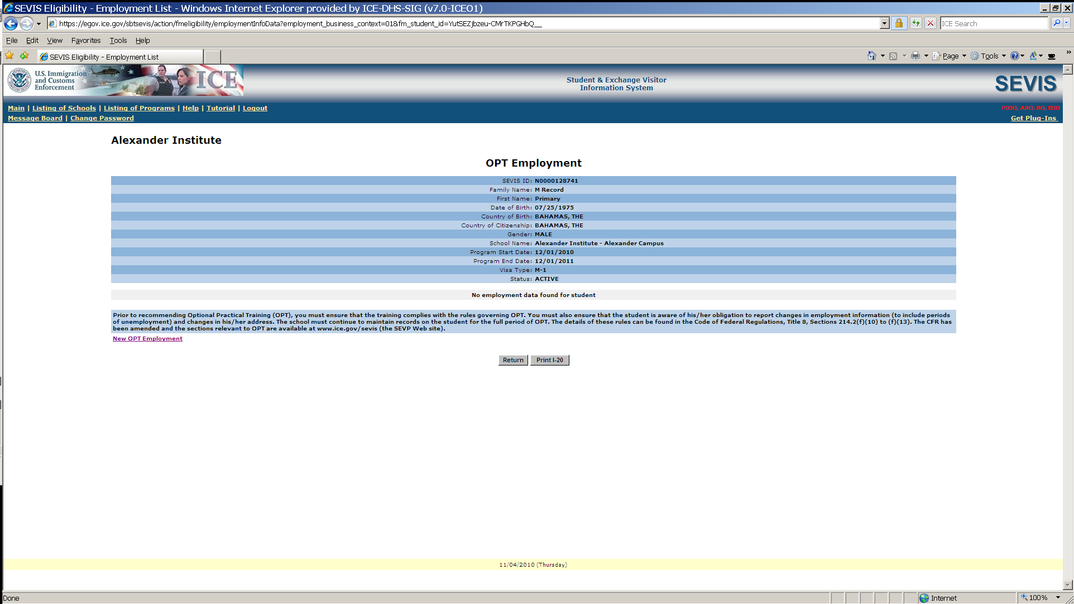

Add OPT Employment information to an M-1 Student SEVIS Record
