## CREAPP-001: Create Application – Choose Program Office



## CREAPP-005: Create Application – Choose Application Type for VS



## CREAPP-0094: Select Agent Confirmation

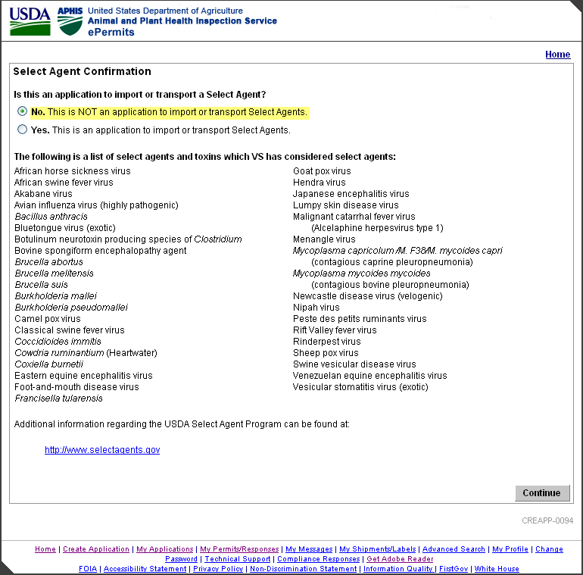

## CREAPP-0096: Select Agent Warning

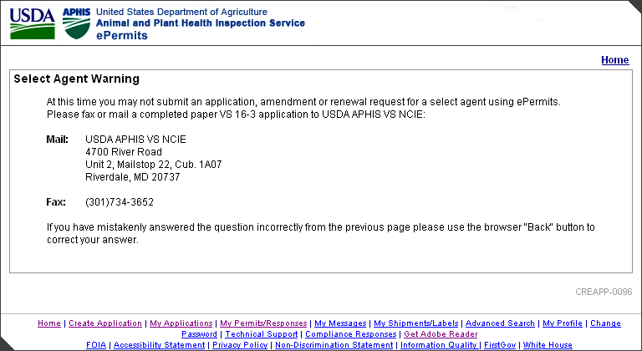

## CREAPP-0042: Specify: New, Amendment or Renewal Application (Applicant View)

**CREAPP-0039: Specify: New, Amendment or Renewal Application (APHIS View)**

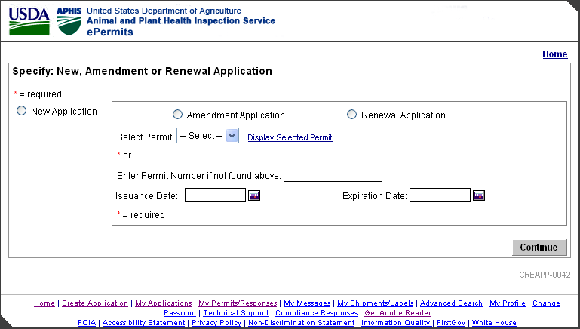

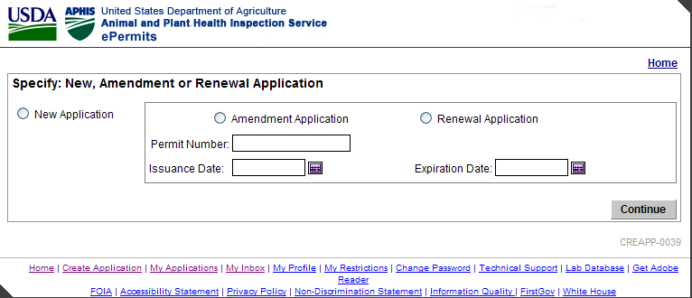

## CREAPP-0098: Permit Number Prefix will be Changed

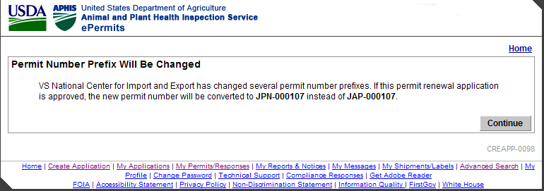

## 

## VS0163-010-080: Type of 16-3



. 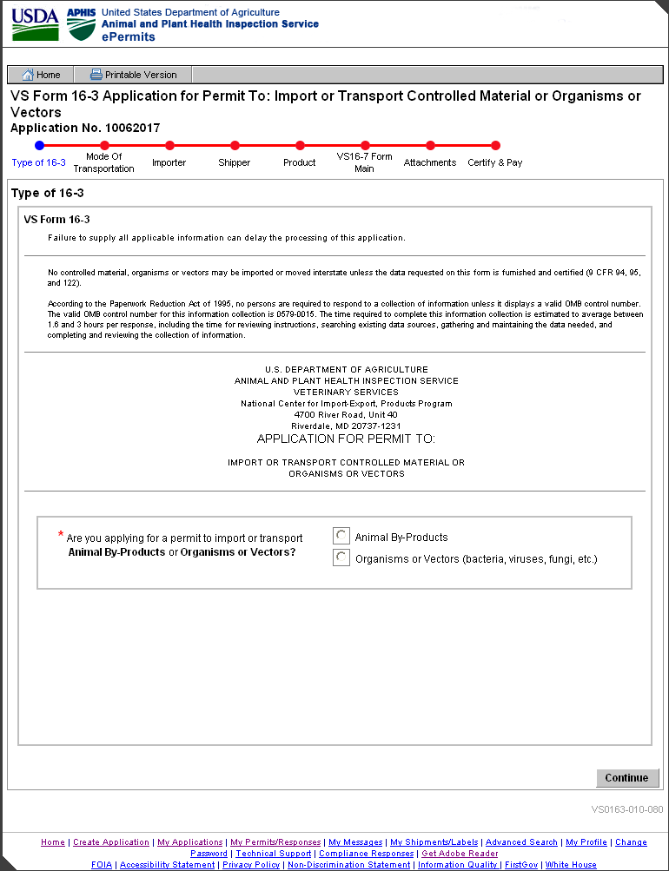

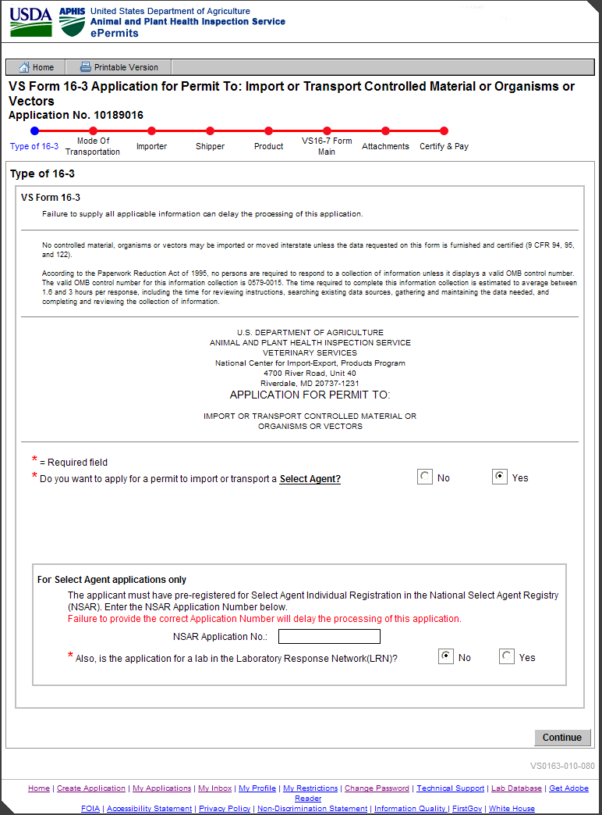

Figure : Type of 16-3: APHIS View after Selecting Yes for Select Agent

[VS0163-010-080]

## VS0163-001-001: Mode of Transportation

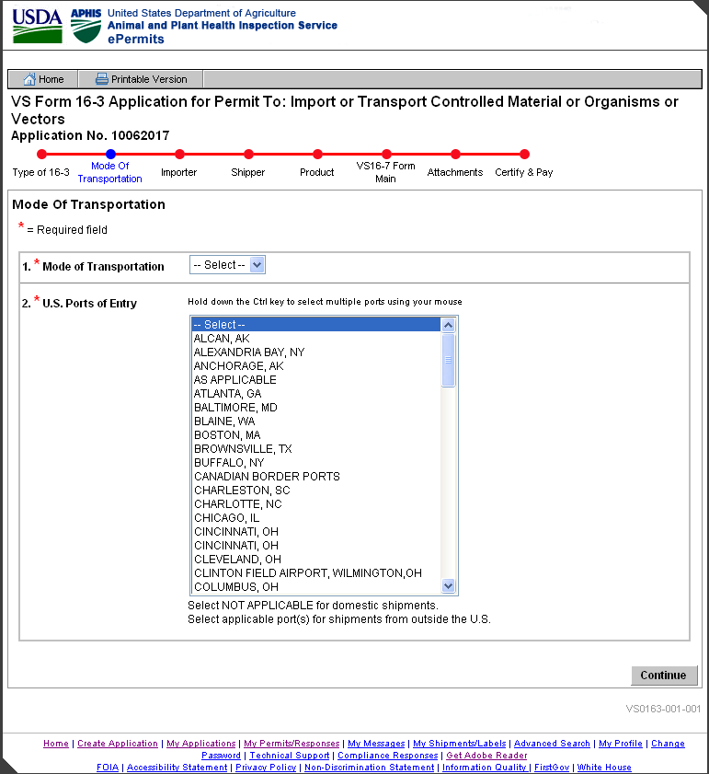

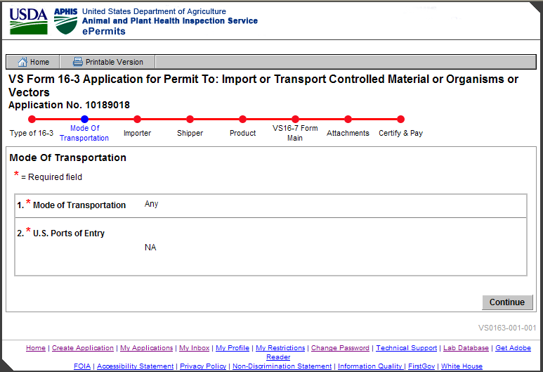

## VS0163-002-108: Importer Information

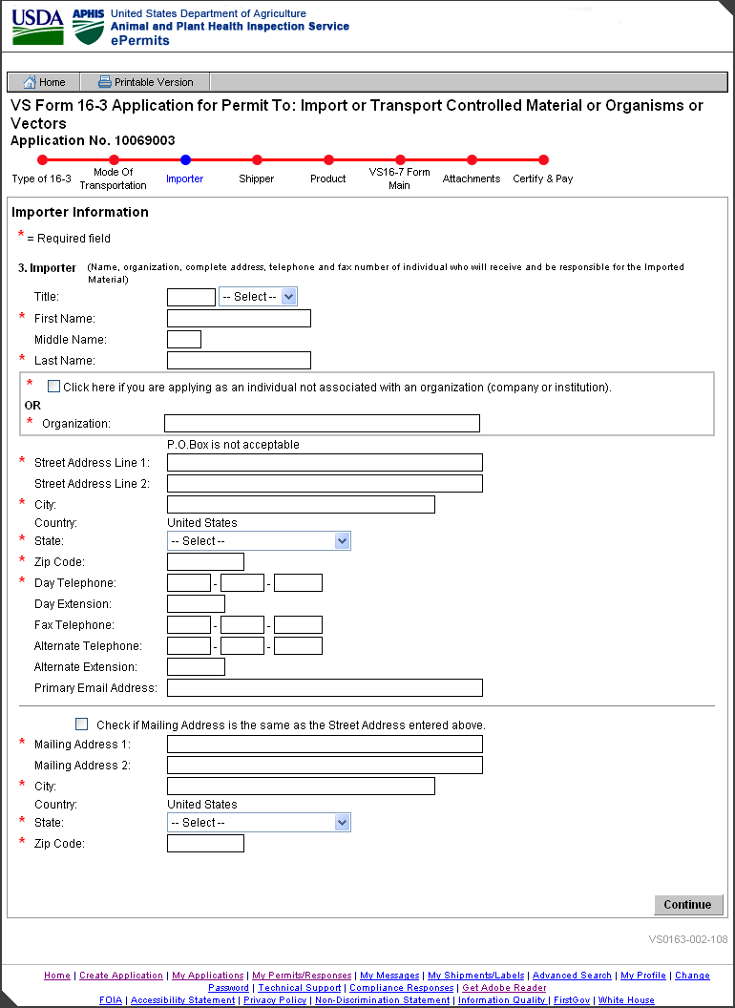

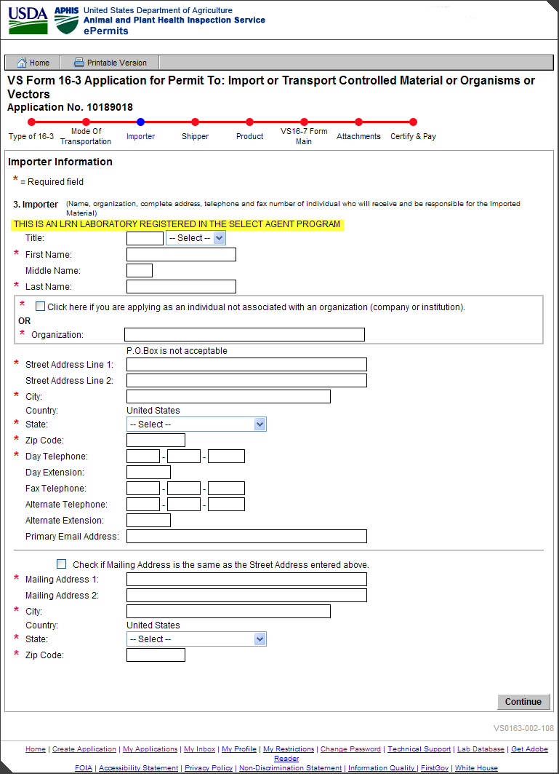

## VS0163-002-110: Unknown City and ZIP Code Combination

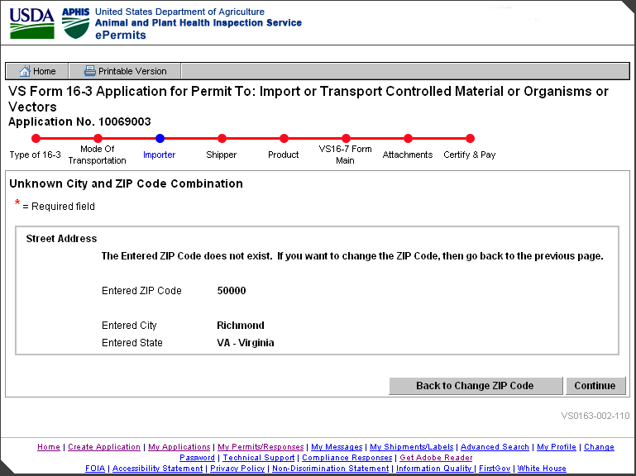

## VS0163-005-114: Unknown City and ZIP Code Combination

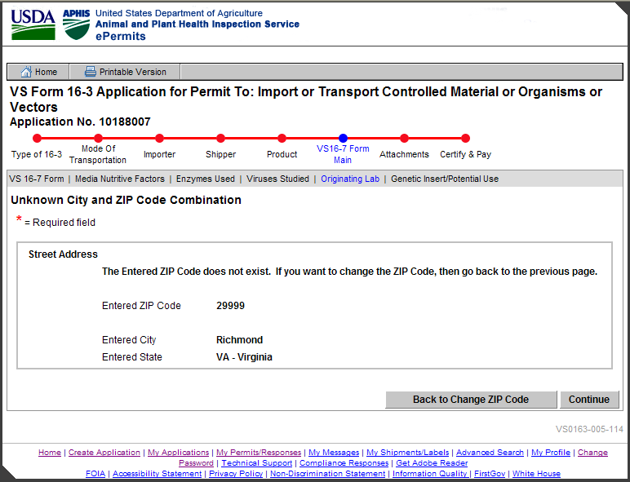

## VS0163-003-112: Unknown City and ZIP Code Combination

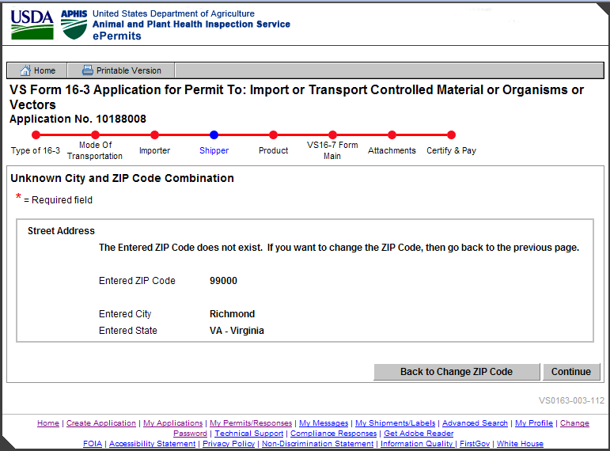

## VS0163-002-102: Verify Application Does Not Duplicate Previous Application

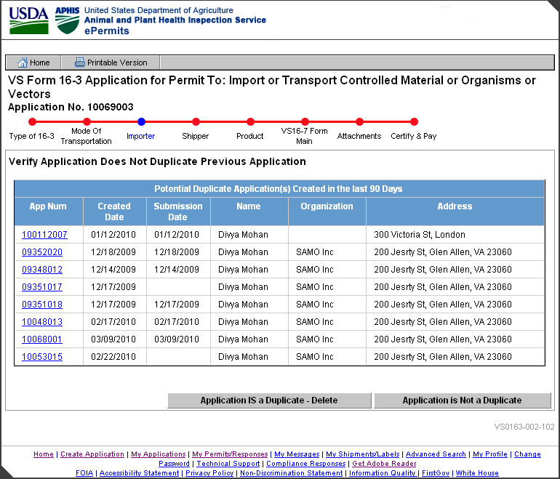

## VS0163-003-011: Quantity of Shippers

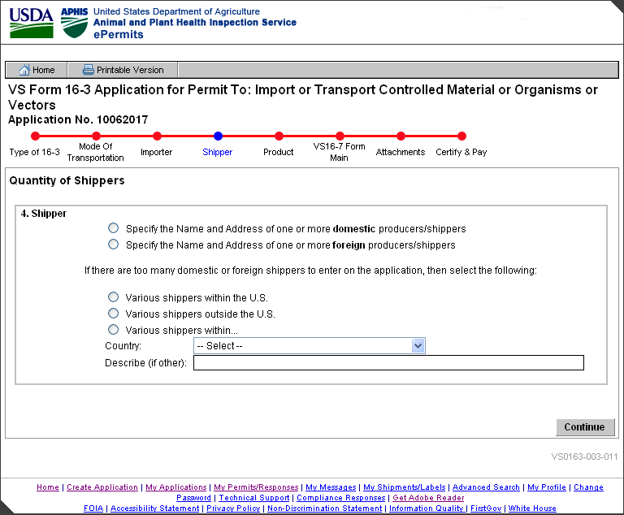

## VS0163-003-016: Shipper Summary

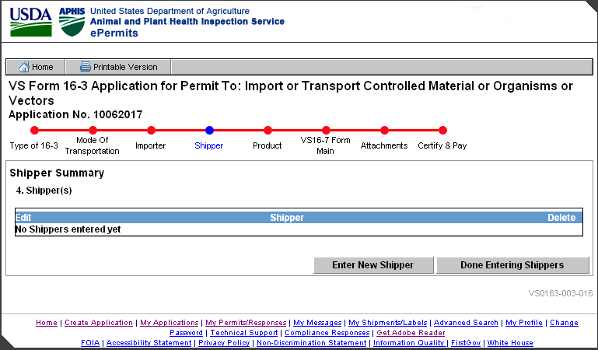

## VS0163-003-015: Shipper Information

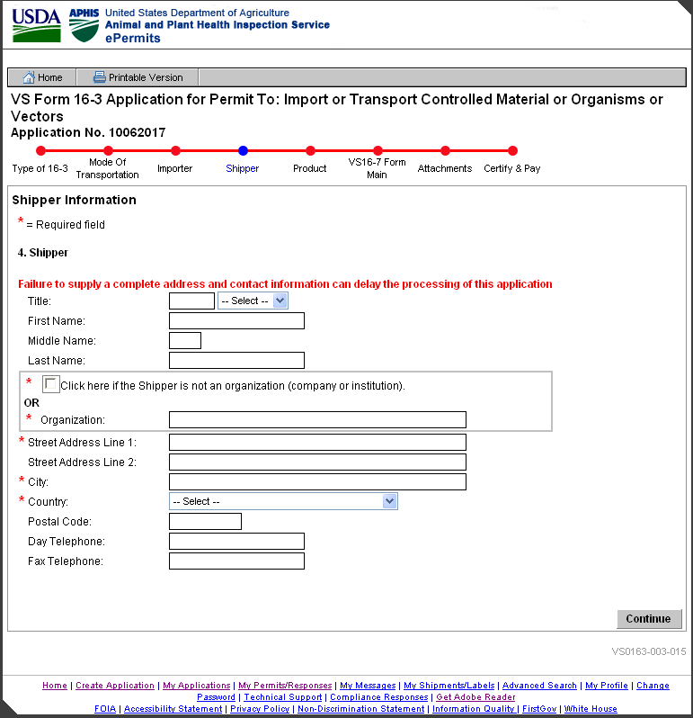

## VS0163-003-067: LRN Lab Shipper(s)

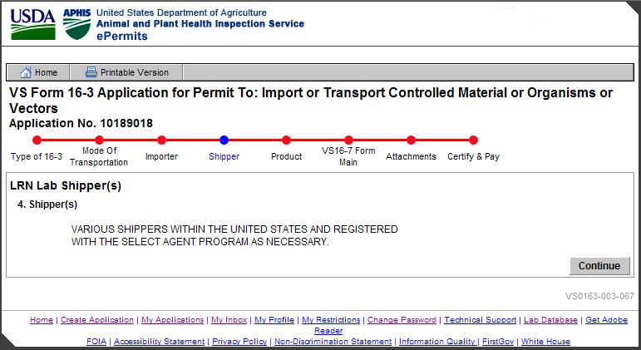

## VS0163-004-017: Product Summary

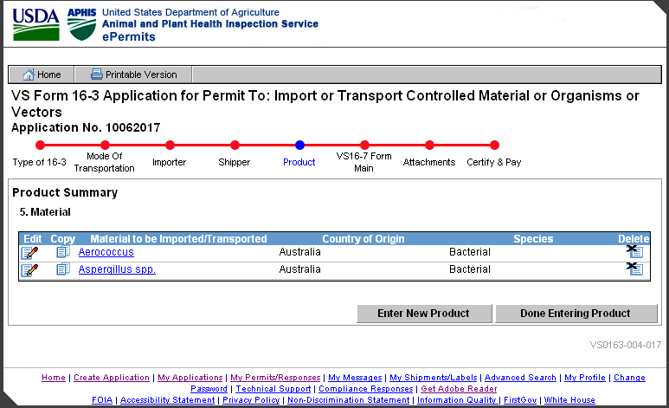

## VS0163-004-022: Product Information

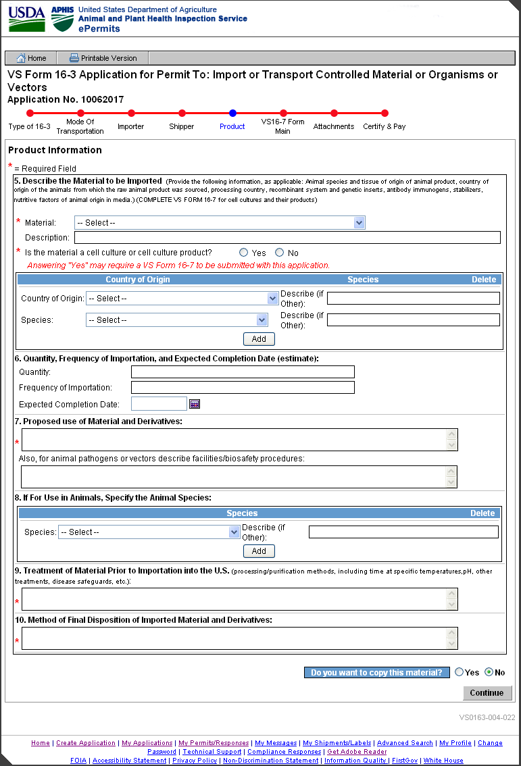

## 

## VS0163-004-019: Product Information – Select Agent

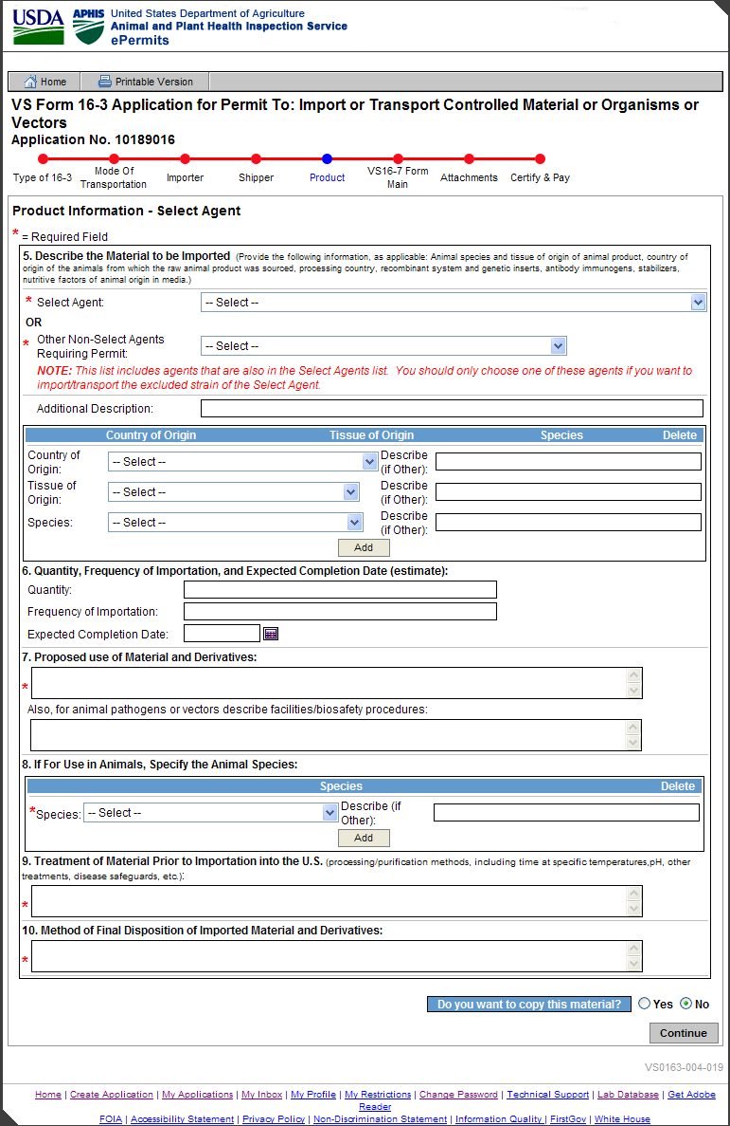

## VS0163-004-020: Product Information – LRN

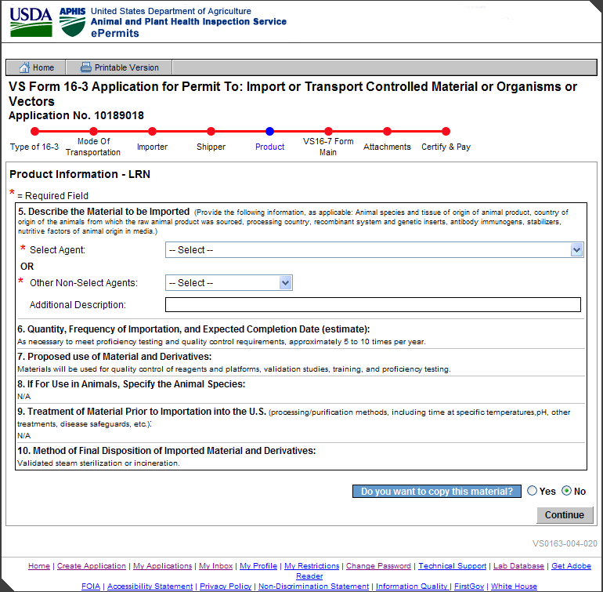

## VS0163-005-055: VS16-7 Summary

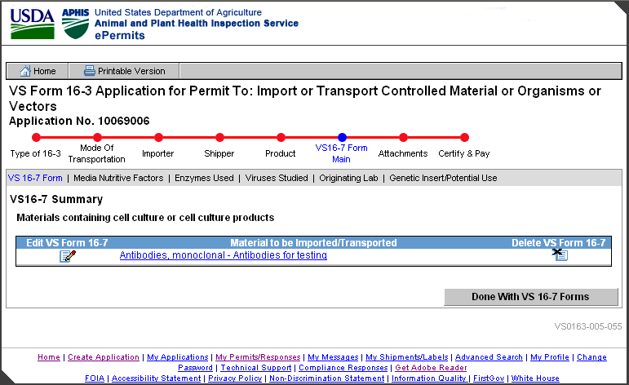

## VS0163-005-027: VS16-7 Information

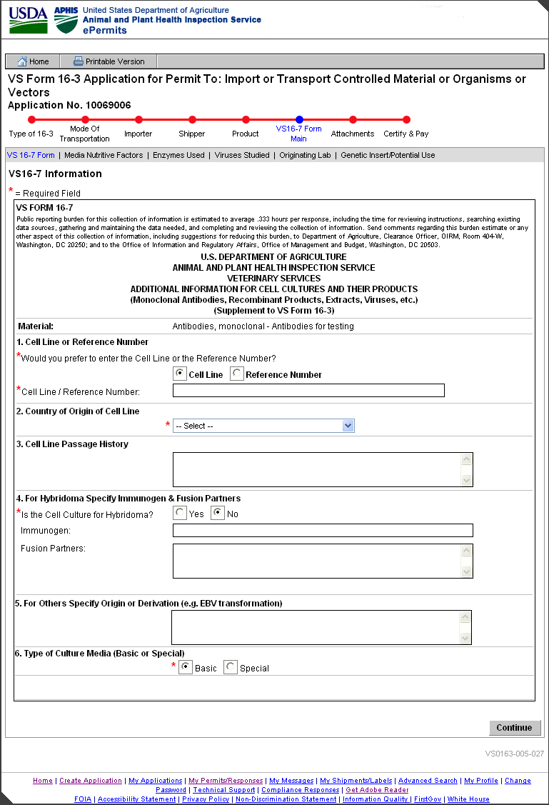

## 

## VS0163-005-032: Media Nutritive Factors Summary

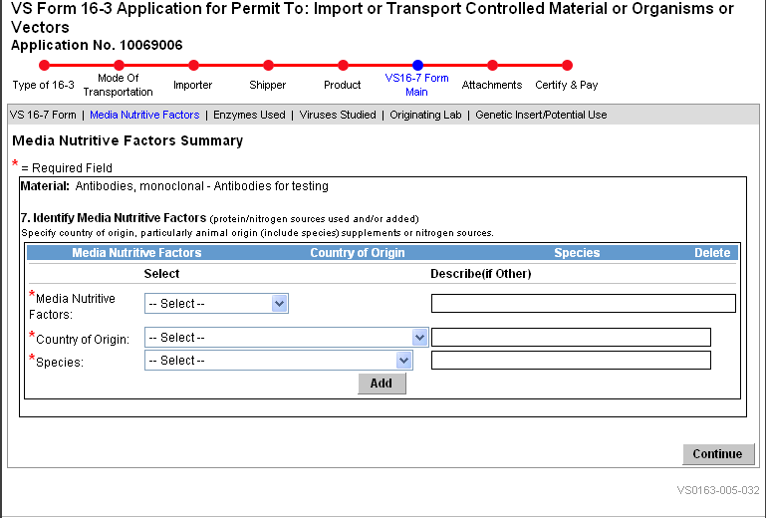

## VS0163-005-035: Country of Origin and Source of Enzymes Used Summary

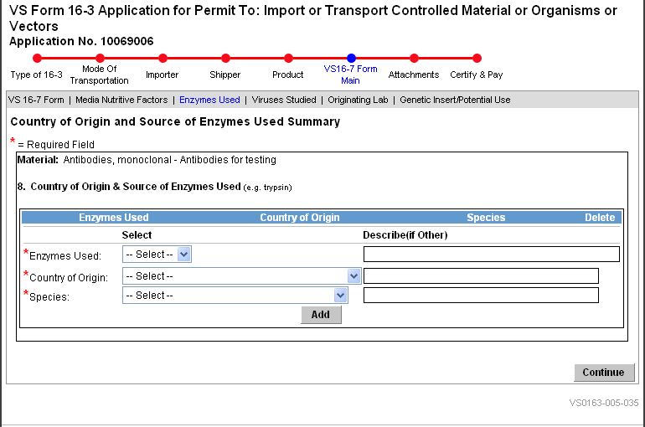

## 

## VS0163-005-042: Animal Virus Studied Summary

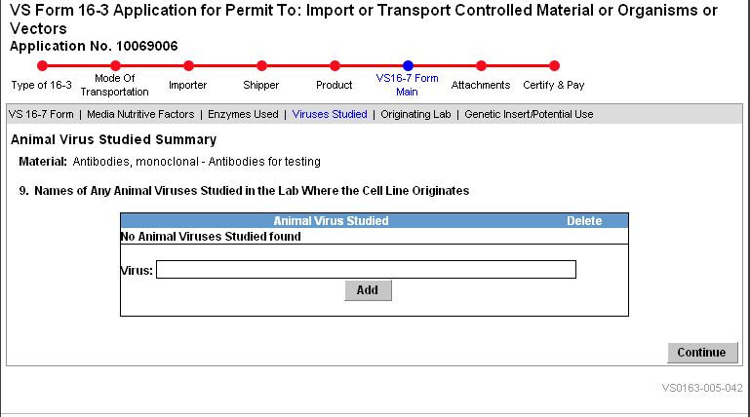

## VS0163-005-049: Originating Labs Summary

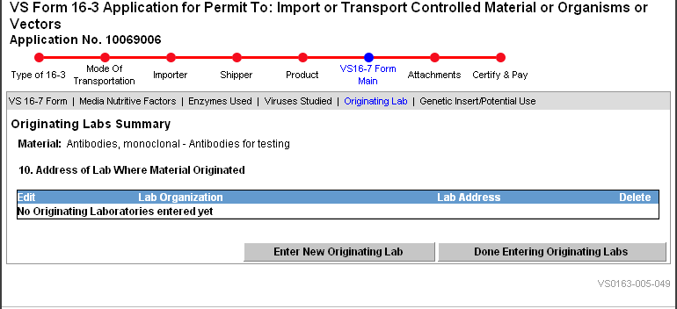

## VS0163-005-046: Originating Lab Address Information

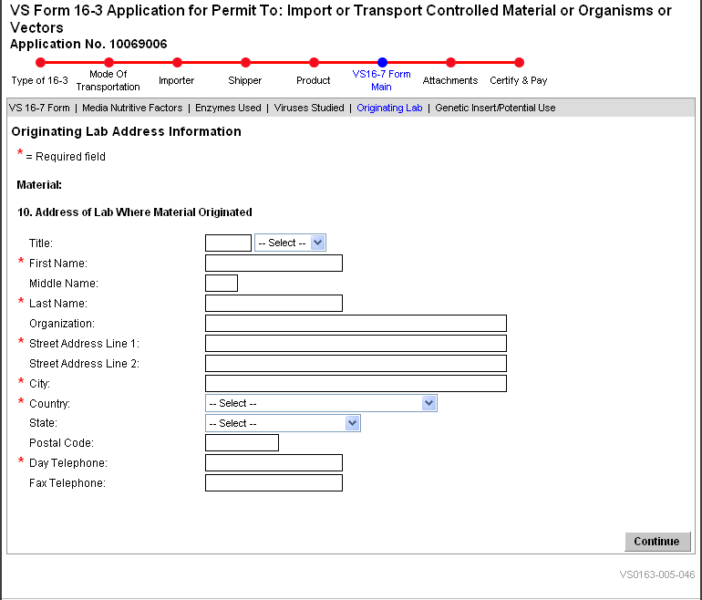

## VS0163-005-050: Genetic Insert and Potential Use

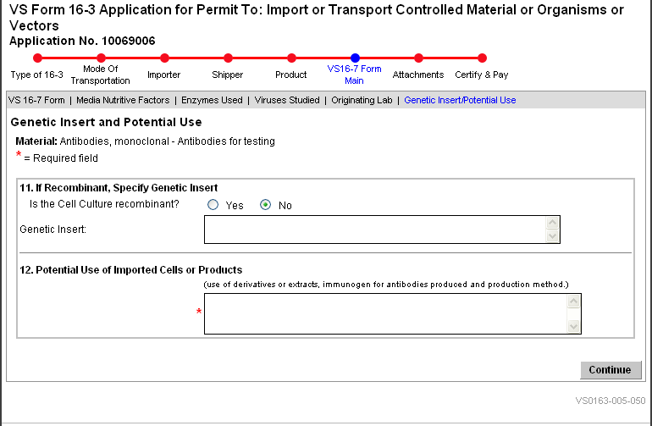

## VS0163-006-056: Attachments Summary

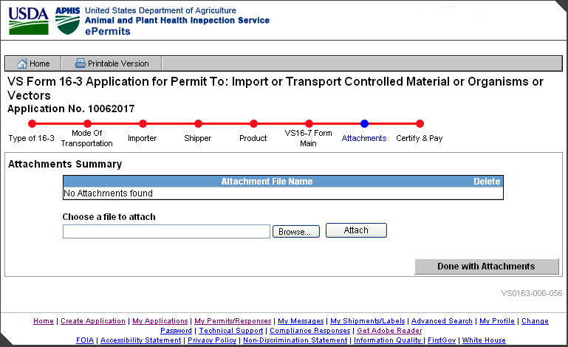

## VS0163-011-082: Initiate Workflow

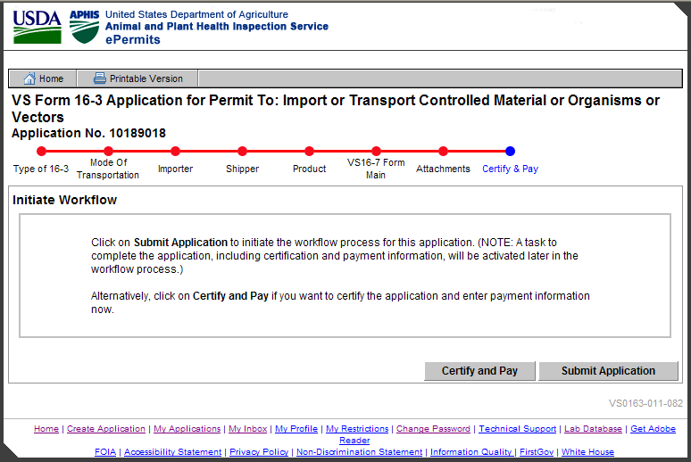

## VS0163-011-083: Workflow Initiated

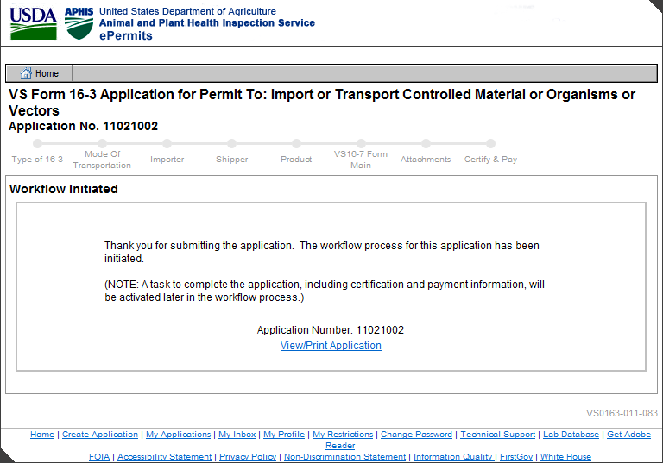

## VS0163-011-072: Certify & Pay

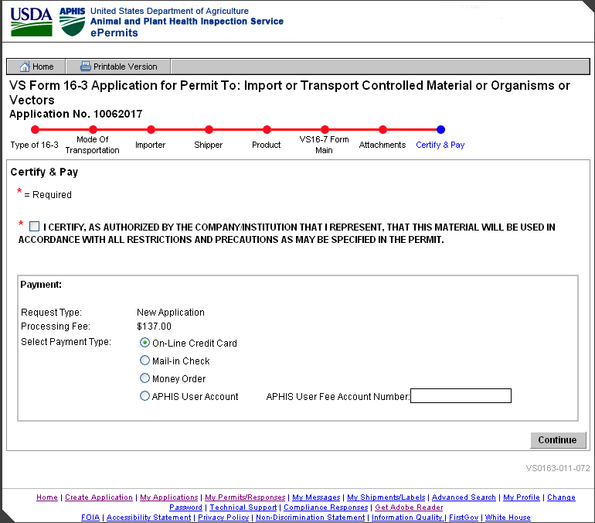

Certify & Pay Applicant View

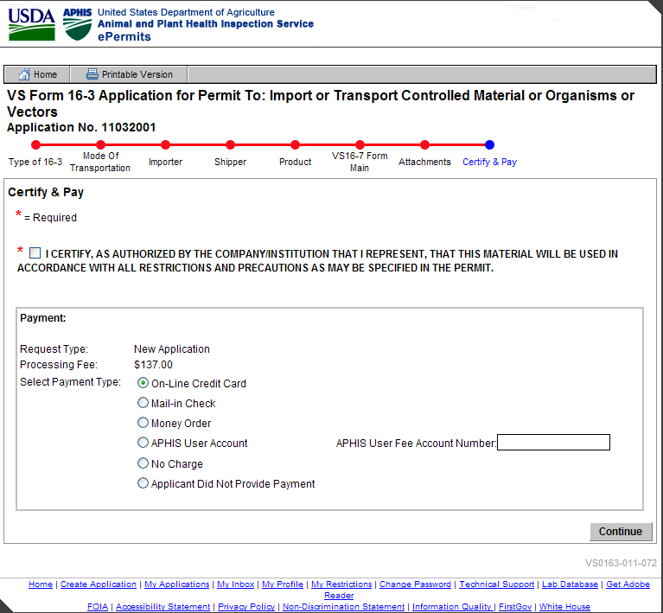

Certify & Pay APHIS View

## VS0163-011-064: Credit Card Payment

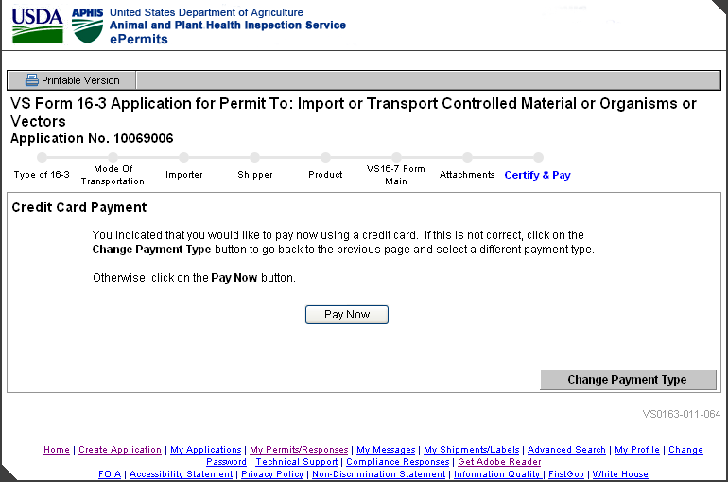

## Online Payment: Step 1: Enter Payment Information

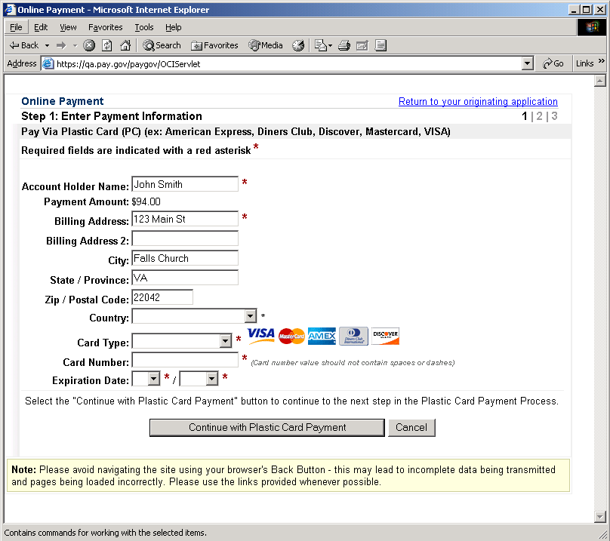

## Online Payment: Step 2: Authorize Payment

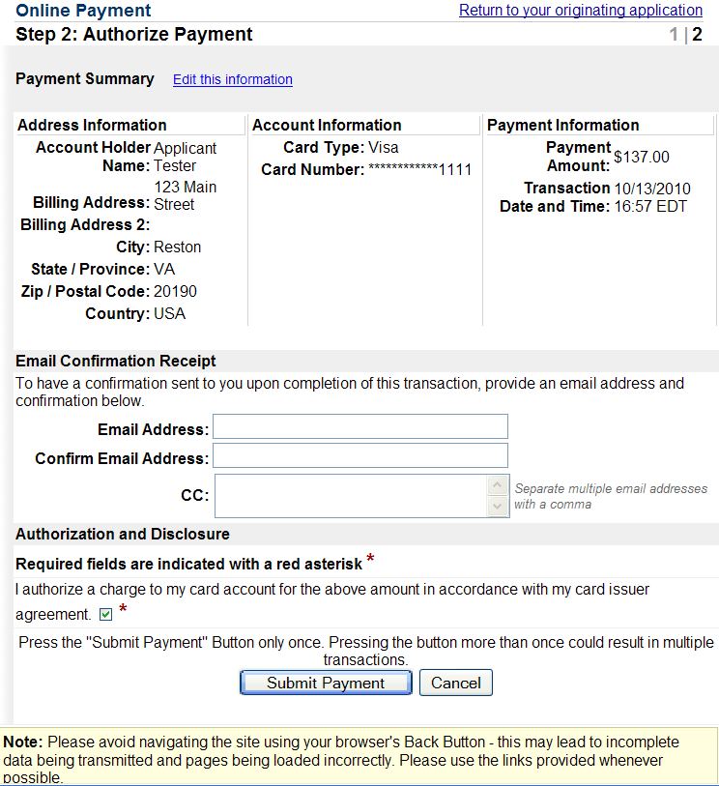

## Online Payment: Your request is being processed. Please wait.

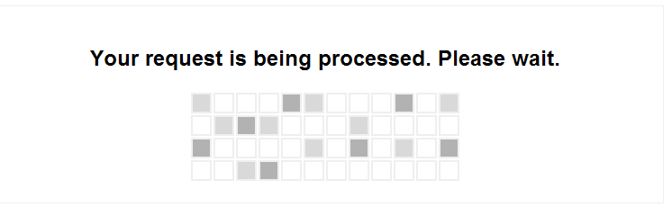

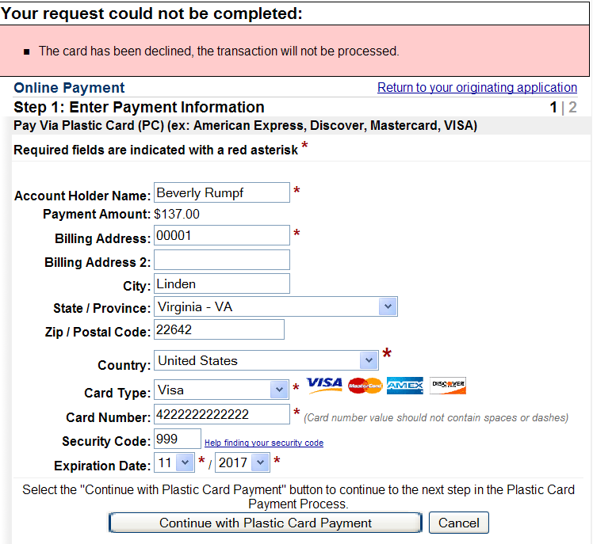

## VS0163-011-076: Application Submitted



