OADC Message and Material Feedback Surveys Email Invitation

Sample Email Invitation – sent by Qualtrics

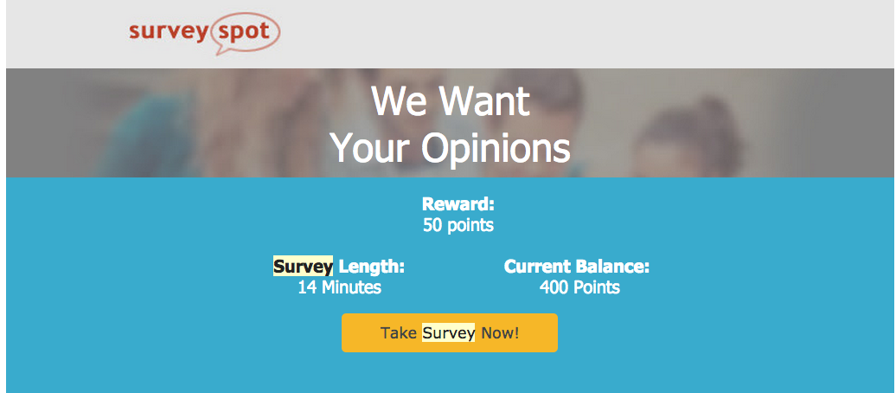

15

