Mosquito Control During an Outbreak
Why it’s important to kill mosquitoes NOW

When infected adult mosquitoes are spreading a virus to people, acting quickly can stop further spread and prevent more people from getting sick. By using multiple mosquito control methods at the same time, people and communities can help stop an outbreak.

Local government departments and mosquito control districts take the lead for large-scale mosquito control activities to immediately kill infected mosquitoes. You can also take steps to help protect yourself, your family, and your community.

Mosquito control activity | Why control activity is important | What local government departments or mosquito control districts can do | What you and pest control professionals can do
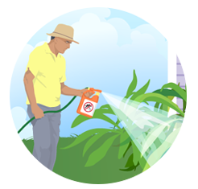  Use adulticides to kill infected adult mosquitoes | Adulticides are the only way to immediately kill infected adult mosquitoes and stop the spread of viruses. | Depending on the size of the area, use backpack sprayers, trucks, or airplanes to apply adulticides. | Apply adulticides according to label instructions to kill mosquitoes inside and outside homes.
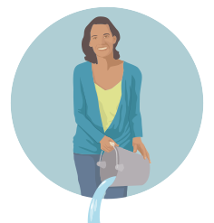  Prevent mosquitoes from laying eggs and eggs from hatching | Mosquitoes lay eggs near water. Eggs can develop into adults in about a week. | - Collect and dispose of abandoned tires and roadside trash.  - Clean up and maintain public spaces like parks and greenways. | Once a week, empty and scrub, turn over, cover, or throw away items that hold water like tires, buckets, planters, toys, pools birdbaths, flower pot saucers, and trash containers.
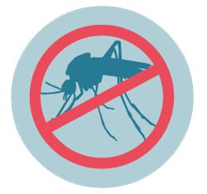  Use larvicides to stop young mosquitoes from becoming adults | Larvicides kill young mosquitoes in water that will not be used for drinking and cannot be dumped. | - Treat standing water or storage containers in public places.  - Treat standing water on private property as part of a neighborhood cleanup or mosquito control campaign. | - Apply larvicides according to label instructions to fountains, septic tanks, and pool covers that hold water.  - Do not treat water that will be used for drinking.

