# ATTACHMENT B: Online Message Testing Survey

# CDC/NCCDPHP/DCPC Message Testing of “Bring Your Brave” Campaign Materials

## Demographics

1. Gender: (1a)

* Male [terminate]
* Female

1. In which of the following categories does your age fall: (2a.)

* under 18 years of age [terminate]
* 18-29 years of age
* 30-44 years of age
* 45 years of age or older [terminate]

1. Have you ever been diagnosed with [breast or ovarian cancer]? (44a.)

* Yes [terminate]
* No

1. What is the highest level of education you have completed? (4a.)

* Less than high school graduate/some high school
* High school graduate or completed GED
* Some college or technical school
* Received four-year college degree
* Some post graduate studies

1. Please indicate your race and/or ethnic background. Are you? (6a.)

Race: SELECT ONE OR MORE.

* White/Caucasian
* Black or African-American
* American Indian or Alaska Native
* Native Hawaiian or Other Pacific Islander
* Asian

Ethnicity: SELECT ANY THAT APPLY.

* Hispanic or Latino
* Not Hispanic or Latino

1. [non HTMS] Are you of Ashkenazi Jewish descent?

* Yes
* No

1. In what zip code do you currently live? ENTER FIVE DIGIT ZIP CODE. (9a.)
2. [non HTMS] Which of the following websites or social media channels do you access once a month or more? Check all that apply.

* Facebook
* Twitter
* Instagram
* Pinterest
* Reddit
* YouTube

1. Has your doctor talked with you about [breast cancer]? (70d.)

* Yes
* No

1. Is [breast cancer] a topic on which you seek out information? (72d.)

* Yes
* No

## Materials

*Materials are to be rotated in order shown to respondents. This survey shows one variation of the rotation.*

## Material B (1-3)

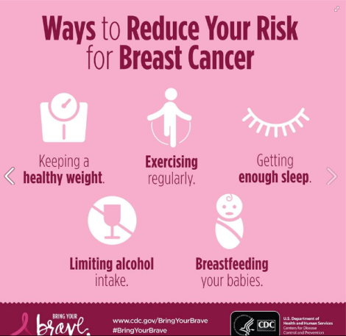

#### Prior Familiarity with Materials

1. Do you remember seeingthis infographic before? (123d.)

* Yes
* No
  + IF YES
    - Please indicate any actions you took after seeing this infographic (check all that apply)
      * I did not take any action after seeing this infographic
      * I ‘liked’ it on social media
      * I shared it with others on social media
      * I thought about the issue
      * I talked with a family member about the information
      * I talked with a friend about the information
      * I took steps to learn my family history of cancer
      * I talked with my doctor about this information
      * Other: (please explain)

|  |
| --- |
|  |

#### Overall Response

1. Overall, did you like this [infographic]? (26e.)

* Yes
* No

1. Does it seem like this message is talking to you, and people like you? (24d.)

* Yes
* No

1. Is [the infographic] easy to understand? (33e.)

* Yes
* No

If no, please describe the areas that were confusing or hard to understand:

Please indicate how much you agree or disagree with the following statements about the (infographic.).

|  |  |  |  |  |  |
| --- | --- | --- | --- | --- | --- |
|  | Strongly Disagree | Disagree | Neutral | Agree | Strongly Agree |
| 1. This [infographic] said something important to me. (69e.) | 1 | 2 | 3 | 4 | 5 |
| 1. The message was dumb. (79e.) | 1 | 2 | 3 | 4 | 5 |
| 1. I can do what this ad suggests (40e.) | 1 | 2 | 3 | 4 | 5 |
| 1. I will do what this ad suggests (41e.) | 1 | 2 | 3 | 4 | 5 |
| 1. I trust the information in this ad (42e.) | 1 | 2 | 3 | 4 | 5 |

1. Did you learn something new by reading this? (E.55.e)

* Yes
* No

|  |  |  |  |  |  |
| --- | --- | --- | --- | --- | --- |
|  | Strongly Disagree | Disagree | Neutral | Agree | Strongly Agree |
| 1. The images are engaging (5e.) | 1 | 2 | 3 | 4 | 5 |
| 1. The images are helpful (7e.) | 1 | 2 | 3 | 4 | 5 |
| 1. I like the way this ad looks (37e.) | 1 | 2 | 3 | 4 | 5 |

1. What other comments would you like to make about this infographic? (E.63.e)

### Material A1

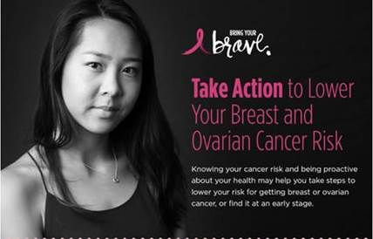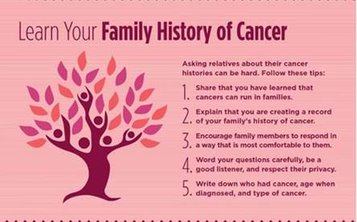

#### Prior Familiarity with Materials

1. Do you remember seeingthis infographic before? (123d.)[1]

* Yes
* No
  1. IF YES
     1. Please indicate any actions you took after seeing this infographic (check all that apply)
        + I did not take any action after seeing this infographic
        + I ‘liked’ it on social media
        + I shared it with others on social media
        + I thought about the issue
        + I talked with a family member about the information
        + I talked with a friend about the information
        + I took steps to learn my family history of cancer
        + I talked with my doctor about this information
        + Other: (please explain)

|  |
| --- |
|  |

#### Overall Response

1. Overall, did you like this [infographic]? (26e.)

* Yes
* No

1. Does it seem like this message is talking to you, and people like you? (24d.)

* Yes
* No

1. How much of the [infographic] would you read? Please choose all that apply. (37d.)

* I would only read the headline
* I would only look at the image/s
* I would only read the headline and look at the image/s
* I would read the whole thing
* I wouldn’t read any of it

1. Is [the infographic] easy to understand? (33e.)

* Yes
* No

If no, please describe the areas that were confusing or hard to understand:

1. Did you learn something new by reading this? (E.55.e)

* Yes
* No

Please indicate how much you agree or disagree with the following statements about the (infographic.).

|  |  |  |  |  |  |
| --- | --- | --- | --- | --- | --- |
|  | Strongly Disagree | Disagree | Neutral | Agree | Strongly Agree |
| 1. This [infographic] said something important to me. (69e.) | 1 | 2 | 3 | 4 | 5 |
| 1. I am interested in this ad’s topic (36e.) | 1 | 2 | 3 | 4 | 5 |
| 1. The message was dumb. (79e.) | 1 | 2 | 3 | 4 | 5 |
| 1. I like the way this ad looks (37e.) | 1 | 2 | 3 | 4 | 5 |
| 1. I trust the information in this ad (42e.) | 1 | 2 | 3 | 4 | 5 |

1. Would you consider doing the 5 steps listed to learn your family history of cancer? (40d.)

* Yes
* No

[If no] Please indicate why not (Check all the reasons that apply)

* I don’t think it’s important
* I don’t have time
* I’m afraid [of talking with my family about our cancer history]
* I don’t have a health care provider
* I would be embarrassed
* I don’t know how to [talk with my family about medical issues]
* I’m not at risk for [breast and ovarian cancer]
* Other:

1. What other comments would you like to make about this infographic? (E.63.e)

### Material C (1-3)

#### Prior Familiarity with Materials

1. Do you remember seeingthis video before? (123d.)

* Yes
* No
  + IF YES
    - Please indicate any actions you took after seeing this video (check all that apply)
      * I did not take any action after seeing this video
      * I clicked on a link provided
      * I thought about the issue
      * I talked with a family member about the information
      * I talked with a friend about the information
      * I took steps to learn my family history of cancer
      * I talked with my doctor about this information
      * Other: (please explain)

|  |
| --- |
|  |

#### Overall Response

1. Is [the video] easy to understand? (33e.)

* Yes
* No

1. [Non HTMS] Were there parts of the video that were unclear or confusing?

* Yes
* No

If yes, please describe the parts that were confusing or hard to understand:

1. Does it seem like this message is talking to you, and people like you? (24d.)

* Yes
* No

1. What do you think about the length of the video? (18e.)

* Too long
* Too short
* Just right

*Please select the number which indicates how much you agree or disagree with each statement.*

|  |  |  |  |  |  |
| --- | --- | --- | --- | --- | --- |
|  | **Strongly Disagree** |  |  |  | **Strongly Agree** |
| 1. This [video] grabbed my attention. (71e.) | 1 | 2 | 3 | 4 | 5 |
| 1. This [video] told me something I didn’t already know. (72e.) | 1 | 2 | 3 | 4 | 5 |
| 1. This [video] was confusing. (74e. ) | 1 | 2 | 3 | 4 | 5 |
| 1. I do not like this [video]. (76e.) | 1 | 2 | 3 | 4 | 5 |
| 1. I liked the person in this [video] (27e.) | 1 | 2 | 3 | 4 | 5 |
| 1. I am interested in this [video’s] topic (36e.) | 1 | 2 | 3 | 4 | 5 |
| 1. I trust the information in this video (42e.) | 1 | 2 | 3 | 4 | 5 |

1. What other comments would you like to make about this video? (E.63.e)

#### Material C4

#### Prior Familiarity with Materials

1. Do you remember seeing [this video] before? (123d.)

* Yes
* No
  + IF YES
    - Please indicate any actions you took after seeing this video (check all that apply)
      * I did not take any action after seeing this video
      * I looked online for more information about the issue
      * I thought about the issue
      * I talked with a family member about the information
      * I talked with a friend about the information
      * I talked with my doctor about this information
      * Other: (please explain)

|  |
| --- |
|  |

#### Overall Response

1. Is [the video] easy to understand? (33e.)

* Yes
* No

1. [Non HTMS] Were there parts of the video that were unclear or confusing?

* Yes
* No

If yes, please describe the parts that were confusing or hard to understand:

1. Does it seem like this message is talking to you, and people like you? (24d.)

* Yes
* No

1. What do you think about the length of the video? (18e.)

* Too long
* Too short
* Just right

*Please select the number which indicates how much you agree or disagree with each statement.*

|  |  |  |  |  |  |
| --- | --- | --- | --- | --- | --- |
|  | **Strongly Disagree** |  |  |  | **Strongly Agree** |
| 1. This [video] grabbed my attention. (71e.) | 1 | 2 | 3 | 4 | 5 |
| 1. This [video] told me something I didn’t already know. (72e.) | 1 | 2 | 3 | 4 | 5 |
| 1. This [video] was confusing. (74e. ) | 1 | 2 | 3 | 4 | 5 |
| 1. I do not like this [video]. (76e.) | 1 | 2 | 3 | 4 | 5 |
| 1. I liked the person in this [video] (27e.) | 1 | 2 | 3 | 4 | 5 |
| 1. I am interested in this [video’s] topic (36e.) | 1 | 2 | 3 | 4 | 5 |
| 1. I plan on looking into [my personal family medical history of cancer] (20f.) | 1 | 2 | 3 | 4 | 5 |
| 1. The message that I saw about [breast cancer and genetic counseling] was compelling. (77e.) | 1 | 2 | 3 | 4 | 5 |
| 1. I trust the information in this video (42e.) | 1 | 2 | 3 | 4 | 5 |

1. What other comments would you like to make about this video? (E.63.e)

## Concluding Question

1. What types of information would you like to receive regarding [breast cancer or breast health, in general]?

|  |
| --- |
|  |

1. [non HTMS] Where do you think the content you have seen in this survey should be posted? Check all that apply. [Similar to 80d.]

* Facebook
* Twitter
* Instagram
* Pinterest
* Reddit
* YouTube
* CDC website
* Other

|  |
| --- |
|  |

1. Strikethrough text indicates wording changes from original question in the HMTS Question Bank.