Consumer Educational Materials
- Antibiotics Aren’t Always the Answer

- Chart
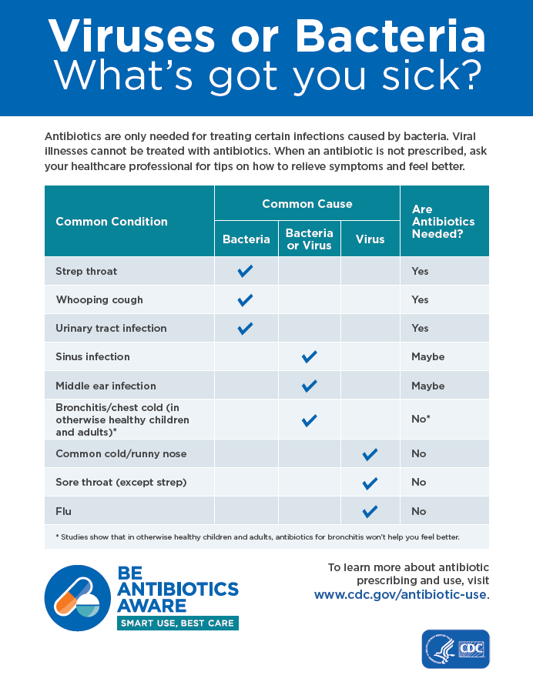

- Infographics
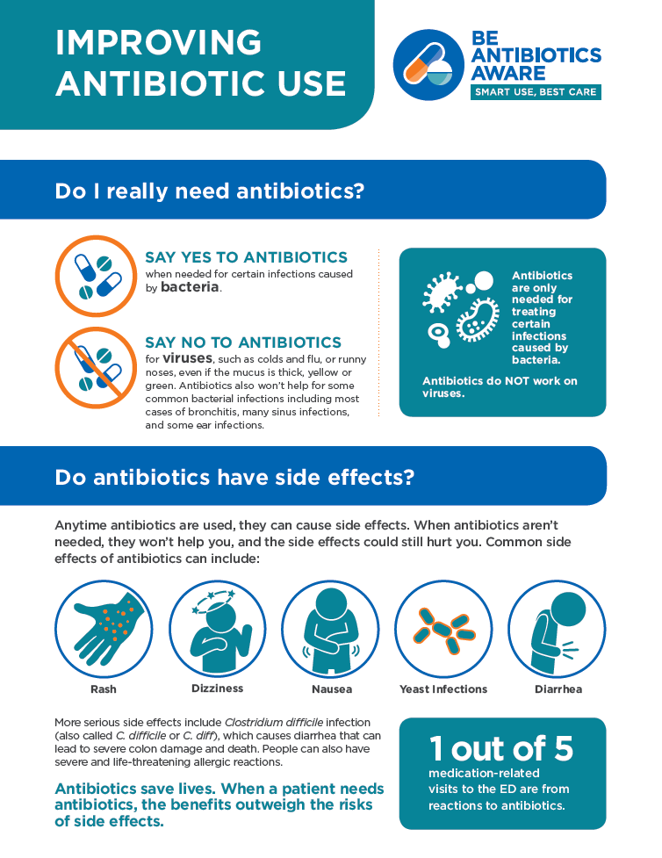
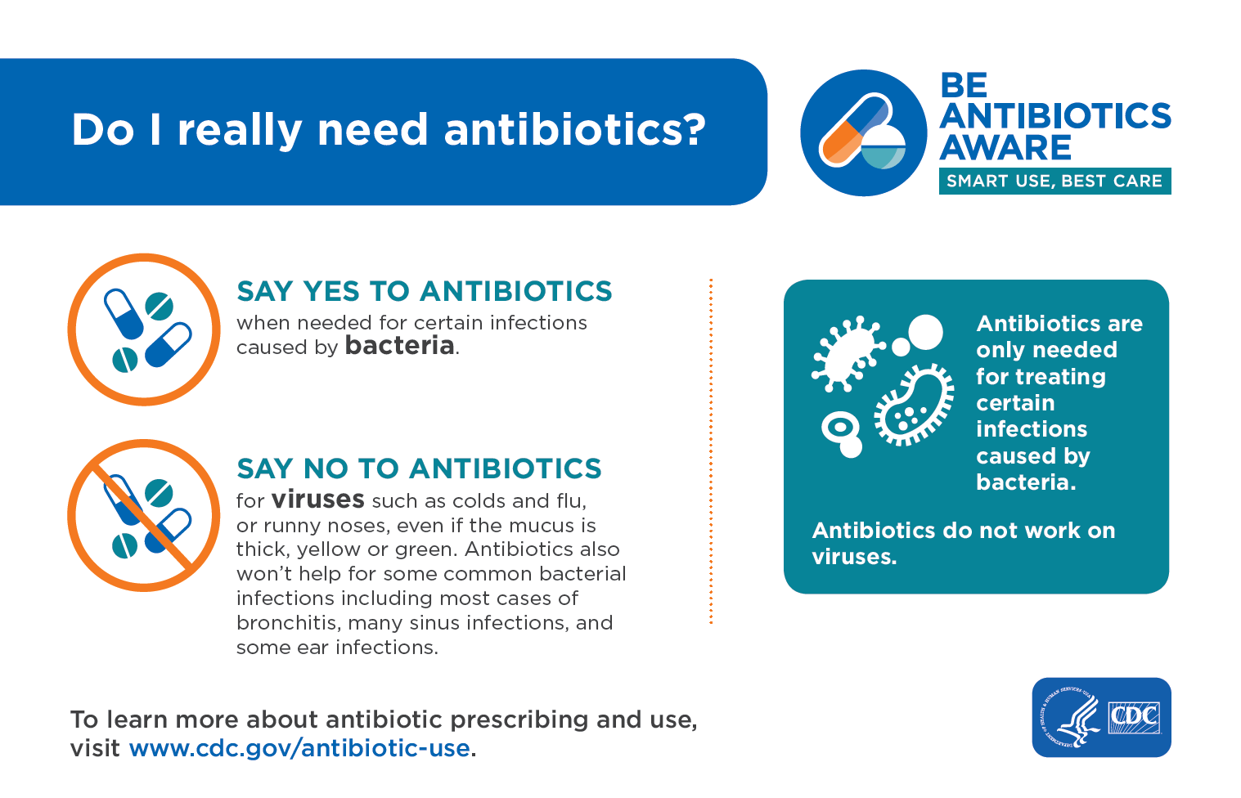

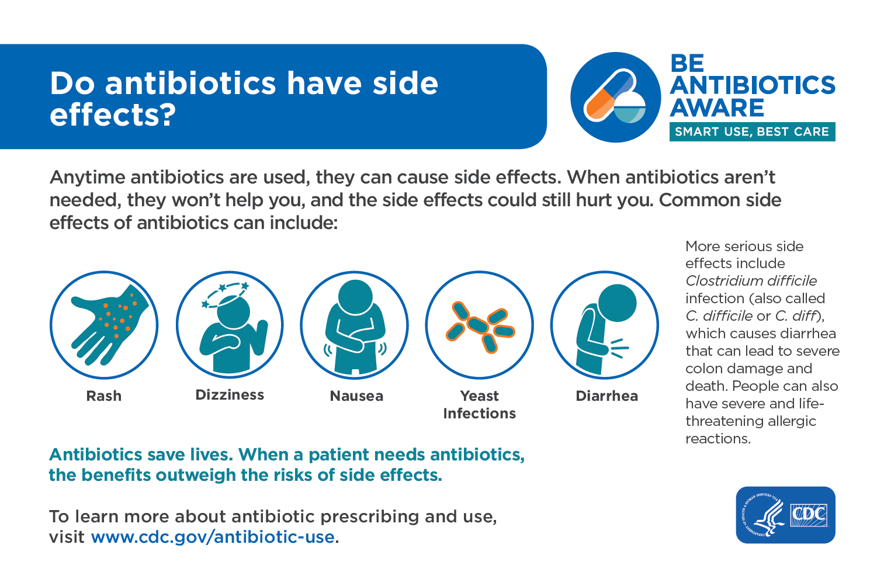

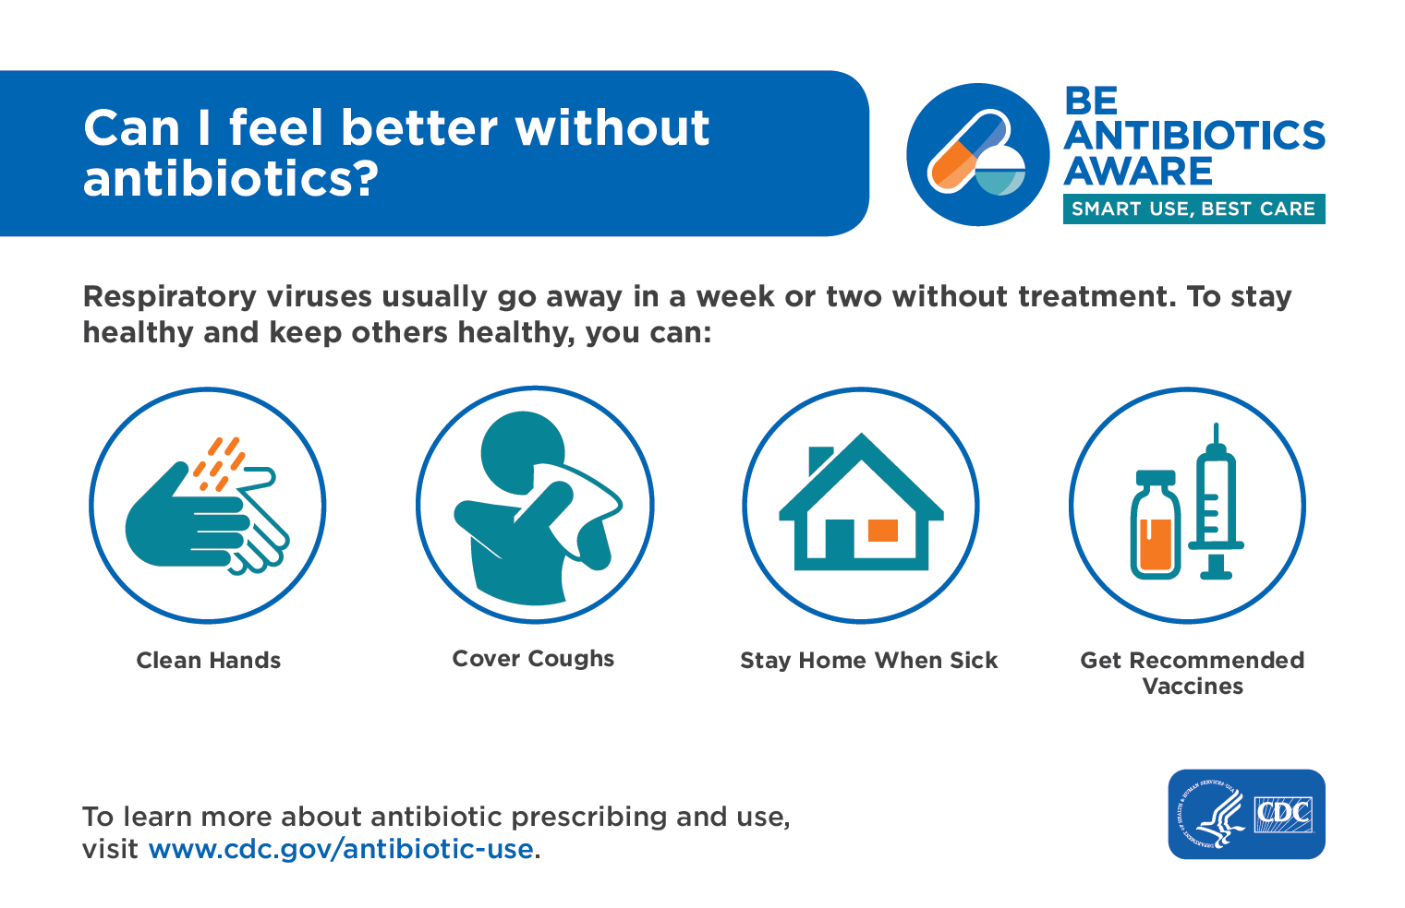

- Observance
- Print PSA: Right Tool

- Tri-Fold
(Front)
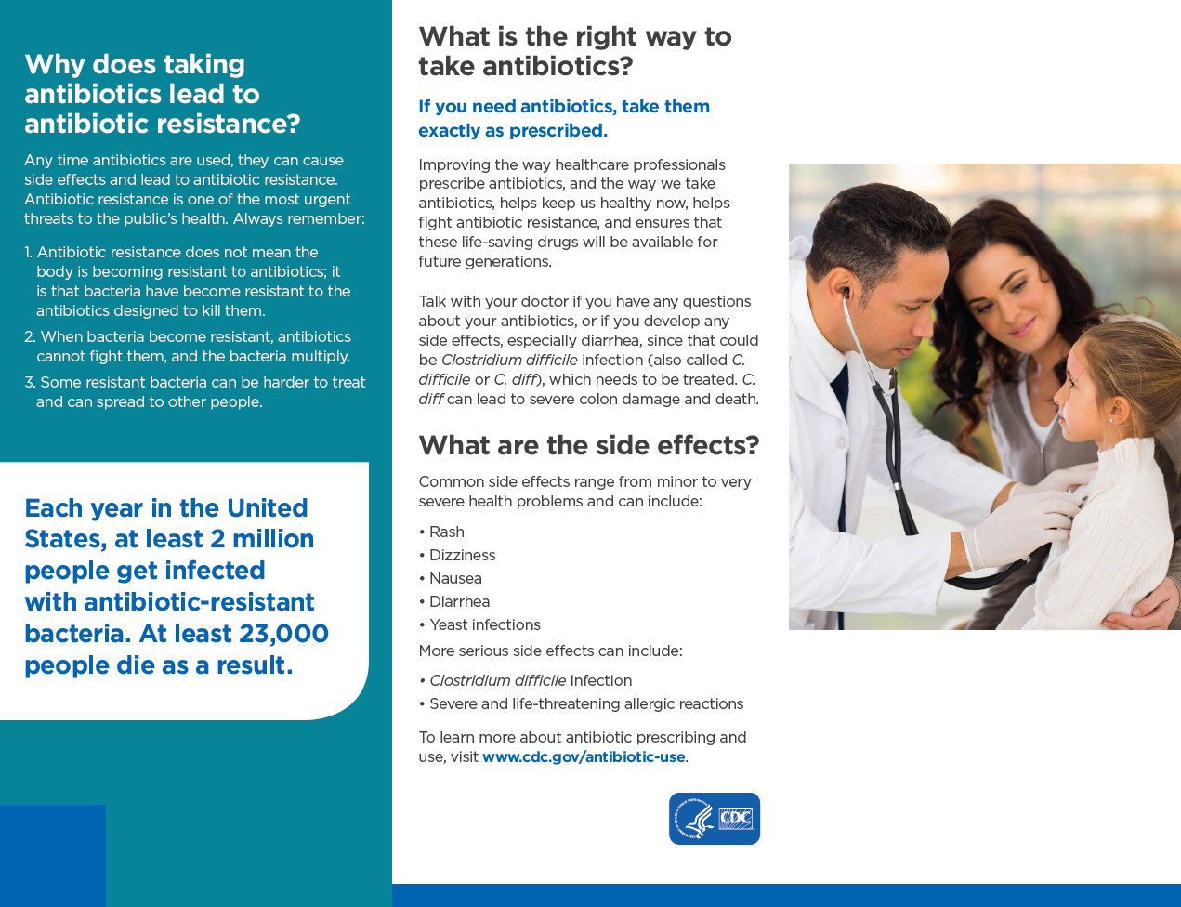

(Back)

- Facebook Ads for Consumers

Facebook Ads for Consumers (cont’d.)

- Online Radio Ad

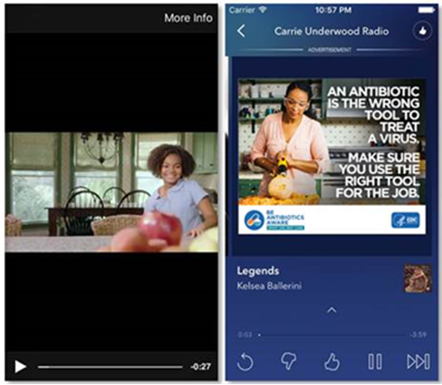
- Links to Animated Videos and PSAs
- Antibiotics Aren’t Always The Answer: https://www.youtube.com/watch?v=XM0EYKfUxkc
- :30 The Right Tool PSA: https://www.youtube.com/watch?v=dETK7Jc-XWA
- :15 The Right Tool PSA: https://www.youtube.com/watch?v=6RfW-TJ-GmM

