Healthcare Provider (HCP) Educational Materials
- Wait Room Poster
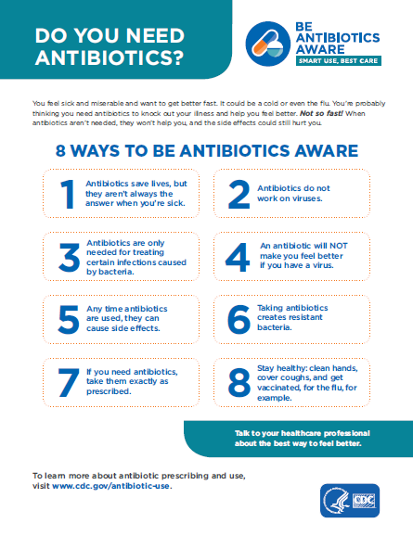

- HCP Commitment Poster
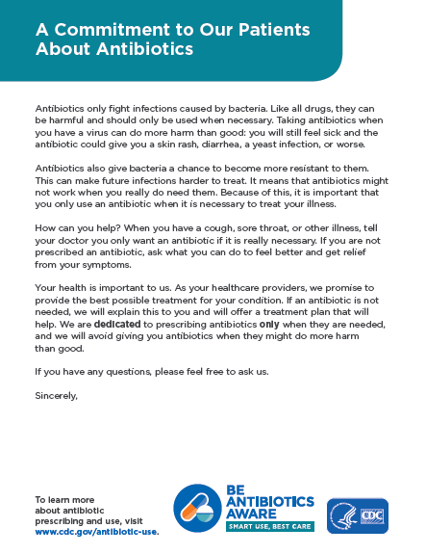

- Be Antibiotics Aware Static Counter Cling
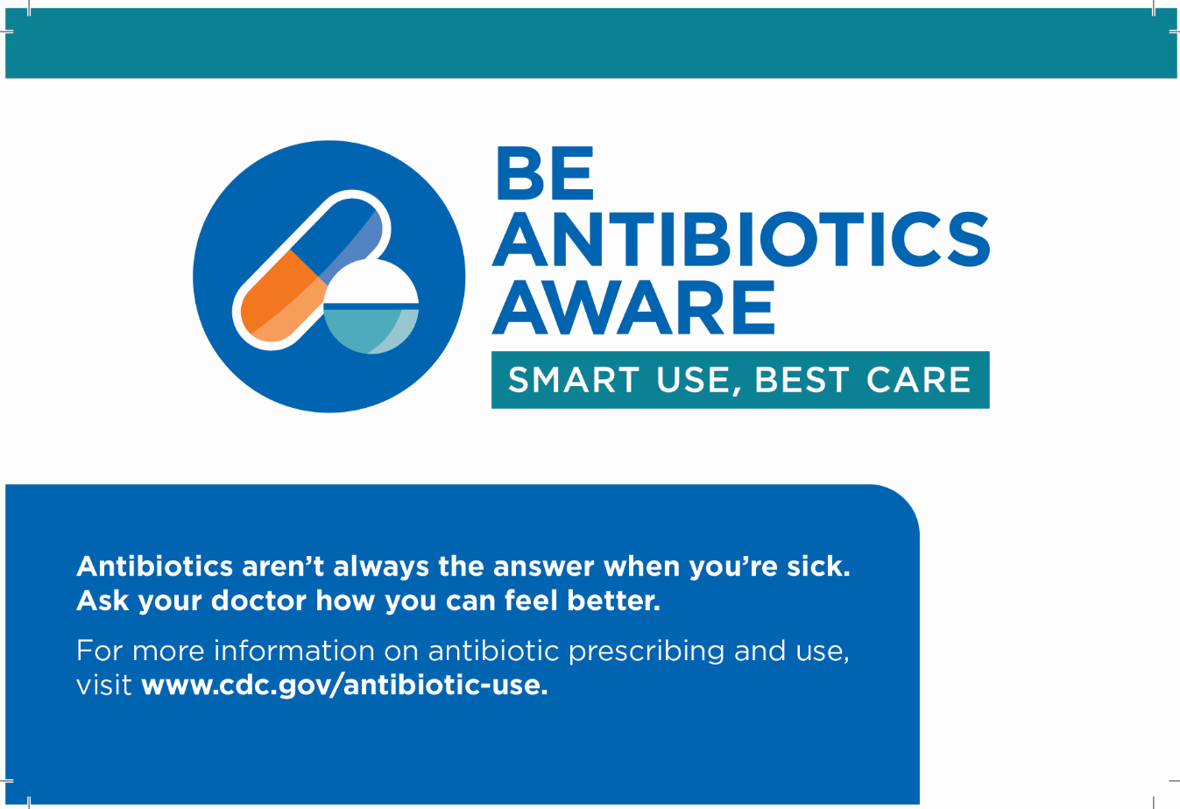

- Be Antibiotics Aware Window Cling
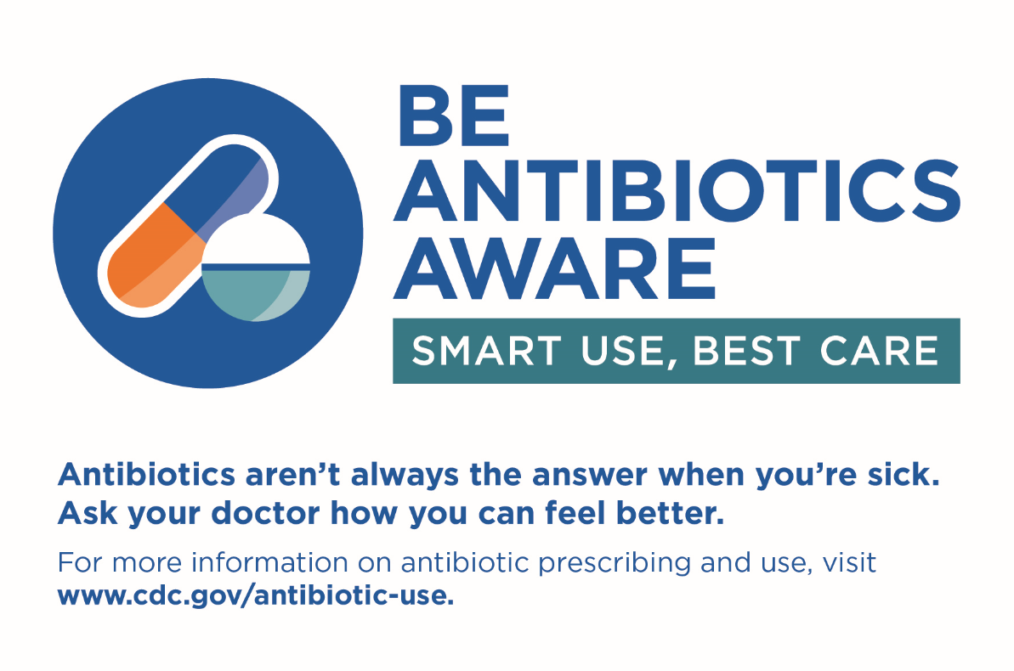

- Be Antibiotics Aware Stickers
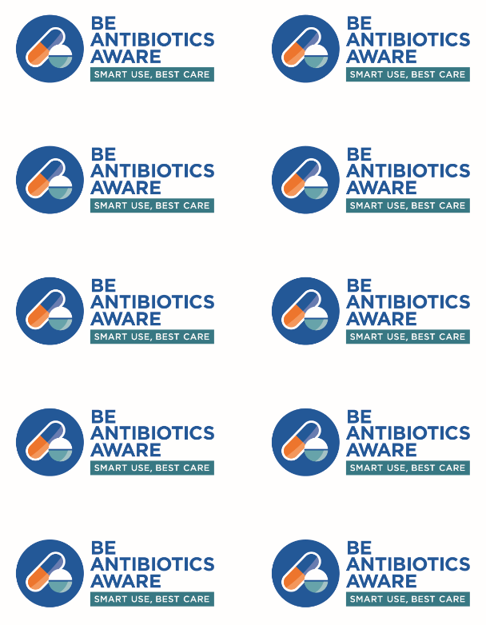

- Prescription Pad (Large and Small): Delayed Prescribing
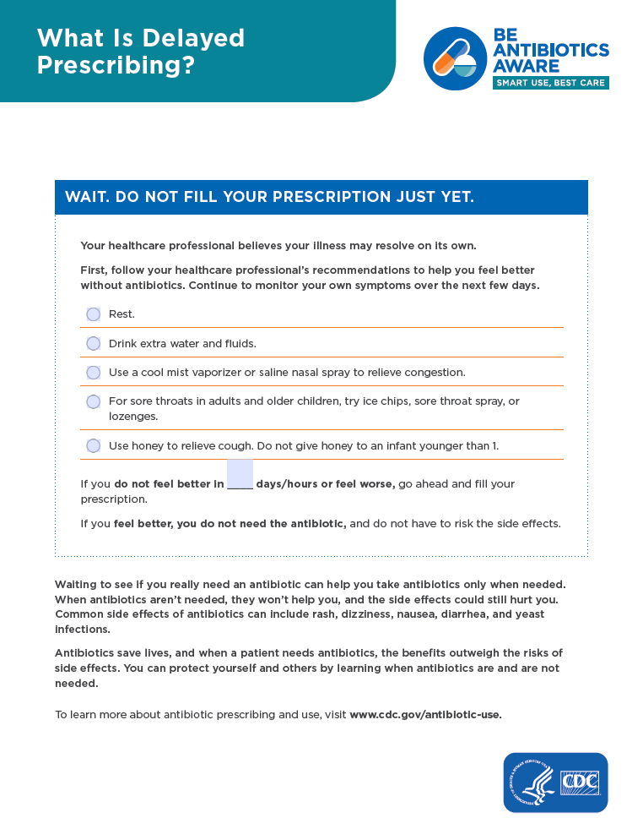
- Prescription Pad (Large and Small): Relief for Viral Illnesses
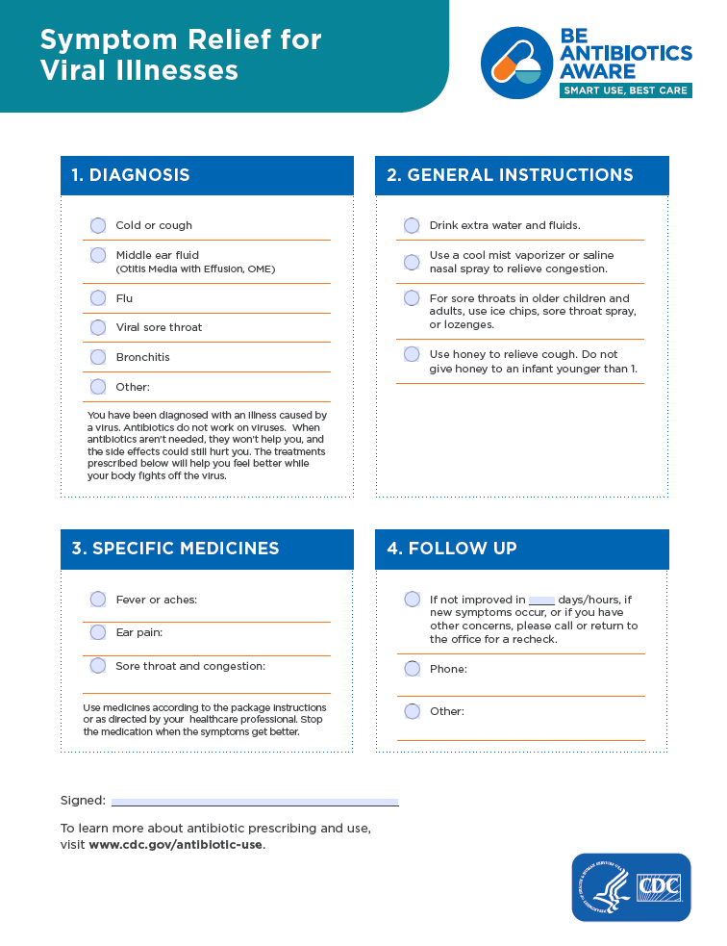

- Prescription Pad (Large and Small): Taking your Antibiotics
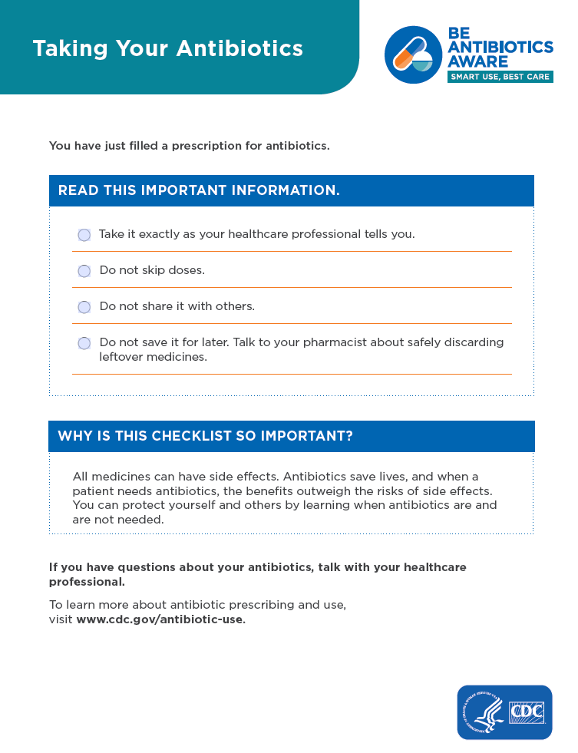
- Prescription Pad (Large and Small): Watchful Waiting
