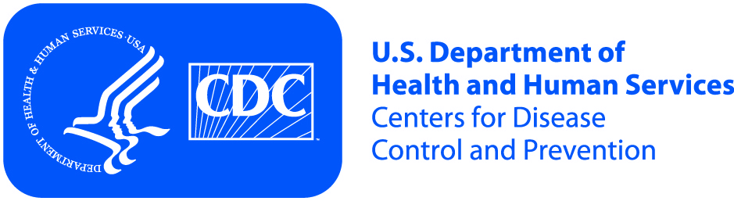
United States Department of Health and Human Services (HHS)
Centers for Disease Control and Prevention, Division of Cancer Prevention and Control (DCPC)

Purpose of the Project | You are invited to voluntarily participate in an online survey conducted by Oak Ridge Associated Universities (ORAU) for the U.S. Government Department of Health and Human Services (HHS) Centers for Disease Control and Prevention (CDC) under the authority of Section 301 of the Public Health Service Act.  During the survey, you will be shown a series of educational materials about a health issue that impacts young women and asked to share your opinions.

If you Agree to Participate Remember | - You choose to participate.  - You are not required to answer the questions.  - This survey should last about 20 minutes.  - You will receive an incentive for participating in the discussion.  - You are free to exit the survey at any time without penalty.

Risks | The risks of taking part in this online survey are the same as you would face in daily life activities at home or work.

Benefits | - You may become better informed about a health issue.  - You may have a sense of satisfaction from contributing.  - Your comments may help improve the information given to young women and medical providers.

Privacy | We will keep the information you give us private to the extent allowed by law. Your name will not be used in any report. No survey responses you provide will be linked to you by name. Only members of the project staff will be allowed to look at the records. When we present this project data, your name or other facts that point to you will not show or be used.

Persons to Contact | If you have any questions about the project, you may contact:  Jennifer Reynolds, Oak Ridge Associated Universities (ORAU), 919-619-0403, Jennifer.Reynolds@orau.org.

