ATTACHMENT 2

Form Approved
OMB No. 0920-0920
Expiration Date 6/30/2018

Development of Messages for the Act Against AIDS National Testing Campaign

Web-based Survey Instrument

Public reporting burden of this collection of information is estimated to average 2 minutes per response, including the time for reviewing instructions, searching existing data sources, gathering and maintaining the data needed, and completing and reviewing the collection of information. An agency may not conduct or sponsor, and a person is not required to respond to a collection of information unless it displays a currently valid OMB control number. Send comments regarding this burden estimate or any other aspect of this collection of information, including suggestions for reducing this burden to CDC/ATSDR Reports Clearance Officer; 1600 Clifton Road NE, MS D-74, Atlanta, Georgia 30333; Attn: OMB-PRA (0920-0920)

SECTION 1: CAMPAIGN EXPOSURE
SCRIPT: We’d now like to ask you some questions about some campaign advertising that you may or may not have seen over the past 12 months [Self-reported exposure to specific AAA campaigns]
1.1 Please complete the following sentence if you have heard or seen this campaign.
[PROGRAMMER: present collage of images for each campaign]
        - Testing Makes Us ________
        - My ________ for getting an HIV test.
        - Start ________. Stop ________.
        - Take________. Take the Test.
        - Let’s _________ HIV ________.
        - We can _____ HIV one ________ at a time.
1.2 In the past 12 months, did you see or hear the following campaign slogans or messages? Check all that apply.
[PROGRAMMER: present collage of images for each campaign]
 | Yes | No | Don’t know/ Can’t recall | Prefer not to answer
- Let’s Stop HIV Together | ₁ | ₂ | ₈ | ₉
- Reasons/Razones | ₁ | ₂ | ₈ | ₉
- Testing Makes Us Stronger | ₁ | ₂ | ₈ | ₉
- Protest | ₁ | ₂ | ₈ | ₉
- Start Talking. Stop HIV. | ₁ | ₂ | ₈ | ₉
- Take Charge. Take the Test. | ₁ | ₂ | ₈ | ₉
- WE Can Stop HIV One Conversation at a Time.
- HIV Treatment Works | ₁ | ₂ | ₈ | ₉
- Greater Than AIDS | ₁ | ₂ | ₈ | ₉
- Act Against AIDS | ₁ | ₂ | ₈ | ₉

[PROGRAMMER: Repeat Q1.3 and Q1.4 for each campaign that was answered “1” (YES) in the preceding question - Q1.2]

1.3 You said you saw or heard a(n) [INSERT CAMPAIGN] campaign slogan or message. On a scale of 0 to 5, where 0 means ‘not very effective’ and 5 means ‘very effective’, how effective do you think this campaign slogan or message is at getting you to get an HIV test?
Not Very Effective  0 | 1 | 2 | 3 | 4 | Very Effective  5 | Prefer not to answer
₁ | ₂ | ₃ | ₄ | ₅ | ₆ | ₉
[PROGRAMMER: present image for each campaign]

1.4 In the past 12 months, how often did you see or hear the following campaign slogans or messages?
[INSERT CAMPAIGN SLOGAN/MESSAGE AND IMAGE]
₁ Very often
₂ Often
₃ Sometimes
₄ Rarely
₅ Never
₉ Prefer not to answer

SECTION 2: CAMPAIGN AD RECEPTIVITY
[Message Receptivity]
SCRIPT: The following questions are about advertisements or ads related to HIV testing. First you will be shown some potential messages for an HIV testing campaign and asked some questions. Next, you will be shown the ads and asked some additional questions. Then you will be asked some questions about potential logos for a campaign.
[PROGRAMMER: ROTATE ORDER OF MESSAGES]
SCRIPT: We are going to show you [insert number] messages that might appear in an HIV testing ad. Some messages may look similar, but each message is different.
2.1 Tell us how strongly you disagree or agree with the following as a message to include in an HIV testing ad:
[Sample Message] Our Reason. Knowledge. Knowledge is power and knowing our statuses empowers us. We’re testing for HIV. Get tested too. It’s free, fast, and confidential. For more information visit hivtest.cdc.gov.
 | Strongly agree | Agree | Neither agree nor disagree | Disagree | Strongly disagree | Prefer not to answer
1. Overall, I liked this message. | ₁ | ₂ | ₃ | ₄ | ₅ | ₉

  - Please explain what, if anything, you liked about this message. ____
[DO NOT FORCE RESPONSE]

  - How would you change the message to make it better? ___
[DO NOT FORCE RESPONSE]

[REPEAT FOR REMAINING MESSAGES]
I’m doing it. I’m testing for HIV. I have the power to be healthy. Get tested and be empowered by knowing your status. Testing is fast, free, and confidential. For more information visit hivtest.cdc.gov.
I am making the time to test for HIV. Knowing my status is important to me. Are you doing it? Get tested and know your status too. For more information visit hivtest.cdc.gov.
My Reason. Me. I matter. Are you doing it? Get tested for HIV. For more information visit hivtest.cdc.gov.
My reason. My future. My future is filled with possibilities. I test for HIV now because I can’t wait to see what’s next, no matter what my status. Get tested and know yours. For more information visit hivtest.cdc.gov.
If you’re doing it, you are part of the [community] who test for HIV and know their HIV status. Your HIV test expires every time you have risky sex. Keep doing it. Get tested. Know your status. For more information visit hivtest.cdc.gov.

  - Please rank these messages from 1-6]. Drag and drop the message that motivates you the most to get tested for HIV in the box on the right. Your first choice should be on top, followed by your second choice underneath it, and so on. If you want to change your response, move the ad back to its original location on the left or drag it above or below another ad. If you would prefer not to answer, you may skip ahead to the next question.

Rank (1–[insert number]) | Message
 | Our Reason. Knowledge. Knowledge is power and knowing our statuses empowers us. We’re testing for HIV. Get tested too. It’s free, fast, and confidential. For more information visit hivtest.cdc.gov.
 | I’m doing it. I’m testing for HIV. I have the power to be healthy. Get tested and be empowered by knowing your status. Testing is fast, free, and confidential. For more information visit hivtest.cdc.gov.
 | I am making the time to test for HIV. Knowing my status is important to me. Are you doing it? Get tested and know your status too. For more information visit hivtest.cdc.gov.
 | My Reason. Me. I matter. Are you doing it? Get tested for HIV. For more information visit hivtest.cdc.gov.
 | My reason. My future. My future is filled with possibilities. I test for HIV now because I can’t wait to see what’s next, no matter what my status. Get tested and know yours. For more information visit hivtest.cdc.gov.
 | If you’re doing it, you are part of the [community] who test for HIV and know their HIV status. Your HIV test expires every time you have risky sex. Keep doing it. Get tested. Know your status. For more information visit hivtest.cdc.gov.
₉ Prefer not to answer

[Ad Receptivity]
SCRIPT: Now we are going to show you some ads that could be part of a campaign about HIV testing. We will show the ads to you in a collage format and ask you some questions after each grouping.
[ROTATE the order of concepts. Participants will view a collage of executions for each concept.]
[REPEAT following questions Q2.1-Q2.3 for ALL ADS]
2.5. Please tell us how much you agree or disagree with each of the following statements about the ad.
Perceived Effectiveness Scale | Strongly agree | Agree | Neither agree nor disagree | Disagree | Strongly disagree | Prefer not to answer
- These ads grabbed my attention. | ₁ | ₂ | ₃ | ₄ | ₅ | ₉
- These ads were confusing. | ₁ | ₂ | ₃ | ₄ | ₅ | ₉
- These ads convinced me to get an HIV test. | ₁ | ₂ | ₃ | ₄ | ₅ | ₉
- These ads said something important to me. | ₁ | ₂ | ₃ | ₄ | ₅ | ₉
- I learned something new from these ads. | ₁ | ₂ | ₃ | ₄ | ₅ | ₉
- These ads gave me good reasons to get an HIV test. | ₁ | ₂ | ₃ | ₄ | ₅ | ₉
- These ads gave me good reasons to talk to my partner about getting an HIV test. | ₁ | ₂ | ₃ | ₄ | ₅ | ₉
- These ads spoke to me. | ₁ | ₂ | ₃ | ₄ | ₅ | ₉
- I liked these ads overall. | ₁ | ₂ | ₃ | ₄ | ₅ | ₉
- I do not like these ads overall. | ₁ | ₂ | ₃ | ₄ | ₅ | ₉
- I believe what these ads are saying. | ₁ | ₂ | ₃ | ₄ | ₅ | ₉
- I like the colors, images or graphics in these ads. | ₁ | ₂ | ₃ | ₄ | ₅ | ₉
- These ads stereotype people. | ₁ | ₂ | ₃ | ₄ | ₅ | ₉
- These ads would make me feel bad if I had HIV. | ₁ | ₂ | ₃ | ₄ | ₅ | ₉
- If I had HIV, these ads would make me feel accepted. | ₁ | ₂ | ₃ | ₄ | ₅ | ₉
- These are important messages for people in my community. | ₁ | ₂ | ₃ | ₄ | ₅ | ₉
- These ads are offensive. | ₁ | ₂ | ₃ | ₄ | ₅ | ₉
- These ads would motivate me to go to the campaign website for more information. | ₁ | ₂ | ₃ | ₄ | ₅ | ₉

[PROGRAMMER: ASK 2.2 IF Q2.1t= “AGREE” OR “STRONGLY AGREE”]
  - Please explain what, if anything, was offensive. ____
[DO NOT FORCE RESPONSE]
[ASK ALL]
  - How would you change the ad to make it better? ___
[DO NOT FORCE RESPONSE]

  - Please rank these ads from 1-[insert number]. Drag and drop the group of ads that motivates you the most to get tested for HIV in the box on the right. Your first choice should be on top, followed by your second choice underneath it, and so on. If you want to change your response, move the ad back to its original location on the left or drag it above or below another ad. If you would prefer not to answer, you may skip ahead to the next question.
Rank (1–[insert number]) | Ad
 | DOING IT
 | [INSERT ADDITIONAL CONCEPT NAMES]
₉ Prefer not to answer

[Execution Testing]
SCRIPT: Now we are going to show you different versions of one of the ads you just saw. Please look at the new version, which is on the left, and compare it to the version of the ad you saw before, which is on the right.
  - Select which version of the ad would most motivate you to get tested for HIV. [Executions shown side by side]
  - Why did you select this version?__________________
[DO NOT FORCE RESPONSE]
[REPEAT FOR ALL EXECUTIONS. ROTATE EXECUTIONS]

2.11 Now we would like to show you some individual ads on their own and ask you a question.
 | Strongly agree | Agree | Neither agree nor disagree | Disagree | Strongly disagree | Prefer not to answer
- I liked this ad overall. | ₁ | ₂ | ₃ | ₄ | ₅ | ₉

[REPEAT FOR ALL EXECUTIONS (SEE BELOW). ROTATE EXECUTIONS]

SCRIPT: Now we are going to show you all of the different versions of the ads together.
2.12 Please rank your top five versions of the ads. Type a 1 in the box to the left of the ad that motivates you the most to get tested for HIV. Type a 2 next in the box to the left of your second choice, and so on. If you would prefer not to answer, you may skip ahead to the next question.
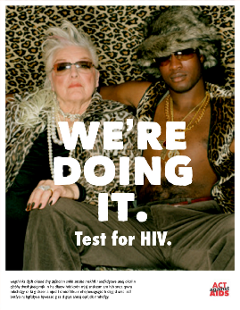 | 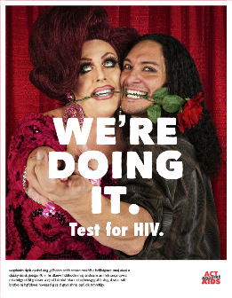 | 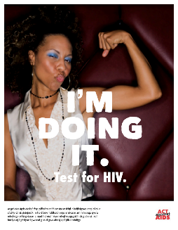 | 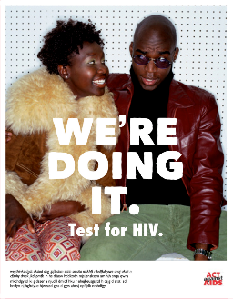
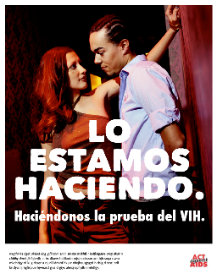 | 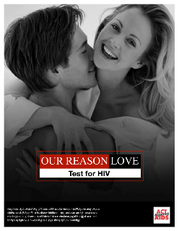 | 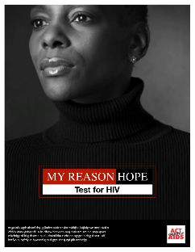 | 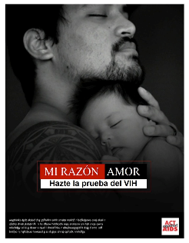
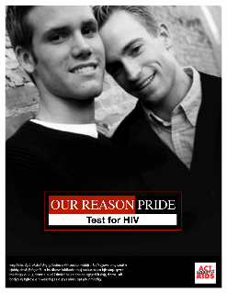 | 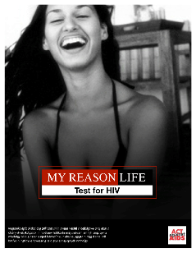 | 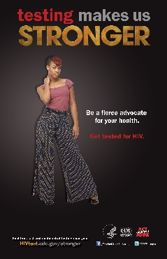 | 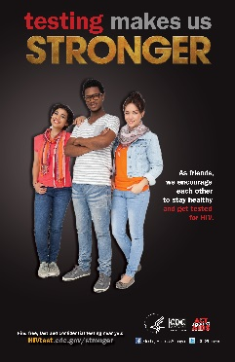
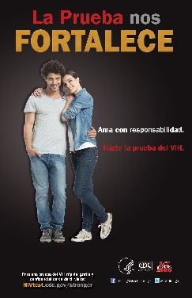 | 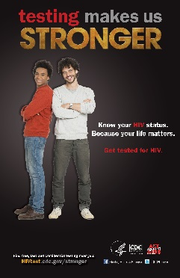 | 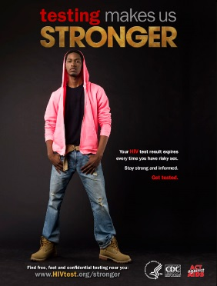 | 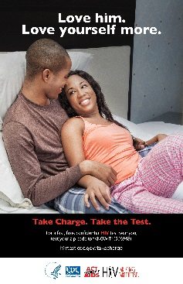
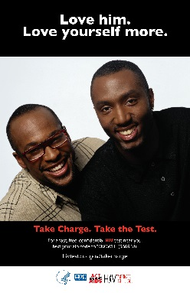 | 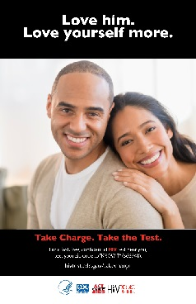 | 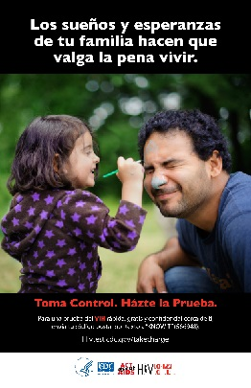 | 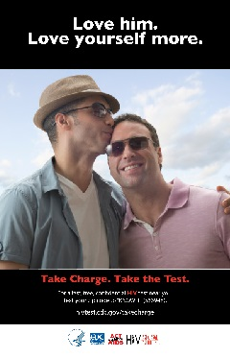

₉ Prefer not to answer

SECTION 3: THEORETICAL CONSTRUCTS
[HIV TESTING: NORMS]
  - Please tell us how much you agree or disagree with each of the following statements.
 | Strongly agree | Agree | Neither agree nor disagree | Disagree | Strongly disagree | Prefer not to answer
- Most people who are important to me think I should get tested for HIV. (By “people who are important to me,” we mean sexual partners, friends, family, and anyone else who is an important part of your life.) | ₁ | ₂ | ₃ | ₄ | ₅ | ₉
- Most of my sexual partners get tested for HIV. | ₁ | ₂ | ₃ | ₄ | ₅ | ₉
- Most people I know get tested for HIV. | ₁ | ₂ | ₃ | ₄ | ₅ | ₉
- Most people in my community think HIV testing is important. | ₁ | ₂ | ₃ | ₄ | ₅ | ₉

[HIV testing: KNOWLEDGE]
  - Please tell us how much you agree or disagree with each of the following statements:
Someone who is HIV-negative and not taking medicines to prevent HIV (e.g., PrEP/Truvada,) should get tested for HIV if they…
 | Strongly agree | Agree | Neither agree nor disagree | Disagree | Strongly disagree | Prefer not to answer
- …always have sex with a condom. | ₁ | ₂ | ₃ | ₄ | ₅ | ₉
- …have had vaginal or anal sex without a condom. | ₁ | ₂ | ₃ | ₄ | ₅ | ₉
- …have a sex partner who is HIV positive. | ₁ | ₂ | ₃ | ₄ | ₅ | ₉
- …have had vaginal or anal sex without a condom with a partner whose HIV status they don’t know. | ₁ | ₂ | ₃ | ₄ | ₅ | ₉
- …have had more than one sex partner since their last HIV test. | ₁ | ₂ | ₃ | ₄ | ₅ | ₉

[HIV testing: Self-Efficacy]
3.3 Please tell us how much you agree or disagree with the following statement: I am confident that I can get an HIV test.
₁ Strongly agree
₂ Agree
₃ Neither agree nor disagree
₄ Disagree
₅ Strongly disagree
₉ Prefer not to answer

3.4 How easy or hard would it be for you to get an HIV test if you…
 | Very Easy | Easy | Neither easy nor hard | Hard | Very hard | Prefer not to answer
- …could find a free testing site? | ₁ | ₂ | ₃ | ₄ | ₅ | ₉
- …had to travel far to find a free testing site? | ₁ | ₂ | ₃ | ₄ | ₅ | ₉
- …could get the results of your HIV test within 20 minutes? | ₁ | ₂ | ₃ | ₄ | ₅ | ₉
- …knew that your test results would be kept confidential? | ₁ | ₂ | ₃ | ₄ | ₅ | ₉
- …could find an HIV test provider that spoke your language (e.g., English, Spanish)? | ₁ | ₂ | ₃ | ₄ | ₅ | ₉
- …could find a provider that you feel comfortable with/ trust? | ₁ | ₂ | ₃ | ₄ | ₅ | ₉
- …could use a home-based HIV testing kit? | ₁ | ₂ | ₃ | ₄ | ₅ | ₉

[HIV TESTING: ATTITUDES]
3.5 Please answer the following questions by choosing the answer that best describes your opinion.
 | Very Impor-tant | Some-what impor-tant | Neither impor-tant nor unimpor-tant | Some-what unimpor-tant | Very unimpor-tant | Prefer not to answer
a. Having access to free HIV tests is… | ₁ | ₂ | ₃ | ₄ | ₅ | ₉
b. Having access to confidential HIV tests is… | ₁ | ₂ | ₃ | ₄ | ₅ | ₉
c. Taking better care of my sexual partner is… | ₁ | ₂ | ₃ | ₄ | ₅ | ₉
d. Keeping myself healthy is… | ₁ | ₂ | ₃ | ₄ | ₅ | ₉
e. Doing things to help my future is… | ₁ | ₂ | ₃ | ₄ | ₅ | ₉
f. Knowing my HIV status is… | ₁ | ₂ | ₃ | ₄ | ₅ | ₉

[HIV TESTING: BEHAVIORAL BELIEFS]
3.6 Please tell us how much you agree or disagree with each of the following statements:
Getting tested for HIV…
 | Strongly agree | Agree | Neither agree or disagree | Disagree | Strongly disagree | Prefer not to answer
a. …will help me stay strong. | ₁ | ₂ | ₃ | ₄ | ₅ | ₉
b. …will help me make informed decisions. | ₁ | ₂ | ₃ | ₄ | ₅ | ₉
c. …will help me take better care of my sexual partner. | ₁ | ₂ | ₃ | ₄ | ₅ | ₉
d. …keeps me healthy. | ₁ | ₂ | ₃ | ₄ | ₅ | ₉
e. …will help my future. | ₁ | ₂ | ₃ | ₄ | ₅ | ₉
f. …is fast, free, and confidential. | ₁ | ₂ | ₃ | ₄ | ₅ | ₉
g. …is important for my health. | ₁ | ₂ | ₃ | ₄ | ₅ | ₉
h. …is something everyone should do in their lifetime. | ₁ | ₂ | ₃ | ₄ | ₅ | ₉
i. …is important so that people who test positive can start getting treated right away. | ₁ | ₂ | ₃ | ₄ | ₅ | ₉

[HIV TESTING: INTENTIONS]
3.7 Please tell us how likely or unlikely it is that you intend to...
 | Very likely | Somewhat likely | Neither likely nor unlikely | Somewhat unlikely | Very unlikely | Prefer not to answer
- …get an HIV test within the next 6 months. | ₁ | ₂ | ₃ | ₄ | ₅ | ₉
- …get an HIV test within the next 12 months. | ₁ | ₂ | ₃ | ₄ | ₅ | ₉
- …get an HIV test before sex with a new sexual partner. | ₁ | ₂ | ₃ | ₄ | ₅ | ₉
- …get tested with a sexual partner. | ₁ | ₂ | ₃ | ₄ | ₅ | ₉

SECTION 4: COMMUNICATION
4.1 In the past 12 months, have you had a conversation about HIV testing with any of the following people?
 | Yes | No | Don’t know/ Can’t recall | Prefer not to answer
- Boyfriend/girlfriend/spouse
- Sexual partners | ₁ | ₂ | ₃ | ₉
- Health care provider, counselor, or outreach worker | ₁ | ₂ | ₃ | ₉
- Friends | ₁ | ₂ | ₃ | ₉
- Child | ₁ | ₂ | ₃ | ₉
- Parent | ₁ | ₂ | ₃ | ₉
- Other family member [Specify: ] | ₁ | ₂ | ₃ | ₉
- Spiritual advisor/Clergy | ₁ | ₂ | ₃ | ₉
- Health care provider
- Other [Specify: _____________________________] | ₁ | ₂ | ₃ | ₉

SECTION 5: INFORMATION SEEKING/ MEDIA USE
[MEDIA USE]
SCRIPT: The next question is about sources you would want to go to for health related information.
5.1 Please tell us from which of the following sources you’d be most interested in getting health information. (Select up to 10)
 | Top 10
a. Doctor’s office or community health clinic | ₁
b. Community center | ₁
c. Church | ₁
d. Community health fair | ₁
e. Sporting event | ₁
f. Night club | ₁
g. Coffee shop | ₁
h. Health club or gym | ₁
i. Advertisements in shopping malls | ₁
j. Government service offices (e.g. social services, DMV) | ₁
k. College campuses | ₁
p. Newspaper | ₁
q. Magazine | ₁
r. Radio advertisement | ₁
s. Television advertisement | ₁
t. Billboard | ₁
u. Bus or train stop advertisement | ₁
v. Social networking sites or mobile app (e.g. Facebook, Twitter) | ₁
w. Dating or hook up sites or mobile app (e.g. Match, Adam4Adam) | ₁
x. Text message to your cell phone | ₁
y. Health websites | ₁
₉ Prefer not to answer

SCRIPT: The next several questions are about different media you may use.
5.2 In an average month, how often do you…
 | Daily | 2 -5 Times a Week | Once a Week | 2-3 Times a Month | Once a Month | Less than Once a Month | Never | Prefer not to answer
- use Facebook? (www.facebook.com) | ₁ | ₂ | ₃ | ₄ | ₅ | ₆ | ₇ | ₉
- use Twitter? (www.twitter.com) | ₁ | ₂ | ₃ | ₄ | ₅ | ₆ | ₇ | ₉
- use YouTube? (www.youtube.com) | ₁ | ₂ | ₃ | ₄ | ₅ | ₆ | ₇ | ₉
- use dating/hook-up sites or mobile apps? (e.g., Match, OK Cupid, e-harmony, manhunt.com, Plenty of Fish, adam4adam, Tinder, Grindr, etc.) | ₁ | ₂ | ₃ | ₄ | ₅ | ₆ | ₇ | ₉
- visit online news websites? (e.g., cnn.com, slate.com, etc.) | ₁ | ₂ | ₃ | ₄ | ₅ | ₆ | ₇ | ₉
- watch television? | ₁ | ₂ | ₃ | ₄ | ₅ | ₆ | ₇ | ₉
- listen to radio? | ₁ | ₂ | ₃ | ₄ | ₅ | ₆ | ₇ | ₉
- use buses, subways, or trains? | ₁ | ₂ | ₃ | ₄ | ₅ | ₆ | ₇ | ₉
- read magazines? | ₁ | ₂ | ₃ | ₄ | ₅ | ₆ | ₇ | ₉
- read newspapers? | ₁ | ₂ | ₃ | ₄ | ₅ | ₆ | ₇ | ₉
[PROGRAMMER: ASK 5.3 IF Q5.2d=any response except for “Never”or “Prefer not to answer”]
  - Please list what dating/hook-up sites or mobile apps you use. ____
[DO NOT FORCE RESPONSE]

[HIV/AIDS INFORMATION SEEKING BEHAVIOR]
5.4 In the past 12 months, about how often have you seen [or heard] HIV/AIDS-related ads on…]?
 | Very often | Often | Some-times | Rarely | Never | Don’t know/ Can’t recall | Prefer not to answer
- Facebook (www.facebook.com) | ₁ | ₂ | ₃ | ₄ | ₅ | ₈ | ₉
- Twitter (www.twitter.com) | ₁ | ₂ | ₃ | ₄ | ₅ | ₈ | ₉
- YouTube (www.youtube.com) | ₁ | ₂ | ₃ | ₄ | ₅ | ₈ | ₉
- Dating/Hook-up sites or mobile apps (e.g., Grindr, OKCupid, Match.com, etc.) | ₁ | ₂ | ₃ | ₄ | ₅ | ₈ | ₉
- Online news websites (e.g., cnn.com, slate.com, etc.) | ₁ | ₂ | ₃ | ₄ | ₅ | ₈ | ₉
- Television | ₁ | ₂ | ₃ | ₄ | ₅ | ₈ | ₉
- Radio | ₁ | ₂ | ₃ | ₄ | ₅ | ₈ | ₉
- Billboards | ₁ | ₂ | ₃ | ₄ | ₅ | ₈ | ₉
- Buses, subways, or trains | ₁ | ₂ | ₃ | ₄ | ₅ | ₈ | ₉
- Magazines [Specify:_______________________] | ₁ | ₂ | ₃ | ₄ | ₅ | ₈ | ₉
- Newspapers [Specify:_______________________] | ₁ | ₂ | ₃ | ₄ | ₅ | ₈ | ₉
- Other [Specify:_______________________] | ₁ | ₂ | ₃ | ₄ | ₅ | ₈ | ₉

5.5 In the past 12 months, how often have you…
 | Very often | Often | Some-times | Rarely | Never | Don’t know/ Can’t recall | Prefer not to answer
- …looked for information about HIV testing? | ₁ | ₂ | ₃ | ₄ | ₅ | ₈ | ₉
- …searched online for a location to get an HIV test? | ₁ | ₂ | ₃ | ₄ | ₅ | ₈ | ₉
- …called an HIV testing hotline? | ₁ | ₂ | ₃ | ₄ | ₅ | ₈ | ₉
- …texted your zip code for a location to get an HIV test? | ₁ | ₂ | ₃ | ₄ | ₅ | ₈ | ₉
- …talked about HIV testing? |  |  |  |  |  | ₈

[trust in cdc]
  - Please tell us if you agree or disagree with the following statement: I trust the Centers for Disease Control, or CDC, as a source for HIV information.
₁ Strongly agree
₂ Agree
₃ Neither agree nor disagree
₄ Disagree
₅ Strongly disagree
₉ Prefer not to answer

SECTION 6: HIV TESTING HISTORY
[PROGRAMMER: If S7=2, SKIP to Q6.4]
6.1 When did you have your first HIV test?
DATE (MM/YYYY):________ [ERROR CHECK: CANNOT BE BEFORE 1985 OR BEYOND CURRENT DATE]
₉ Prefer not to answer
6.2 When did you have your most recent HIV test?
DATE (MM/YYYY):__________
₉ Prefer not to answer
6.3. When you got tested on ____/____ [insert date from Q6.2], where did you get tested?
₁ Private doctor’s office
₂ HIV counseling and testing site
₃ Public health clinic/community health clinic
₄ Street outreach program/mobile unit
₅ Sexually transmitted disease clinic
₆ Hospital (inpatient)
₇ Correctional facility (jail or prison)
₈ Emergency room
₉ At home
₁₀ Other
₈₈ Don’t know [INELIGIBLE]
₉ Prefer not to answer [INELIGIBLE]

[PROGRAMMER: If Q6.2 is greater than 12 months OR S7=2, ask Q6.4]
6.4. Below is a list of reasons why some people have not been tested for HIV. Which of these best describes the most important reason you have not been tested for HIV in the past 12 months? [Check one]
₁ I think I am at low risk for HIV infection.
₂ I am afraid of finding out that I have HIV.
₃ I didn’t have time.
₄ Some other reason [Specify: ]
₅ No particular reason
₉ Prefer not to answer

SECTION 7: HIV PERCEPTIONS
[PERCEPTION OF HIV AS A PROBLEM]
  - On a scale from 1 to 10, where 1 is the least important and 10 is the most important, how would you rate the importance of HIV as a health problem facing the nation today?
INSERT SLIDER 1- least important to 10- most important

₉ Prefer not to answer

[Perceived risk of HIV infection]
  - Thinking about the sex you’ve had over the past 12 months, do you consider yourself to be low, medium or high risk for getting HIV?
₁ Low risk
₂ Medium risk
₃ High risk
₉ Prefer not to answer

SECTION 8: RAPID SELF-TESTING
SCRIPT: The next question is about your experiences with rapid HIV tests that are sold over the counter, as well as at pharmacies and on the internet, and allow you to test yourself in your home. These tests have a collection pad device that you use to swab the inside of your mouth, between the teeth and upper and lower gum. You then place the collection device into a solution and read the result between 20-40 minutes.

8.1. Have you ever used an over-the-counter rapid HIV test you can administer yourself to determine your HIV status?
₁ Yes
₂ No
₈ Don’t know
₉ Prefer not to answer

SECTION 9: HIV PREVENTION STRATEGIES
9.1 In the past 12 months, how often did you use condoms for vaginal or anal sex with a non-main/casual partner? (A non-main or casual sexual partner is someone who you do not consider to be a spouse, significant other, or life partner.)
₁ Always
₂ Usually
₃ Occasionally
₄ Never
₅ Not Applicable: I have not had a non-main/casual partner in the past 12 months.
₉ Prefer not to answer
9.2 True or false: There are medicines available to treat HIV.
₁ True
₂ False
₈ Don’t know
₉ Prefer not to answer
9.3 Before today, have you ever heard of people who do not have HIV taking HIV medicines (PrEP or Truvada) before sex, to keep from getting HIV?
₁ Yes
₂ No
₉ Prefer not to answer
9.4 Before today, have you ever heard of people who do not have HIV taking HIV medicines (PEP or post-exposure prophylaxis) after sex, to keep from getting HIV?
₁ Yes
₂ No
₉ Prefer not to answer
9.5 True or false: If a person’s viral load is “undetectable”, they are cured and no longer have HIV.
₁ True
₂ False
₈ Don’t know
₉ Prefer not to answer
9.6 In the past 12 months, have you taken HIV medicines (PEP or post-exposure prophylaxis) after sex because you thought it would keep you from getting HIV?
₁ Yes
₂ No
₉ Prefer not to answer

9.7 In the past 12 months, have you taken HIV medicines (PrEP or Truvada) before sex because you thought it would keep you from getting HIV?
₁ Yes
₂ No
₉ Prefer not to answer

SECTION 10: OTHER SOCIODEMOGRAPHIC VARIABLES
SCRIPT: We’d now like to ask you a few more questions about your background.

[SOCIODEMOGRAPHICS]
  - What is the highest grade or year of school you finished?
₁ Never attended school or only attended kindergarten
₂ Grades 1 through 8 (elementary)
₃ Grades 9 through 11 (some high school)
₄ Grade 12 or GED (high school graduate)
₅ College 1 year to 3 years (some college or technical school)
₆ College 4 years or more (college graduate)
₉ Prefer not to answer
  - Which best describes your total personal income during the past year?
₁ Less than $20,000
₂ $20,001 to $30,000
₃ $30,001 to $40,000
₄ $40,001 to $50,000
₅ $50,001 or more
₉ Prefer not to answer
  - What is your relationship status?
₁ Single
₂ Married to a man
₃ Married to a woman
₄ In a relationship with a man
₅ In a relationship with a woman
₉ Prefer not to answer
10.4 Are you a parent or guardian of a child younger than 18 years of age?
₁ Yes
₂ No
₉ Prefer not to answer
  - In what ZIP Code do you currently live? ______________
[PROGRAMMER: IF S5=1, ASK Q10.6]
10.6 What language are you most comfortable using with your family and friends?
₁English
₂Spanish
₃English and Spanish equally
₄Other [Specify: ]
₉Prefer not to answer
[PROGRAMMER: IF S5=1, ASK Q10.7]
10.7 In what country or territory were you born?
₁United States [SKIP TO END]
₂Puerto Rico
₃Mexico
₄Cuba
₅Other (Please type in: )
₉Prefer not to answer
[PROGRAMMER: IF S5=1 AND Q10.7≠1, ASK Q10.8 ]
10.8 How many years have you been living in the United States? [If less than one year, put 0 in the space. Round to whole years] __ NUM RANGE 0-99___________years
₉Prefer not to answer

