Healthy Homes - Asthma Page
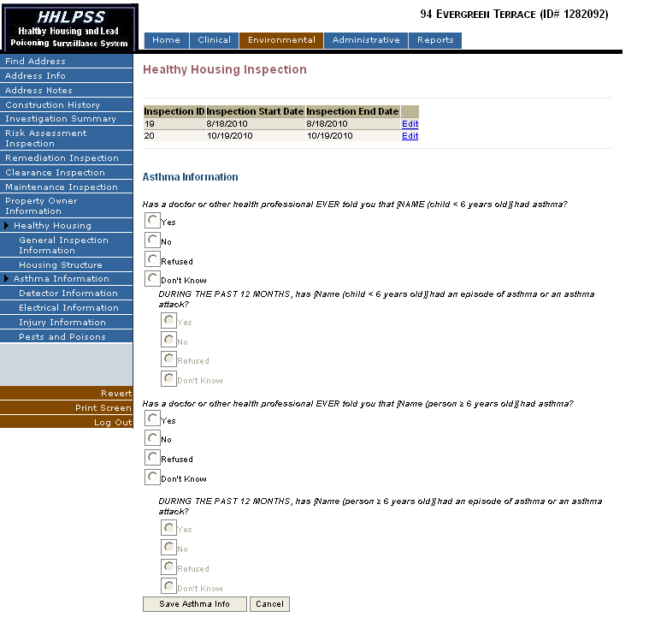
Race Selection

