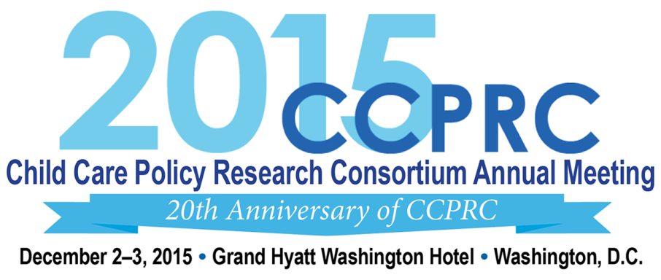
Overall Evaluation Form
This evaluation form can also be completed online at: https://www.surveymonkey.com/s/2015CCPRC.
What is your current professional role? (You may select up to 2 roles.)
Federal agency employee | State or Territory administrator | Other (specify)  _____________________
Foundation Staff | State or Territory agency staff member
Researcher | Local Administrator/Staff
Training or Technical Assistance Provider | National Policy Organization Staff

Please check each day you attended.
Wednesday, December 2, 2015 | Thursday, December 3, 2015

Overall Program
Please rate the statements using the following scale: 1=Poor, 2=Fair, 3=Good and 4=Excellent.
Poor Fair Good Excellent
My overall impression of the meeting was: …………………. 1 2 3 4
The information discussed and provided was: ………………. 1 2 3 4
The presenters and moderators were: ………………………... 1 2 3 4
The plenary session topics were: ……………..……………..... 1 2 3 4
The workshop/breakout session topics were: ……………....... 1 2 3 4
The number of opportunities for networking were: …………. 1 2 3 4
1. Were the presentations, discussions, and topics covered in this year’s meeting interesting and relevant to your work? Please explain.

2. What topics would you like to have covered in future meetings? Are there issues that emerged that you would like to see addressed or explored further, e.g., through a webinar, roundtable, conference call, briefing paper, or workgroup? If so, please specify the topics and preferred format.

3. Which plenary sessions and workshops did you find most effective and why?

4. What can we improve for next time in terms of meeting content (e.g., topics, sessions, participants)? Suggestions would be appreciated.

5. What can we improve for next time in terms of meeting format (e.g., time of year, length of meeting, session format, new CCPRC communications system in Huddle)? Suggestions would be appreciated.

6. Do you have anything else that you would like to share?

Meeting Logistics
Poor Fair Good Excellent
Overall meeting 1 2 3 4
Location of hotel 1 2 3 4
Hotel accommodations 1 2 3 4
Meeting registration process 1 2 3 4
Logistics staff assistance 1 2 3 4
Meeting materials 1 2 3 4
The use of USB drives for resource-sharing 1 2 3 4

Thank you for completing this Evaluation Form. Please return this completed form to the Registration Desk,
fax it to (240) 399-8471, or e-mail it to opre@blhtech.com.

Paperwork Reduction Act Statement: This collection of information is voluntary and will be used to collect participant feedback to shape future CCPRC meetings. Public reporting burden for this collection of information is estimated to average 5 minutes per response, including the time for reviewing instructions, gathering and maintaining the data needed, and reviewing the collection of information. An agency may not conduct or sponsor, and a person is not required to respond to, a collection of information unless it displays a currently valid OMB control number. The OMB number and expiration date for this collection are OMB #: 0970-0401, Exp: 05/31/2018. Send comments regarding this burden estimate or any other aspect of this collection of information, including suggestions for reducing this burden to opre@blhtech.com.

