Form Approved
OMB No. 0990-0388
Exp. Date 07/31/2018
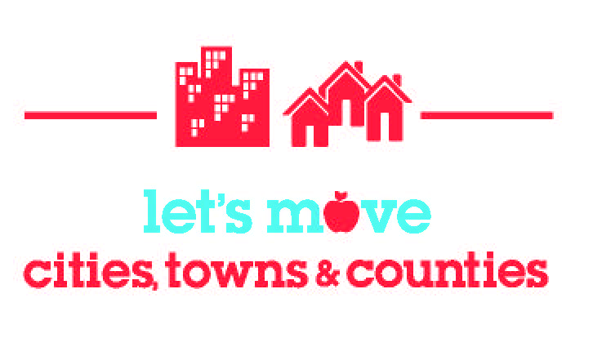

Medal Status Survey

Please fill out the following to the best of your ability. You may not know the answer to each survey question. That is okay; if you are having trouble finding data, submit what you can and return to the same link to complete your survey at a later date. Update the survey responses and resubmit when progress on the five goals has been made or new information has been gathered. Click here to review the goals before completing the survey.

If you have questions while completing this survey, please email lmctc@nlc.org or call Elena Hoffnagle at (202)626-3012.

You can submit this Word version to lmctc@nlc.org.

Mandatory fields in red

1. What is your municipality name?

2. What is your municipality’s state?

3. What type of site are you? ☐ City ☐ Town ☐ County

4. What is the title, name and contact information for the local elected official leading your Let’s Move! efforts?
Title:
☐ Mayor
☐ Town Administrator/City Manager
☐ City Council Member
☐ Alderperson
☐ County Executive/Commissioner
☐ County Supervisor
☐ County Council Member
According to the Paperwork Reduction Act of 1995, no persons are required to respond to a collection of information unless it displays a valid OMB control number. The valid OMB control number for this information collection is 0990-0388 . The time required to complete this information collection is estimated to average 30 minutes per response, including the time to review instructions, search existing data resources, gather the data needed, and complete and review the information collection. If you have comments concerning the accuracy of the time estimate(s) or suggestions for improving this form, please write to: U.S. Department of Health & Human Services, OS/OCIO/PRA, 200 Independence Ave., S.W., Suite 336-E, Washington D.C. 20201, Attention: PRA Reports Clearance Officer
Name
Address 1
Address 2
City/Town
State
Zip Code
Email
Telephone

5. Do you have a lead person who will coordinate your site’s Let's Move! activities and be responsible for reporting your progress to Let's Move! ? ☐ Yes ☐ No

Name
Title and Organization
Email
Telephone

6. If there is a political affiliation associated with the local elected official representing your community, please identify his or her affiliation (optional).
☐ Democrat
☐ Republican
☐ Independent
☐ Other
☐ N/A

Important note: for each goal below, the medal benchmarks build on each other, meaning that fulfilling the bronze benchmark is a requirement to achieve a silver medal, and fulfilling the bronze and silver benchmarks are requirements to achieve a gold medal. See all medal benchmarks here.

Goal I: Start Early Start Smart

To provide children with a healthier start, local elected officials commit to helping early care and education program providers incorporate best practices for nutrition, physical activity and screen time into their programs. Visit the Goal I page to learn more.

Let’s Move! Child Care is a nationwide effort to empower early care and education providers to make positive changes for children’s health that can last a lifetime by focusing on good nutrition, limited screen time and regular physical activity. Let’s Move! Child Care has five goals which focus on physical activity, screen time, food, beverages and infant feeding.
7. Bronze: Does your city/town/county participate in an active interagency collaboration on early care and education programs? ☐ Yes ☐ No

8. Silver: What approaches is your city/town/county using to promote the five goals of Let’s Move! Child Care to local early care and education (ECE) providers? (To earn silver, three approaches must be used.)
☐ Your city's, town's or county's website.
☐ Your city's, town's or county's public service agency's newsletter.
☐ A local elected official's press announcement.
☐ A state of the city or state of the county address by a mayor or county executive, or a city/county council meeting.
☐ City or county official statements supporting Let's Move! Child Care and encouraging
participation by ECE providers.
☐ Local Media stories and ads (television, newspapers, radio).
☐ Visits made to local ECE providers.
☐ Community events and other opportunities for ECE providers to sign up for Let's Move! Child Care.
☐ Opportunities for public recognition of ECE providers who are implementing Let's Move! Child Care best practices.

☐ I am not promoting the five goals of Let's Move! Child Care to ECE providers.

9. How many professional development trainings for early care and education providers does your city/town/county provide or partner with to provide per year?

10. Gold: How many of those relevant professional development trainings has your city/town/county integrated the five goals of Let’s Move! Child Care into? (To earn gold, the five goals of Let’s Move! Child Care must be integrated into at least one professional development training offered annually to early care and education providers.)

Goal II: MyPlate, Your Place

To empower parents and caregivers, local elected officials commit to prominently displaying MyPlate in all municipally- or county-owned or operated venues that offer or sell food/beverages. Visit the Goal II page to learn more.
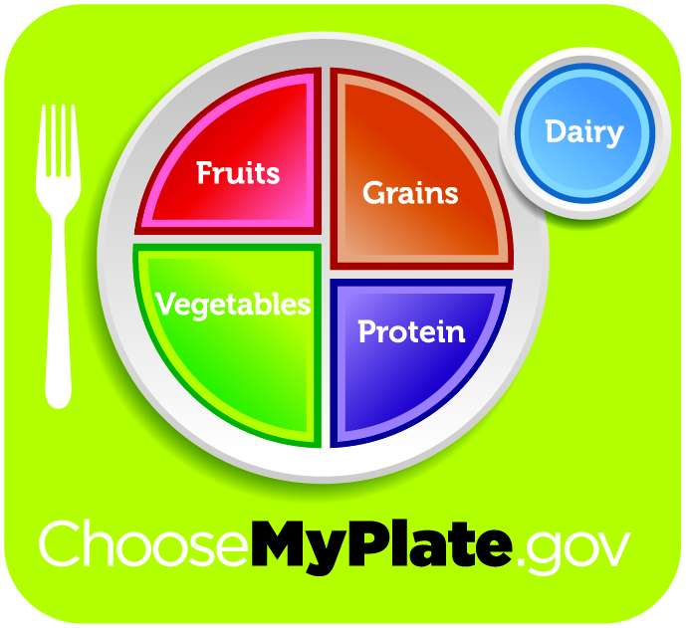
MyPlate is the United States Department of Agriculture’s (USDA) icon that replaced the food pyramid to empower families and individuals to make healthy nutritious choices. To earn bronze, silver and gold medals in Goal II, at least 51%, 75%, and 100%, respectively, of your municipally-or county-owned or operated venues that offer or sell food/beverages must prominently display MyPlate AND the LMCTC site must be registered to be a MyPlate Community Partner.
11. Is your city/town/county currently a Community Partner with USDA for Choose MyPlate? (Sign up here.) ☐ Yes ☐ No

12. How many municipally- or county-owned or operated venues does your city/town/county have that offer or sell food/beverages (i.e., cafeterias, vending machines, concession stands, parks and recreation facilities, libraries, department of motor vehicles, police departments or fire stations, public medical facilities/clinics or areas served by food distribution programs.)?

13. How many municipally- or county-owned or operated venues that offer or sell food/beverages are currently displaying MyPlate?

Goal III: Smart Servings for Students

To provide healthy food to children and youth, local elected officials commit to expanding access to meal programs before, during and after the school day, and/or over the summer months. Visit the Goal III page to learn more.

Municipal and county leaders have an important role to play in championing nutrition programs. Programs that offer healthy food before, during and after the school day include the School Breakfast Program, the National School Lunch Program and the Afterschool Meal Program offered through the Child and Adult Care Food Program; the Summer Food Service Program performs a similar function during the summer months. These programs provide balanced, low-cost or free meals for children/youth from low-income families. To help you complete this section, your state education agency's child nutrition program director may be able to help.

14. Bronze: Do you participate in an active collaboration involving the city/town/county, schools and other partners to expand access to programs that offer healthy food before, during and after the school day and/ or over the summer months? ☐ Yes ☐ No

15. Silver: Has your city/town/county taken at least two actions to expand children’s access to programs that offer healthy food before, during and after the school day, and/or over the summer months? (To earn silver, at least two actions must be taken.) ☐ Yes ☐ No

If yes, check all that your city/town/county is doing:

☐ Serving as a sponsor for a healthy summer meal program. (Sponsors are organizations that manage Summer Food Service Program feeding sites. Learn more about sponsors.)
☐ Serving as a feeding site, with another organization serving as a sponsor, providing healthy summer meals to children in city facilities, including parks, schools and recreation centers or during city-operated summer programs.
☐ Providing healthy meals and/or snacks at city/town/county afterschool programs.
☐ Collaborating with the private sector, nonprofits and/or faith-based organizations to expand the number of healthy afterschool meal and/or snack programs or summer meal programs.
☐ Playing a role with schools increasing participation rates in school breakfast and school lunch programs.
16. Gold: To make meal programs more accessible to children, what approaches is your city/town/county using to publicize the availability of programs that offer healthy food before, during and after the school day, and/or over the summer months? (To earn gold, at least four approaches must be used.)

☐ The city’s/town’s/county’s website.
☐ The city’s/town’s/county’s public service agency newsletter or parks and recreation program guide.
☐ A local elected official’s press announcement.
☐ A state of the city/county address by a mayor/county executive or announcement at a city/county council meeting.
☐ Official statements by the city/town/county supporting the availability and participation of students in these programs.
☐ Media stories and ads (television, local public access channel, newspaper and radio).
☐ Social media (e.g., Facebook and/or Twitter).
☐ Ads, banners or billboards.
☐ A resource guide for parents and caregivers on the availability of these programs.
☐ Visits made to schools or program sites by a local elected official.
☐ Community events and other opportunities for parents, caregivers and students to be informed of these opportunities for healthy meals.
☐ Distribute information about nutrition programs at recreation centers, community centers, local housing authorities and Head Start Programs, as well as WIC, SNAP and other human service offices that serve residents.
☐ Seek authentic community input on these programs and opportunities for increased participation.
☐ Opportunities for public recognition by local elected official(s) for schools and program sites who are maximizing participation in these programs.

Goal IV: Model Food Service

To improve access to healthy, affordable foods, local elected officials commit to implementing healthy and sustainable food service guidelines that are aligned with the Dietary Guidelines for Americans in all municipally- or county-owned or operated venues that offer or sell food/beverages. Visit the Goal IV page to learn more.

Municipally- or county-owned or operated venues that offer or sell food/beverages may include cafeterias, vending machines, concession stands, parks and recreation facilities, libraries, department of motor vehicles, police departments or fire stations, public medical facilities/clinics, or areas served by food distribution programs.

17. Bronze: Has your city/town/county identified all the vendors and contractors for municipally- or county-owned or operated venues that offer or sell food/beverages and when their contracts can be amended or renegotiated? ☐ Yes ☐ No

18. Silver: Has your city/town/county finalized model food service guidelines that align with the standards of the Dietary Guidelines for Americans for municipally- or county-owned or operated venues that offer or sell food/beverages? ☐ Yes ☐ No
19. Gold: What percentage of your municipally- or county-owned or operated venues implement food service guidelines that align with the standards of the Dietary Guidelines for Americans? (To earn gold, at least 30% of venues must implement the food services guidelines.)

Goal V: Active Kids at Play

To increase physical activity, local elected officials commit to mapping local playspaces, completing a needs assessment, developing an action plan and launching a minimum of three recommended policies, programs or initiatives. Visit the Goal V page to learn more.

Playspaces are where children and youth can play and be physically active. Playspaces can include publicly accessible playgrounds, indoor and outdoor recreational facilities, skate parks, parks, fields, trails and greenways. Providing safe, convenient places to play and be physically active can improve the health of residents and reduce childhood obesity.

20. Bronze: Has your city/town/county mapped the playspaces in your community? ☐ Yes ☐ No

21. Silver: Using the map of your playspaces, has your city/town/county assessed the need for safe, convenient places to play and be physically active in your community and developed a plan to address those needs? ☐ Yes ☐ No

22. Gold: Has your city/town/county implemented at least three actions to increase access to safe, convenient places to play and be physically active? (To earn gold, at least three actions must be taken.) ☐ Yes ☐ No
☐ Joint use agreements.
☐ Recess policy in schools.
☐ Zoning ordinances.
☐ Strategies for walking and biking to school or work.
☐ Providing multi-modal transportation options.
☐ Creating or revitalizing parks and recreation facilities.
☐ Increasing the number of playgrounds.
☐ Periodic closing of public streets for play.
☐ Physical activity requirements for city- or county-funded youth programs.
☐ City/County Master Plan includes provisions to encourage walking and biking.

General Question

23. Is an existing or new task force (i.e. childhood obesity or healthy kids’ task force) being used to take action on your Let’s Move! Activities? ☐ Yes ☐ No

Affirmation of Complete Survey
24. ☐ I affirm I am completing this survey as the Let's Move! local elected official, or because my Let's Move! local elected official has empowered me to do so on his/her behalf.
Type Signature Here.
Permission to Use Data

We would like to use the information you submitted, with your agreement, to highlight the progress your municipality or county is making over time. Please check the box below indicating you allow us to use your data in an aggregate fashion for public purposes.

25. ☐ I allow my lead person's name and email address to be displayed publicly for the purposes of local elected officials, their staff or the public to directly learn more about our LMCTC activities from my lead person.

26. ☐ I grant permission for the use of the data I provided in an aggregate fashion and for purposes of Let’s Move!, National League of Cities or others determined appropriate, to highlight my municipality or county.

