OMB Control No 2127-0682
Expiration Date 04/30/2018

Survey for Child Passenger Safety Public Service Advertising Campaign
[INTRODUCTION] Thank you for agreeing to participate in this online study. The survey will take about 10-15 minutes to complete. All responses are anonymous and will only be viewed in aggregate.
This study is being conducted on behalf of the National Highway Traffic Safety Administration (NHTSA). Please note that an agency may not conduct or sponsor, and a person is not required to respond to, a collection of information unless it displays a current valid OMB control number. The OMB control number for this study is 2127-0682. This survey is voluntary. We will not collect any personal information that would allow anyone to identify you. Any information you do provide will be kept private to the fullest extent of the law.

- We are looking for people who work in certain occupations and industries. Do you or does anyone in your household work in any of the following occupations or industries? (Please select all that apply).
- Market Research
- Advertising Agency / Public Relations
- Marketing
- Automobile manufacturing or sales
- Manufacturer, Distributor or Seller of household paper products
- A company that supplies or sells telephone, cellular or Internet services
- Insurance
- Banking
- None of these

IF “MARKET RESEARCH” OR “ADVERTISING AGENCY / PUBLIC RELATIONS” OR “MARKETING” OR “Automobile manufacturing or sales” THEN TERMINATE, OTHERWISE CONTINUE

- Are you the parent or guardian of any children under the age of 18 who are living in your household?

- Yes [GO TO Q2a.]
- No [SKIP TO Q3]

2a. How old are your children? (Select all that apply)
MULTIPLE RESPONSE

- 0-12 months [CONTINUE TO Q4]
- 1-3 years [CONTINUE TO Q4]
- 4-7 years [CONTINUE TO Q4]
- 8-12 years [CONTINUE TO Q4]
- 13 years or older [TERMINATE IF ONLY SELECTION CHECKED]

IF CHILD AGE “0-12 MONTHS”, “1-3 YEARS”, “4-7 YEARS”, OR “8-12 YEARS” CHECKED, THEN CONTINUE; IF “13 YEARS OR OLDER” IS THE ONLY SELECTION CHECKED, TERMINATE.

- Do you look after children for family or friends for three or more days per week regularly?
- Yes [CONTINUE TO Q3a]
- No [TERMINATE]

3a. How old are the children you care for? (Select all that apply)
MULTIPLE RESPONSE

- 0-12 months
- 1-3 years
- 4-7 years
- 8-12 years
- 13 years or older [TERMINATE IF ONLY SELECTION CHECKED]

IF CHILD AGE “0-12 MONTHS”, “1-3 YEARS”, “4-7 YEARS”, OR “8-12 YEARS” CHECKED, THEN CONTINUE; IF “13 YEARS OR OLDER” IS THE ONLY SELECTION CHECKED, TERMINATE.

- What is your gender?

- Male
- Female

RECRUIT 55% FEMALE, 45% MALE

- What is your age? _________ PROGRAMMER NOTE: MUST BE 18+

- 18-24 years
- 25-34 years
- 35-44 years
- 45-54 years
- 55+ years
- Refused [TERMINATE]

- Are you of Hispanic or Latino descent?
- Yes
- No

- Select one or more of the following that best describes your race?
(ACCEPT MULTIPLE RESPONSES)

  - American Indian or Alaska Native
  - Asian
  - Black or African American
  - Native Hawaiian or Other Pacific Islander
  - White

PLEASE ADD THE FOLLOWING DUMMY VARIABLE (ETHNICITY):

- CAUCASIAN = SELECTED WHITE AT Q7:

- AFRICAN AMERICAN = SELECTED BLACK OR AFRICAN-AMERICAN AT Q7

- ASIAN/OTHER = SELECTED ONE OF THE FOLLOWING AT Q7
  - ASIAN
  - NATIVE HAWAIIAN OR OTHER PACIFIC ISLANDER
  - AMERICAN INDIAN OR ALASKA NATIVE
  - OTHER

- HISPANIC = SELECTED YES AT Q6

CHECK ETHNICITY QUOTAS. IF OPEN, CONTINUE. OTHERWISE TERMINATE

- What is the highest level of education that you have completed? ACCEPT ONE

- 8th grade or below
- 9th grade to 11th grade
- High school graduate
- Some college
- Associate's degree
- Bachelor's degree
- Some postgraduate study
- Graduate school degree
- Trade school
- None of the above/ Prefer not to state

- Which classification best describes your total pre-tax household income? [*Add popup option: “Why do we ask this question?”] ACCEPT ONE

  - Under $10,000
  - $10,000-$19,999
  - $20,000-$29,999
  - $30,000-$39,999
  - $40,000-$49,999
  - $50,000-$74,999
  - $75,000-$99,999
  - $100,000-$124,999
  - $125,000-$149,999
  - $150,000-$174,999
  - $175,000-$199,999
  - More than $200,000
  - Prefer not to state

Do you live in the city, suburbs, or some other area?

- City
- Suburbs
- Small town
- Rural community
- Some other area

CHECK URBANICITY QUOTAS. IF OPEN, CONTINUE. OTHERWISE TERMINATE

PROGRAMMER NOTE: INSTRUCTION 1
[If “Yes” in S2 and ONLY ONE AGE SELECTED in S3:]
“Please answer the rest of this survey with your child age [X] in mind.”
[“X” is the age RANGE of child 0-12 indicated in S3]

[If “Yes” in S2 and MULTIPLE AGES SELECTED in S3:]
“Please answer the rest of this survey with your child age [X] in mind.”
[“X” is the age RANGE of one child 0-12 indicated in S3, randomly selected from all AGES 0-12 indicated in S3]

- How often do you drive with [your child(ren)/the child(ren) you care for], age [INSERT AGE OF CHILD] in the car?

- Three days a week or more
- Less than three days a week [TERMINATE]
- I do not drive [TERMINATE]

IF “LESS THAN THREE DAYS A WEEK” OR “DO NOT DRIVE” THEN TERMINATE, OTHERWISE CONTINUE

- How often does your child age [X] currently use each of the following types of passenger safety restraints when he/she is in the car with you? (An example of what each might look like has been provided.) MATRIX – RANDOMIZE

 | Always | Sometimes | Never | Not sure
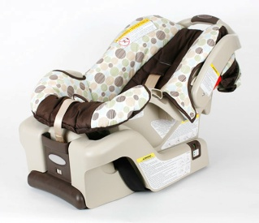
Rear-facing car seat
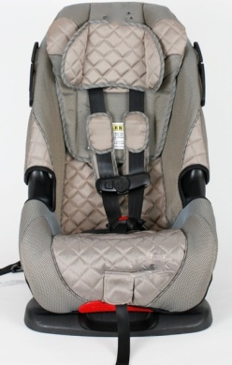
Forward-facing car seat
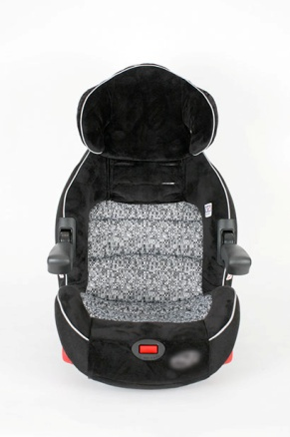
Booster Seat
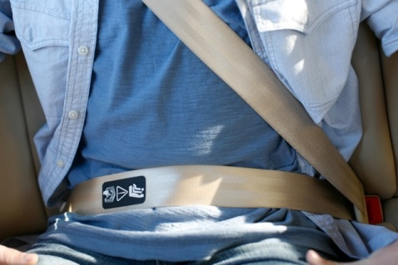
Adult Seat Belt

- Have you recently seen, heard, or read messages about using child passenger safety restraints in advertising, publicity, the media, the Web or other places? ACCEPT ONE

Yes
No
Not sure

ASK IF YES AT Q13
13a. Where was that…? MATRIX – RANDOMIZE. MUST SELECT EITHER YES OR NO FOR EACH ROW.

 | YES | NO
TV program | Yes | No
TV ad | Yes | No
Radio program | Yes | No
Radio commercial | Yes | No
Magazine article | Yes | No
Magazine ad | Yes | No
Newspaper article | Yes | No
Newspaper ad | Yes | No
Website content | Yes | No
Web ad | Yes | No
Outdoor billboards or outdoor posters | Yes | No
From friends or family | Yes | No
Car seat or vehicle owner’s manual | Yes | No
Hospital or physician’s office | Yes | No
Car seat fitting station | Yes | No
Automobile dealer | Yes | No
Some other place | Yes | No

IF SELECTS YES FOR “SOME OTHER PLACE” IN Q12a, ASK FOLLOW UP Q13b:
13b. You mentioned you have recently seen, heard, or read messages about using child passenger safety restraints in some other place. Where was that? OPEN END. NO CODING.

- In the past year, have you sought information about which car safety restraint to use for your child? ACCEPT ONE

Yes
No
Not sure

ASK IF YES AT Q14
- Where did you seek information about which car safety restraint to use for your child?
Please list all sources of information below. OPEN END. NO CODING.

- Have you ever heard of a website called SaferCar.gov/TheRightSeat? ACCEPT ONE

Yes
No
Not sure

PROGRAMMER NOTE: RANDOMIZE ORDER OF AD RECOGNITION QUESTIONS (Q17-24): KEEP TV (Q17-19) AND RADIO (Q20-21) AND BANNER (Q23-Q23a) ADS TOGETHER IN BLOCKS & RANDOMIZE ADS WITHIN BLOCKS

- IF TV AD: HIDE THE CONTINUE BUTTON FOR 45 SECONDS. INCLUDE THE FOLLOWING TEXT UNDER THE AUDIO FILE: Please note that the ‘Continue’ button will appear at the bottom of the screen, once the ad is almost completed.
- IF radio AD: HIDE THE CONTINUE BUTTON FOR 30 SECONDS. INCLUDE THE FOLLOWING TEXT UNDER THE AUDIO FILE: Please note that the ‘Continue’ button will appear at the bottom of the screen, once the ad is almost completed.
- if PRINT, bAnner, or ooh ad: insert the following text below the image: You may click on the image above to see a larger version of the ads.

Below is a video of a public service ad you might see on TV or some other place. After you view the ad, please indicate if you have seen it before.

[INSERT VIDEO_REAL KNOW IT ALLS :30]

- Have you seen this ad? ACCEPT ONE

- Yes
- No
- Not sure

[INSERT VIDEO_CHAIRS :30]

- Have you seen this ad? ACCEPT ONE

Yes
No
Not sure

[INSERT VIDEO_FLASHBACK:30]

- Have you seen this ad? ACCEPT ONE

Yes
No
Not sure

Below is an audio file of a public service ad you might hear on the radio. After you listen to the ad, please indicate if you have heard it before.

[INSERT AUDIO FILE_BASEBALL :60]

- Have you heard this ad? ACCEPT ONE

Yes
No
Not sure

[INSERT AUDIO FILE_PARTY :30]

- Have you heard this ad? ACCEPT ONE

Yes
No
Not sure

- Have you seen any of these ads in a newspaper or magazine? ACCEPT ONE

[INSERT PRINT AD MONTAGE]

Yes
No
Not sure

- Have you seen any of these ads online? ACCEPT ONE

[INSERT “OLD” BOTTLE/POPSICLE BANNER AD MONTAGE]

Yes
No
Not sure

23a. Have you seen any of these ads online? ACCEPT ONE

[INSERT “NEW” PENCIL/TOY BANNER AD MONTAGE]

Yes
No
Not sure

- Have you seen any of these ads someplace, such as on a poster, billboard, or phone kiosk? ACCEPT ONE

[INSERT OUTDOOR AD MONTAGE]

Yes
No
Not sure

The following background questions will help us divide the interviews into groups.

- What is your marital status? ACCEPT ONE

- Single (never married)
- Living together but not married
- Married
- Separated
- Divorced
- Widowed
- Prefer not to state

- What state do you live in?

[DROP-DOWN BOX]
CODE FOR REGION

DROP DOWN LIST - PLEASE ADD TRACKING VARIABLE - LABEL AS “REGION”:
Northeast: Selected Connecticut, Maine, Massachusetts, New Hampshire, Rhode Island, Vermont, New Jersey, New York Or Pennsylvania
Midwest: Selected Indiana, Illinois, Michigan, Ohio, Wisconsin, Iowa, Kansas, Minnesota, Missouri, Nebraska, North Dakota Or South Dakota
South: Selected Delaware, Dc, Florida, Georgia, Maryland, North Carolina, South Carolina, Virginia, West Virginia, Alabama, Kentucky, Mississippi, Tennessee, Arkansas, Louisiana, Oklahoma Or Texas
West: Selected Arizona, Colorado, Idaho, New Mexico, Montana, Utah, Nevada, Wyoming, Alaska, California, Hawaii, Oregon Or Washington

OUTSIDE SAMPLE TERM AND THANK YOU PAGE

Thank you for taking our survey! Those are all of the questions we have for you today. Please click “Continue” to submit your survey.

SAMPLE:
n=1000

GENERAL SPECS
- Adults ages 18+ (balanced across gender)
- Parents/guardians of children ages 0-12 (balanced across age and gender)
- Must own or have access to a car and drive with child at least once per week
- Match U.S. Census on: HH income, Census region, and Ethnicity

QUOTAS:
 |  | QUOTAS
 |  | Boys | Girls
Total |  | 500 | 500
Age Of Child (Q2, Q3) | Ages 0-12 months old | 125 | 125
 | Ages 1-3 years old | 125 | 125
 | Ages 4-7 years old | 125 | 125
 | Ages 8-12 years old | 125 | 125
Parent Gender (Q4) | Male | 445
 | Female | 555
HH Income (Q9) | < $49,999 | 445
 | $50,000 + | 500
 | Prefer not to answer | 75
Urbanicity (Q10) | City | 285
 | Suburbs | 555
 | Other | 160
Region (Q26)  Ethnicity (Q6,7) | Northeast | Total n=180
 |  | Caucasian | 128
 |  | African American | 18
 |  | Hispanic | 23
 |  | Asian/Other | 11
 | Midwest | Total n=225
 |  | Caucasian | 177
 |  | African American | 23
 |  | Hispanic | 15
 |  | Asian/Other | 10
 | South | Total n=370
 |  | Caucasian | 236
 |  | African American | 64
 |  | Hispanic | 54
 |  | Asian/Other | 16
 | West | Total n=225
 |  | Caucasian | 135
 |  | African American | 12
 |  | Hispanic | 52
 |  | Asian/Other | 26

