Typical Riding Gear (Form A)
For each item, indicate whether you: never, rarely, sometimes, usually or always wear it. The pictures are examples only.
Example | Item | Use  Mark your response with an “X”
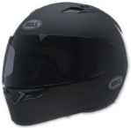  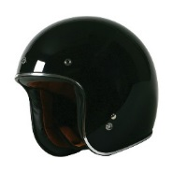  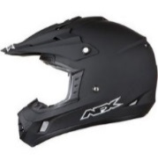  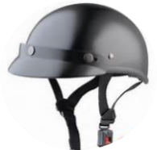  If you wear a helmet, circle the type that best reflects the one you use. | Helmet | Never
 |  | Rarely
 |  | Sometimes
 |  | Usually
 |  | Always
If you wear a helmet, is it DOT certified? (circle your response)

YES NO DON’T KNOW

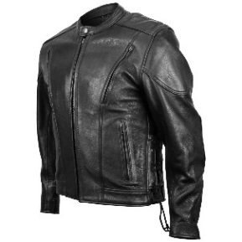 | Leather jacket | Never
 |  | Rarely
 |  | Sometimes
 |  | Usually
 |  | Always
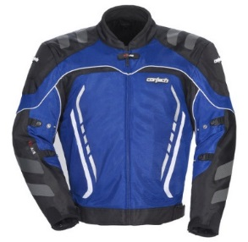 | Armored/protective jacket | Never
 |  | Rarely
 |  | Sometimes
 |  | Usually
 |  | Always
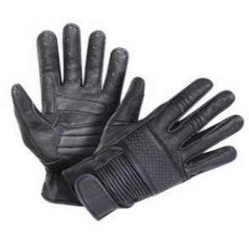 | Riding gloves | Never
 |  | Rarely
 |  | Sometimes
 |  | Usually
 |  | Always
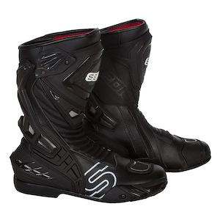  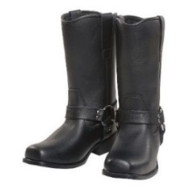 | Riding boots | Never
 |  | Rarely
 |  | Sometimes
 |  | Usually
 |  | Always

Example | Item | Use  Mark your response with an “X”
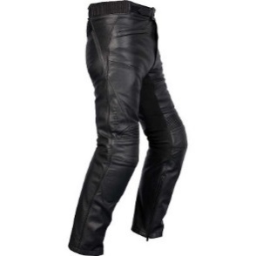 | Leather pants | Never
 |  | Rarely
 |  | Sometimes
 |  | Usually
 |  | Always
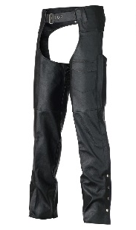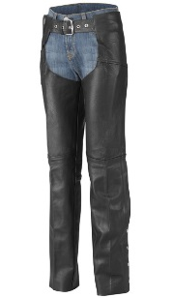 | Chaps | Never
 |  | Rarely
 |  | Sometimes
 |  | Usually
 |  | Always
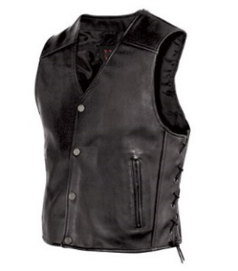 | Leather vest | Never
 |  | Rarely
 |  | Sometimes
 |  | Usually
 |  | Always
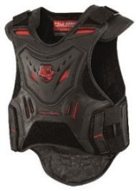 | Armored vest | Never
 |  | Rarely
 |  | Sometimes
 |  | Usually
 |  | Always
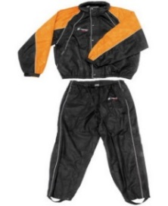 | Rain gear | Never
 |  | Rarely
 |  | Sometimes
 |  | Usually
 |  | Always
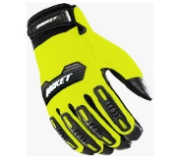  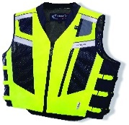  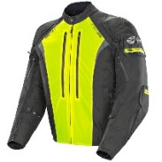  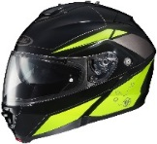 | High visibility gear | Never
 |  | Rarely
 |  | Sometimes
 |  | Usually
 |  | Always

Example | Item | Use  Mark your response with an “X”
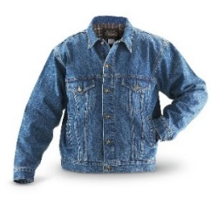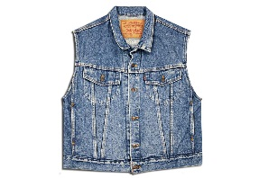 | Denim jacket /vest | Never
 |  | Rarely
 |  | Sometimes
 |  | Usually
 |  | Always
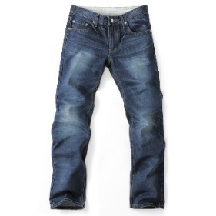 | Denim pants | Never
 |  | Rarely
 |  | Sometimes
 |  | Usually
 |  | Always
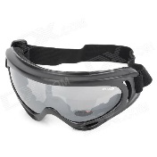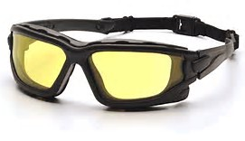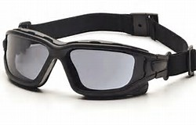 | Eye protection | Never
 |  | Rarely
 |  | Sometimes
 |  | Usually
 |  | Always

OTHER (Specify) ________________________________________________________________________

