**APPENDIX**

**NHTSA Autonomous Vehicles Discussion Guide**

**Images for Image Collateral Review**

**IMAGE 1: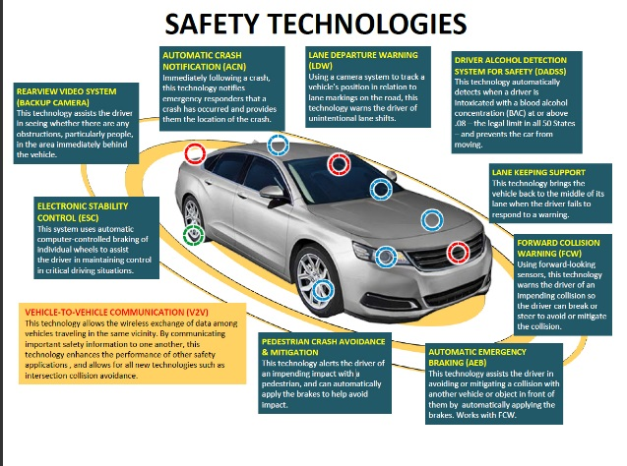IMAGE 2:**

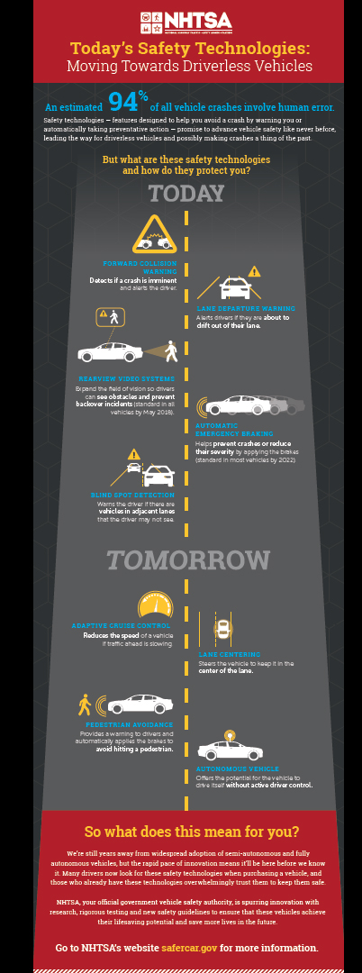

**IMAGE 3:**

