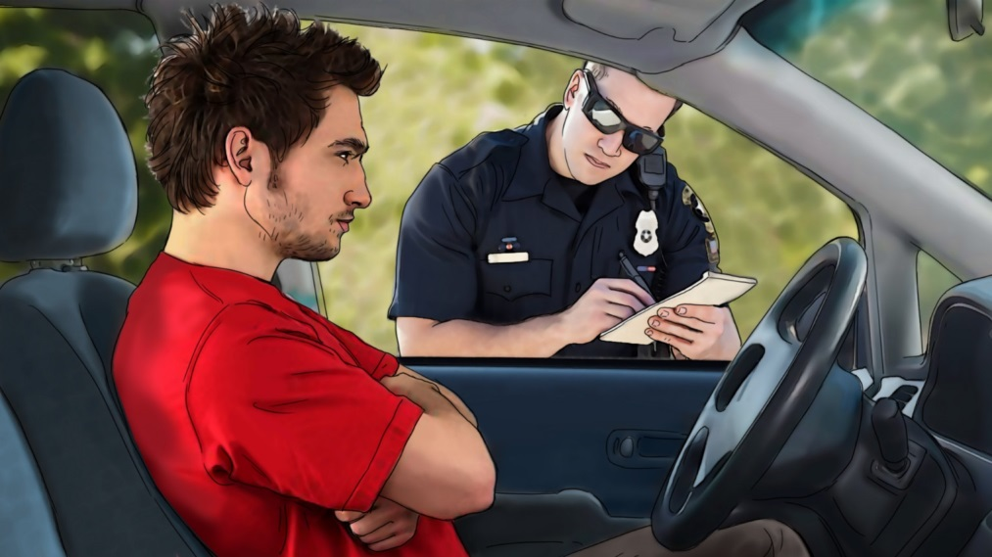

NO GOOD EXCUSE

We see a series of unbuckled guys just after they wreck. They appear to be unconscious but come to long enough to offer up a feeble excuse for their behavior. The last guy gets a ticket.

Open on a scene of a car crash. Through the steam and smoke we see a guy was thrown into the floorboard of the passenger seat with his legs sticking up in the air. His neck is bent and he looks knocked out but comes to long enough to speak to camera then passes out again.

MAN1: I wasn’t going very far.

Cut to different man lying on a stretcher at a crash scene being wheeled to an ambulance. He looks unconscious but comes to and speaks to camera.

MAN2: I’ve never gotten into an accident before.

Cut to a different man crashing thru the windshield of his car and landing on his hood. He looks passed out but comes to long enough to speak to camera then passes out again.

MAN3: It’s too uncomfortable.

Cut to an upset man with his arms crossed. He turns and speaks to camera.

MAN4: Sometimes I just forget.

He gets a ticket and buckles up.

ANNCR: There’s no such thing as a good excuse for not buckling up.

Click it or ticket.

