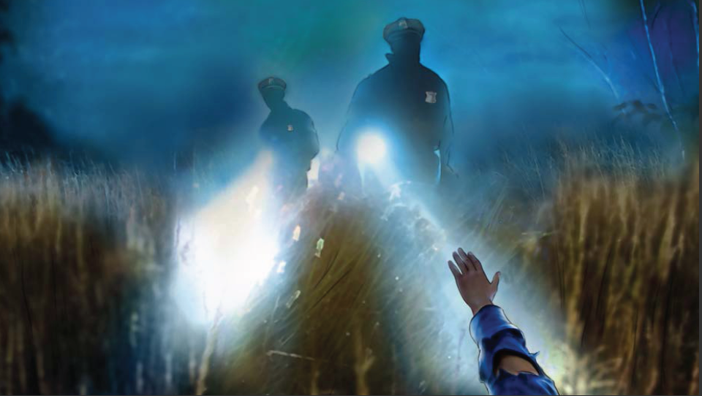

“THE SEARCH”

:30 TV
OPEN ON TIGHT SHOT OF A COP WALKING IN THE DARKNESS OF NIGHT THROUGH TALL GRASS. HE IS SCANNING HIS FLASHLIGHT AROUND, SEARCHING FOR SOMETHING – BUT WE DON’T KNOW WHAT HE’S SEARCHING FOR. AS HE SEARCHES IN THE DARKNESS, RED LIGHTS FROM FIRST RESPONDERS ADD A REDDISH TINT OF COLOR TO THE SCENE.

SUDDENLY, THE COP SPOTS SOMETHING, BUT WE DON’T KNOW WHAT IT IS.

COP: Over here!

ADDITIONAL LIGHT FROM ANOTHER COP’S FLASHLIGHT ADDS MORE BRIGHTNESS TO THE SCENE AS BOTH LIGHTS SHINE ON THE TALL GRASS. THE LIGHTS STOP ON AN INJURED MAN LYING IN THE WEEDS. WE SEE THE MAN RAISE HIS HAND IN THE AIR AS THE LIGHT HITS HIM. THE COPS RUN UP TO HIM AND CROUCH DOWN BESIDE HIM.

THE OTHER COP STANDS UP AND TAKES OUT HIS WALKIE TALKIE TO CALL AN AMBULANCE.

AT THIS MOMENT, WE SLOWLY GO WIDE TO REVEAL THAT THE INJURED MAN IS ONLY ABOUT 20 FEET AWAY FROM THE ROAD. WE SEE HIS MANGLED CAR - WITH A GAPING HOLE IN THE WINDSHIELD - SMASHED INTO A TREE NEXT TO THE ROAD. THE COP WITH THE WALKIE TALKIE IS WALKING TOWARD THE CAR. MANY OTHER FIRST RESPONDERS ARE PARKED ALONG THE ROADSIDE.

VO: If you’re still not buckling up, it’s time you do.

WE CUT TO THE COP WITH THE WALKIE TALKIE AND ANOTHER FIRST RESPONDER LOOKING AT THE HOLE IN THE WINDSHIELD. THE COP IS SHAKING HIS HEAD.

VO: Your safety is our priority. That’s why we’re stepping up enforcement. Click it or ticket.

CLICK IT OR TICKET LOGO

