# APPENDIX A – SuperTracker Screenshots

## Create Profile Page

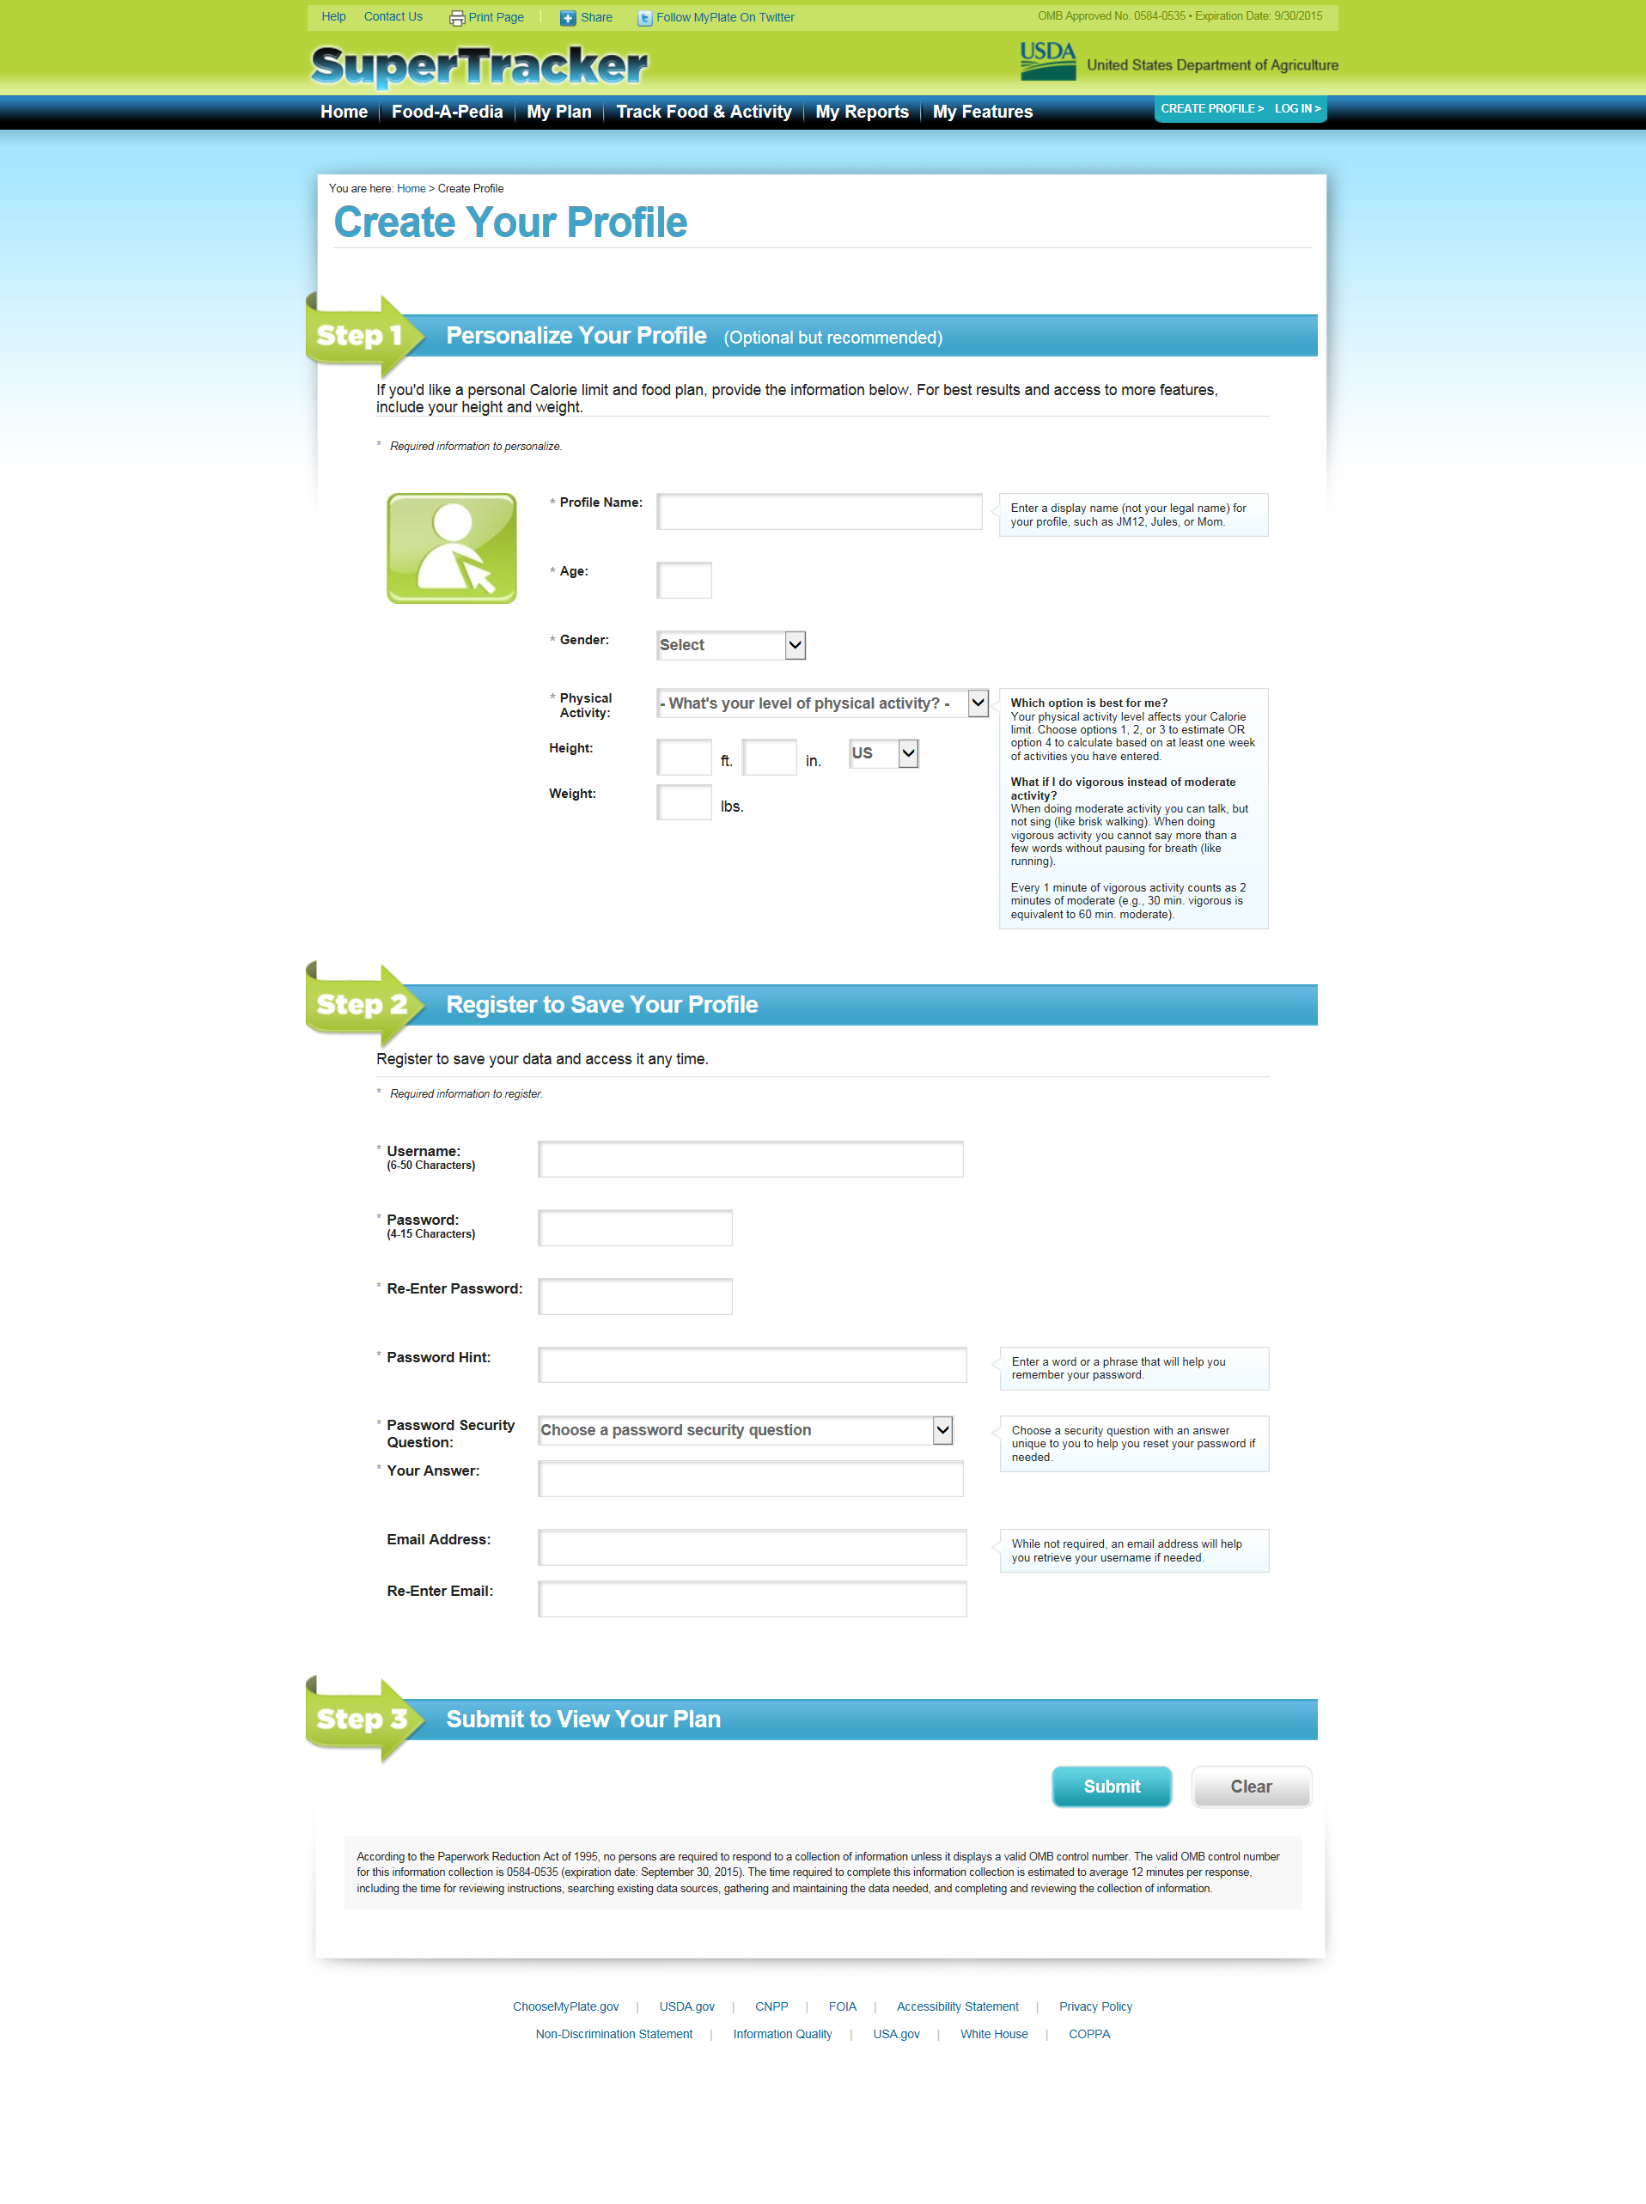

**Enlarged view of public burden statement on the next page**

**Enlarged View of Public Burden Statement** 