**Attachment A**

**Quantitative Evaluation Survey for High School Students**

**PILOT PROGRAM EVALUATION SURVEY AMONG HIGH SCHOOL STUDENTS**

**PARTICIPATING IN PILOT TEEN NUTRITION AND PHYSICAL ACTIVITY PROGRAM**

Timing: 20 minutes

OMB BURDEN STATEMENT: According to the Paperwork Reduction Act of 1995, an agency may not conduct or sponsor, and a person is not required to respond to, a collection of information unless it displays a valid OMB control number. The valid OMB control number for this information collection is 0584-0606. The time required to complete this information collection is estimated to average 20 minutes (.333 hours) per response for the entire survey, including reading and answering each question.

**FOR OMB: All language in the survey that is BOLD and/or IN ALL CAPITAL LETTERS is programming language or guidance for researchers and OMB review. Students will not see this language in the online platform.**

**I. INTRODUCTION**

TEACHER INTRODUCTION: To access the questionnaire, copy this link [<https://krcresearch.az1.qualtrics.com/SE/?SID=SV_czIsBramP7KBuPb>] **(FOR AN EXAMPLE OF THE SURVEY LANDING PAGE, SEE APPENDIX B)** into your preferred web browser. The purpose of this survey is to help the researchers figure out what the program is teaching you. Students will take this survey before the program begins and then again after the program completes. This survey is not a test in any way, but instead, will be one way for the researchers to see if the program works. Your answers and feedback are important to the research, so please answer to the best of your ability.

STUDENT INTRODUCTION: Dear Student:

If your high school teacher gave you the link to this survey to take as part of your health and nutrition class this semester, welcome!

Please complete this survey, from start to finish. It will take approximately 20 minutes to complete. Please answer all questions to the best of your ability. If you don’t know an answer, indicate that you’re not sure.

Your teacher will be notified once you have completed the survey, so he or she can give you credit for completing it.

Thank you very much for participating in this survey.

Sincerely,

USDA Food and Nutrition Service

**II. SCREENING QUESTIONS (Programming Note: Page Break)**

**FOR OMB ONLY: Objectives of this section:**

* **Confirm respondents qualify for this study by virtue of being in one of ten high school pilot program classes**

What high school do you attend? Choose one response.

Bayside High School 1

Ocoee High School 2

Rainbow Center 3

Thurgood Marshall Academy 4

None of the above TERMINATE

Which grade are you currently in?

9th 1

10th 2

11th 3

12th 4

Other TERMINATE

**[SHOW Q3 AND Q3A ON THE SAME PAGE]**

Which of the following classes, if any, are you enrolled in? **[INSERT CLASS NAMES THAT ALIGN WITH SPECIFIC PILOT SCHOOL]**

INSERT CLASS NAME 1

INSERT CLASS NAME 2

INSERT CLASS NAME 3

INSERT CLASS NAME 4

INSERT CLASS NAME 5

INSERT CLASS NAME 6

INSERT CLASS NAME 7

INSERT CLASS NAME 8

INSERT CLASS NAME 9

INSERT CLASS NAME 10

None of the above 99

3a. And is this class and elective or a required class?

Elective class 1

Required class 2

**III. VALUES, PERCEPTIONS, ATTITUDES, AND SELF-EFFICACY (Programming Note: Page Break)**

**FOR OMB ONLY: Objectives of this section:**

* **Determine interest in healthy eating and physical activity.**
* **Explore the extent to which students are currently leading a healthy lifestyle, based on physical activity and nutrition choices.**

Here are statements about a healthy diet. For each one, indicate how much you agree or disagree. Use a scale from 1 to 7, where a 1 means you completely disagree and a 7 means you completely agree. You can pick any number between 1 and 7. **[RANDOMIZE STATEMENTS.]**

|  |  | **Completely Disagree <<< >>> Completely Agree** | | | | | | | | **Not sure** |
| --- | --- | --- | --- | --- | --- | --- | --- | --- | --- | --- |
|  | Eating healthy foods is very important to me. | 1 | 2 | 3 | 4 | 5 | | 6 | 7 | 9 |
|  | A healthy diet can also be a tasty diet that I like to eat. | 1 | 2 | 3 | 4 | | 5 | 6 | 7 | 9 |
|  | I am very interested in learning about healthy foods. | 1 | 2 | 3 | 4 | 5 | | 6 | 7 | 9 |
|  | Eating healthy foods does not matter at my age. | 1 | 2 | 3 | 4 | | 5 | 6 | 7 | 9 |
|  | Eating a healthy diet now will help me build a foundation for a healthy future. | 1 | 2 | 3 | 4 | | 5 | 6 | 7 | 9 |
|  | I do not have enough information in order to know how to eat a healthy diet today. | 1 | 2 | 3 | 4 | 5 | | 6 | 7 | 9 |
|  | I feel I have the ability to eat a healthy diet regularly if I want to. | 1 | 2 | 3 | 4 | 5 | | 6 | 7 | 9 |
|  | My family supports and encourages me to eat a healthy diet. | 1 | 2 | 3 | 4 | | 5 | 6 | 7 | 9 |
| 12. | I cannot afford to buy healthy foods. | 1 | 2 | 3 | 4 | | 5 | 6 | 7 | 9 |
| 13. | I don’t have the time to eat healthy foods. | 1 | 2 | 3 | 4 | | 5 | 6 | 7 | 9 |

Here are statements about physical activity. For each one, indicate how much you agree or disagree. Use a scale from 1 to 7, where a 1 means you completely disagree and a 7 means you completely agree. You can pick any number between 1 and 7. **[RANDOMIZE STATEMENTS.]**

|  |  | **Completely Disagree <<< >>> Completely Agree** | | | | | | | | **Not sure** |
| --- | --- | --- | --- | --- | --- | --- | --- | --- | --- | --- |
| 14. | Being physically active is very important to me. | 1 | 2 | 3 | 4 | 5 | | 6 | 7 | 9 |
| 15. | I can include physical activity in my daily routine without it becoming a lot of work. | 1 | 2 | 3 | 4 | | 5 | 6 | 7 | 9 |
| 16. | I am very interested in learning about physical activity. | 1 | 2 | 3 | 4 | 5 | | 6 | 7 | 9 |
| 17. | At my age, being physically active does not matter. | 1 | 2 | 3 | 4 | | 5 | 6 | 7 | 9 |
| 18. | Getting into a regular physical activity routine now will help me build a foundation for a healthy future. | 1 | 2 | 3 | 4 | | 5 | 6 | 7 | 9 |
| 19. | I do not have enough information about what kind of physical activity I really need to be healthy. | 1 | 2 | 3 | 4 | 5 | | 6 | 7 | 9 |
| 20. | I have the ability to get the regular physical activity I need if I want to. | 1 | 2 | 3 | 4 | 5 | | 6 | 7 | 9 |
| 21. | My family supports and encourages me to stay active and get physical activity. | 1 | 2 | 3 | 4 | | 5 | 6 | 7 | 9 |
| 22. | I do not have enough time to get regular physical activity. | 1 | 2 | 3 | 4 | | 5 | 6 | 7 | 9 |

**IV. KNOWLEDGE AND SKILLS (Programming Note: Page Break)**

**FOR OMB ONLY: Objective of this section:**

* **Assess knowledge and skills that will be taught in the curriculum.**

1. Which of the following makes a healthy snack? Please select all that apply.  
    **[RANDOMIZE]** Has 100 calories or less*[1] 1

Relatively low in added sugars, fats and salt* 2

Low in carbohydrates* 3

Contains naturally occurring sugars* 4

High in fat and low in calories 5

Contains zero calorie sweeteners 6

All of the above* **[ANCHOR, EXCLUSIVE]** 7

None of the above **[ANCHOR, EXCLUSIVE]** 8

Not sure **[ANCHOR, EXCLUSIVE]** 99

1. Which of the following do you consider healthy snacks? Please select all that apply.  
    **[RANDOMIZE]**

Fresh fruit* 1

Hummus* 2

Yogurt* 3

Sugar peas* 4

Whole grain crackers* 5

Pretzels 6

Sliced whole grain bread* 7

Low-fat string cheese* 8

Mini bagels* 9

Slices of lean turkey or chicken* 10

Avocado* 11

Fruit snacks 12

Chocolate 13

Tortilla Chips 14

All of the above **[ANCHOR, EXCLUSIVE]** 15

None of the above **[ANCHOR, EXCLUSIVE]** 16

Not sure **[ANCHOR, EXCLUSIVE]** 99

1. Which of the following foods are high in protein? Please select all that apply. **[RANDOMIZE]**

Peanut butter* 1

Bean dip* 2

Chicken* 3

Peas* 4

Eggs* 5

Sunflower Seeds* 6

Nuts* 7

Apples 8

Honey 9

All of the above* **[ANCHOR, EXCLUSIVE]** 10

None of the above **[ANCHOR, EXCLUSIVE]** 11

Not sure **[ANCHOR, EXCLUSIVE]** 99

1. Which of the following are good for you when choosing a healthy meal? Please select all that apply. **[RANDOMIZE]**

Dairy* 1

Protein* 2

Vegetables* 3

Fruit* 4

Grains* 5

Sugar 6

Fat 7

Oils 8

All of the above **[ANCHOR, EXCLUSIVE]** 9

None of the above **[ANCHOR, EXCLUSIVE]** 10

Not sure **[ANCHOR, EXCLUSIVE]** 99

Here are some statements about what makes a healthy meal. For each one, indicate if the statement is true, false, or if you are not sure. **[RANDOMIZE]**

|  |  |  |  |  |
| --- | --- | --- | --- | --- |
|  |  | True | False | Not Sure |
| 1. 25 | Half of your plate should include vegetables and fruits. | 1* | 2 | 9 |
| 1. 26. | You should choose lean proteins. | 1* | 2 | 9 |
| 1. 27. | You should include whole grains. | 1* | 2 | 9 |
|  | For quality control purposes, please choose false. | 1 | 2* | 9 |
| 1. 28. | You should choose low-fat dairy. | 1* | 2 | 9 |
| 1. 29. | Half of your grains should be whole. | 1* | 2 | 9 |
|  |  |  |  |  |
|  | You should leave room for dessert on your plate. | 1 | 2* | 9 |
|  |  |  |  |  |
|  | All protein is the same in terms of how healthy it is. | 1 | 2* | 9 |
| 1. T | The lower the calories the healthier the meal | 1 | 2* | 9 |

**SHOW Q36 AND Q37 ON THE SAME SCREEN TOGETHER:**

1. What is the recommended amount of vegetables a **teenage boy** should eat each day?

Less than 1 cup 1

1 cup 2

1.5 cups 3

2 cups 4

3 cups* 5

Not sure 9

1. What is the recommended amount of fruit a **teenage** girl should eat each day?

Less than 1 cup 1

1 cup 2

1.5 cups* 3

2 cups 4

3 cups 5

Not sure 9

1. There are many ways to make a recipe healthier. Which of the following ways do you think could make a recipe healthy? Please select all that apply. **[RANDOMIZE]**

Substitute ingredients with lower saturated fat and less sugar* 1

Add fruits and vegetables* 2

Reduce the amount of salt* 3

Add seasoning for taste instead of sauces or salt* 4

Bake rather than fry* 5

Use only raw vegetables 6

Make the food spicy 7

All of the above **[EXCLUSIVE]** 8

None of the above **[EXCLUSIVE]** 9

Not sure **[EXCLUSIVE]** 99

1. When you are shopping on a limited budget, what are some ways to make sure you save money and still make healthy choices? Please select all that apply. **[RANDOMIZE]**

Buy fewer packaged foods* 1

Buy food in bulk* 2

Buy store brands 3

Compare unit costs* 4

Shop around for weekly deals* 5

Shop for ingredients each time you make a meal 6

Buy food in smaller quantities 7

All of the above* **[EXCLUSIVE]** 8

None of the above **[EXCLUSIVE]** 9

Not sure **[EXCLUSIVE]** 99

Here is an example of a food label that you typically find on food packaging. Please look at the label and answer the following questions.

**SHOW IMAGE OF LABEL ON THIS PAGE (SEE APPENDIX A)**

1. What is the suggested serving size? **[OPEN END]**
2. What are the calories per serving? **[OPEN END]**
3. What are the primary ingredients? **[OPEN END]**
4. What is the total percentage of fats for the recommended daily amount? **[OPEN END]**
5. Is this statement true or false? People need calories because calories provide the fuel and energy for basic body functions and daily activities.

True* 1

False 2

Not sure 9

1. Is this statement true or false? To be physically active, you it’s important to have athletic skill and the right body type.

True 1

False* 2

Not sure 9

1. How can being physically active help you? Please select all that apply. **[RANDOMIZE AND MULTI SELECT]**

Reduces the risk for health problems* 1

Strengthens muscles and bones* 2

Reduces stress* 3

Gives you more energy* 4

Reduces anxiety and depression* 5

Helps you sleep better* 6

Helps you manage your weight* 7

Helps you feel better about yourself* 8

Increases your intelligence 9

Helps you make friends 10

Helps your eyesight 11

All of the above **[EXCLUSIVE]** 12

None of the above **[EXCLUSIVE]** 13

Not sure **[EXCLUSIVE]** 99

1. Overall, what is the recommended amount of time a teenager should spend in daily physical activity?

30 minutes each day 1

60 minutes each day* 2

30 minutes a few times a week 3

60 minutes a few times a week 4

Not sure 9

1. Below are different types of physical activities people can do to stay active. For each activity, drag it to the best corresponding category of exercise.

|  |  |
| --- | --- |
| **Activity** | **Category** |
| Running | Bone Strengthening |
| Jumping rope | Muscle Strengthening |
| Basketball | Aerobic |
| Push-ups |  |
| Lifting weights |
| Climbing stairs |
| Dancing |
| Biking |

Here are different types of physical activities. For each one, indicate whether that activity is a moderate intensity activity or not by choosing yes, no, or not sure. **[RANDOMIZE]**

|  |  |  |  |  |
| --- | --- | --- | --- | --- |
|  |  | Yes, it is | No, it is not | Not Sure |
| 1. 25 | Brisk walking | 1* | 2 | 9 |
| 1. 26. | Skateboarding | 1* | 2 | 9 |
| 1. 27. | Hiking | 1* | 2 | 9 |
| 1. 28. | Bike riding | 1* | 2 | 9 |
| 1. 29. | Martial arts | 1 | 2* | 9 |
|  | Swimming | 1 | 2* | 9 |
|  |  |  |  |  |

**V. BEHAVIORS & HABITS**

**FOR OMB ONLY: Objective of this section:**

* **Measure behaviors and habits associated with healthy eating and physical activity.**

In the past week, how often did you eat each the following?

|  |  |  |  |  |  |  |  |  |
| --- | --- | --- | --- | --- | --- | --- | --- | --- |
|  |  | | Every  day | 5-6 times a week | 3-4 times a week | 1-2 times a week | Did not eat in the past week | (Don’t know/Refused) |
|  | | **Fruit**, including fresh, canned, frozen or dried/dehydrated | 1 | 2 | 3 | 4 | 5 | 9 |
|  | | **Vegetables**, including raw or cooked; fresh, frozen, canned or dried/dehydrated | 1 | 2 | 3 | 4 | 5 | 9 |
|  | | **Whole Grains**, including those made from wheat, rice, oats, cornmeal or barley | 1 | 2 | 3 | 4 | 5 | 9 |
|  | | **Protein**, such as meat, poultry, seafood, beans and peas, eggs, soy products, nuts and seeds | 1 | 2 | 3 | 4 | 5 | 9 |
|  | | Low-fat or fat-free **dairy** products, including skim or 1% milk | 1 | 2 | 3 | 4 | 5 | 9 |

1. In the past week, how often did you participate in physical activity, like walking for exercise or playing sports?

Every day 1

5-6 times a week 2

3-4 times a week 3

1-2 times a week 4

Did not participate in the past week 5

(Don’t know/Refused) 9

**VI. CURRICULUM ASSESSMENT, FUTURE INTENT**

**FOR OMB ONLY: Objectives of this section:**

* **Identify whether students plan to live a healthy lifestyle in the future**
* **Determine if students will apply what they learned in the pilot program in their lives**
* **Assess program from students’ point of view**

**POST SURVEY ONLY:** For the next two questions, think about your nutrition and physical activity class this semester.

1. **POST SURVEY ONLY:** What did you like most about your nutrition and physical activity class this semester? Please explain. **[OPEN END]**
2. **POST SURVEY ONLY:** Is there anything that you think would make the nutrition and physical activity class more useful to future students like yourself? Please explain. **[OPEN END]**

For the next set of questions, think about the rest of this school year…

1. When choosing a **snack** for yourself, how often will you choose something healthy?

Every time 1

Most of the time 2

Some of the time 3

Rarely 4

Never 5

Not sure 9

1. When planning or choosing a **meal**, how often will you choose something healthy?

Every time 1

Most of the time 2

Some of the time 3

Rarely 4

Never 5

Not sure 9

1. How often do you plan to get physical activity?

Every day 1

A few times a week 2

About once a week 3

About every few weeks 4

Once a month or less 5

Not sure 9

1. **POST SURVEY ONLY:** Do you plan to use the SuperTracker and/or FitnessTracker in the future?

Yes, I will use both 1

Yes, but only the SuperTracker 2

Yes, but only the FitnessTracker 3

No, I will not use either 4

Not sure 9

1. **POST SURVEY ONLY:** Will you use what you learned in the Teen Nutrition and Physical Activity Program class to help you make choices about what to eat and what physical activity to get?

Yes, I will use what I learned to improve my eating habits and physical activity 1

Yes, but only my eating habits 2

Yes, but only my physical activity 3

No, I will not use what I learned 4

I did not learn anything new 5

Not sure 9

**POST SURVEY ONLY:** Think about the health class you have participated in over the last several weeks. Here are adjectives. For each one, indicate how much you agree or disagree that that adjective describes the class. Use a scale from 1 to 7, where a 1 means you completely disagree and a 7 means you completely agree. You can pick any number between 1 and 7. **[RANDOMIZE STATEMENTS.]**

|  |  | **Completely Disagree <<< >>> Completely Agree** | | | | | | | **Not sure** |
| --- | --- | --- | --- | --- | --- | --- | --- | --- | --- |
|  | Informative | 1 | 2 | 3 | 4 | 5 | 6 | 7 | 9 |
|  | Interesting | 1 | 2 | 3 | 4 | 5 | 6 | 7 | 9 |
|  | Engaging | 1 | 2 | 3 | 4 | 5 | 6 | 7 | 9 |
|  | Useful | 1 | 2 | 3 | 4 | 5 | 6 | 7 | 9 |
|  | Fun | 1 | 2 | 3 | 4 | 5 | 6 | 7 | 9 |
|  | Recommend the class to others | 1 | 2 | 3 | 4 | 5 | 6 | 7 | 9 |

**VII. DEMOGRAPHICS**

**FOR OMB ONLY: Objectives of this section:**

* **Collect demographic information for analytics**

To wrap up, we have a few additional questions about you.

1. Are you…?

Male 1

Female 2

72. What is your ethnicity? Are you of Hispanic or Latino background—such as Mexican, Puerto Rican, Cuban, or another Latin American background?

Hispanic or Latino 1

Not Hispanic or Latino 2

73. Which of the following categories best describe your race? You can mark more than one.

American Indian or Alaskan Native 1

Asian (e.g., Asian Indian, Chinese, Filipino, Japanese, Korean, Vietnamese) 2

Black or African American 3

Native Hawaiian or other Pacific Islander…………………………………………… 4

White 5

74. Do you speak any languages in addition to English at home?

Yes 1

No 2

75. What is your name? **[PROGRAM FOR FIRST AND LAST NAME ENTRY]**

**That is the end of our survey – thank you for participating!**

**APPENDIX A: FOOD PACKAGE LABEL**

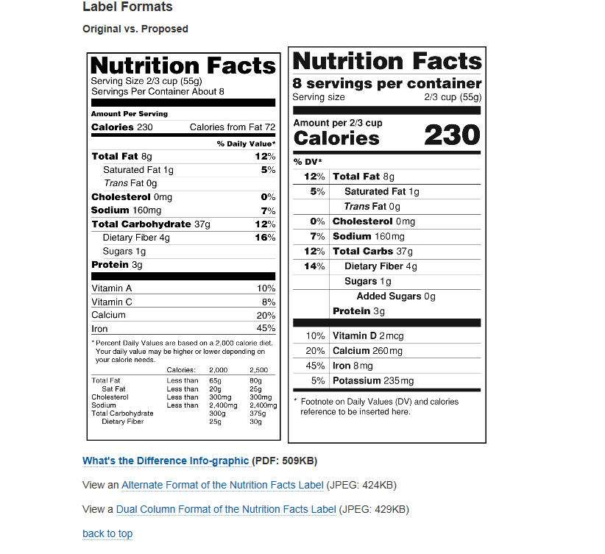

**APPENDIX B: SURVEY LANDING PAGE**

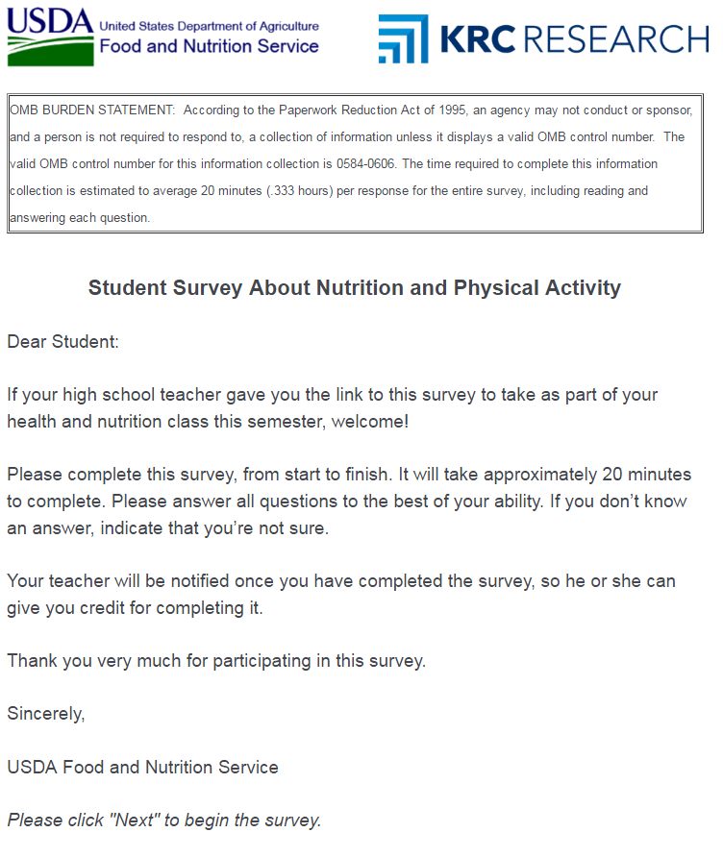

1. FOR OMB: An asterisk indicates a correct response. This will not be shown to the respondent.