**Appendix A-3b: Pretest Recruitment Flyer, English, D.C. area**

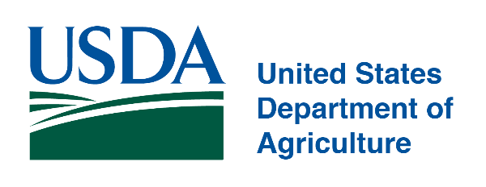

**Get $40 by Completing an Interview about a Survey**

We are seeking individuals:

* between the ages of 18 and 69;
* currently receiving Supplemental Nutrition Assistance Program (SNAP) in Maryland, D.C., or Virginia, also known as the Food Supplement Program in Maryland; and
* NOT receiving disability benefits.

This study is sponsored by the US Department of Agriculture, Food and Nutrition Service. On behalf of the Food and Nutrition Service, Westat, a social science research organization located at 1600 Research Blvd., in Rockville, Maryland, is seeking volunteers to participate in a 60-minute interview about SNAP benefits and employment. As part of the interview, you’ll be asked to complete a survey and answer questions about the survey. Your responses will be kept private, except as otherwise required by law. Your input will help to identify ways to improve the survey.

Participation in this study is voluntary. You can skip any survey or interview question and stop the interview at any time. Stopping the interview or choosing not to participate will have no impact on your SNAP benefits.

The interview will occur during the weeks of March 4th and March 11th in Oakland. Participants will receive $40 in cash for an in-person interview to offset any costs such as childcare or traveling that you may have incurred by your participation.

Interested individuals, including Spanish speakers, should contact [NAME] at [TELEPHONE NUMBER].

We will ask you a few questions to see if you are eligible to participate. Please note that we may not be able to interview everyone who contacts us at the number listed above.

Public reporting burden for this collection of information is estimated to average 2 minutes per response, including the time for reviewing instructions, searching existing data sources, gathering and maintaining the data needed, and completing and reviewing the collection of information. An agency may not conduct or sponsor, and a person is not required to respond to, a collection of information unless it displays a currently valid OMB control number. Send comments regarding this burden estimate or any other aspect of this collection of information, including suggestions for reducing this burden, to: U.S. Department of Agriculture, Food and Nutrition Services, Office of Policy Support, 3101 Park Center Drive, Room 1014, Alexandria, VA 22302 ATTN: PRA (0584-0606). Do not return the completed form to this address.