**ACE-L1**

**(03-2015) UNITED STATES DEPARTMENT OF COMMERCE**

## Economics and Statistics Administration

**U.S. Census Bureau**

Washington, DC 20233-0001

# PAST DUE NOTICE

## A Message from the Chief, Economy-Wide Statistics Division, U.S. Census Bureau

Our records indicate that we have not received your **2014 Annual Capital Expenditures Survey (ACES)**. Please complete the survey online using the following information:

**Website:** <https://econhelp.census.gov/aces>

**User ID:** XXXXXXXXXXX

**Password:** XXXXXXXX

**Due Date:** May 1, 2015

If you recently submitted your report, please visit the website noted above and use the “Self-Service Log in” to verify your filing status.

This report is **MANDATORY and was due by May 1, 2015**. Title 13, United States Code, Sections 131 and 182, authorizes the Census Bureau to conduct this survey. Sections 224 and 225 **require your participation**. Section 9 of Title 13 requires that the Census Bureau keep **your response strictly confidential**. Your information is only used to develop summary statistics that do not reveal the individual activities of your company. Under the same law, information cannot be used for taxation, regulation, or

investigation and is exempt from release under the Freedom of Information Act.

Summary statistics from this survey are a key source of information about our country’s economic performance. Business investment in structures and equipment is an important component of the official estimates of the Gross Domestic Product. The ACES data also help U.S. businesses identify market opportunities, develop new products, and establish strategic plans. The Census Bureau is determined to

provide the most accurate and useful data possible, and to achieve that standard, **it is critical to obtain information from companies such as yours**.

For additional information or assistance, please call us at 1-800-528-3049 weekdays between 8 a.m. and 6 p.m., Eastern time.

**Thank you** in advance for ensuring that the results of the 2014 Annual Capital Expenditures Survey are comprehensive, timely, and reliable.

Sincerely,

Kevin E. Deardorff Enclosure

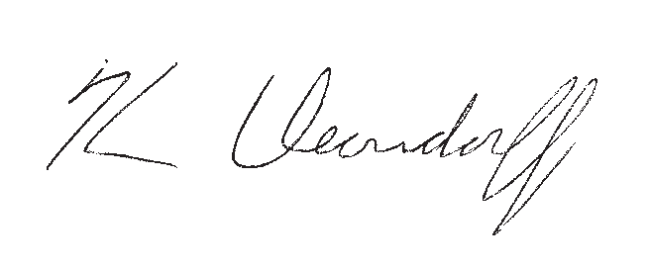

Toll-free help: 1-800-528-3049, Monday through Friday, 8 a.m. to 6 p.m., Eastern time.

census.gov