**ACE-L2**

**(03-2015) UNITED STATES DEPARTMENT OF COMMERCE**

## Economics and Statistics Administration

**U.S. Census Bureau**

Washington, DC 20233-0001

# PAST DUE NOTICE #2

## A Message from the Chief, Economy-Wide Statistics Division, U.S. Census Bureau

In March we mailed you instructions for completing the **2014 Annual Capital Expenditures Survey (ACES)** online and our records indicate it has not been received. Please complete the survey online using the following information:

**Website:** <https://econhelp.census.gov/aces>

**User ID:** XXXXXXXXXXX

**Password:** XXXXXXXX

**Due Date:** May 1, 2015

If you recently submitted your report, please visit the website noted above and use the “Self-Service Log in” to verify your filing status.

We remind you this report is **MANDATORY** and was **due by May 1, 2015**. Title 13, United States Code, Sections 131 and 182, authorizes the Census Bureau to conduct this survey. Sections 224 and 225 **require your participation**. Section 9 of Title 13 requires that the Census Bureau keep **your response strictly confidential**. Your information is only used to develop summary statistics that do not reveal the individual activities of your company. Under the same law, information cannot be used for taxation, regulation, or

investigation and is exempt from release under the Freedom of Information Act.

To avoid further action and help reduce the cost of further mail and/or telephone follow-ups, complete the survey online **IMMEDIATELY**. The Census Bureau depends on your input to ensure the accuracy of our data. Completion of this survey will provide valuable input to our nation’s system of economic statistics.

For additional information or assistance, please call us at 1-800-528-3049 weekdays between 8 a.m. and 6 p.m., Eastern time.

**Thank you** in advance for ensuring that the results of the 2014 Annual Capital Expenditures Survey are comprehensive, timely, and reliable.

Sincerely,

Kevin E. Deardorff Enclosure

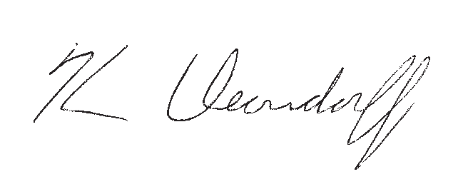

Toll-free help: 1-800-528-3049, Monday through Friday, 8 a.m. to 6 p.m., Eastern time.

census.gov