ACE-L3

(03-2015) UNITED STATES DEPARTMENT OF COMMERCE

Economics and Statistics Administration
U.S. Census Bureau
Washington, DC 20233-0001

FINAL NOTICE

A Message from the Chief, Economy-Wide Statistics Division, U.S. Census Bureau

Five months ago, we requested that you participate in a mandatory survey by completing the 2014 Annual Capital Expenditures Survey (ACES). We have made repeated attempts to obtain your data and still have not received your response. Please complete the survey online using the following information:

Website: https://econhelp.census.gov/aces
User ID: XXXXXXXXXXX
Password: XXXXXXXX
Due Date: May 1, 2015
If you recently submitted your report, please visit the website noted above and use the “Self-Service Log in” to verify your filing status.

Your response is required by law. Title 13, United States Code, Sections 131 and 182, authorizes the Census Bureau to conduct this survey. Sections 224 and 225 require your participation. Section 9 of Title 13 requires that the Census Bureau keep your response strictly confidential. Your information is only used to develop summary statistics that do not reveal the individual activities of your company. Under the
same law, information cannot be used for taxation, regulation, or investigation and is exempt from release under the Freedom of Information Act.

To remove your company / organization from delinquent status, we ask that you take the time to complete the survey IMMEDIATELY. To make reporting easier, we will accept estimates when book figures are not available. Your prompt response will alleviate the need for future mail and/or telephone follow-ups.

For additional information or assistance, please call us at 1-800-528-3049 weekdays between 8 a.m. and 6 p.m., Eastern time.

Thank you in advance for ensuring that the results of the 2014 Annual Capital Expenditures Survey are comprehensive, timely, and reliable.
Sincerely,

Kevin E. Deardorff Enclosure

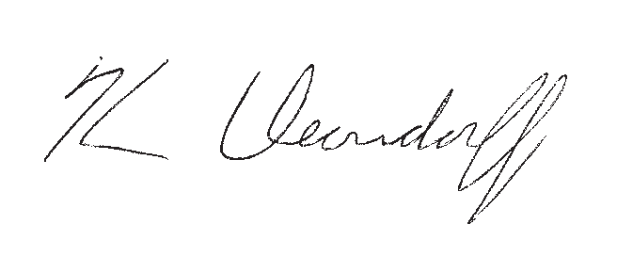

Toll-free help: 1-800-528-3049, Monday through Friday, 8 a.m. to 6 p.m., Eastern time.

census.gov

